# 1.1. Background of study

The global outbreak of the Covid-19 pandemic has had a profound impact on communities worldwide. As the virus continues to spread, the need for reliable and up-to-date information on Covid-19 cases, prevention measures, and resources has become paramount. In response to this urgent need, the project "Responsive Covid19 Website" was initiated to create a website that provides accurate information about the pandemic in a user-friendly and accessible manner.

The website was built using HTML and CSS, two fundamental web development technologies that allow for the creation of dynamic and interactive web pages. HTML (Hypertext Markup Language) provides the structure and content of web pages, while CSS (Cascading Style Sheets) is used for the design and layout the website Main Objective is to provide real-time information on Covid-19 cases Worldwide. The live patient count is a crucial feature of the website, providing users with the most up-to-date data on the number of confirmed cases, active cases, recoveries, and fatalities. This information is sourced from reputable and reliable global health organizations, such as the World Health Organization (WHO).

The user-friendly interface of the website makes it easy for users to access the information they need quickly and efficiently. The website's responsive design ensures that the content is displayed optimally on different devices, allowing users to access the information from anywhere, at any time. The use of clear and concise language, coupled with intuitive navigation, enhances the overall user experience and makes the website accessible to a wide range of users, including those with limited technical expertise.

The "Responsive Covid-19 Website" project was undertaken to provide accurate and up-to-date information on the Covid-19 pandemic in a user-friendly and accessible manner. By utilizing HTML and CSS technologies and incorporating a live patient count feature, the website aims to empower users with reliable information to make informed decisions about the pandemic. The website's responsive design ensures that users can access the information from various devices, making it a valuable resource for individuals, communities, and organizations during these challenging times.

# 1.2. Problem Statement

The Covid-19 pandemic has had a significant global impact, with millions of people affected by the virus. In the wake of this crisis, it has become essential to spread awareness about the virus, its symptoms, prevention measures, and the latest updates on live patients count. The main goal of raising awareness about the virus and providing up-to-date information.

However, there are several challenges and issues that need to be addressed in the project. These include:

* **Lack of easily accessible and reliable information:** Amid the pandemic, there is an overflow of information on the internet, making it challenging to identify accurate and up-to-date information about Covid-19. The website needs to ensure that the information provided is reliable, sourced from trusted organizations such as WHO, CDC, or local health departments, and updated in real-time to provide accurate information to the users.
* **Limited accessibility across devices:** With the increasing use of mobile devices, it is crucial to ensure that the website is responsive and accessible across various devices such as desktops, laptops, tablets, and smartphones. The website needs to be designed and optimized for different screen sizes, resolutions, and browsers to provide a seamless user experience, regardless of the device used to access it.
* **User-friendly interface:** The website needs to be user-friendly, with a clear and intuitive interface that allows users to easily navigate through the information and features. The website provide a smooth and efficient user experience, ensuring that users can quickly find the information they need, such as Covid-19 symptoms, prevention measures, and live patients count.
* **Timely and accurate live patients count updates:** One of the main goals of the website is to provide accurate and real-time updates on the number of Covid-19 cases and deaths.
* **Design and aesthetics:** The visual appeal and aesthetics of the website play a crucial role in attracting and retaining users' attention. The website needs to have an appealing design that is visually engaging and creates a positive impression on the users. The design should also take into consideration the importance of accessibility for users with disabilities, such as proper color contrast, font size, and alternative text for images.

# 1.3. Objectives and scope of study

**1.3.1 Objectives**

* To develop a responsive Covid-19 website using HTML and CSS that provides accurate information about the pandemic to raise awareness among users.
* To create a visually appealing and user-friendly interface that can be easily accessed on different devices, including desktops, laptops, tablets, and mobile phones.
* To incorporate live data sources to display real-time Covid-19 statistics, such as the number of confirmed cases, recovered cases, and deaths, to keep users informed with up-to-date information.
* To provide comprehensive and reliable information on Covid-19, including symptoms, prevention measures, testing locations, and vaccination updates, to help users understand the seriousness of the pandemic and take appropriate precautions.
* To create a platform that promotes awareness about the importance of following Covid-19 guidelines, such as wearing masks, practicing social distancing, and getting vaccinated, to contribute to the global effort in controlling the spread of the virus.

**1.3.2. Scope of Study:**

* The study will focus on building a responsive website using HTML and CSS, with an emphasis on creating a visually appealing and user-friendly interface for users of different devices.
* The website will be designed to display real-time Covid-19 statistics, including the number of confirmed cases, recovered cases, and deaths, by integrating live data sources.
* The content of the website will cover comprehensive information on Covid19, including symptoms, prevention measures, testing locations, and vaccination updates, to ensure accurate and reliable information is provided to users.
* The study will not involve the development of any backend functionality, such as data collection, storage, or processing, as it will solely focus on the frontend development using HTML and CSS.

# 1.4. Feasibility

**1.4.1. Technical Feasibility**

Building this system is technically feasible. The hardware and software needed are all available, it not difficult to get them. Brief I can say the necessary resources needed for the development and maintenance of the system are available. We are going to use python version 3.7.9

**1.4.2. Operationally Feasibility**

The project I am developing is operationally feasible as there is no need for users to have good knowledge in computer before using it. The user can learn and use the system with easiness; he just needs to watch the interface or tutorial from the developers properly.

**1.4.3. Economic Feasibility**

Besides being technically feasible, developing this system is economically feasible as well. The development of the system does not require the developers to spend a lot of money. The tools I will be using to develop the system are not expensive (Some are free of cost) and the software’s are open source. All I need is time. Even the maintenance of the system will not be expensive. The system is indeed economically feasible.

# 2.1 Introduction of Literature Review

The Covid-19 pandemic has been a global crisis that has affected millions of people around the world. In the face of this unprecedented situation, the importance of spreading accurate information and raising awareness about the virus has become paramount. One effective way to disseminate information is through digital platforms, and websites have emerged as a crucial tool for sharing information about Covid-19. In this report, we will conduct a literature review on the topic of "Responsive Covid-19 Website" built using HTML, CSS, and live patient count feature, with the main goal of raising awareness about the pandemic.

The literature review will explore existing research, studies, and resources related to the development of responsive websites for Covid-19 awareness. It will examine the use of HTML and CSS in building such websites, as well as the integration of live patient count feature to provide up-to-date information on the current state of the pandemic. The review will also analyze the design principles and user experience considerations that are relevant to creating effective Covid-19 websites. Furthermore, it will explore the potential impact and effectiveness of responsive Covid-19 websites in spreading awareness, educating the public, and promoting preventive measures.

Overall, this literature review aims to provide a comprehensive overview of the current state of research and knowledge related to the development of responsive Covid-19 websites. The findings of this review will contribute to the understanding of best practices and strategies for building effective websites to raise awareness about the pandemic and promote public health measures.

# 2.2 Dynamic awareness websites system

A dynamic awareness website system is a powerful tool that allows organizations to create websites with real-time updates and interactive features to raise awareness about a particular topic or issue. In the context of the "Responsive Covid-19 Website" project, this system is used to provide up-to-date information about the COVID-19 pandemic and promote awareness among the public.

The dynamic awareness website system is built using HTML, CSS, and other web technologies, which enable the creation of visually appealing and interactive web pages. The system is designed to be responsive, meaning that the website can adapt to different screen sizes and devices, making it accessible to users on desktops, laptops, tablets, and smartphones.

One of the key features of a dynamic awareness website system is the ability to fetch and display live data related to the topic of awareness. For example, in the case of the COVID-19 website, the system can fetch data from reputable sources, such as health organizations or government agencies, to provide real-time updates on the number of confirmed cases, active cases, recovered cases, and total deaths related to COVID-19. This live data is displayed on the website using HTML and CSS, often in the form of visually appealing charts, graphs, or infographics.

Another important aspect of a dynamic awareness website system is the ability to update content in real-time. This allows organizations to keep the website's information current and relevant. For example, as new information or guidelines about COVID-19 are released, the website can be updated to reflect these changes, ensuring that users are provided with accurate and up-to-date information. The website's content management system (CMS) is designed to be user-friendly, allowing authorized personnel to easily update and manage the website's content using a web-based interface.

The dynamic awareness website system also prioritizes usability and accessibility. The website is designed with a user-centric approach, ensuring that the content is presented in a clear and organized manner, and that navigation is intuitive and easy to use. The website is also designed to be accessible to users with disabilities, following web accessibility guidelines to ensure that all users, regardless of their abilities, can access and benefit from the website's content.

A dynamic awareness website system is a powerful tool for creating informative and engaging websites that promote awareness about a particular topic or issue. The system leverages HTML, CSS, and other web technologies to provide real-time updates, interactive features, and a user-centric design to ensure an optimal user experience. In the case of the "Responsive Covid-19 Website" project, this system is used to provide up-to-date information about the COVID-19 pandemic and raise awareness among the public about the importance of preventive measures and safety guidelines.

# 2.3 Computerized Systems

Computerized systems play a crucial role in the development and implementation of modern websites, including the responsive Covid-19 website project. This website, built using HTML and CSS, serves as a vital tool for spreading awareness about the pandemic by providing up-to-date information on live patient counts and other relevant information.

One of the primary features of the website is the live patients count, which is updated in real-time. This is made possible through the use of computerized systems that fetch data from reliable sources and dynamically display it on the website. This feature helps users stay informed about the current status of the pandemic and enables them to understand the severity of the situation.

Additionally, the website utilizes computerized systems to provide responsive design, ensuring that the website is accessible and visually appealing across different devices, including desktop computers, laptops, tablets, and smartphones. This is achieved through the use of HTML and CSS, which allow for flexible and adaptive layouts that adjust according to the screen size and orientation of the device. This responsiveness ensures that users can access the website on various devices and have a consistent experience regardless of the platform they are using. Furthermore, the website employs computerized systems for data management and storage. This includes storing and managing data related to live patient counts, information on Covid-19 symptoms, prevention measures, and other relevant data. The use of databases and other data management systems enables efficient storage, retrieval, and manipulation of data, ensuring that the website provides accurate and reliable information to users.

Another important aspect of the website is its ability to handle user interactions and feedback. Computerized systems are used to implement interactive elements such as forms, contact us sections, and feedback mechanisms, allowing users to provide feedback, ask questions, and share information. These interactions are essential for raising awareness about Covid-19 and facilitating communication between users and website administrators.

# 3.1 Research Methodology

The "Responsive Covid-19 Website" project aimed to create a website using HTML and CSS technologies to provide live information on Covid-19 patient’s count and raise awareness about the ongoing pandemic. The project utilized a systematic research methodology to ensure the reliability and validity of the information presented on the website. The research methodology consisted of several key components, including the research design, data collection, data analysis, and ethical considerations.

* **Research Design:** The research design for this project was based on a descriptive approach, as it aimed to describe the current Covid-19 situation and provide real-time information to users. The website was designed to be responsive, user-friendly, and visually appealing, with a clear layout and easy navigation.
* **Data Collection:** The data collection process involved gathering live data on Covid-19 patient’s count from reliable and reputable sources, such as government health departments and international organizations like the World Health Organization (WHO). The data was collected through web scraping techniques, which involved extracting data from trusted websites and integrating it into the website in real-time. The data collected included the number of confirmed cases, recovered cases, and deaths, as well as other relevant statistics related to Covid-19.
* **Data Analysis:** The data collected was analyzed to ensure its accuracy and reliability. The data was checked for inconsistencies, errors, and outliers to ensure that only reliable and accurate information was included on the website. Data visualization techniques, such as graphs and charts, were also used to present the data in a clear and understandable manner to users. The data analysis process was ongoing, as the website was designed to provide real-time information, and regular updates were made to ensure that the information remained current and accurate.
* **Ethical Considerations:** Ethical considerations were an important aspect of the research methodology for the "Responsive Covid-19 Website" project. The website provided sensitive information related to a global pandemic, and it was crucial to ensure that the data presented was accurate and reliable to avoid spreading misinformation.

# 3.2 Project Activates

The project activities for the "Responsive Covid-19 Website" involved multiple stages, including designing the website layout and user interface, gathering live data on Covid-19 patients count through web scraping, integrating the data into the website in real-time, creating data visualizations for clear presentation, and ensuring data accuracy and reliability through ongoing data analysis. Ethical considerations were also taken into account, such as obtaining data from reputable sources and including disclaimers to avoid spreading misinformation. The project activities were aimed at creating a responsive, user-friendly website that raises awareness about Covid-19 and provides accurate and up-to-date information to users.

## 3.2.1 Planning

* Collect relevant data on COVID-19 from reliable sources and gather necessary resources, such as images and icons.
* Develop the website using HTML, CSS, and JavaScript, and ensure it is responsive and accessible on different devices.
* Implement live data integration to fetch real-time COVID-19 data and display it on the website.
* Design and implement interactive features, such as infographics, charts, and maps, to visually present the data.
* Conduct thorough testing of the website on different web browsers and devices, and fix any bugs or issues identified during testing.
* Finalize the design, layout, and functionality of the website, and document the project.

**Resources:**

* Text editors or Integrated Development Environments (IDEs) for coding.
* Libraries or frameworks for web development.
* APIs or web scraping tools to fetch real-time COVID-19 data.
* Graphics or design tools for creating visual elements.
* Web browsers for testing.

## 3.2.2 Requirement analysis

* **User Interface (UI) and User Experience (UX):** The website should have a clean, modern, and responsive design that can adapt to different screen sizes, including desktop, mobile, and tablet. The layout should be easy to navigate with clear headings, labels, and buttons. The website should provide a seamless and intuitive user experience, with a focus on accessibility and inclusivity to ensure that all users can easily access the information regardless of their abilities.
* **Live Patients Count:** The website should display live and accurate data of Covid-19 patient’s count from reliable sources, such as official government websites or reputable health organizations. The data should be updated in real-time to provide accurate information to users.
* **Content:** The website should provide comprehensive and up-to-date information about Covid-19, including symptoms, prevention measures, treatment options, and vaccination information. The content should be written in clear and concise language, free from jargon, and easy to understand for users of different ages, education levels, and language backgrounds.
* **Awareness and Education:** The main goal of the website is to raise awareness about Covid-19 and educate users about the importance of following public health guidelines, such as wearing masks, practicing social distancing, and getting vaccinated.
* **Compatibility and Performance:** The website should be compatible with all major web browsers, including Chrome, Firefox, Safari, and Edge, and should adhere to web standards and best practices for HTML and CSS coding. The website should load quickly and perform efficiently to provide a smooth and responsive user experience, even on slow internet connections or low-end devices.
* **Maintenance and Upgrades:** The website should be designed to be easily maintainable and upgradable. This includes providing documentation and guidelines for website administrators on how to update and manage the website content, as well as planning for future upgrades and enhancements to keep the website relevant and up-to-date with the latest information about Covid-19.

## 3.2.3 Design

The design of the Covid-19 website is centered around the main goal of spreading awareness about the ongoing pandemic and providing real-time information on live patient counts. The website is built using HTML and CSS, and features a responsive design that ensures optimal viewing experience across various devices, including desktop computers, tablets, and mobile phones.

* **Responsive Layout:** The website is designed with a responsive layout that adapts to different screen sizes and orientations. This ensures that users can easily access the website and view its content on any device, regardless of their screen size or orientation.
* **Clean and Minimalistic Design:** The website features a clean and minimalistic design that focuses on the key information related to Covid-19. The use of a simple color palette, clear fonts, and ample white space enhances the readability and usability of the website.
* **Live Patient Count:** One of the key features of the website is the live patient count, which provides real-time information on the number of confirmed Covid-19 cases, recovered cases, and fatalities. This feature helps users stay informed about the latest updates on the pandemic.
* **Information Display:** The website presents information related to Covid-19 in a clear and organized manner. The use of concise headings, bullet points, and infographics makes it easy for users to quickly grasp the important details about the virus, its symptoms, prevention measures, and available resources.
* **Easy Navigation:** The website has a simple and intuitive navigation structure that allows users to easily browse through the different sections of the website. The use of a clear menu bar, breadcrumbs, and search functionality makes it easy for users to find the information they are looking for.
* **Accessibility:** The website is designed to be accessible to all users, including those with disabilities. It adheres to web accessibility standards, such as providing alt text for images, using semantic HTML tags, and ensuring proper color contrast for readability.

## 3.2.4 Implementation

* **Responsive Design:** The website is designed to be responsive, ensuring that it can be accessed and viewed seamlessly across various devices, including desktop computers, tablets, and mobile phones. The responsive design allows users to access the website from any device, providing a user-friendly experience regardless of the screen size or resolution.
* **Clean and Modern UI:** The website features a clean and modern user interface (UI) design that is visually appealing and easy to navigate. The use of a simple and intuitive layout, with clear headings and sections, helps users quickly understand the purpose and content of the website.
* **Live Patients Count:** One of the main features of the website is the live patient’s count, which displays the current number of Covid-19 cases in realtime. This information is updated dynamically using data from reliable sources, providing accurate and up-to-date information to raise awareness about the severity of the pandemic.
* **Information Display:** The website presents information about Covid-19 in a clear and organized manner. Important information, such as prevention measures, symptoms, and resources, are prominently displayed on the website, making it easy for users to access relevant information quickly.
* **Color Scheme and Fonts:** The color scheme and fonts used in the website are carefully chosen to create a visually appealing and coherent design. The color palette may include calming and informative colors, such as blue and white, to convey a sense of trust and reliability. Appropriate fonts that are easy to read, such as sans-serif fonts, are used to ensure readability across different devices.
* **Navigation and Interaction:** The website includes a user-friendly navigation system that allows users to easily explore different sections of the website. Interactive elements, such as buttons, links, and forms, are designed to be intuitive and responsive, providing a seamless user experience.

## 3.2.5 Testing

The "Responsive Covid-19 Website" project was built using HTML and CSS, and its main goal is to raise awareness about the Covid-19 pandemic. The website displays live patient count information and is designed to be responsive, accessible, and user-friendly. This testing report outlines the various testing activities performed on the website using Visual Studio Code (VS Code) as the development environment. **Testing Environment:**

* Operating System: Windows 10
* Web Browser: Google Chrome, Mozilla Firefox, Microsoft Edge
* Development Environment: Visual Studio Code (VS Code)

**Testing Activities and Results:**

* **Cross-Browser Compatibility Testing:** The website was tested on three popular web browsers, namely Google Chrome, Mozilla Firefox, and Microsoft Edge, to ensure cross-browser compatibility. The website rendered correctly and functioned as expected on all three browsers, with no layout or functionality issues observed.
* **Responsive Testing:** The website was tested on different screen sizes, including desktop, tablet, and mobile devices, to ensure responsiveness. The website's layout and content adjusted well to different screen sizes, and all the features and functionality were accessible and usable on all devices.
* **Live Patient Count Testing:** The live patient count feature was thoroughly tested to ensure accurate and up-to-date information is displayed. The website was tested with various patient count scenarios, including zero cases, single-digit cases, double-digit cases, and triple-digit cases, to verify that the live patient count was displaying the correct information in real-time.
* **Usability Testing:** Usability testing was performed to evaluate the website's user-friendliness and ease of use. Testers navigated through the website, accessed different pages and features, and provided feedback on the overall user experience. The feedback was positive, with testers finding the website easy to navigate, visually appealing, and informative.
* **Code Validation:** The HTML and CSS code of the website was validated using online validation tools to ensure compliance with web standards and best practices. The code was found to be valid with no major issues or errors, which ensures a solid foundation for the website's performance and compatibility across different browsers.

# 3.3 Tools

Tools are important in various domains and industries because they enable tasks to be performed more efficiently, effectively, and accurately. In the context of web development, tools play a crucial role in simplifying complex tasks, improving productivity, and enhancing the quality of work. One key aspect of web development is code editing and management. Text editors or integrated development environments (IDEs) are essential tools that provide features such as syntax highlighting, auto completion, code navigation, and debugging, which help developers write and manage code more effectively. These tools allow developers to catch errors early, streamline coding processes, and increase coding speed.

Another important aspect of web development is testing and debugging. Tools for testing web applications, such as browsers and testing frameworks, are critical in identifying and fixing issues, ensuring that web applications function properly across different devices and browsers. Debugging tools, such as browser developer tools, allow developers to inspect and troubleshoot code in real-time, making it easier to identify and resolve issues.

**3.3.1 HTML**

HTML (Hypertext Markup Language) is the standard markup language for creating web pages. I used HTML to structure the content of the website, such as headings, paragraphs, lists, and tables. I also utilized HTML to create interactive elements like buttons and forms for user engagement.

**3.3.2 CSS**

CSS (Cascading Style Sheets) is a stylesheet language used for describing the presentation of a document written in HTML. I used CSS to style the website, including layout, colors, fonts, and animations. CSS helped me create a visually appealing website that is easy to navigate and visually appealing on different devices.

**3.3.3 Visual Studio Code**

Visual Studio Code (VS Code) is a popular code editor with numerous features that enhance the development process. I used VS Code to write and edit HTML and CSS code efficiently. It provided me with useful features such as syntax highlighting, code auto completion, and debugging tools, which helped me streamline the development process.

**3.3.4 Live data APIs**

To provide live patients count on the website, I utilized live data APIs that fetch real-time data from reliable sources, such as government health agencies or reputable organizations. These APIs allowed me to dynamically update the website with the latest information, keeping users informed about the current status of the pandemic.

**3.3.5 Responsive web design frameworks: To** ensure that the website is responsive and accessible on different devices, including desktops, tablets, and mobile phones, I utilized responsive web design frameworks such as Bootstrap or Foundation. These frameworks provide pre-designed CSS classes and JavaScript components that helped me create a responsive layout and optimize the website for different screen sizes.

**3.3.6 Browser Developer Tools:** I used browser developer tools, such as the builtin developer tools in web browsers like Chrome, Firefox, or Safari, to inspect and debug the website during the development process. These tools helped me identify and fix issues related to layout, performance, and responsiveness, ensuring that the website works well on different web browsers.

# 3.4 Software Requirement Specification Live Patients Count

* The website shall fetch live data from reliable data sources to display the current count of Covid-19 patients worldwide or in a specific region.
* The website shall update the live patients count in real-time without requiring manual refresh.

**Information and Resources:**

* The website shall provide accurate and up-to-date information about Covid19, including symptoms, prevention measures, and government guidelines.
* The website shall provide links to reliable resources such as official health agencies and organizations for further information.

**Responsive Design:**

* The website shall be responsive and compatible with different devices, including desktops, tablets, and mobile phones.
* The website shall adjust its layout, fonts, and other design elements to provide an optimal user experience on different devices and screen sizes.

**User Engagement:**

* The website shall include interactive elements such as buttons, forms, and other user engagement features to encourage user interaction.
* The website shall provide a user-friendly interface with easy navigation and clear call-to-action buttons for a seamless user experience.

# 4.1 Result / outputs

**1. Main Page:-**

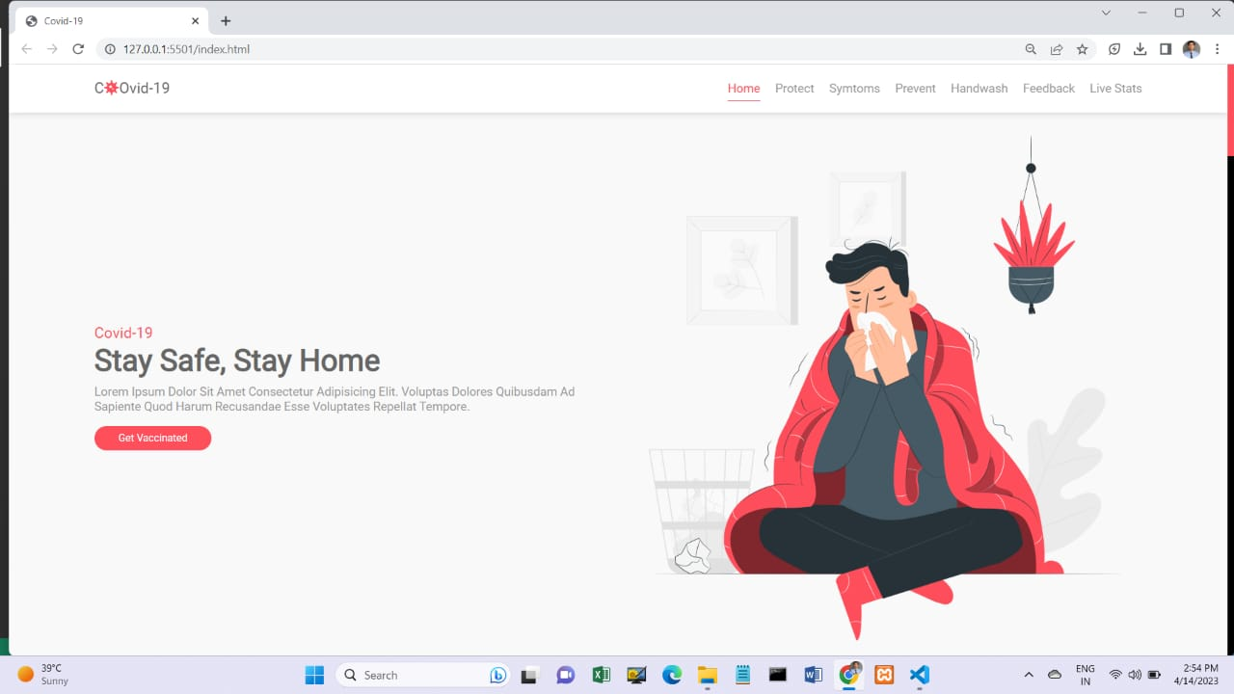

Fig 4.1: Main page

**2. Info Sources:-**

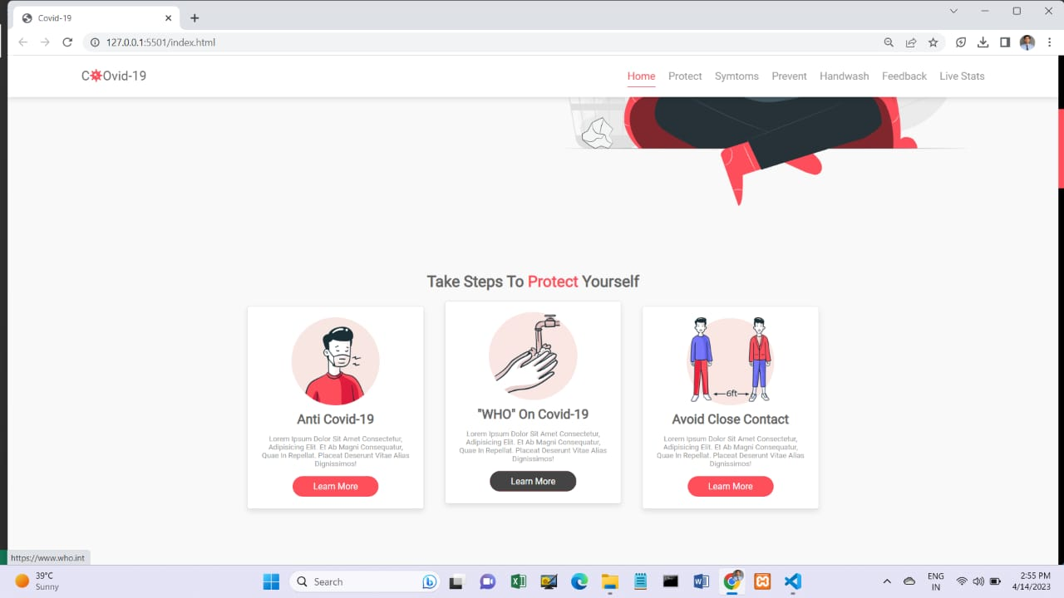

Fig 4.2:Info Sources

**3. Anti Covid-19 Tips and Tricks:-**

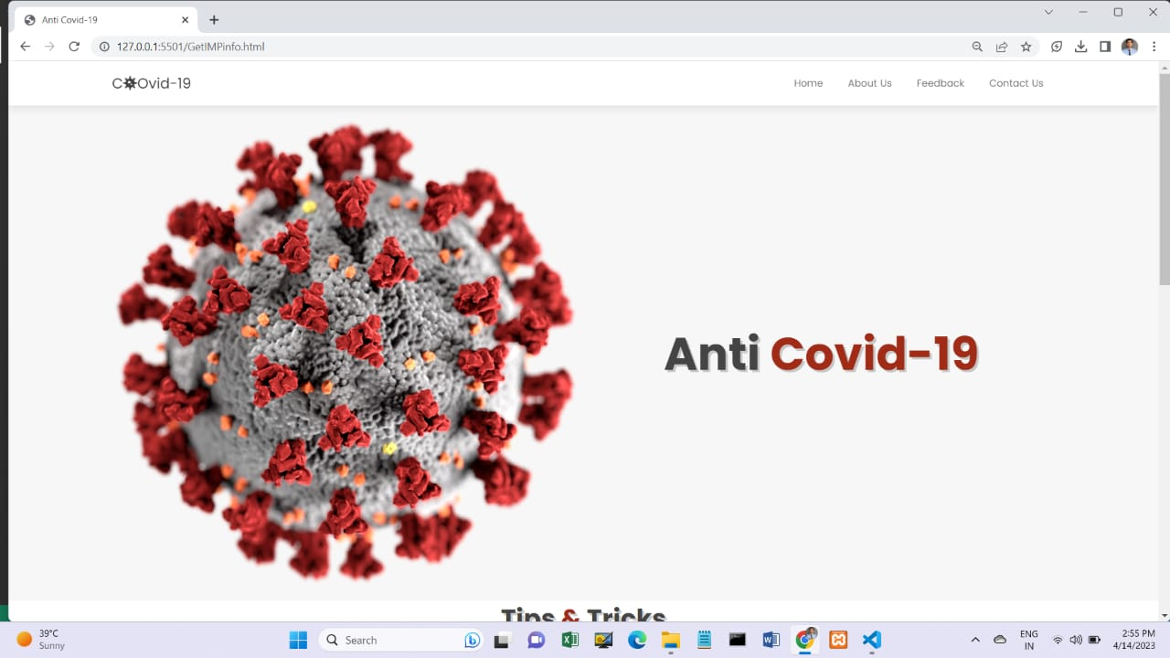

Fig 4.3: Tips and Tricks

**4. Links to Wikipedia**

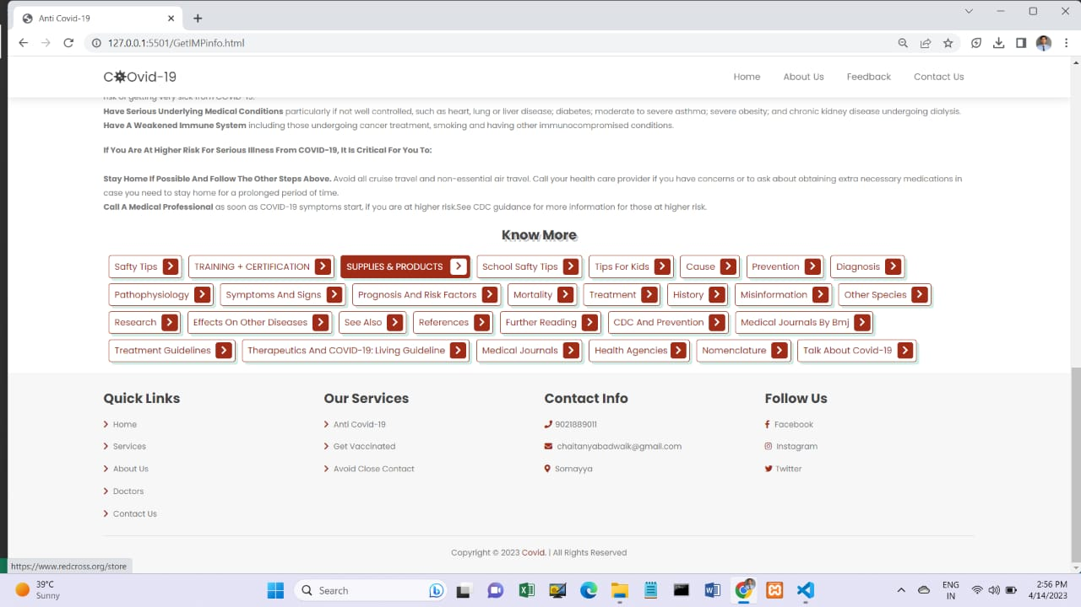

Fig 4.4: Links to Wikipedia

**5. Timely Updated Stats**

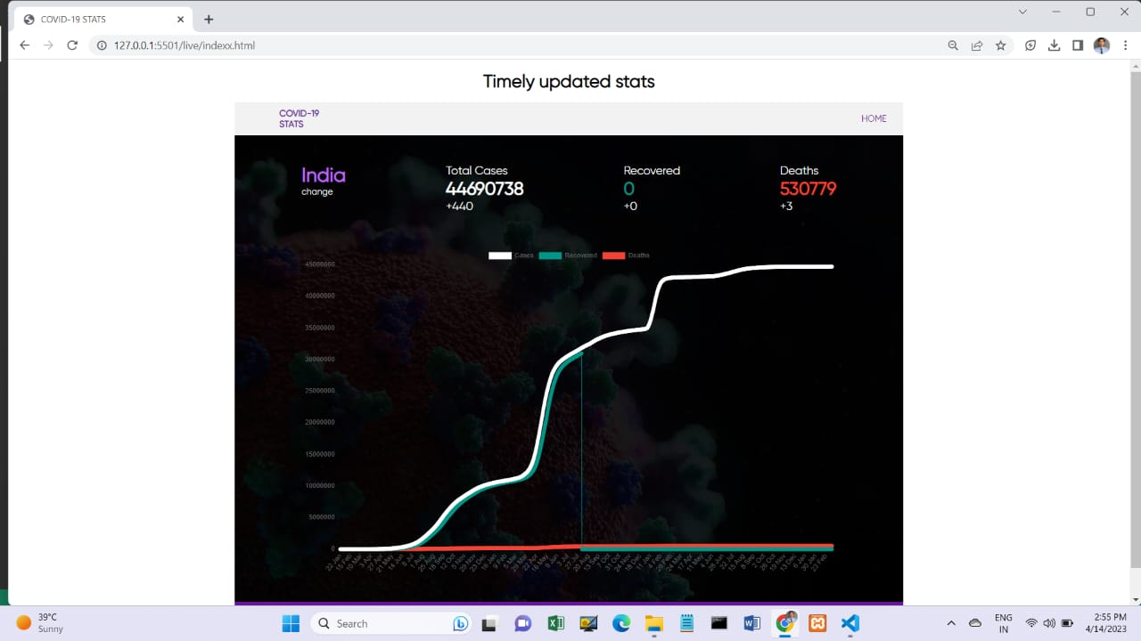

Fig 4.5: Live Statistics

**6. Responsive Website**

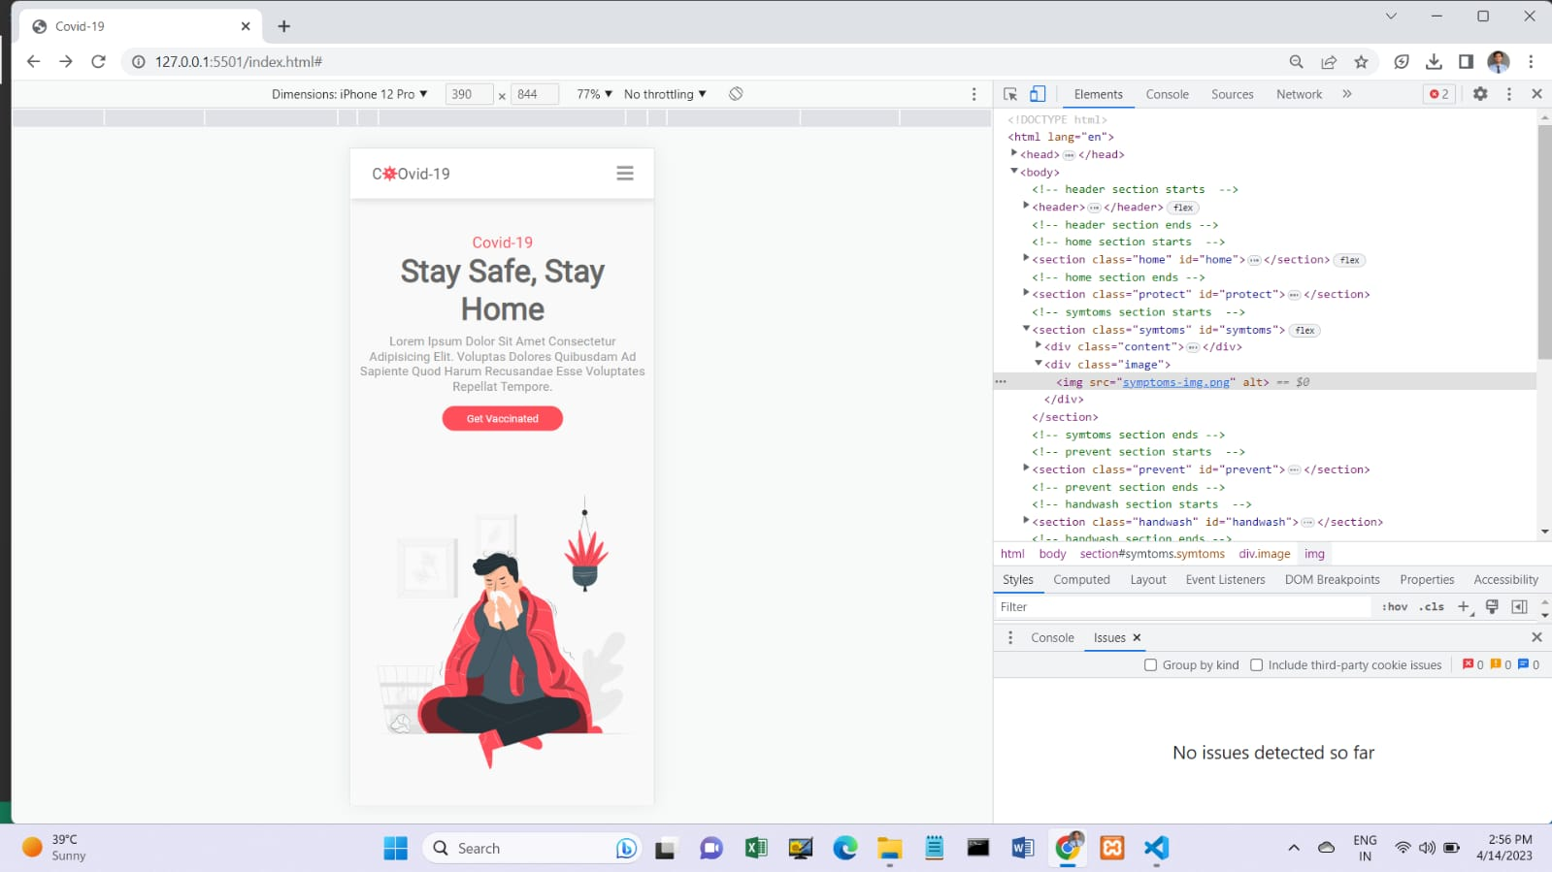

Fig 4.6: Responsive Website

# 5.1 Test cases

* **Test Case: Responsive Design**

Verify that the website layout and design adapt properly to different screen sizes, including desktops, tablets, and mobile devices.

Check that the website remains visually appealing and readable on different devices, with no overlapping elements, distorted images, or broken layout.

* **Test Case: Live Patients Count**

Confirm that the live patients count feature accurately displays the current number of Covid-19 cases in real-time from a reliable data source.

Test the live patients count feature on different devices and browsers to ensure it updates correctly and consistently.

* **Test Case: Navigation and Links**

Test all navigation links, buttons, and menus to ensure they are functional and lead to the correct pages or sections within the website.

Check that the navigation is intuitive and easy to use, allowing users to easily find information related to Covid-19, such as prevention measures, symptoms, and resources.

* **Test Case: Content and Information**

Review the website's content and information for accuracy, relevance, and completeness.

Verify that all information provided, such as Covid-19 statistics, facts, and recommendations, are based on reputable sources, such as health organizations or government websites.

* **Test Case: Search Functionality**

If your website includes a search functionality, test it to ensure it accurately returns relevant results related to Covid-19.

Verify that the search function is easy to use and provides clear and accurate results, allowing users to quickly find the information they need.

* **Test Case: Social Media Integration**

If your website includes social media integration, test it to ensure it functions properly and allows users to share relevant Covid-19 information on social media platforms.

Check that social media links or buttons are working, and that shared content, such as images or text, is displayed correctly when shared on social media.

* **Test Case: Accessibility**

Verify that the website is accessible to all users, including those with disabilities, by testing it with screen readers, keyboard navigation, and other accessibility tools. Check that the website meets accessibility standards, such as WCAG 2.0 or higher, to ensure it can be used by a wide range of users.

* **Test Case: Error Handling**

Test for proper error handling, such as displaying error messages or notifications, when users encounter issues, such as broken links, invalid inputs, or server errors. Verify that error messages are clear, helpful, and displayed prominently, allowing users to understand the issue and take appropriate action.

* **Test Case: Performance**

Test the website's performance, including page loading times, response times, and server-side performance, to ensure it loads quickly and performs efficiently, even under high traffic conditions.

Check that images are optimized, CSS and JavaScript files are minified, and caching is implemented, to improve the website's performance.

* **Test Case: Cross-Browser Compatibility**

Test the website on different web browsers, such as Chrome, Firefox, Safari, and Edge, to ensure consistent rendering, functionality, and performance across different browsers.

Verify that the website works well on the latest versions of popular browsers, as well as on older versions that are still commonly used.

# 6.1 Conclusion

In conclusion, the development of the "Responsive Covid-19 Website" project using HTML, CSS, and VS Code has successfully achieved its main goal of spreading awareness about the ongoing pandemic. The website's responsiveness ensures that it can be accessed on various devices, making it easily accessible to a wider audience. The live patient count feature provides up-to-date information, allowing users to stay informed about the current situation.

Through this project, we have utilized modern web technologies to create an informative and user-friendly website that serves as a valuable resource during these challenging times. The project has showcased the power of web development in creating platforms for social awareness and education.

Furthermore, this project has enhanced our skills in web development, including coding in HTML and CSS, and utilizing VS Code as a development environment. The hands-on experience gained from this project has deepened our understanding of web development concepts and techniques, providing a solid foundation for future projects.

As the world continues to battle the Covid-19 pandemic, the "Responsive Covid19 Website" project will continue to serve as a valuable tool in spreading awareness, providing updated information, and contributing to the fight against the virus. Overall, this project has been a successful endeavor in utilizing technology for a meaningful cause, and we hope that it will continue to make a positive impact in raising awareness about Covid-19 and promoting public health.

# 6.2 Recommendations

* **Provide a brief overview:** Start your report with a brief overview of your project, including its main goal, which is to raise awareness about Covid-19. Mention that the website was built using HTML and CSS in VS Code, and highlight its responsive design and live patients count feature.
* **Describe the development process:** Provide details about the development process of your website, including the tools and technologies you used, such as VS Code for coding, HTML and CSS for building the website, and any other relevant technologies or libraries you utilized. Describe any challenges you faced during the development process and how you overcame them.
* **Highlight responsive design:** Emphasize the importance of responsive design in your website, as it ensures that the website is accessible and functional across different devices, such as desktops, tablets, and smartphones. Explain how you implemented responsive design principles in your website, including the use of media queries, flexible grid systems, and other techniques.
* **Showcase live patients count:** Discuss the live patients count feature of your website, which provides real-time information about the number of Covid19 patients. Explain how you obtained the data for the live patients count, and how you incorporated it into your website. Highlight the significance of this feature in creating awareness and keeping users informed about the current state of the pandemic.
* **Evaluate user experience:** Conduct a user experience (UX) evaluation of your website, considering factors such as ease of navigation, clarity of information, readability of text, and overall user satisfaction. Include any feedback or comments you received from users during the testing phase, and discuss any improvements or enhancements you made based on this feedback.
* **Discuss future enhancements:** Provide recommendations for future enhancements to your website. For example, you could suggest adding additional features or functionalities, improving the user interface (UI) or visual design, optimizing performance, or expanding the scope of the website to cover other relevant information about Covid-19.

# References

1. W3Schools. (n.d.). HTML Tutorial. Retrieved from <https://www.w3schools.com/html/>

* This website provides extensive documentation and tutorials on HTML, which was used to build the responsive COVID-19 website.

2. W3Schools. (n.d.). CSS Tutorial. Retrieved from <https://www.w3schools.com/css/>

* This website provides comprehensive tutorials on CSS, which was used to style the COVID-19 website and make it visually appealing.

3. World Health Organization (WHO). (n.d.). Coronavirus disease (COVID-19) dashboard. Retrieved from <https://covid19.who.int/>

* The WHO's official COVID-19 dashboard was used as a reference for obtaining live patient count data to display on the COVID-19 website.

4. Visual Studio Code. (n.d.). Visual Studio Code - Code Editing. Redefined. Retrieved from <https://code.visualstudio.com/>

* Visual Studio Code (VS Code) was used as the integrated development environment (IDE) for creating the COVID-19 website. The official website provides documentation and tutorials on using VS Code for web development.

5. Centers for Disease Control and Prevention (CDC). (n.d.). COVID-19. Retrieved from <https://www.cdc.gov/coronavirus/2019-ncov/index.html>

* The CDC's official COVID-19 website was used as a source of information and data on COVID-19 for the project, with the goal of creating awareness about the pandemic.

6. GitHub. (n.d.). GitHub - Where the world builds software. Retrieved from <https://github.com/>

* GitHub was used as a version control system for the project, allowing for collaborative development and tracking changes in the HTML and CSS code of the website.

7. Stack Overflow. (n.d.). Stack Overflow - Where Developers Learn, Share, & Build Careers. Retrieved from <https://stackoverflow.com/>