Department of Information Technology

Semester: V Name of Student:
Academic Year: 2022-23 Student ID:
Class / Branch: TE IT
Subject: Security Lab (SL)
Name of Instructor: Prof. Apeksha Mohite

EXPERIMENT NO. 9
Aim: To study and implement IPSEC in Linux .

1. sudo apt-get install ipsec-tools strongswan-starter
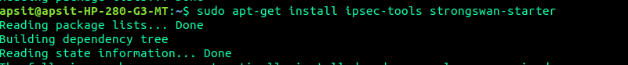
2. configuration file
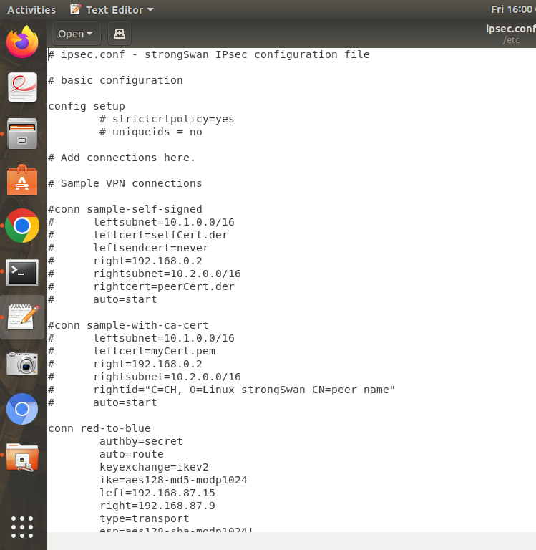

3. secret file with same passwords.
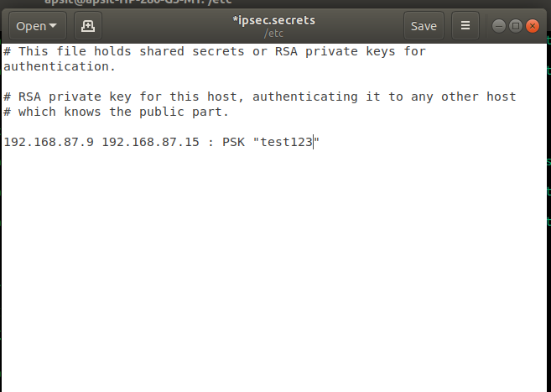

4. successful connection between 2 machines.
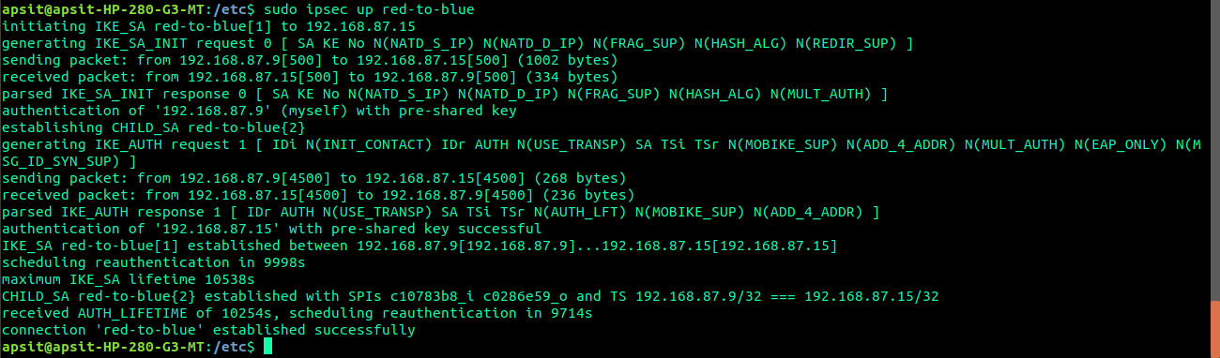
5. secret file with different password.
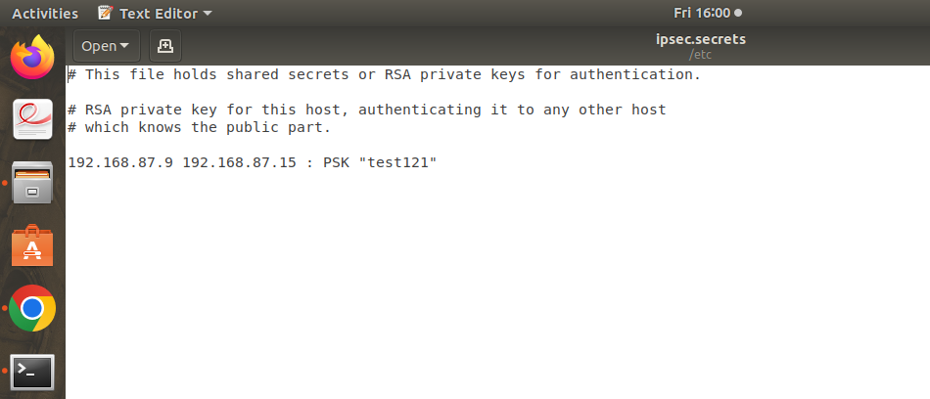

6. connection failed.
