**Title:** Measures of Central Tendency and Graphical Display statistical description

**Objective/Aim:**

1. Calculate the mean, median and standard deviation for all attributes.
2. Draw the boxplots for each attribute.
3. Draw a scatter plot and a q-q plot basedon these four variables*.*
4. Normalize the two variables based on z-score normalization.
5. Calculate the correlation coefficient (Person's product moment coefficient). Are these variables positively or negatively correlated?

**Actual Experimentation/ simulation/ result/ Observation:**

Data Description:



1. 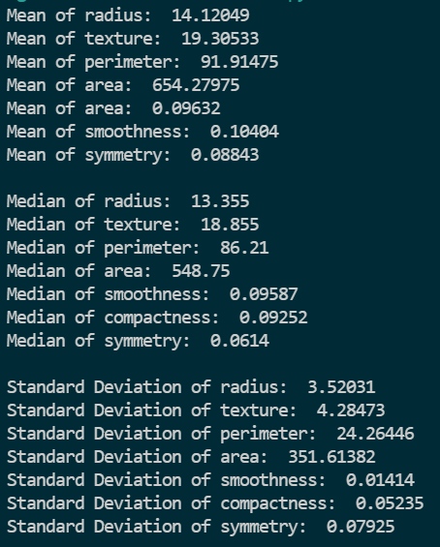
2. 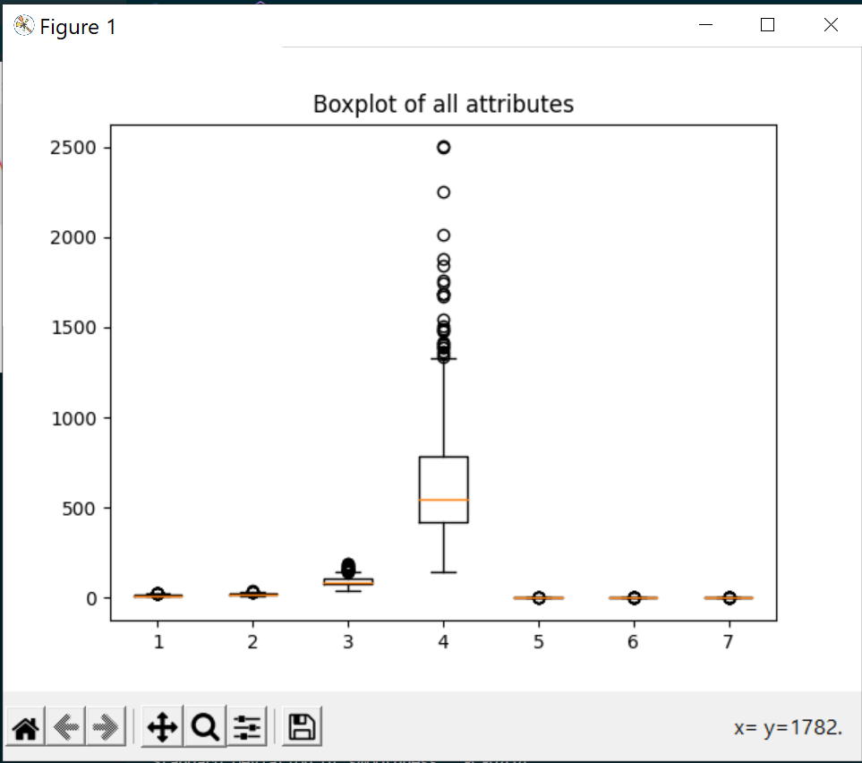
3. Scatter plot for First attribute ‘radius’: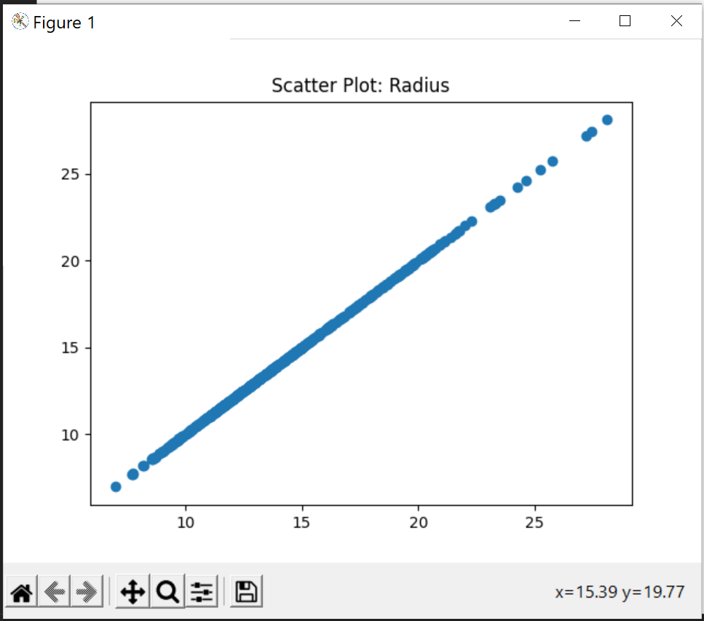
4. Z-score Normalization

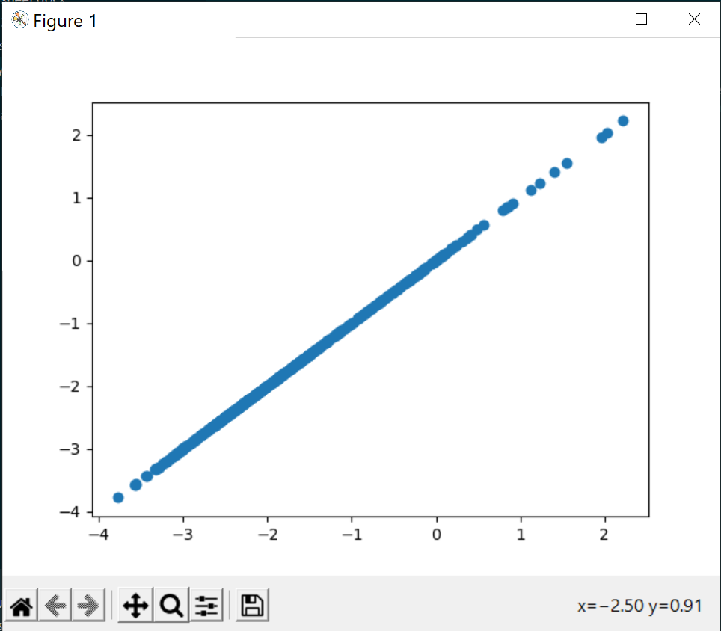

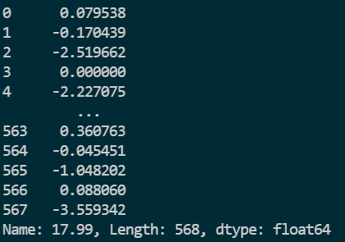

1. Person Coefficient for ‘radius’ and ‘texture’ attributes:



**References:**

1. <https://www.wikipedia.org/>
2. <https://towardsdatascience.com/>