DataStruct Lab: Data Structure Analysis and Performance Evaluation
Shreyashkumar Patel
Colorado State University Global
CSC506: Design and Analysis of Algorithms
Jonathan Vanover
September 20th, 2026

Data Structure Analysis and Performance Evaluation
Data structures determine how software stores, retrieves, and modifies information. The choice of structure affects not only code organization but also the amount of work required for common operations. DataStruct Lab was developed as an interactive learning tool that demonstrates these trade-offs through a Python-list-backed stack, a deque-backed queue, and a custom singly linked list. The tool combines operation visualizations, a rule-based complexity analyzer, automated testing, and measured performance experiments so that theoretical Big-O behavior can be compared with actual execution trends.

Data Structure Importance and Selection Criteria
A stack follows the last-in, first-out (LIFO) principle, so the most recently added value is removed first. This access pattern is appropriate for undo history, nested processing, backtracking, and similar workflows in which recent items must be handled before older items. In the implementation, push appends to the end of a Python list, while pop removes that end and peek reads it without removal. Push is O(1) amortized and pop is O(1), although a dynamic-array resize can occasionally require O(n) work (Morin, 2013). Searching remains O(n) in the worst case because each stored value may need to be examined.
A queue follows the first-in, first-out (FIFO) principle and is appropriate when arrival order must be preserved. Printer jobs, service requests, and message-processing tasks are common examples. DataStruct Lab uses collections.deque, allowing enqueue at the rear and dequeue from the front without shifting the remaining values. Python documents these endpoint operations as supporting approximately constant-time behavior, while a linear search may still examine the full queue (Python Software Foundation, n.d.).
A singly linked list stores each value in a node containing data and a reference to the next node. Inserting at the head changes only a small number of references and therefore takes O(1) time. Search, traversal, and deletion by value are O(n) in the worst case because the list may need to be followed node by node. Linked lists support flexible growth and efficient local relinking, but they add reference overhead and do not provide constant-time indexed access (Morin, 2013).
Table 1
Core Operation Complexity and Selection Implications
Structure | Insert | Delete | Search | Best fit
Stack | O(1) amortized | O(1) | O(n) | Recent-first (LIFO) processing
Queue | O(1) | O(1) | O(n) | Arrival-order (FIFO) processing
Linked list | O(1) at head | O(n) by value | O(n) | Frequent head insertion and node-based traversal
Note. All three structures require O(n) total storage for n values. The table reports the operations used by DataStruct Lab; different implementations or insertion locations can change particular bounds.
Selection should therefore begin with the dominant access pattern and operation frequency rather than with a general preference for one structure. A stack is appropriate for recent-first work, a queue preserves arrival order, and a linked list is useful when explicit node relationships and head insertion are important. Input size, memory overhead, latency requirements, and concurrency needs also affect the decision. Asymptotic analysis describes how cost grows with input size rather than how many milliseconds a particular machine will require (Cormen et al., 2022).

Implementation and User Interface
The Streamlit interface in app.py maintains independent stack, queue, and linked-list instances in session state so that user actions persist across interface refreshes. After a user selects an operation, the interface validates the input and calls the appropriate public method. The current state is then redrawn: Stack.to_list displays values from top to bottom, Queue.to_list displays front to rear, and LinkedList.traverse follows the node chain. The interface also presents friendly feedback for invalid operations, such as attempting to remove or inspect an item when a structure is empty.
The implementation separates behavior from presentation. The stack and queue expose public operations such as insertion, removal, peek, search, size, and empty-state checks, while the linked list exposes insertion, deletion, search, traversal, size, and empty-state checks. LinkedList.delete tracks current and previous node references. If the target is the head, the head reference is replaced; otherwise, the preceding node is linked to the target node's successor. A successful deletion updates the stored count once and returns True, while a missing value returns False. This separation keeps the visualization layer from modifying private storage directly.

Complexity Prediction Tool
The complexity analyzer in src/analysis/complexity_analyzer.py is rule based rather than timing based. It validates the selected structure, operation, and positive input size, then returns the documented time bound, space bound, explanation, and illustrative growth points for the requested operation. For example, a linked-list search at n = 10,000 is identified as O(n) worst-case time. The growth illustration shows relative work at n, 2n, and 4n rather than predicting exact elapsed time. This design helps users distinguish theoretical complexity from the variability of measured execution time.
The analyzer also distinguishes overall storage from auxiliary work and returned results. A linked-list traversal, for example, can return an O(n) Python list while requiring only O(1) traversal bookkeeping. Likewise, a stack operation may be constant time on average even though the underlying dynamic array occasionally allocates additional storage during resizing. These distinctions reduce the risk of confusing a constant-time operation with a constant-size data structure.

Testing and Validation
Correctness was evaluated through an automated pytest suite containing 128 passing tests. The tests cover ordinary behavior, empty-structure handling, duplicate values, object independence, and linked-list update cases. Representative cases are summarized in Table 2; the complete suite remains in the project repository. Runtime thresholds are intentionally excluded from these correctness tests because small timing measurements can vary across machines and operating conditions.
Table 2
Representative Functional Tests
Structure | Representative checks | Expected result
Stack | Ordering; empty pop; independent instances | LIFO order is preserved; empty pop raises IndexError; instances remain independent.
Queue | Ordering; empty dequeue; independent instances | FIFO order is preserved; empty dequeue raises IndexError; instances remain independent.
Linked list | Head insert; middle delete; duplicate delete | Traversal order is correct; relinking updates the list; only the first matching duplicate is removed.
Note. These examples summarize existing project tests. The full automated suite reported 128 passing tests.

Performance Evaluation
The saved benchmark compared Stack push/search, Queue enqueue/search, and Linked List insert/search at 100, 1,000, 10,000, and 50,000 elements. Each case used 30 timed trials and three untimed warmups, producing 24 case summaries and 720 timed samples. Fresh fixtures were created outside the timed region, and search cases used an absent value so that each search exercised the worst-case traversal path. Only the bound method call was measured with perf_counter_ns. The recorded run used CPython 3.14.4 on Windows 11.

Table 3
Saved Median Runtimes at the Smallest and Largest Inputs
Operation | Predicted time | n = 100 | n = 50,000 | Ratio
Stack push | O(1) amortized | 0.10 µs | 0.10 µs | 1.00
Stack search | O(n) | 0.70 µs | 243.60 µs | 348.00
Queue enqueue | O(1) | 0.10 µs | 0.25 µs | 2.50
Queue search | O(n) | 1.20 µs | 180.40 µs | 150.33
Linked List insert | O(1) | 0.15 µs | 0.90 µs | 6.00
Linked List search | O(n) | 1.50 µs | 777.40 µs | 518.27
Note. Ratio = largest-input median / smallest-input median. The source benchmark file retains measurements in nanoseconds. Stack push is amortized O(1); an individual resize can be O(n).
At 50,000 elements, the missing-value search medians were 243.6 microseconds for Stack, 180.4 microseconds for Queue, and 777.4 microseconds for Linked List. From 10,000 to 50,000 elements, the corresponding medians increased by approximately 5.03, 5.11, and 5.69 times. This behavior is consistent with increasing traversal work as n grows. The measurements do not establish a universal speed ranking because different implementations can share the same asymptotic class while having different constants and memory-access patterns.
Insertion measurements remained extremely small, ranging from roughly 0.10 to 0.90 microseconds in the saved cases. At that scale, timer resolution, allocation behavior, garbage collection, and background system activity can materially affect the observed value. Consequently, the performance comparison uses the shape of runtime growth rather than a percentage score for prediction accuracy. Figure 1 shows the measured runtimes, while Figure 2 compares normalized observed growth with the theoretical constant or linear model.

Figure 1
Input Size Versus Measured Runtime
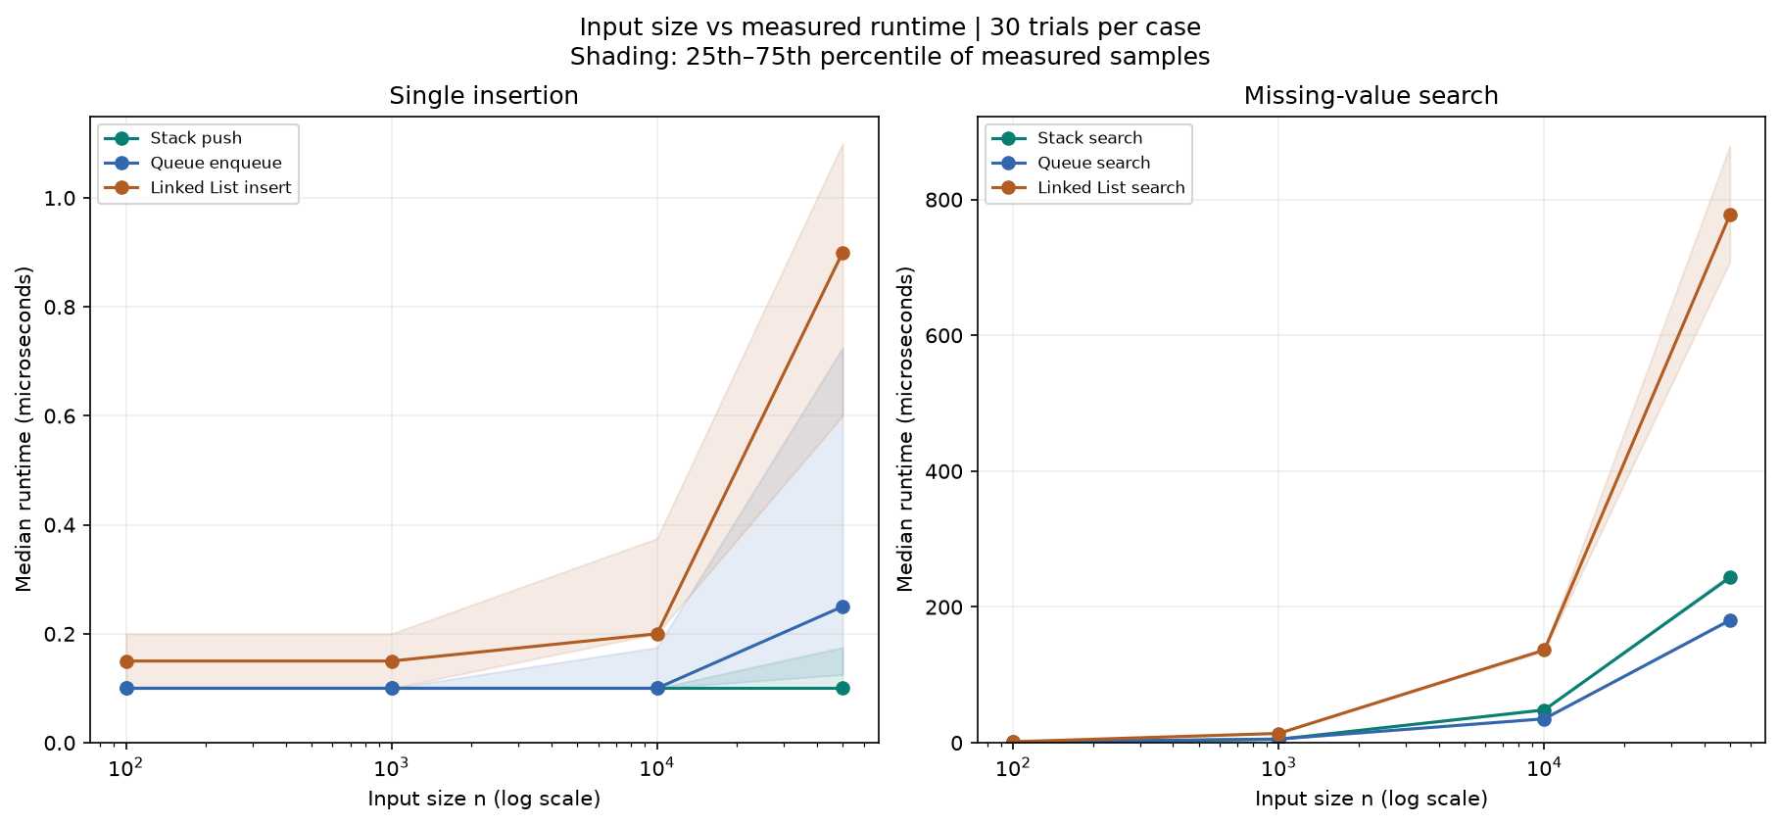
Note. Source: the saved 30-trial project benchmark. Horizontal axes use a logarithmic input-size scale; vertical axes show median microseconds. Shading represents the 25th-75th percentile of measured samples, not a confidence interval. Separate panels preserve readability for very short insertion times and slower missing-value searches.
Figure 1 illustrates the most important practical distinction between the tested operations. Push, enqueue, and head insertion remain comparatively flat as the input grows, while missing-value searches increase substantially. This is the expected qualitative difference between constant or amortized-constant operations and linear traversal operations. The exact height of each line is implementation- and environment-specific, so the figure should be interpreted as evidence about growth behavior rather than a universal benchmark.

Figure 2
Predicted Versus Observed Growth
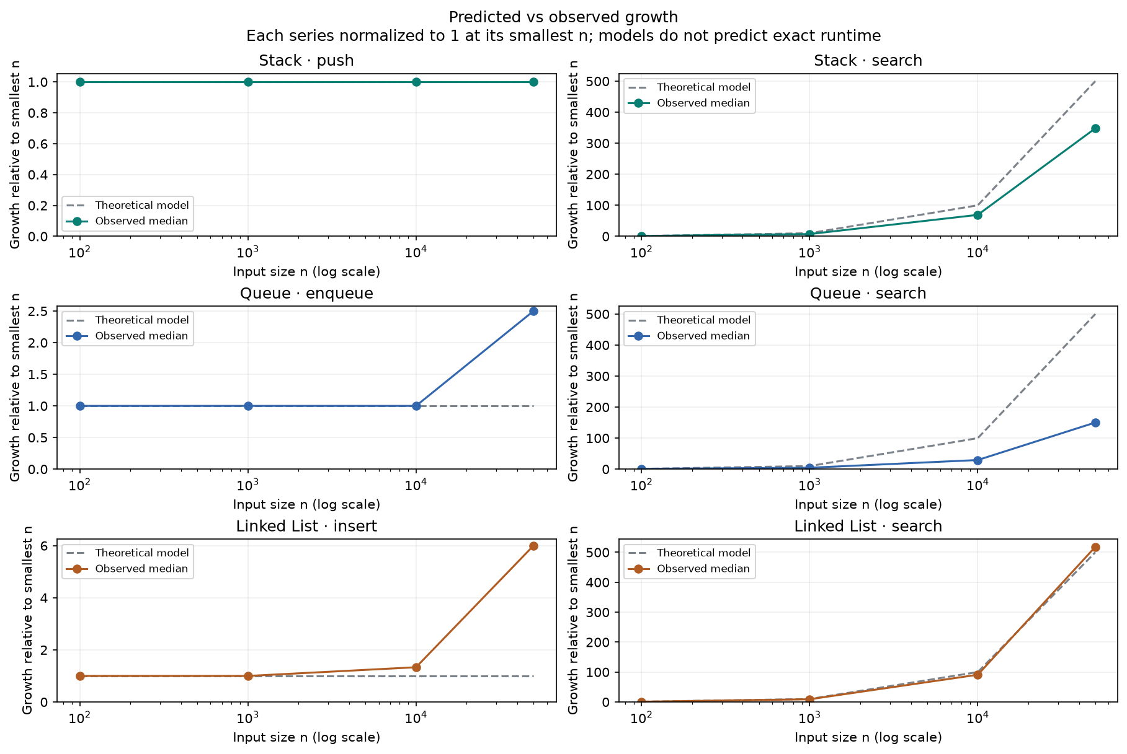
Note. Each operation family is normalized to 1 at n = 100. Dashed lines represent the theoretical model: constant growth for O(1) operations and n/100 for O(n) search. Solid lines use observed medians. The comparison demonstrates trend agreement but does not predict exact time, prove asymptotic bounds, or justify a percentage-accuracy claim.
Figure 2 provides the report's prediction-accuracy comparison. The linked-list search follows the normalized linear model closely at the largest input, while stack and queue search show slower normalized growth over the tested range. Constant-time operations remain relatively stable until small timing effects become visible at the largest case. These differences do not contradict the documented Big-O classes because Big-O describes asymptotic upper-growth behavior and omits constants, lower-order terms, interpreter overhead, and hardware effects (Cormen et al., 2022).

Limitations and Conclusion
The experiment has several limitations. It evaluates one implementation of each structure on one Windows and CPython environment, uses a fixed case order, and measures only six operation types. Pop, dequeue, and linked-list deletion have documented complexity predictions but were not included in the saved benchmark. Small insertion measurements are especially sensitive to timer resolution and allocation effects. In addition, finite timing experiments can illustrate expected scaling but cannot mathematically prove an asymptotic bound.
Despite these limitations, DataStruct Lab demonstrates the central design lesson of the assignment: no single data structure is optimal for every workload. A stack is appropriate for LIFO processing, a queue supports FIFO processing, and a linked list is useful when node-based traversal and flexible insertion are more important than indexed access. Effective selection depends on access order, operation frequency, input size, memory overhead, and latency requirements. Connecting these choices to both theoretical complexity and measured behavior provides practical preparation for algorithm analysis, software engineering interviews, and system-design decisions.

References
Cormen, T. H., Leiserson, C. E., Rivest, R. L., & Stein, C. (2022). Introduction to algorithms (4th ed.). MIT Press.
Morin, P. (2013). Open data structures: An introduction. AU Press. https://doi.org/10.15215/aupress/9781927356388.01
Python Software Foundation. (n.d.). collections - Container datatypes. Python 3.14 documentation. https://docs.python.org/3.14/library/collections.html

