Data Structure Analysis and Performance Evaluation

Shreyashkumar Patel
Colorado State University Global
CSC506: Design and Analysis of Algorithms
Jonathan Vanover
[Assignment due date]

Data Structure Analysis and Performance Evaluation
Data structures determine how an application stores, retrieves, and changes information. Choosing an appropriate structure can reduce unnecessary traversal and preserve the processing order a task requires. DataStruct Lab demonstrates these decisions through a Python-list-backed stack, a deque-backed queue, and a custom singly linked list. All three require O(n) storage for n values, but their access patterns and memory overhead differ. The complexity estimates assume constant-time equality comparisons and fixed-size references.
A stack uses last in, first out (LIFO): the most recently added value is removed first. This ordering suits undo history, nested processing, and backtracking. Stack.push appends to the end of a Python list; pop removes that end; peek reads it without removal. Push and pop have O(1) amortized cost, although a resizing operation may take O(n), consistent with dynamic-array analysis (Morin, 2013). Searching from the top may still inspect every value.
A queue uses first in, first out (FIFO), making it suitable for printer jobs and messages processed in arrival order. Queue.enqueue appends at the rear, while dequeue uses collections.deque.popleft to remove the front. Endpoint operations take O(1) time without shifting the remaining values (Python Software Foundation, n.d.). Search remains O(n) in the worst case.
A singly linked list stores each value in a Node with data and next fields. Inserting at the head changes only a few references, taking O(1). Deletion by value must first find the matching node; therefore, its worst-case cost is O(n), even though relinking is constant work. Traversal and search are also linear. Linked nodes permit dynamic growth but add reference overhead and lack constant-time indexed access (Morin, 2013).

Implementation and Complexity Prediction
The interface in app.py keeps independent structure instances in Streamlit session state. After a user selects an operation, perform_operation validates the integer input and calls the appropriate public method. The interface then obtains a shallow snapshot and redraws the diagram. Stack.to_list displays top to bottom; Queue.to_list displays front to rear; LinkedList.traverse follows the node chain. These snapshots avoid exposing private storage or maintaining a second editable copy.
LinkedList.delete uses current and previous references. If the first match is the head, it updates the head; otherwise, it connects previous.next to current.next. A successful deletion decreases the maintained count once and returns True. A missing value returns False. Stack and Queue removal or peek raise IndexError when empty, and the interface converts that error into friendly feedback. Search leaves all structures unchanged; size and is_empty are O(1).
The complexity tool in src/analysis/complexity_analyzer.py validates the structure, operation, and positive integer size. It selects an explicitly documented rule for one of 20 public operations and returns time bounds, space bounds, an explanation, and three illustrative growth points. It does not infer complexity by timing arbitrary code. For Linked List search at n = 10,000, it predicts O(n) worst-case time and relative work of 1, 2, and 4 at n, 2n, and 4n.
Storage, auxiliary work, and returned results are reported separately. Linked-list traversal returns an O(n) list while using O(1) traversal bookkeeping; a Stack resize can temporarily allocate O(n) extra storage. These distinctions prevent a constant-time operation from being confused with a constant-size data structure. The implementation guide documents every public method, and Appendix A illustrates three existing tests per structure.

Selection Criteria and Performance Evidence
Selection should begin with operation frequency and access order. A stack fits recent-first processing; a queue preserves arrival order; a linked list fits workloads centered on head insertion and explicit node relationships. Frequent arbitrary lookup or indexed access may justify another structure. Input size, memory overhead, latency requirements, and concurrency needs also matter. The teaching queue is not a complete concurrent message-processing system.
The saved experiment measured Stack push/search, Queue enqueue/search, and Linked List insert/search at 100, 1,000, 10,000, and 50,000 elements. Each case used 30 timed trials and three untimed warmups, producing 24 summaries and 720 samples. Fresh fixtures were created outside the timer; searches used an absent value. The report and charts in Appendices B and C use this project's Windows and CPython 3.14.4 results.
At 50,000 elements, missing-search medians were 243.6 microseconds for Stack, 180.4 for Queue, and 777.4 for Linked List. All three searches are O(n), yet their actual implementations have different costs. From 10,000 to 50,000 elements, those medians grew approximately 5.03, 5.11, and 5.69 times. These observations are consistent with increasing traversal work but do not prove asymptotic bounds or establish a universal speed ranking.
Insertion medians ranged from 100 to 900 nanoseconds across the saved cases, making clock overhead and allocation important. Isolated pushes do not establish amortized cost over a sequence. Big-O predicts growth rather than exact elapsed time, so the report does not assign a prediction-accuracy percentage. Correctness is supported by 128 passing tests; nine representative cases are summarized without listing the entire suite. No single structure is optimal for every application: choose for the workload, then measure its implementation.

References
Morin, P. (2013). Open data structures: An introduction. AU Press. https://doi.org/10.15215/aupress/9781927356388.01
Python Software Foundation. (n.d.). collections - Container datatypes. Python 3.14 documentation. https://docs.python.org/3.14/library/collections.html

Appendix A

Representative Test Cases
These nine existing pytest cases passed in the full 128-test run. They illustrate three checks per structure; the complete suite remains in the repository.
Table A1
Selected Inputs and Expected Outcomes
Case | Action | Expected outcome
S1 Stack ordering | Push 10, 20, 10, 30; peek/search, then pop. | Peek = 30; reads keep size 4; pops = 30, 10, 20, 10.
S2 Stack empty removal | Pop an empty stack, then reuse it with 42. | IndexError; size stays 0; reuse succeeds.
S3 Stack independence | Put a list and None in one of two stacks. | Equality search works; the second stack stays independent.
Q1 Queue ordering | Enqueue 10, 20, 10, 30; peek/search, then dequeue. | Peek = 10; reads keep size 4; removals = 10, 20, 10, 30.
Q2 Queue empty removal | Dequeue an empty queue, then reuse it with 42. | IndexError; size stays 0; reuse succeeds.
Q3 Queue independence | Put a list and None in one of two queues. | Equality search works; the second queue stays independent.
L1 Head insertion | Insert 10, 20, 30; traverse and search. | Order = 30, 20, 10; search 99 = False; size = 3.
L2 Middle deletion | From 30, 20, 10, delete 20. | Returns True; order = 30, 10; size = 2.
L3 Duplicate deletion | Insert 7, 3, 7; delete 7. | Only the first match is removed: 3, 7; size = 2.
Note. Exact test identifiers and commands appear in docs/selected_test_cases.md. These tests check behavior, not fixed runtime thresholds.

Appendix B

Performance Comparison
The saved run began September 20, 2026, at 02:35 UTC, using CPython 3.14.4 on Windows 11. Four sizes, six operation types, 30 timed trials per case, and three untimed warmups produced 720 samples. Each fresh fixture contained range(n); the argument -1 was absent. Only the bound method call was timed with perf_counter_ns.
Table B1
Saved Median Runtimes at the Smallest and Largest Inputs
Operation | Predicted time | n = 100 | n = 50,000 | Ratio
Stack push | O(1) amortized | 0.10 | 0.10 | 1.00
Stack search | O(n) | 0.70 | 243.60 | 348.00
Queue enqueue | O(1) | 0.10 | 0.25 | 2.50
Queue search | O(n) | 1.20 | 180.40 | 150.33
Linked List insert | O(1) | 0.15 | 0.90 | 6.00
Linked List search | O(n) | 1.50 | 777.40 | 518.27
Note. Runtimes are microseconds; ratio = largest-input median / smallest-input median. Source: data/benchmark_results.csv. The CSV retains nanoseconds. Predicted Stack push is amortized; single resizing calls can be O(n).
The input increased 500-fold, while search medians grew 348.00-fold for Stack, 150.33-fold for Queue, and 518.27-fold for Linked List. Normalization amplifies overhead in the smallest-size baseline. Insertion ratios of 1.00, 2.50, and 6.00 describe this run, not new complexity classes. Timer resolution was 100 ns; fixed case order, garbage collection, allocation, and background activity can affect results.
Pop, dequeue, and linked-list delete have documented predictions but were not measured in this six-operation experiment. No exponent fit or prediction-accuracy percentage is reported. Full raw samples, metadata, and limitations are available in reports/performance_report.md.

Appendix C

Performance Charts
Figure C1
Input Size Versus Measured Runtime
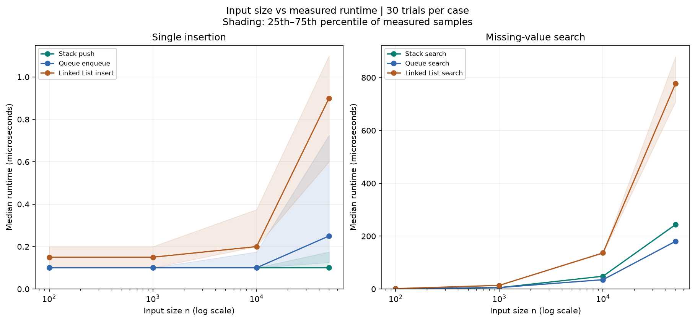
Note. Source: the saved 30-trial project benchmark. Horizontal axes are logarithmic; vertical axes show median microseconds. Shading is the 25th-75th percentile, not a confidence interval. Separate panels keep short insertions visible alongside slower missing-value searches. Different scales across panels should not be mistaken for equal elapsed times.
Figure C2
Predicted Versus Observed Growth
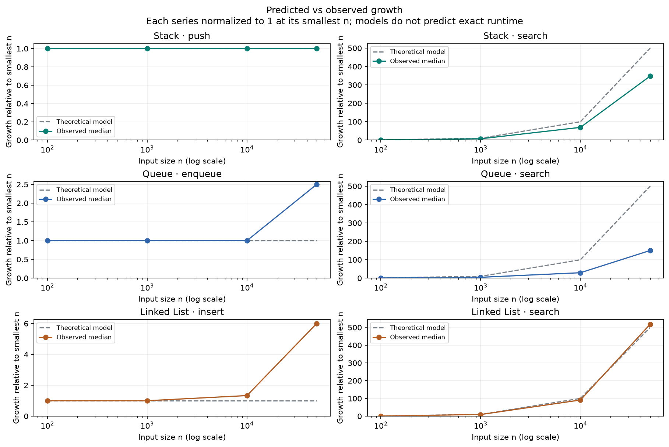
Note. Each family is normalized to 1 at n = 100. Dashed models use 1 for constant/amortized operations and n/100 for linear search. Solid curves use measured medians. Differences reflect finite measurements and baseline noise; these curves do not predict exact time, prove Big-O bounds, or measure a percentage accuracy.

