Sorting Algorithm Benchmarking in Python:
Effects of Input Size and Ordering

Shreyashkumar Patel
Colorado State University Global
CSC506: Design and Analysis of Algorithms
Jonathan Vanover
October 4th, 2026

Abstract
This project evaluated four comparison-based sorting algorithms—Bubble Sort, Selection Sort, Insertion Sort, and Merge Sort—across four input orderings and four input sizes. The study used 64 benchmark scenarios: random, sorted, reverse-sorted, and partially sorted integer lists with 1,000, 5,000, 10,000, and 50,000 elements. Each scenario was measured once in Python 3.14.4 on Windows 11 using time.perf_counter(), and every result was validated against Python's independently computed sorted(original) output. Merge Sort scaled best on random, reverse-sorted, and partially sorted inputs, while the adaptive implementations of Bubble Sort and Insertion Sort were strongest on already sorted inputs. Because the benchmark used one recorded trial per scenario, the results are presented as transparent project evidence rather than statistically generalizable performance claims. The project demonstrates that algorithm choice should account for both input size and data ordering.
Introduction
Sorting algorithms provide a practical way to connect theoretical complexity with observed runtime behavior. Asymptotic analysis explains how execution cost grows as input size increases, but measured performance can also depend on implementation details, input order, timer behavior, and the execution environment. Cormen et al. (2022) identify sorting as a foundational topic in algorithm design and analysis because different strategies can solve the same problem while producing substantially different time and space costs.

SortBench was developed to compare four manually implemented sorting algorithms under controlled project conditions. Bubble Sort and Insertion Sort can exploit already ordered data, Selection Sort performs a predictable quadratic scan pattern with relatively few swaps, and Merge Sort uses divide and conquer to provide O(n log n) behavior while requiring auxiliary storage. The central question was how performance changes when both dataset size and dataset ordering change.
Python's built-in sorting algorithm was not a benchmark target. The built-in sorted function was used only as an independent correctness oracle. Python's Sorting HOWTO notes that Timsort can take advantage of existing order in data (Python Software Foundation, 2026b), but SortBench intentionally focuses on the four course algorithms so their behavior can be examined directly.
Project Implementation
The tool was organized into separate components for sorting algorithms, dataset generation, benchmarking, result validation, CSV reporting, visualization, and recommendation generation. This separation supported repeatable testing and made it possible to compare algorithms under the same input conditions. Each sorting routine accepted a list, sorted it in place, and returned the same list object.
Table 1
Algorithm Characteristics
Algorithm | Best Case | Average Case | Worst Case | Auxiliary Space
Bubble Sort* | O(n) | O(n²) | O(n²) | O(1)
Selection Sort | O(n²) | O(n²) | O(n²) | O(1)
Insertion Sort | O(n) | O(n²) | O(n²) | O(1)
Merge Sort | O(n log n) | O(n log n) | O(n log n) | O(n)
Note. Bubble Sort used an early-exit optimization, producing linear best-case behavior on already sorted input.
Method
The benchmark used four dataset types: random, sorted, reverse-sorted, and partially sorted. The four input sizes were 1,000, 5,000, 10,000, and 50,000 integers, producing 64 total scenarios. Each size used a deterministic seed, and all orderings for that size shared the same multiset of values. This design made the orderings comparable without changing the underlying values. The partially sorted dataset began sorted and then applied size // 20 random swaps, representing a controlled disturbance of an ordered list.
The timing interval included only the sorting call. Dataset generation, list copying, result validation, and CSV output were excluded. Python's time.perf_counter() was selected because the official documentation describes it as a high-resolution performance counter suitable for measuring short durations (Python Software Foundation, 2026a). Benchmark metadata recorded Python 3.14.4, Windows 11, one recorded trial per scenario, and 64 completed result rows.
Each algorithm received an independent list copy. Correctness validation compared every result with sorted(original). The final analysis used the repeated full benchmark run rather than an archived initial run that contained a large wall-time anomaly in one long Bubble Sort case. The analysis therefore reports one complete and audited primary dataset.
Results
The benchmark produced two clear patterns. First, Merge Sort was the fastest recorded algorithm in all random, reverse-sorted, and partially sorted groups. At 50,000 elements, Merge Sort completed random input in 0.0731 seconds, reverse-sorted input in 0.0631 seconds, and partially sorted input in 0.0819 seconds. The closest quadratic competitors required seconds rather than fractions of a second.
Second, already sorted input changed the ranking. Bubble Sort was fastest at 1,000, 5,000, and 50,000 sorted elements, while Insertion Sort was fastest at 10,000 elements. These results are consistent with the adaptive behavior of the implementations: Bubble Sort can stop after a pass with no swaps, and Insertion Sort performs very little shifting when the prefix is already ordered. Selection Sort did not benefit from the existing order because it continued scanning each unsorted suffix for a minimum.
Table 2
Execution Time for 50,000 Elements, in Seconds
Ordering | Bubble | Selection | Insertion | Merge
Random | 61.1792 | 23.6449 | 27.0069 | 0.0731
Sorted | 0.0013 | 29.2821 | 0.0026 | 0.0695
Reverse-sorted | 79.5163 | 28.0274 | 52.9517 | 0.0631
Partially sorted | 40.8929 | 26.2688 | 3.2475 | 0.0819
Note. One recorded trial was used for each scenario; the values should not be interpreted as estimates with statistical uncertainty.

Figure 1
Execution Time by Dataset Size
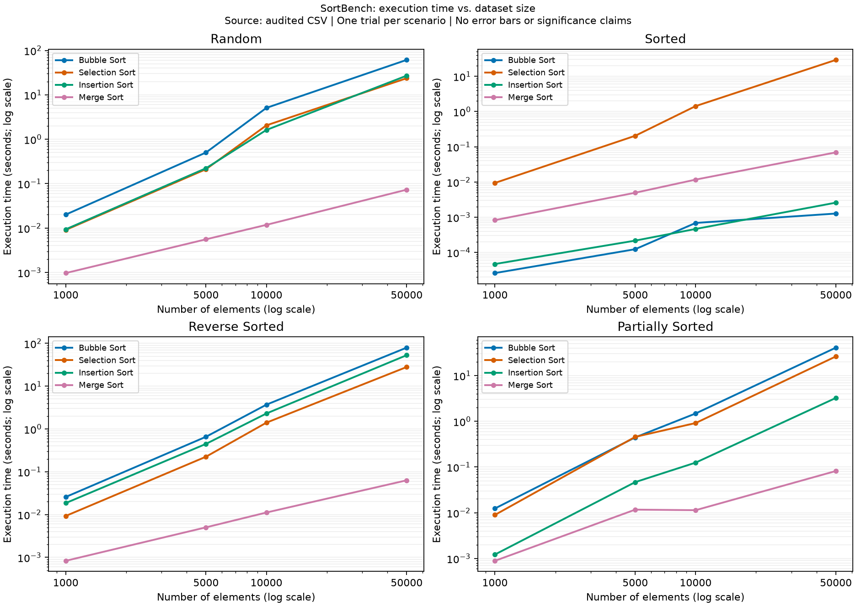
Note. Both axes use logarithmic scaling. The figure summarizes all four dataset orderings and all four algorithms.
Analysis and Discussion
The measured growth rates were consistent with the theoretical distinction between O(n log n) and O(n²) algorithms. On random input, increasing the size from 1,000 to 50,000 elements increased Merge Sort runtime by about 75.5 times, while the quadratic algorithms increased by roughly 2,606 to 3,047 times. The theoretical n log n growth factor over the same size change is about 78.3, while the quadratic growth factor is 2,500. The exact measurements do not prove asymptotic complexity, but their shape aligns with the expected behavior.

Input ordering mattered most for Bubble Sort and Insertion Sort. On sorted input, Bubble Sort grew from approximately 0.000026 seconds at 1,000 elements to 0.001273 seconds at 50,000 elements. Insertion Sort grew from approximately 0.000047 seconds to 0.002595 seconds. These observations are consistent with linear best-case behavior for the specific implementations. The sorted case also demonstrates why a single universal recommendation would be misleading: Merge Sort was the strongest general-purpose performer, but it performed more work than the adaptive algorithms when the data was already ordered.
Selection Sort was comparatively consistent but rarely competitive. Its execution time remained high even for sorted input because the algorithm still scanned the remaining suffix on every pass. Selection Sort can be useful in specialized workloads where minimizing swaps matters more than comparisons, but this project measured in-memory integer sorting time rather than disk writes, expensive object movement, or memory-wear scenarios.
Partially sorted data produced a useful middle case. Insertion Sort improved substantially compared with random and reverse-sorted inputs because many values were already close to their final positions. At 50,000 elements, Insertion Sort completed the partially sorted dataset in 3.2475 seconds, much faster than its 27.0069-second random result and 52.9517-second reverse-sorted result. Merge Sort still remained the fastest recorded method, showing that its O(n log n) scaling provided a strong advantage as dataset size increased.
Recommendation Guide
The benchmark results support conditional recommendations rather than a single algorithm for every situation. Algorithm selection should account for input ordering, dataset size, memory constraints, and the cost of comparisons or data movement.
Table 3
Practical Algorithm Selection Guide
Scenario | Recommended Choice | Rationale
Large random data | Merge Sort | Best scaling in the tested random scenarios; 0.0731 s at 50,000 elements.
Reverse-sorted data | Merge Sort | Avoids the expensive quadratic behavior observed for Bubble and Insertion Sort.
Partially sorted data | Merge Sort | Fastest recorded method overall, although Insertion Sort benefits from existing order.
Known already sorted data | Bubble or Insertion | Adaptive implementations perform very little work when the list is already ordered.
Memory-constrained small data | Insertion / Selection | Both use constant auxiliary space; choose based on ordering and swap cost.
General scalable choice | Merge Sort | Provides predictable O(n log n) time when O(n) auxiliary memory is acceptable.
Limitations
The main limitation is that each scenario has one recorded trial. This makes the project evidence transparent and reproducible, but it does not provide averages, confidence intervals, error bars, or statistical significance. Very short timings, especially the sorted 1,000-element cases, are sensitive to timer resolution and background machine activity. A separate diagnostic run showed that the small difference between Bubble Sort and Insertion Sort at 10,000 sorted elements could change ranking by a very small margin, reinforcing the need for repeated trials before making fine-grained performance claims.

The benchmark also used one Python implementation of each algorithm, one machine, one operating system, one Python version, and one deterministic seed per size. Future work should use repeated trials, randomized execution order, multiple seeds, memory profiling, and possibly additional algorithms such as Heap Sort and Quick Sort. These additions would support stronger statements about variability, memory trade-offs, and crossover points.
Conclusion
SortBench demonstrates how theoretical complexity appears in measured program behavior. Merge Sort was the strongest general recommendation for the tested random, reverse-sorted, and partially sorted inputs because its O(n log n) scaling kept runtime low as dataset size increased. Bubble Sort and Insertion Sort performed exceptionally well on already sorted data because their implementations could exploit existing order. Selection Sort remained predictable but comparatively slow because it did not adapt to ordered input.
The project therefore supports a conditional approach to algorithm selection. Merge Sort should be preferred for scalable general sorting when auxiliary memory is acceptable. Bubble Sort or Insertion Sort can be appropriate when input is known to be already sorted or nearly sorted, especially for small datasets. The benchmark also demonstrates a broader software engineering principle: practical algorithm choices should combine theoretical complexity, data characteristics, resource constraints, and measured evidence.

References
Cormen, T. H., Leiserson, C. E., Rivest, R. L., & Stein, C. (2022). Introduction to algorithms (4th ed.). The MIT Press. https://mitpress.mit.edu/9780262046305/introduction-to-algorithms/
Knuth, D. E. (1998). The art of computer programming: Volume 3: Sorting and searching (2nd ed.). Addison-Wesley.
Python Software Foundation. (2026a). time - Time access and conversions. Python 3.14 documentation. https://docs.python.org/3/library/time.html
Python Software Foundation. (2026b). Sorting techniques. Python 3.14 documentation. https://docs.python.org/3/howto/sorting.html

Appendix A
Performance Visualizations
Figure 2
Algorithm Comparison by Dataset Ordering
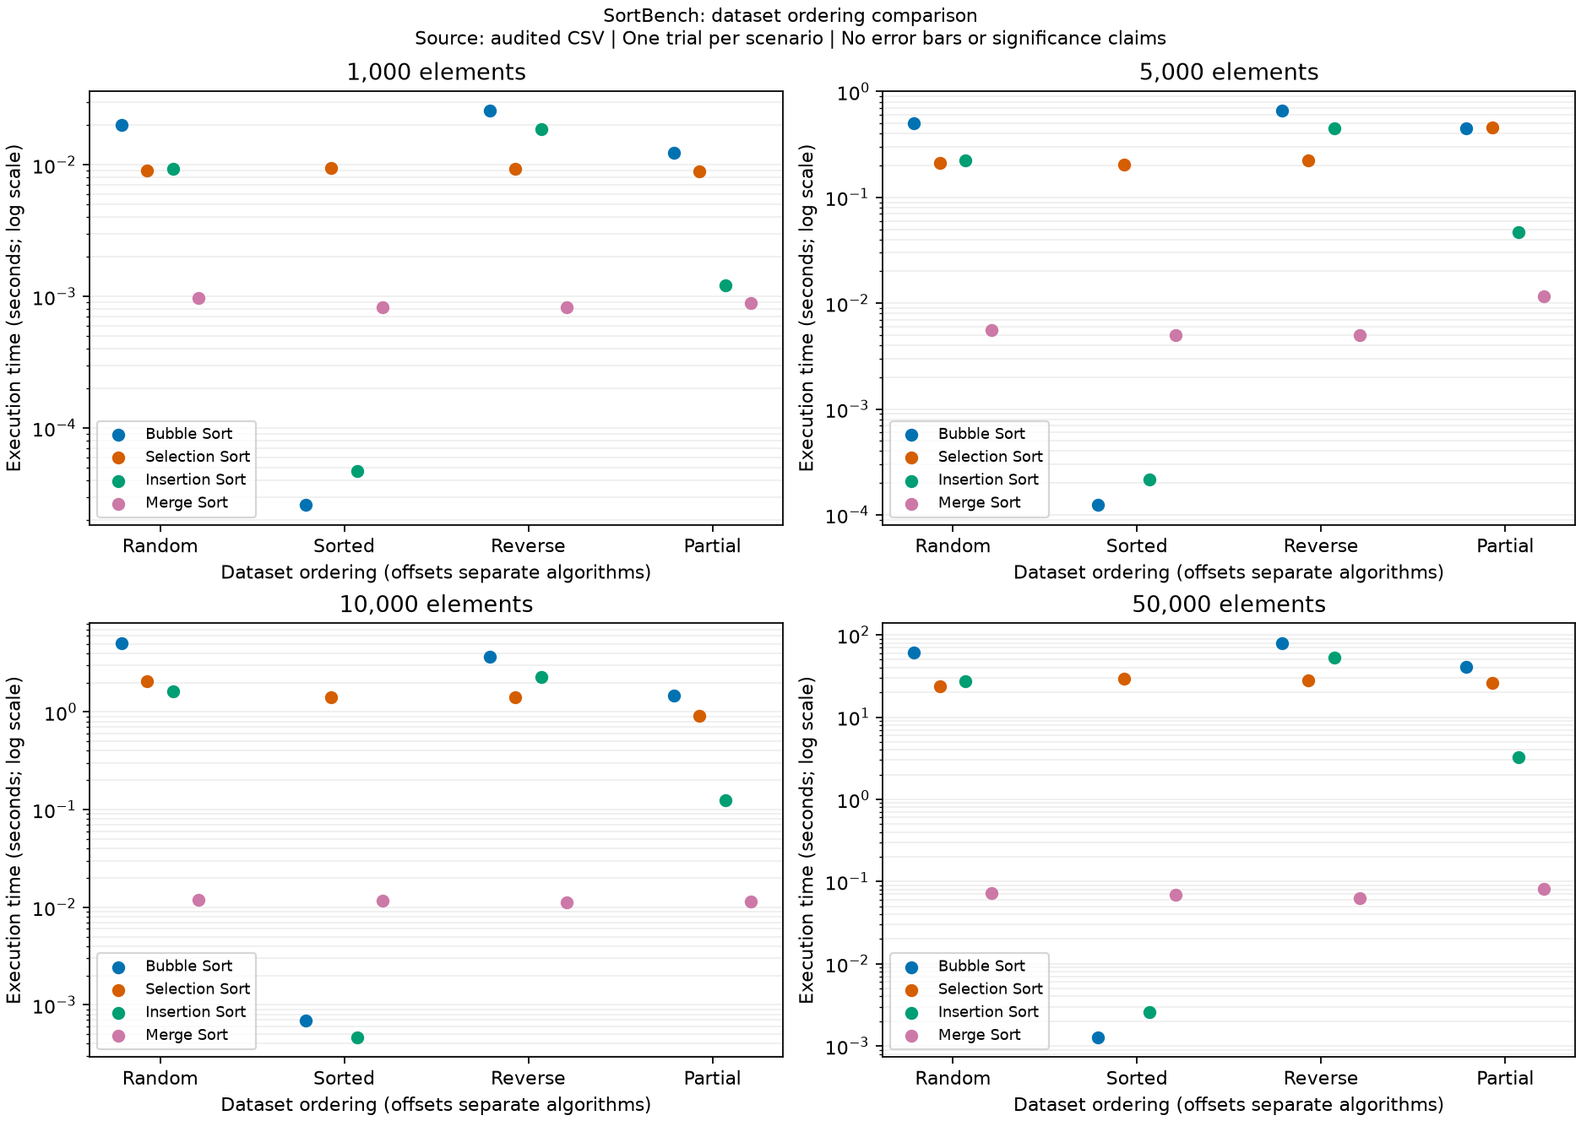
Note. Each panel represents one input size. Log-scaled execution time separates the algorithms across dataset orderings.

Figure 3
Random Dataset Performance
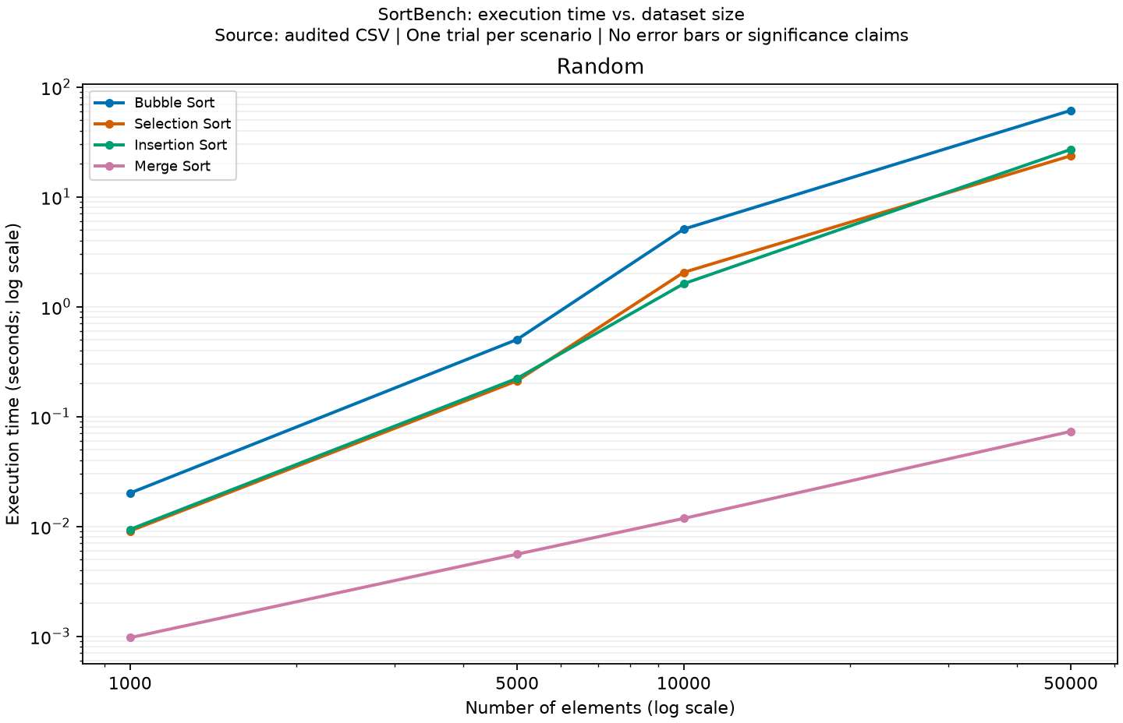
Note. Merge Sort scales much more gradually than the quadratic algorithms as random input size increases.

Figure 4
Sorted Dataset Performance
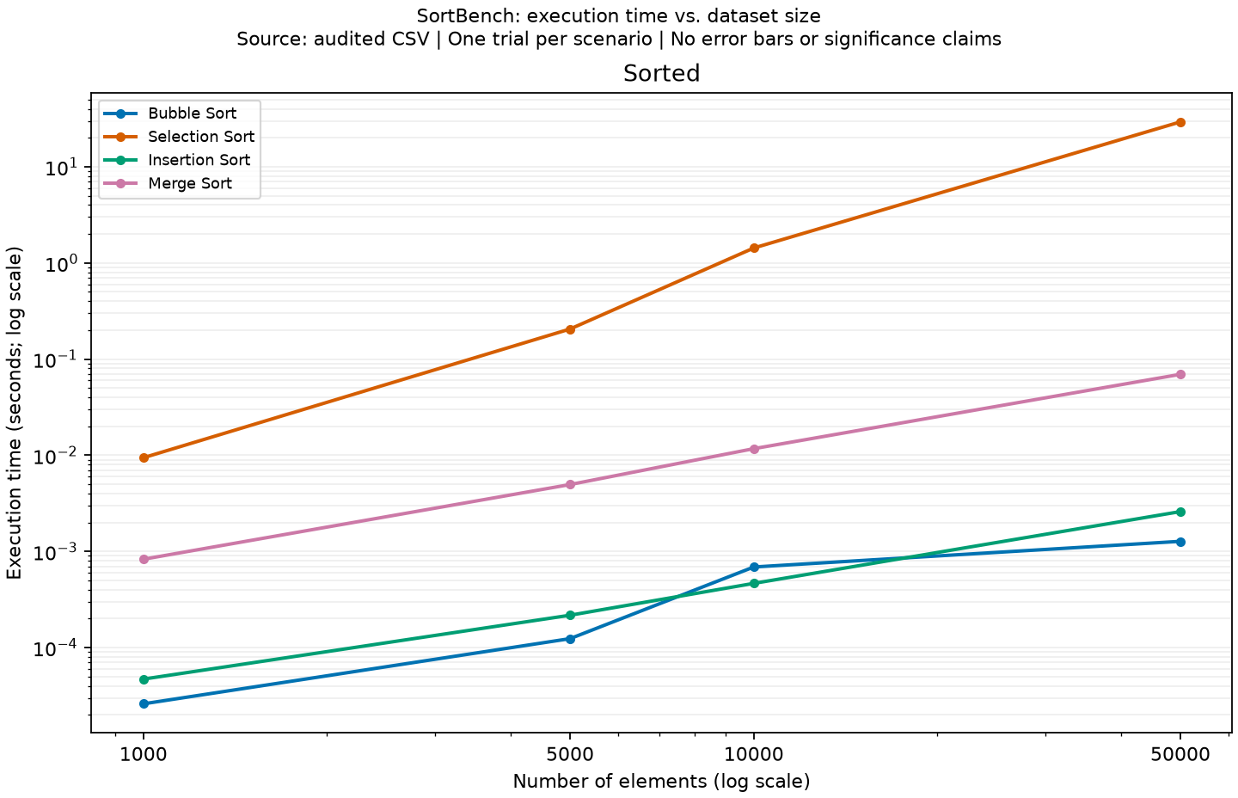
Note. Bubble Sort and Insertion Sort benefit strongly from already ordered input; Selection Sort does not.

Figure 5
Reverse-Sorted Dataset Performance
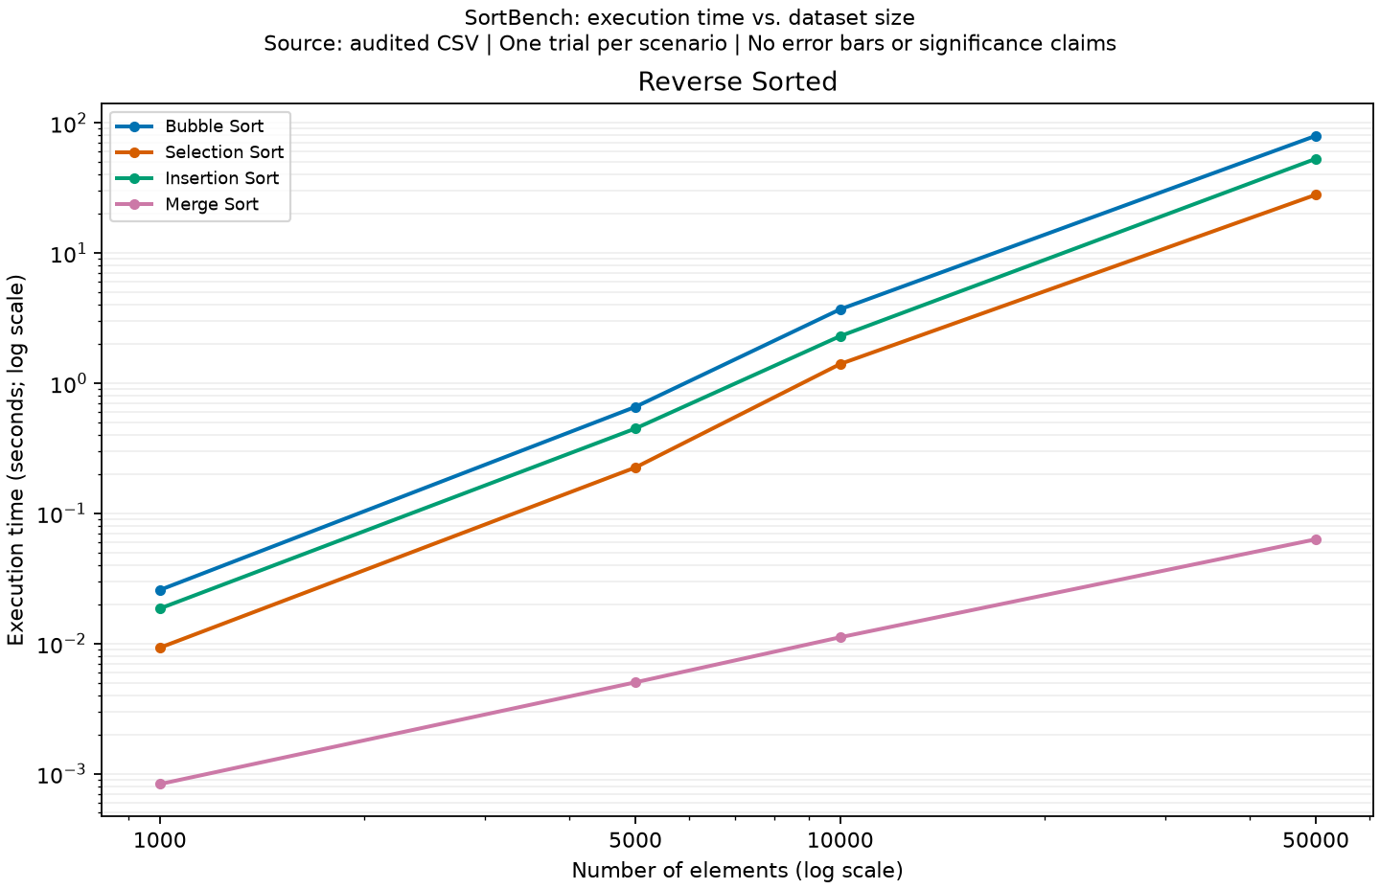
Note. Reverse order exposes the expensive behavior of Bubble Sort and Insertion Sort while Merge Sort remains efficient.

Figure 6
Partially Sorted Dataset Performance
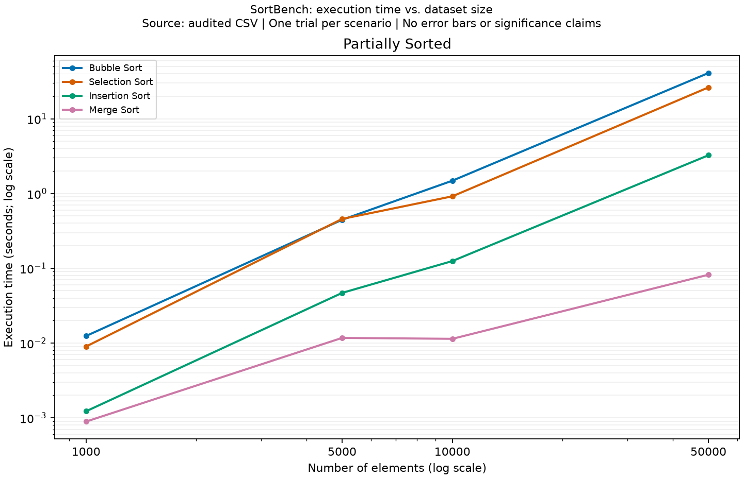
Note. Insertion Sort improves with partial order, but Merge Sort remains the fastest recorded method in the tested sizes.

