Name: Shreyash Milind Chilip Div: SY SEDA D Roll no: 41

**ASSIGNMENT 1**

1. Change your password to a password you would like to use for the remainder of the semester.

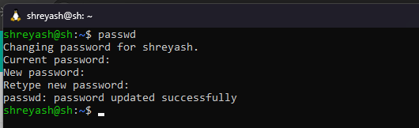

1. Display the system’s date.



1. Count the number of lines in the /etc/passwd file.

wc command along with -l option is used to count number of lines in a file.



1. Find out who else is on the system.



1. Direct the output of the man pages for the date command to a file named mydate.

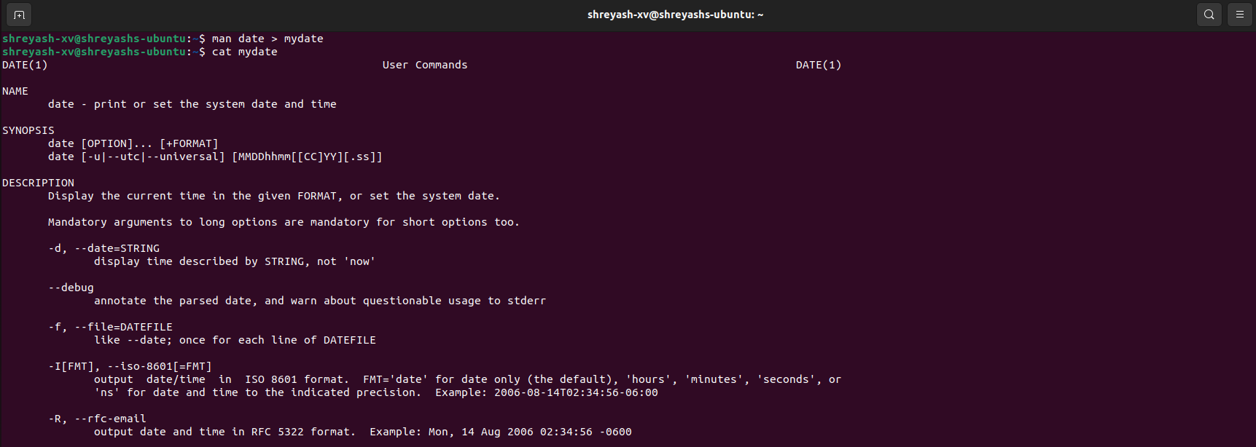

1. Create a subdirectory called mydir.



1. Move the file mydate into the new subdirectory.

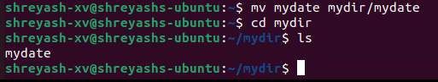

1. Go to the subdirectory mydir and copy the file mydate to a new file called ourdate

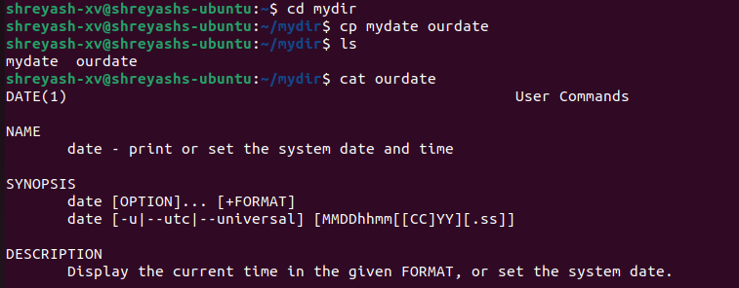

1. List the contents of mydir.

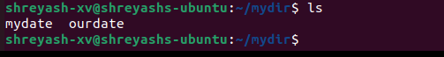

1. Do a long listing on the file ourdate and note the permissions.



1. Display the name of the current directory starting from the root.



1. Move the files in the directory mydir back to your home directory.

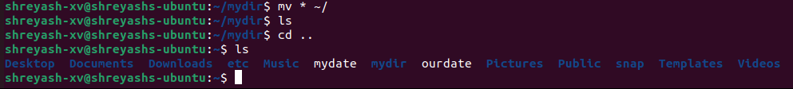

1. Display the first 5 lines of mydate.

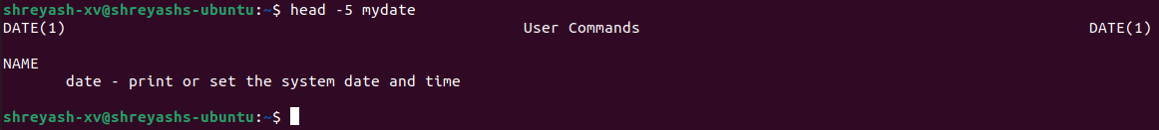

1. Display the last 8 lines of mydate.

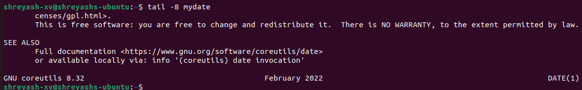

1. Remove the directory mydir.



1. Redirect the output of the long listing of files to a file named list.

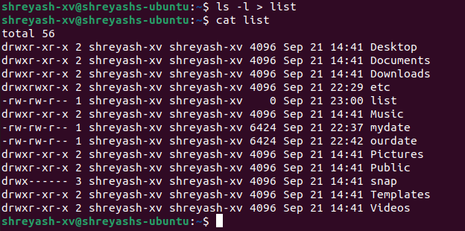

1. Select any 5 capitals of states in India and enter them in a file named capitals1. Choose 5 more capitals and enter them in a file named capitals2. Choose 5 more capitals and enter them in a file named capitals3. Concatenate all 3 files and redirect the output to a file named capitals.

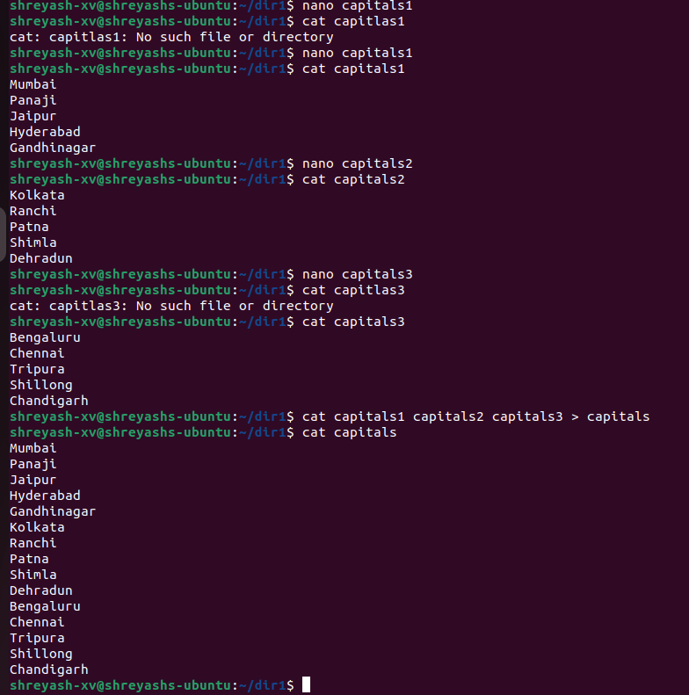

1. Concatenate the file capitals2 at the end of file capitals.

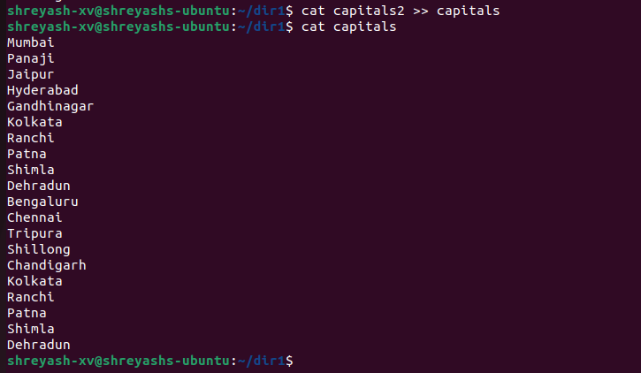

1. Give read and write permissions to all users for the file capitals.

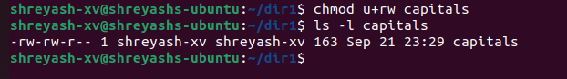

1. Give read permissions only to the owner of the file capitals. Open the file, make some changes and try to save it. What happens ?

Cannot modify the contents of file capitals, as only read permission has been assigned and not write.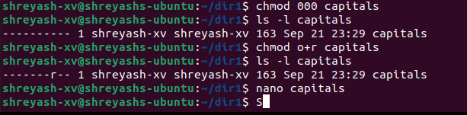

1. Create an alias to concatenate the 3 files capitals1, capitals2, capitals3 and redirect the output to a file named capitals. Activate the alias and make it run.

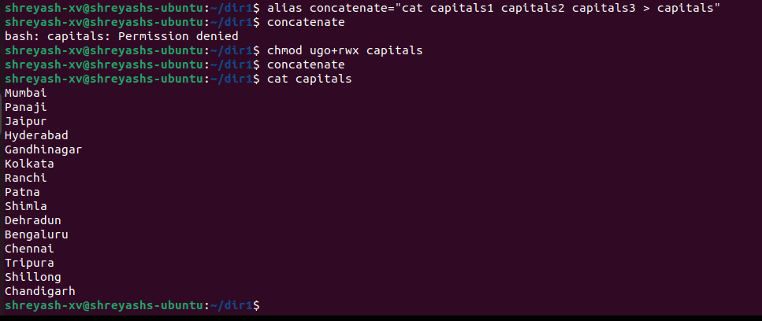

1. Find out the number of times the string “the” appears in the file mydate.

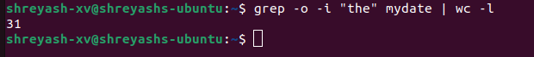

1. Find out the line numbers on which the string “date” exists in mydate.

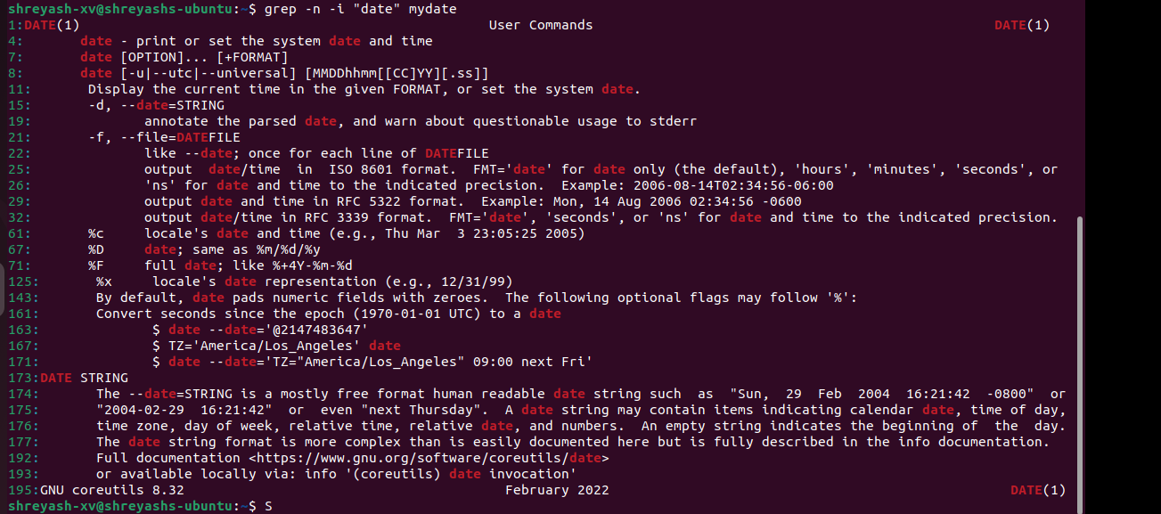

1. Print all lines of mydate except those that have the letter “i” in them.

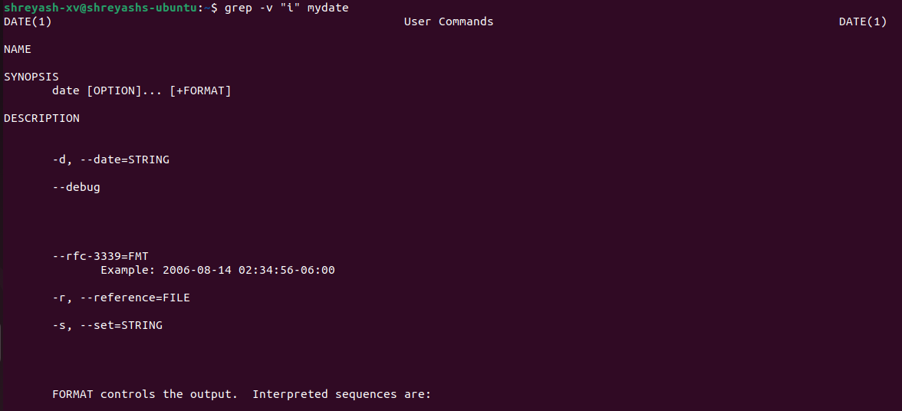

1. List the words of 4 letters from the file mydate

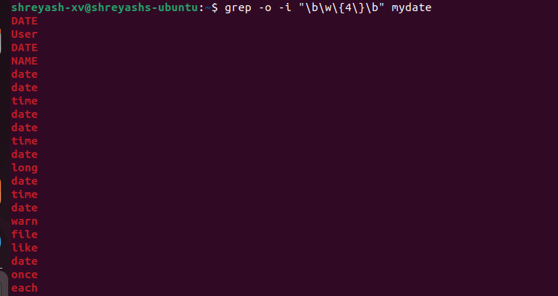

1. List 5 states in north east India in a file mystates. List their corresponding capitals in a file mycapitals. Use the paste command to join the 2 files.

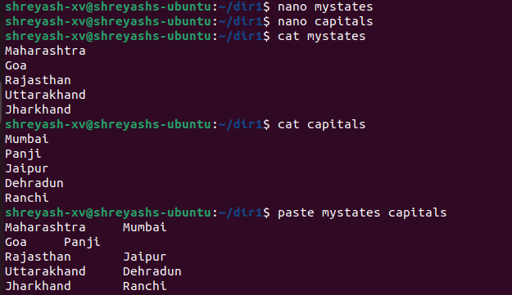

1. Use the cut command to print the 1 st and 3 rd columns of the /etc/passwd file for all students in this class.

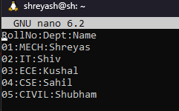 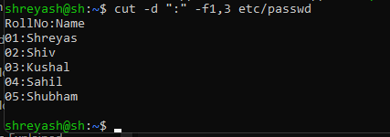

1. Count the number of people logged in and also trap the users in a file using the tee command.



1. Convert the contents of mystates into uppercase.

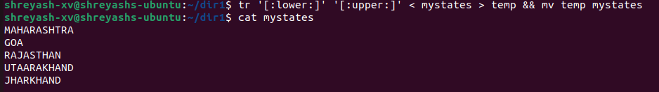

1. Create any two files & display the common values between them.

