Name: Shreyash Milind Chilip Div: SY SEDA D Roll No: 41

**ASSIGNMENT 3:**

1. **Write shell script to execute command ls, date, pwd repetitively.**

#!/bin/bash

while true; do

    ls

    date

    pwd

    sleep 2 # Pause for 2 seconds between iterations

done

**Output:**

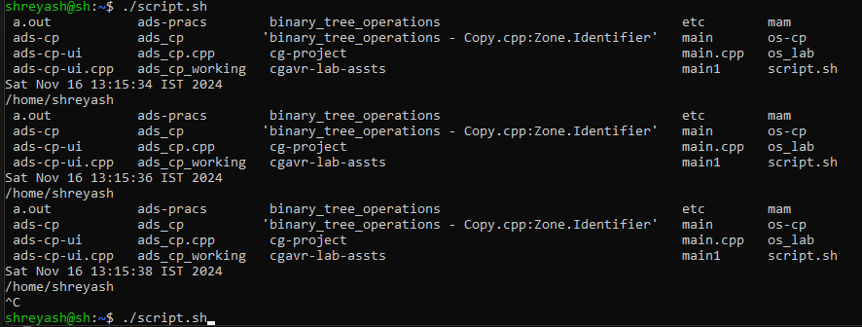

1. **Write a shell script to assign value to the variable? Display value with and without $.**

#!/bin/bash

var="Hello, Shell!"

echo "With \$: $var"

echo "Without \$: var"

**Output:**

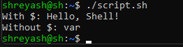

1. **Variables are untyped in Shell Script. Write a shell script to show variables are untyped.**

#!/bin/bash

var=1234

echo "Integer value: $var"

var="Shell scripting"

echo "String value: $var"

**Output:**



1. **Write a shell script to accept numbers from user. (Keyboard)**

#!/bin/bash

echo "Enter a number:"

read num

echo "You entered: $num"

**Output:**

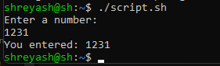

1. **Write a shell script to accept numbers from command line arguments.**

#!/bin/bash

if [ $# -eq 0 ]; then

    echo "No numbers provided."

else

    echo "Numbers provided: $@"

fi

**Output:**



1. **Write a shell script to show the contents of environmental variables SHELL, PATH, HOME.**

#!/bin/bash

echo "SHELL: $SHELL"

echo "PATH: $PATH"

echo "HOME: $HOME"

**Output:**

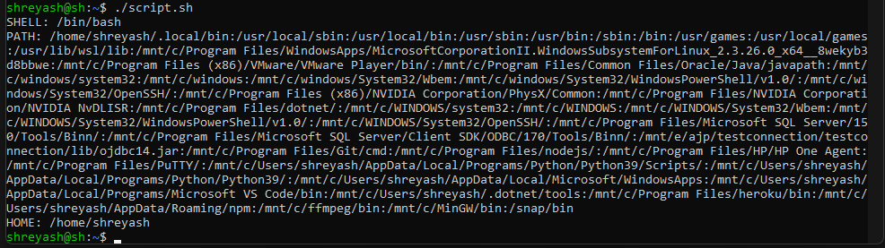

1. **Write a shell script to create two files. Accept file names from user.**

echo "Enter first file name:"

read file1

echo "Enter second file name:"

read file2

touch "$file1" "$file2"

echo "Files $file1 and $file2 created."

**Output:**

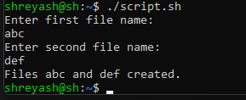

1. **Write a shell script to create two directories. Accept directories name from Command line.**

if [ $# -lt 2 ]; then

    echo "Please provide two directory names as arguments."

else

    mkdir "$1" "$2"

    echo "Directories $1 and $2 created."

fi

**Output:**



1. **Write a shell script to copy file content of one file to another file. Accept files names from command line argument.**

if [ $# -ne 2 ]; then

    echo "Usage: $0 source_file destination_file"

else

    cp "$1" "$2"

    echo "Contents of $1 copied to $2."

fi

**Output:**



1. **Write a shell script to rename the file name. Accept old filename and new filename from command line argument.**

if [ $# -ne 2 ]; then

    echo "Usage: $0 old_filename new_filename"

else

    mv "$1" "$2"

    echo "$1 renamed to $2."

fi

**Output:**



1. **Write a shell script to perform arithmetic operation of integer data.**

echo "Enter two integers:"

read a

read b

echo "Addition: $((a + b))"

echo "Subtraction: $((a - b))"

echo "Multiplication: $((a * b))"

echo "Division: $((a / b))"

**Output:**

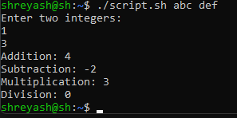

**12.Write a shell script to perform arithmetic operation of float data.**

echo "Enter two floating-point numbers:"

read a

read b

add=$(echo "$a + $b" | bc)

sub=$(echo "$a - $b" | bc)

mul=$(echo "$a * $b" | bc)

div=$(echo "scale=2; $a / $b" | bc)

echo "Addition: $add"

echo "Subtraction: $sub"

echo "Multiplication: $mul"

echo "Division: $div"

Output:

