Name: Shreyash Milind Chilip Div: SY SEDA D Roll No: 41

**ASSIGNMENT 4:**

1. **Write a shell script to check number entered by the user is greater than 10.**

echo "Enter a number:"

read num

if [ "$num" -gt 10 ]; then

    echo "The number is greater than 10."

else

    echo "The number is not greater than 10."

fi

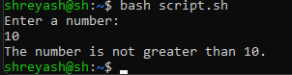

1. **Write a shell script to check if a file exists. If not, then create it.**

echo "Enter file name:"

read file

if [ -e "$file" ]; then

    echo "File already exists."

else

    touch "$file"

    echo "File created."

fi

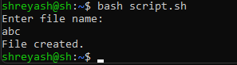

1. **Write a shell script that takes two command line arguments. Check whether the name passed as first argument is of a directory or not. If not, create directory using name passed as second argument.**

if [ $# -ne 2 ]; then

    echo "Usage: $0 <name_to_check> <name_to_create>"

else

    if [ -d "$1" ]; then

        echo "$1 is a directory."

    else

        mkdir "$2"

        echo "Directory $2 created."

    fi

fi

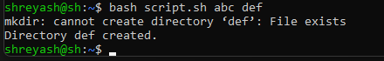

1. **Write a shell script which checks the total arguments passed. If the argument count is greater than 5, then display message “Too many arguments”**

if [ $# -gt 5 ]; then

    echo "Too many arguments."

else

    echo "Arguments are within limit."

Fi



1. **Write a shell script to check arguments passed at command line is whether of a file or directory.**

for arg in "$@"; do

    if [ -d "$arg" ]; then

        echo "$arg is a directory."

    elif [ -f "$arg" ]; then

        echo "$arg is a file."

    else

        echo "$arg does not exist."

    fi

done



1. **Write a shell script to read a month name from the user. Check if the name entered is either August or October.**

echo "Enter a month name:"

read month

if [ "$month" == "August" ] || [ "$month" == "October" ]; then

    echo "The month is either August or October."

else

    echo "The month is neither August nor October."

fi

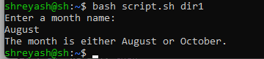

1. **Write a shell script to check whether file or directory exists.**

echo "Enter a file or directory name:"

read name

if [ -e "$name" ]; then

    echo "$name exists."

else

    echo "$name does not exist."

fi

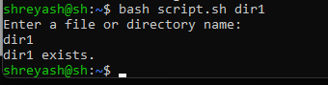

1. **Write a shell script to check whether file is exists and file is readable.**

echo "Enter file name:"

read file

if [ -e "$file" ] && [ -r "$file" ]; then

    echo "$file exists and is readable."

else

    echo "$file does not exist or is not readable."

fi

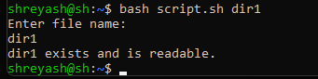

1. **Write a shell script to check if the present month is August or not. Use date command to get present month.**

current_month=$(date +%B)

if [ "$current_month" == "August" ]; then

    echo "The current month is August."

else

    echo "The current month is not August."

fi



1. **Write a shell script to check if the current user is root or regular user.**

if [ "$(id -u)" -eq 0 ]; then

    echo "You are root."

else

    echo "You are a regular user."

fi

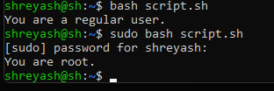

1. **Write a shell script to check the total arguments passed at command line. If the arguments are more than 3 then list the argument else print “type more next time”.**

if [ $# -gt 3 ]; then

    echo "Arguments passed: $@"

else

    echo "Type more next time."

fi

