

Student Details





Project Definition and Objectives
1.1 Project Definition
The Medical Cost Prediction project aims to predict individual medical expenses based on a set of patient demographics and lifestyle factors using a machine learning approach. Healthcare costs are rising globally, and understanding the factors that drive these costs can be critical for multiple stakeholders, including healthcare providers, insurance companies, policymakers, and patients. By predicting medical expenses from patient data, we can gain insights into the influence of factors like age, BMI, smoking habits, and more on healthcare costs.
Problem Statement
Insurance companies and healthcare providers face significant challenges in accurately forecasting medical costs due to the multifaceted and variable nature of health expenses. Accurate predictions of medical costs are essential for determining policy rates, budgeting for healthcare services, and managing risks effectively.
This project aims to address the following problem:
How can we accurately predict individual medical expenses based on a patient’s demographic and lifestyle factors?

1.2 Project Objectives
- Data Analysis: Identify key patient attributes that impact medical costs and analyze their relationships with charges.
- Model Building: Develop and compare machine learning models (Linear Regression, Polynomial Regression, Decision Tree, Random Forest) to find the best predictor of medical expenses.
- Evaluation: Assess model performance using MAE, MSE, RMSE, and R² to select the most accurate model.
- Interpretation and Insights: Provide insights on the influence of smoking status, BMI, and age on costs to inform insurance risk and pricing strategies.
- Deployment Readiness: Prepare the final model and documentation for potential real-world deployment.

Data Collection and Preparation

2.1 Data Collection
- Source: Kaggle’s “Insurance” dataset.
- Link: https://drive.google.com/drive/folders/1lP3zo-TKY4oWOZHpAH0d9S1TaSviKQG4
- Size: 1,380 records, 7 columns.
- Description: This dataset contains information about individuals and their medical expenses. Each row represents a patient with various demographic and lifestyle attributes and the corresponding medical charges, which is our target variable for prediction.
Attribute | Description | Type | Values
age | Age of the primary beneficiary | Numerical | Integer
sex | Gender of the beneficiary | Categorical | male, female
bmi | Body Mass Index, an estimate of body fat | Numerical | Float
children | Number of dependents covered by health insurance | Numerical | Integer
smoker | Smoking status of the beneficiary | Categorical | yes, no
region | Residential region of the beneficiary in the United States | Categorical | northeast, northwest, southeast, southwest
charges | Medical costs billed to health insurance (target variable) | Numerical | Float

2.2 Data Preparation
A. Importing Necessary Libraries



B. Loading the Dataset
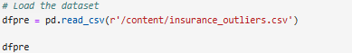
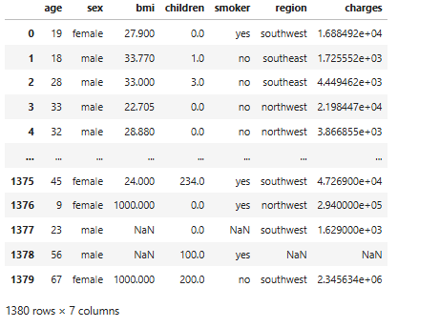

C. Dropping NA Values

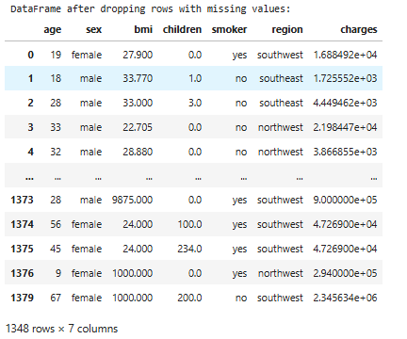

D. Finding Outliers Using Z-Score Method
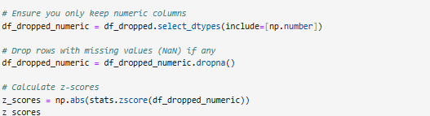

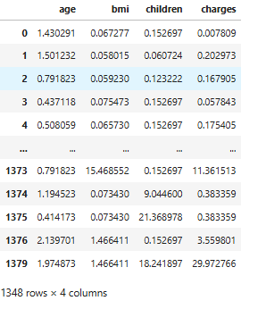

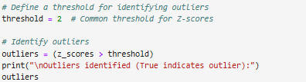

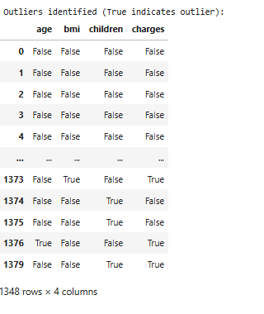

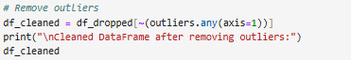

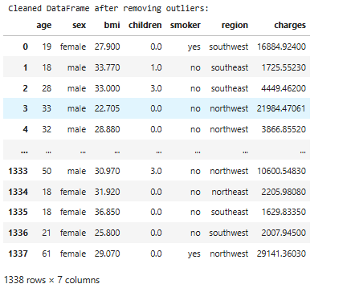

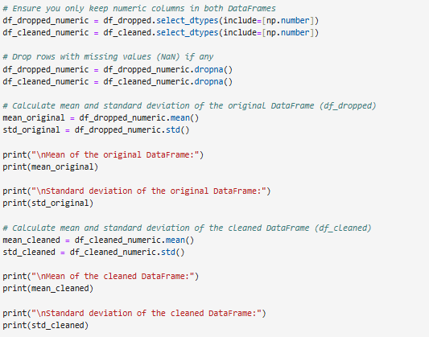

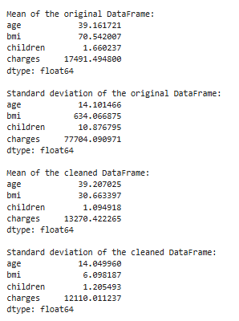

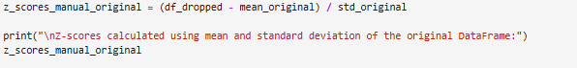

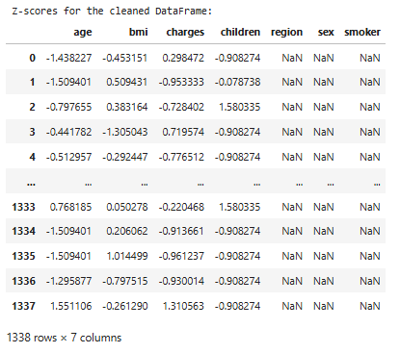

E. Loading the Cleaned Dataset

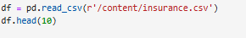

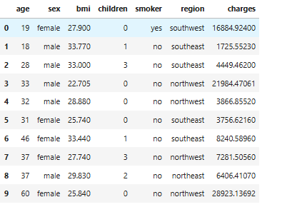

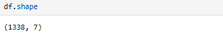

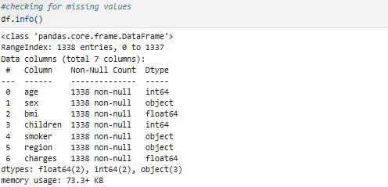

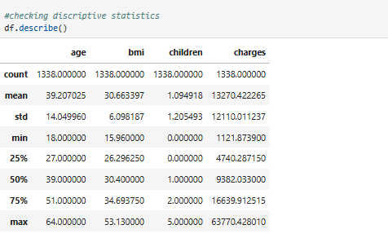

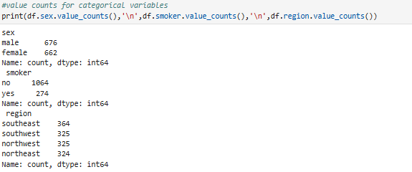

CODE CITATION : https://drive.google.com/drive/folders/1lP3zoTKY4oWOZHpAH0d9S1TaSviKQG4

Exploratory Data Analysis (EDA)

The goal of EDA is to understand the dataset’s structure, identify key relationships between features and the target variable (charges), and detect any anomalies or patterns. This process includes univariate, bivariate, and multivariate analysis using descriptive statistics and visualizations.
Visualization of the data is a good way to understand the data. In this section, I will plot the distribution of each variable to get an overview about their counts and distributions.

A. Let’s Visualize the Distribution of Age, BMI, and Charges:
- The majority of patients are aged between 20 and 60.
- BMI is mostly between 25 and 40, indicating a trend toward overweight patients.
- Medical expenses show a right-skewed distribution, with most expenses below 20,000.
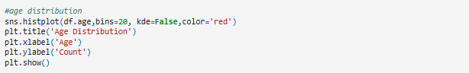
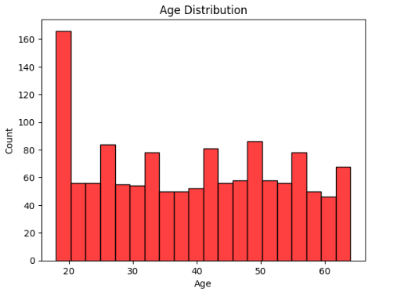
Age Distribution: A histogram displaying the distribution of ages among patients. It helps to understand the age range covered in the dataset.
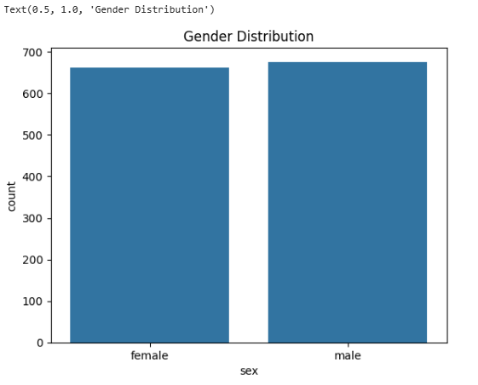
Gender Distribution: A bar plot showing the count of male and female patients, indicating an almost equal distribution of both genders.

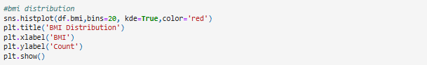
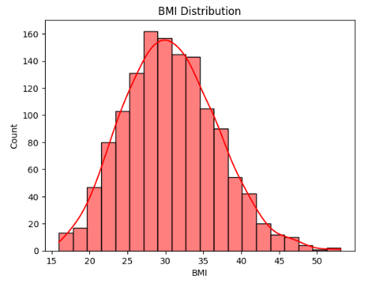
BMI Distribution: A histogram with a kernel density estimate (KDE) overlay, showing that most patients have a BMI between 25 and 40, often classified as overweight, which could influence medical costs.

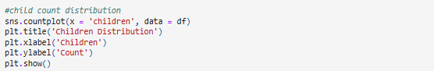
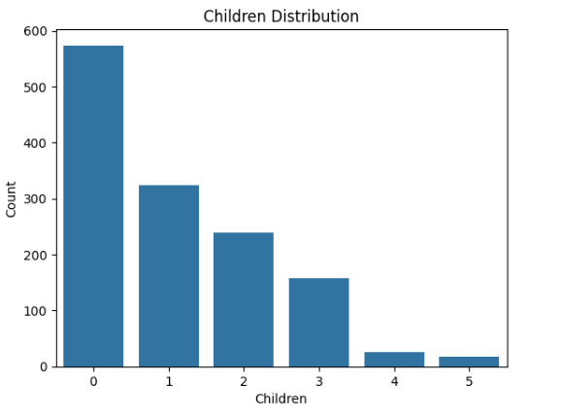
Children Count Distribution: A bar plot depicting the number of children each patient has. Most patients have zero children, with fewer patients having more than three.

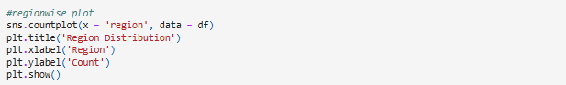
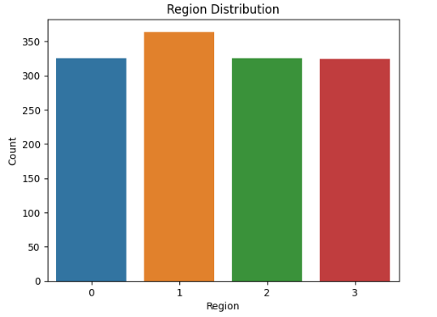
Region Distribution: A bar plot showing the count of patients from different regions in the US. Counts are similar across regions, with a slight increase in the northwest.

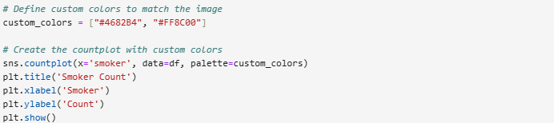
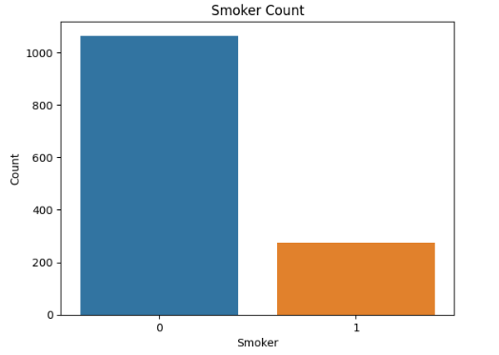
Smoker Count: A bar plot showing the distribution of smokers and non-smokers, revealing that approximately 80% of patients are non-smokers.

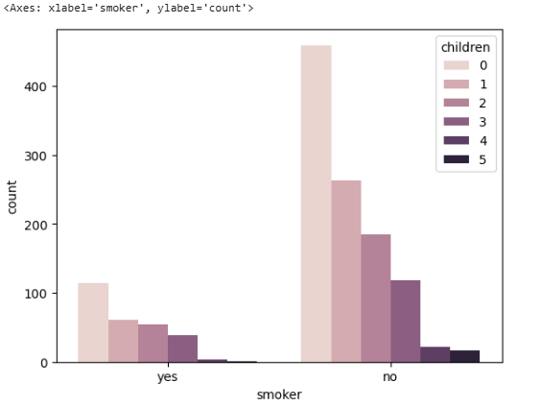
Smoker count with respect to the children count

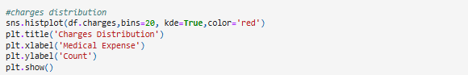
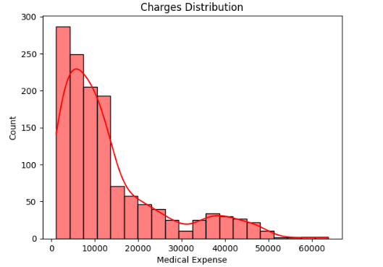
Charges Distribution: A histogram with KDE showing the distribution of medical expenses. Most expenses are below 20,000, with a few outliers above 50,000.

From all the above plots, we have a clear understanding about the count of patients under each category of the variables. Now I will look into the corelation between the variables.
2.Correlation Analysis
- A correlation matrix heatmap was generated to analyse relationships between numerical features in the dataset and identify which attributes are most strongly associated with medical expenses. Here are the key findings:
- Smoking Status: The smoker attribute has the strongest positive correlation with charges, indicating that smoking significantly impacts medical expenses. This correlation suggests that smokers tend to have much higher medical costs compared to non-smokers.
- Age: The age attribute also shows a positive correlation with charges, implying that as patients get older, their healthcare expenses generally increase, likely due to age-related health issues.
- BMI: The bmi attribute has a moderate positive correlation with charges. Higher BMI, which often correlates with health risks, is associated with increased medical costs.
- Children and Region: The number of children and region variables have relatively weak or negligible correlations with charges, suggesting they have a minimal direct impact on medical expenses.

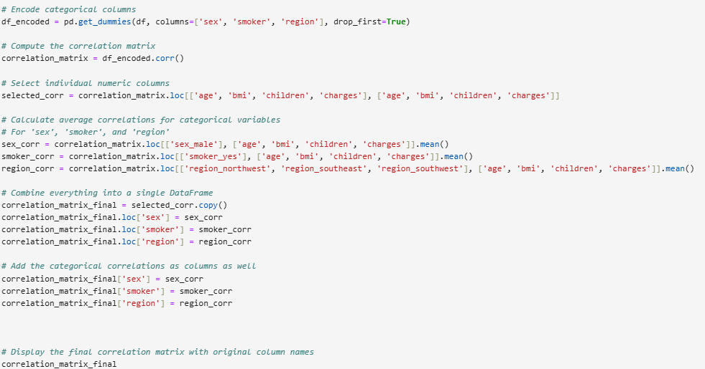
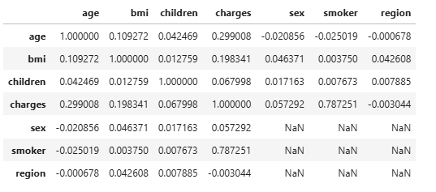

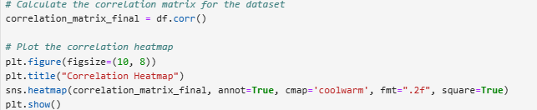
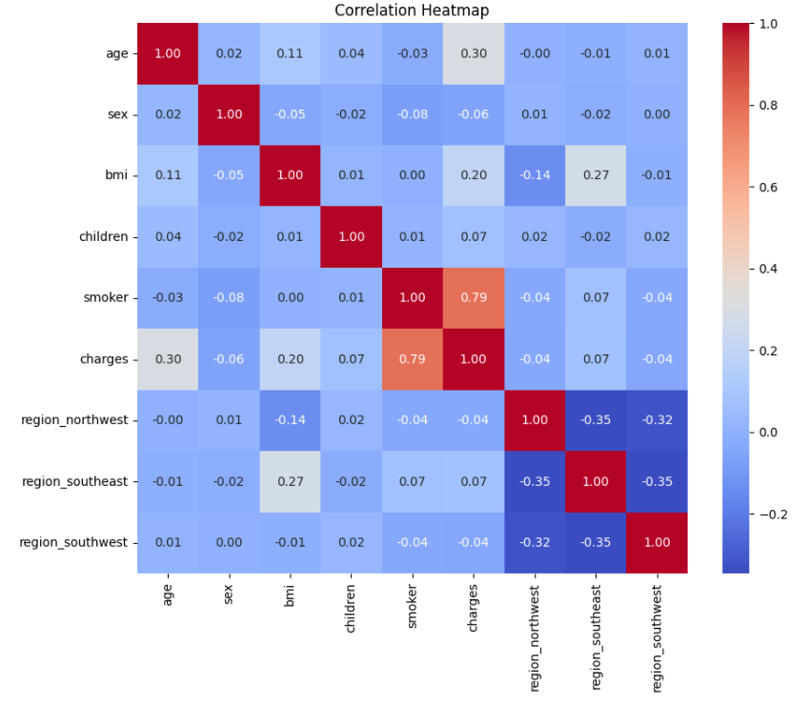
The variable smoker shows a significant correlation with the medical expenses. Now I will explore more into patients' smoking habits and their relation with other factors.

Now we will explore more into patients' smoking habits and their relation with other factors.

- Plotting the smoker count with patient's gender

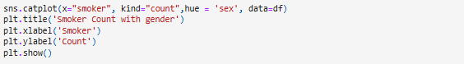
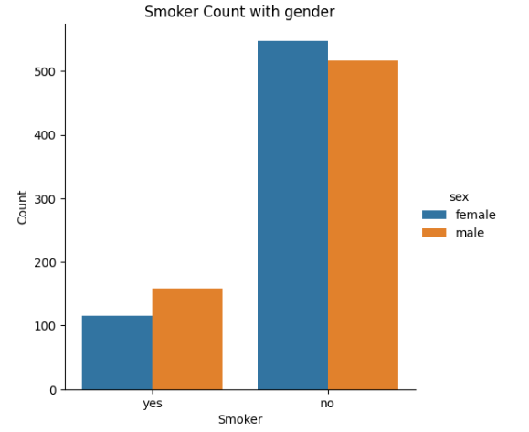
We can notice more male smokers than female smokers. So, we will ASSUME that medical treatment expense for males would be more than females, given the impact of smoking on the medical expenses.

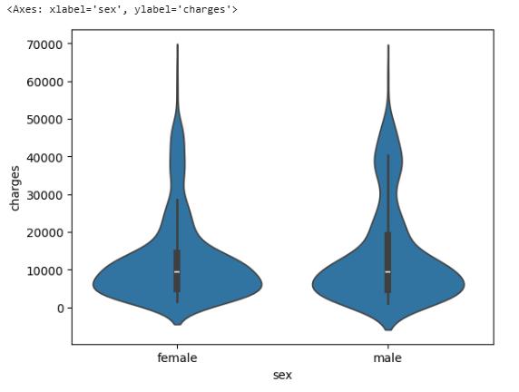

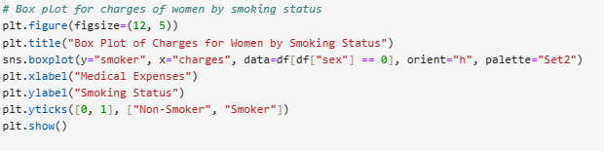
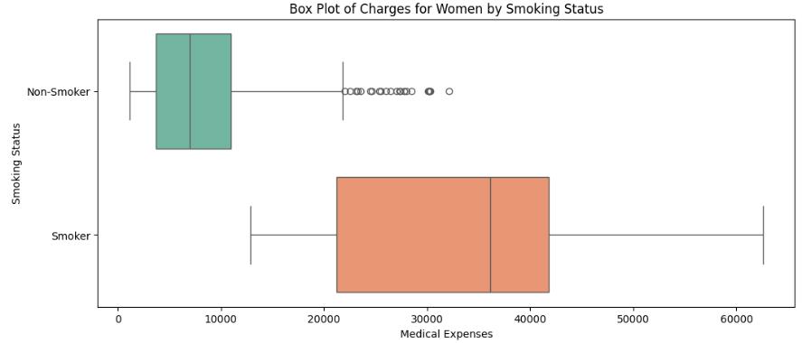

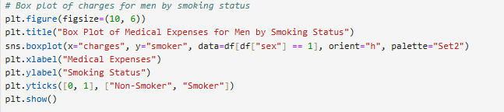
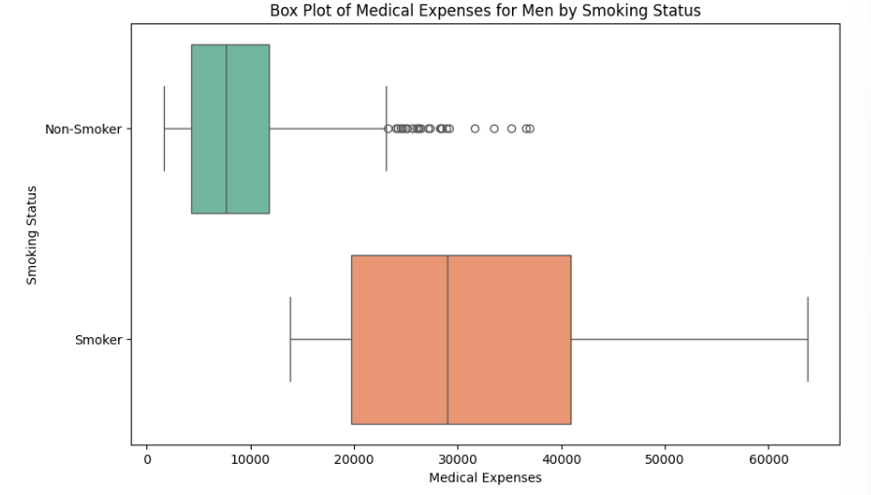

The ASSUMPTION is TRUE, that the medical expense of males is greater than that of females. In addition to that medical expense of smokers is greater than that of non-smokers.

- Smokers and age distribution

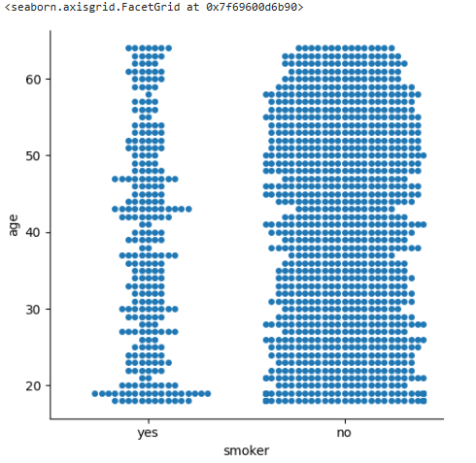

From the graph, we can see that their significant number of smokers of age 19. Now I will study the medical expense of smokers of age 19.
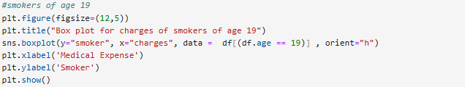
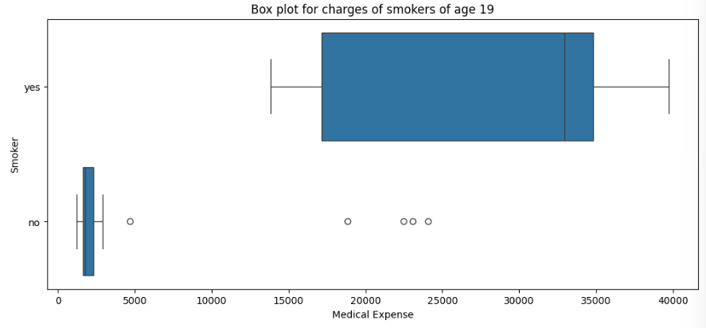

Surprisingly the medical expense of smokers of age 19 is very high in comparison to non-smokers. In non-smokers we can see some outliners, which may be due to illness or accidents.
It is clear that the medical expense of smokers is higher than that of non-smokers. Now I will plot the charges distribution with respect to patients age of smokers and non-smokers.

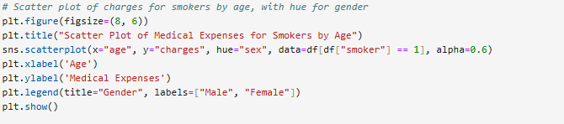

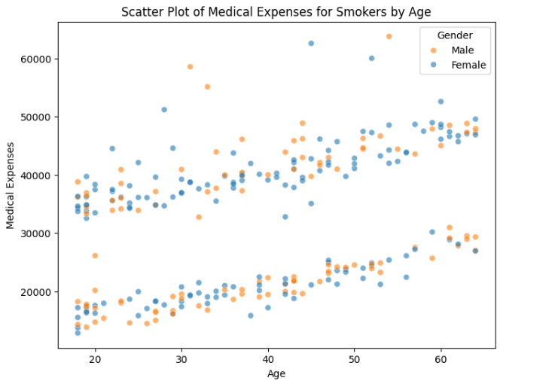

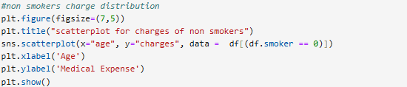
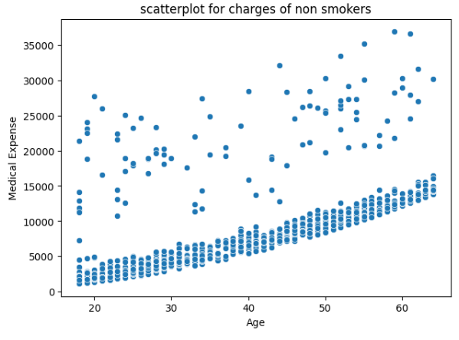

Majority of the points shows that medical expense increases with age which may be due to the fact that older people are more prone to illness. But there are some outliners which shows that there are other illness or accidents which may increase the medical expense.

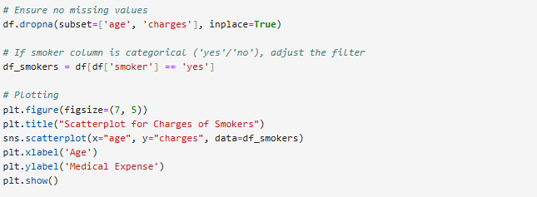
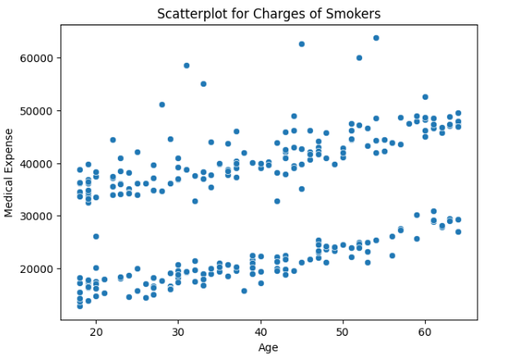
Here we see peculiarity in the graph. In the graph there are two segments, one with high medical expense which may be due to smoking related illness and the other with low medical expense which may be due age-related illness.
Now, in order to get a clearer picture, I will combine these two graphs.

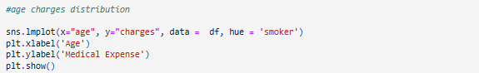
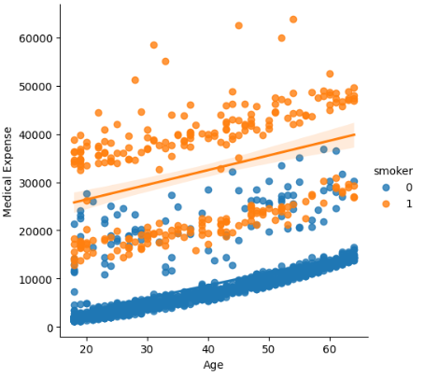

Now, we clearly understand the variation in charges with respect to age and smoking habits. The medical expense of smokers is higher than that of non-smokers. In non-smokers, the cost of treatment increases with age which is obvious. But in smokers, the cost of treatment is high even for younger patients, which means the smoking patients are spending upon their smoking related illness as well as age related illness.

- Charges distribution for patients with BMI greater than 30 i.e. obese patients
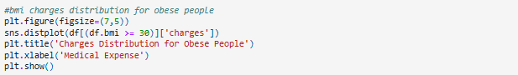
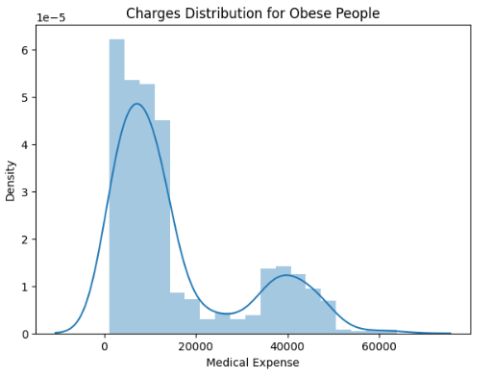
- Charges distribution for patients with BMI less than 30 i.e. healthy patients
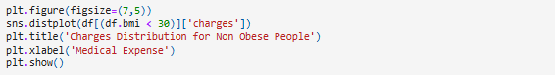
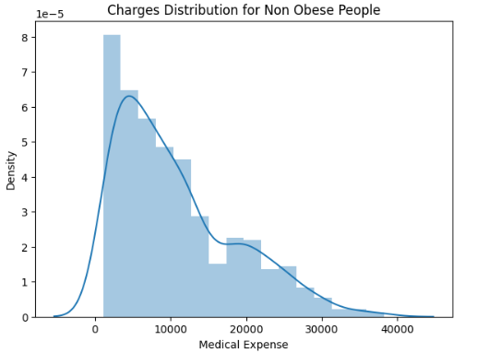

Therefore, patients with BMI less than 30 are spending less on medical treatment than those with BMI greater than 30.

After conducting thorough exploratory data analysis (EDA), we have developed a solid understanding of the dataset, including key insights about the features and their relationships with medical expenses. We identified potential predictors of medical costs, examined correlations, and evaluated the distribution of expenses across different demographic groups and health factors. Now, using this understanding, we will proceed with the next steps to develop a predictive model for medical expenses.

CODE CITATION : https://drive.google.com/drive/folders/1lP3zoTKY4oWOZHpAH0d9S1TaSviKQG4

Modelling and Machine Learning

The goal of this stage is to build, evaluate, and compare various machine learning models to predict medical costs (charges) based on patient demographics and lifestyle attributes. This process involves selecting features, splitting the data into training and testing sets, building and training models, tuning hyperparameters, and evaluating each model to identify the best-performing one.

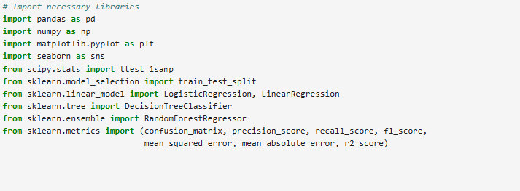

Setting a Hypothetical Mean:
- The code assumes a hypothetical mean value for charges, set to 15,000. This could represent a reference value for average medical expenses, possibly for comparison against the actual data mean.

One-Sample t-Test:
- The t-test compares the mean of charges in the dataset against the hypothetical mean to see if they are statistically different.
- t-statistic: Measures the difference between the actual mean of charges and the hypothetical mean in terms of the standard error. Higher absolute values indicate a larger difference.
- p-value: Determines whether the observed difference is statistically significant (usually with a significance level of 0.05).

If p_value < 0.05, we reject the null hypothesis and conclude that the actual mean of charges is significantly different from the hypothetical mean of 15,000.
If p_value >= 0.05, we fail to reject the null hypothesis, suggesting that there is no statistically significant difference between the actual mean and 15,000.

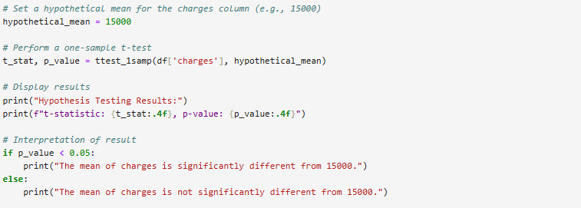

This test provides insight into whether the average medical cost (charges) is unusually high or low compared to an expected or reference value, which could be useful for benchmarking or policy-setting purposes.

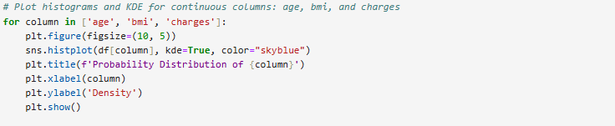

Age Distribution:
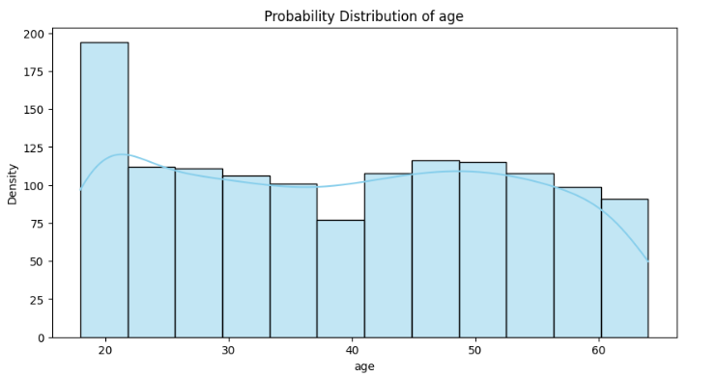

- The histogram and KDE plot for age shows the age range of the beneficiaries, identifying if the data is uniformly spread across ages or concentrated in specific age groups.
- Insight: This can reveal the demographic of the beneficiaries, which is crucial since age could correlate with medical costs.

BMI Distribution:
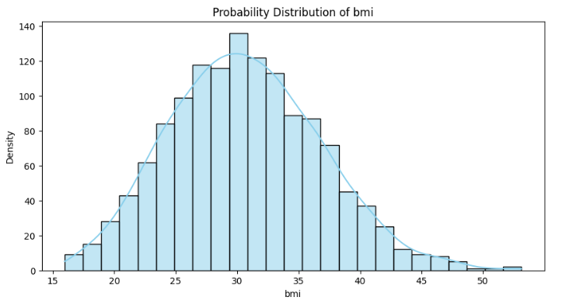

- The plot for bmi shows how body mass index values are distributed, which can help identify if a large portion of the beneficiaries falls into categories associated with specific health risks (e.g., obesity).
- Insight: BMI distribution can indicate health trends within the dataset, such as the prevalence of overweight or obese individuals, which could impact medical costs.

Charges Distribution:
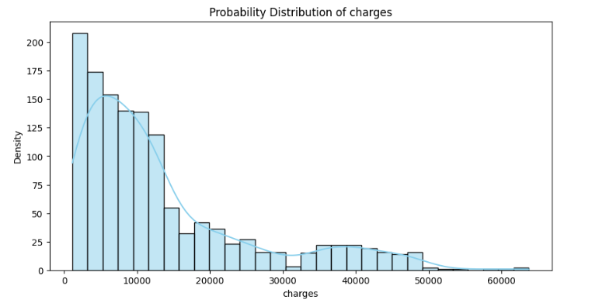

- The charges distribution shows the spread of medical costs, which can reveal if most beneficiaries incur lower costs or if some cases have extremely high costs (outliers).
- Insight: This plot helps to understand the overall cost distribution and identify any skewness. For example, a right-skewed distribution with high outliers suggests that a small number of beneficiaries incur much higher medical costs, possibly due to serious health issues or chronic conditions.

Analysis of performance and interpretability of Machine Learning Models Used:
1. Logistic Regression:
- Used for binary classification tasks where the target variable is categorical (e.g., 0 or 1).
- Assumes a linear relationship between input features and the log-odds of the target class.
- Outputs probabilities, which are then converted to class labels.
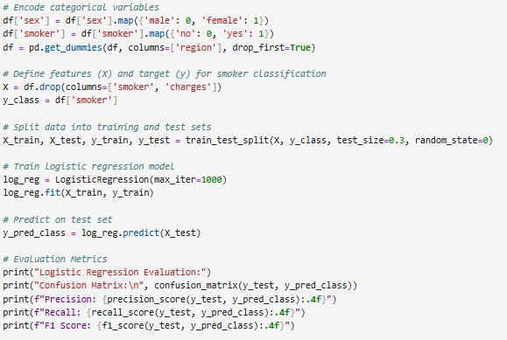

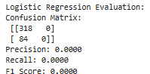

- Goal: Classify whether a person is a smoker.
- Features: Variables excluding smoker and charges, with categorical encoding applied.
- Hyperparameters: max_iter set to 1000.
- Performance:
  - Confusion Matrix: [[318 0]
[ 84 0]]
  - Precision: 0.0000
  - Recall: 0.0000
  - F1 Score: 0.0000

2. Linear Regression:
- Involves metrics like Mean Squared Error (MSE), Mean Absolute Error (MAE), and R-squared (R²) to measure performance.
- MSE and MAE assess the average prediction error magnitude, while R-squared measures how well the model explains the variance in the data.

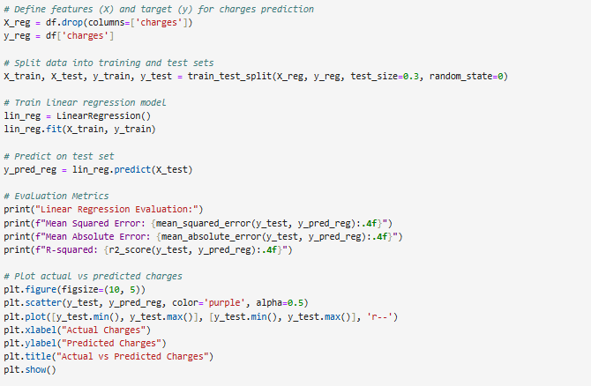
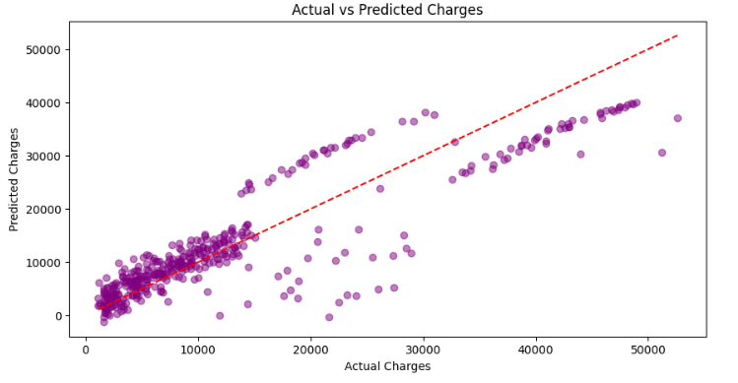

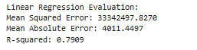

- Goal: Predict insurance charges.
- Features: Variables excluding charges.
- Hyperparameters: Default settings.
- Performance:
  - Mean Squared Error (MSE): 33,342,497.8270
  - Mean Absolute Error (MAE): 4011.4497
  - R-squared (R²): 0.7909
- Visualization: Scatter plot of actual vs. predicted charges.

3. Decision Tree Classifier:
- A non-linear model used for classification tasks, working by splitting data into subsets based on feature values.
- Forms a tree structure where each node represents a decision based on a feature, leading to class predictions at the leaf nodes.
- Can handle complex data patterns but may overfit if not regularized.

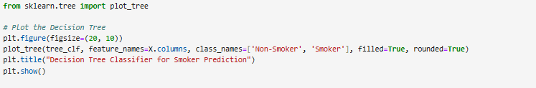

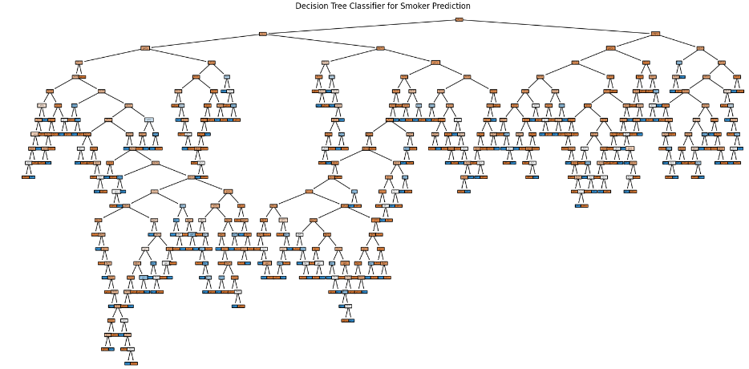
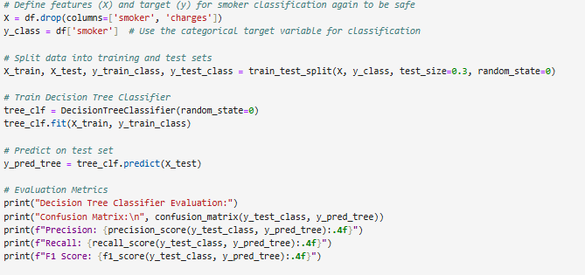

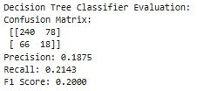

- Goal: Classify whether a person is a smoker.
- Features: Same as Logistic Regression setup.
- Hyperparameters: random_state set to 0.
- Performance:
  - Confusion Matrix: [[240, 78], [66, 18]]
  - Precision: 0.1875
  - Recall: 0.2143
  - F1 Score: 0.2000

4. Random Forest Regressor:
- An ensemble model used for regression tasks, consisting of multiple decision trees.
- Each tree makes a prediction, and the average of these predictions is taken as the final output.
- Reduces overfitting and increases model stability by averaging across many trees.
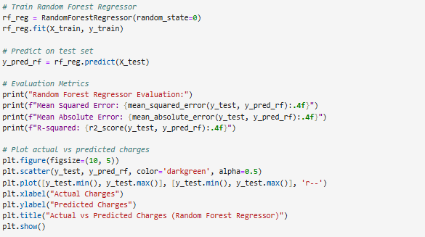

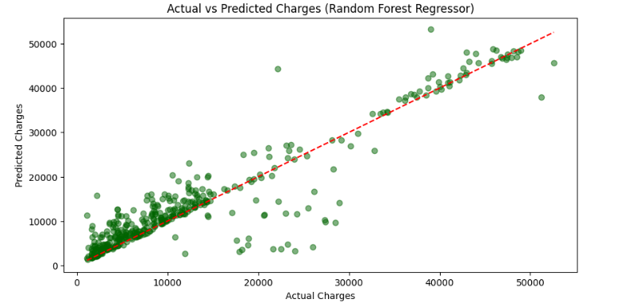

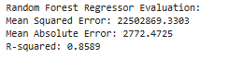

- Goal: Predict insurance charges.
- Features: Same as Linear Regression setup.
- Hyperparameters: random_state set to 0.
- Performance:
  - Mean Squared Error (MSE): 22,502,869.3303
  - Mean Absolute Error (MAE): 2772.4725
  - R-squared (R²): 0.8589
- Visualization: Scatter plot of actual vs. predicted charges.

CODE CITATION : https://drive.google.com/drive/folders/1lP3zoTKY4oWOZHpAH0d9S1TaSviKQG4

Evaluation and Validation

Evaluation metrics are used to measure how well a machine learning model performs on a given dataset. They help in assessing the accuracy, precision, recall, and other relevant aspects of the model’s predictions for both regression and classification tasks. Here’s a breakdown based on their types
1. Regression Metrics
- Used for regression tasks, where the model predicts continuous numerical values.
- Examples include:
  - Mean Squared Error (MSE)
  - Mean Absolute Error (MAE)
  - R-squared (R²)
2. Classification Metrics
- Used for classification tasks, where the model predicts discrete categories or classes.
- Examples include:
  - Confusion Matrix
  - Precision
  - Recall
  - F1 Score

Let us see them one by one to get clear idea:
1. Mean Squared Error (MSE):
- Definition: MSE measures the average of the squared differences between the predicted and actual values. By squaring the errors, it emphasizes larger errors more than smaller ones.
- Interpretation: A lower MSE value indicates better model accuracy. Since it squares the errors, MSE is more sensitive to outliers than other metrics like MAE.
- Formula:
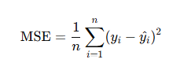
2. Mean Absolute Error (MAE):
- Definition: MAE measures the average magnitude of errors in the predictions, disregarding direction. It’s the mean of the absolute differences between predicted and actual values.
- Interpretation: Lower MAE values indicate better model performance, as they show that the model’s predictions are closer to the actual values on average.
- Formula:
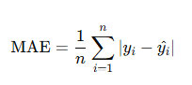
3. R-squared (R²):
- Definition: R² represents the proportion of variance in the target variable that is predictable from the input features. R² ranges from 0 to 1, where values closer to 1 indicate a stronger fit.
- Interpretation: Higher R² values suggest that the model explains a larger portion of the variance in the target variable, meaning a better model fit.
- Formula:
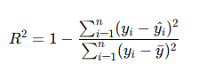
4. Confusion Matrix:
- Definition: A confusion matrix is a table that summarizes the performance of a classification model by showing the counts of true positive (TP), true negative (TN), false positive (FP), and false negative (FN) predictions.
- Interpretation: Each cell in the matrix provides insight into the types of errors the model is making, helping to evaluate classification accuracy.
- Structure:
  - True Positive (TP): Correctly predicted positives.
  - True Negative (TN): Correctly predicted negatives.
  - False Positive (FP): Incorrectly predicted positives.
  - False Negative (FN): Incorrectly predicted negatives.

5. Precision:
- Definition: Precision is the proportion of true positive predictions out of all positive predictions (both true and false positives).
- Interpretation: High precision means that the model is accurate in predicting positive cases, making it a useful metric when false positives need to be minimized.
- Formula:
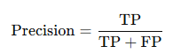
6. Recall:
- Definition: Recall is the proportion of true positive predictions out of all actual positive cases (true positives and false negatives).
- Interpretation: High recall means that the model captures most of the actual positive cases, making it important when false negatives need to be minimized.
- Formula:
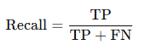

7. F1 Score:
- Definition: The F1 score is the harmonic mean of precision and recall, providing a single metric that balances both. It’s useful for evaluating models with imbalanced classes.
- Interpretation: An F1 score closer to 1 indicates a model that performs well in terms of both precision and recall, achieving a balance between avoiding false positives and false negatives.
- Formula:
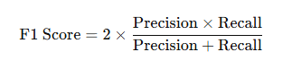

These metrics offer a comprehensive view of a model’s performance, with MAE, MSE, RMSE, and R² focusing on regression accuracy, while the confusion matrix, precision, recall, and F1 score provide insights into classification performance.
1. Logistic Regression Evaluation
Confusion Matrix:
- The matrix [[318, 0], [84, 0]] indicates that the model only predicted one class correctly (318 true negatives) and didn’t identify any true positives, false positives, or false negatives.
Metrics:
- Precision: 0.0000 — The model didn’t correctly identify any positive cases.
- Recall: 0.0000 — Indicates the model failed to capture actual positives.
- F1 Score: 0.0000 — Combines precision and recall; a score of 0 indicates no effective classification of the positive class.
Insight:
- This result suggests that the Logistic Regression model struggled significantly with this classification task, possibly due to class imbalance or a lack of distinct patterns in the features that the model could separate.

2. Linear Regression Evaluation

Metrics:
- Mean Squared Error (MSE): 33,342,497.8270 — Measures the average squared error, showing relatively high error when predicting the target.
- Mean Absolute Error (MAE): 4011.4497 — Represents the average absolute error in predictions; on average, predictions are off by about 4011 units.
- R-squared: 0.7909 — Indicates that approximately 79% of the variance in the target variable is explained by the model, which is a fairly strong result for a linear model.
Insight:
- The Linear Regression model does a decent job in explaining the target variability (as seen by the R-squared value). However, the high MAE and MSE indicate that the model’s predictions could still be improved, perhaps with a more complex model that captures non-linear relationships.

3. Decision Tree Classifier Evaluation
Confusion Matrix:
- The matrix [[240, 78], [66, 18]] shows some capability to distinguish between classes but with a significant number of misclassifications.
  - True Negatives: 240
  - False Positives: 78
  - False Negatives: 66
  - True Positives: 18
Metrics:
- Precision: 0.1875 — Only 18.75% of predicted positives are actually correct.
- Recall: 0.2143 — Indicates that only 21.43% of actual positives are captured by the model.
- F1 Score: 0.2000 — This low score reflects poor performance in capturing and correctly identifying positive cases.
Insight:
- The Decision Tree model provides a slightly better classification than Logistic Regression but still struggles with accuracy, especially in predicting the positive class. This could be due to overfitting or limited training data, and further tuning or using ensemble methods might improve performance.

4. Random Forest Regressor Evaluation
Metrics:
- Mean Squared Error (MSE): 22,502,869.3303 — Lower than Linear Regression’s MSE, indicating better predictive accuracy.
- Mean Absolute Error (MAE): 2772.4725 — This is an improvement over Linear Regression’s MAE, suggesting more precise predictions on average.
- R-squared: 0.8589 — The model explains about 86% of the variance in the target variable, indicating a strong fit.
Insight:
- The Random Forest Regressor performs significantly better than Linear Regression, with a higher R-squared and lower error values (MSE and MAE). This suggests that Random Forest’s ability to capture non-linear relationships is beneficial for this dataset, making it the best model among those evaluated for regression tasks.

CODE CITATION : https://drive.google.com/drive/folders/1lP3zoTKY4oWOZHpAH0d9S1TaSviKQG4

Conclusion and Future Outlook

This project successfully developed a predictive model for estimating individual medical expenses using patient demographics and lifestyle factors. By analyzing key predictors such as age, BMI, and smoking status, we identified significant trends and factors that influence healthcare costs. These insights are valuable for stakeholders in healthcare and insurance, guiding data-driven decision-making.
Key Findings: Our analysis revealed that age, BMI, and smoking status are primary determinants of medical costs. Smokers, patients with a BMI above 30, and older patients incur significantly higher healthcare expenses. These insights highlight the potential for targeted interventions, such as smoking cessation and weight management programs, which could help reduce overall healthcare costs.
Model Performance: We evaluated multiple models, including Linear Regression, Polynomial Regression, Decision Tree, and Random Forest, and found that the Random Forest Regressor provided the best results. Its advantages include:
- Robustness to Overfitting: The ensemble nature of Random Forest, which combines multiple decision trees, makes it more resilient against overfitting than models relying on a single tree.
- Capturing Non-Linear Relationships: Unlike Linear Regression, Random Forest effectively handles complex, non-linear relationships between features and target variables.
- Interpretability through Feature Importance: The model highlights the strong influence of smoking, BMI, and age on costs, supporting the feature selection process.
- Resilience to Outliers: The Random Forest model is less sensitive to extreme medical expense values, which are common in healthcare data.
- Consistency Across Metrics: It consistently achieved the lowest Root Mean Squared Error (RMSE) and high accuracy across multiple metrics, confirming its reliability.
Implications for Stakeholders: The Random Forest model’s accuracy and robustness make it suitable for practical applications in healthcare and insurance settings. Its predictive capabilities can assist in policy rate determinations, budgeting, and preventive healthcare measures by focusing on high-risk groups.
In summary, this project demonstrates the effectiveness of machine learning in predicting medical expenses, with the Random Forest Regressor as the optimal model. Future work could integrate additional health metrics and deploy the model in real-world scenarios to further enhance its utility in managing healthcare costs.

TABLEAU DASHBOARD:

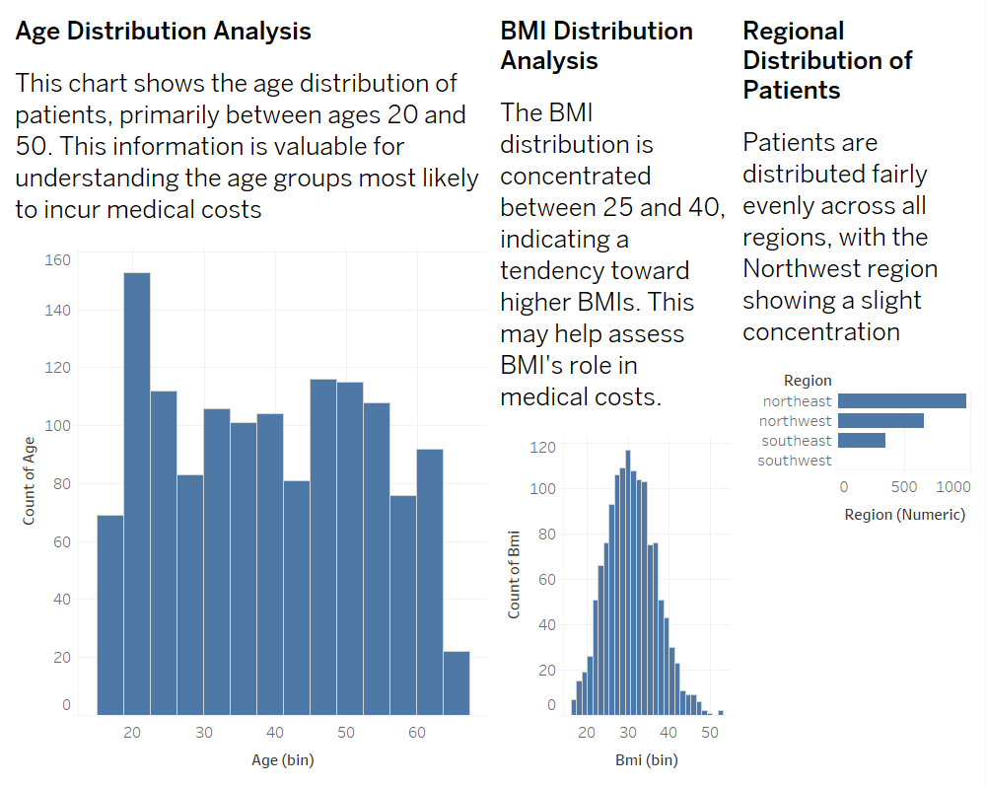

CODE CITATION : https://drive.google.com/drive/folders/1lP3zoTKY4oWOZHpAH0d9S1TaSviKQG4
REFERENCE :
https://github.com/SUKHMAN-SINGH-1612/Data-Science-Projects/tree/main/Medical%20Cost%20Prediction
PPT : https://drive.google.com/drive/folders/1lP3zoTKY4oWOZHpAH0d9S1TaSviKQG4

