1. What is vertx
2. Vertx Verticles - Write first verticle and deploy
https://start.vertx.io/
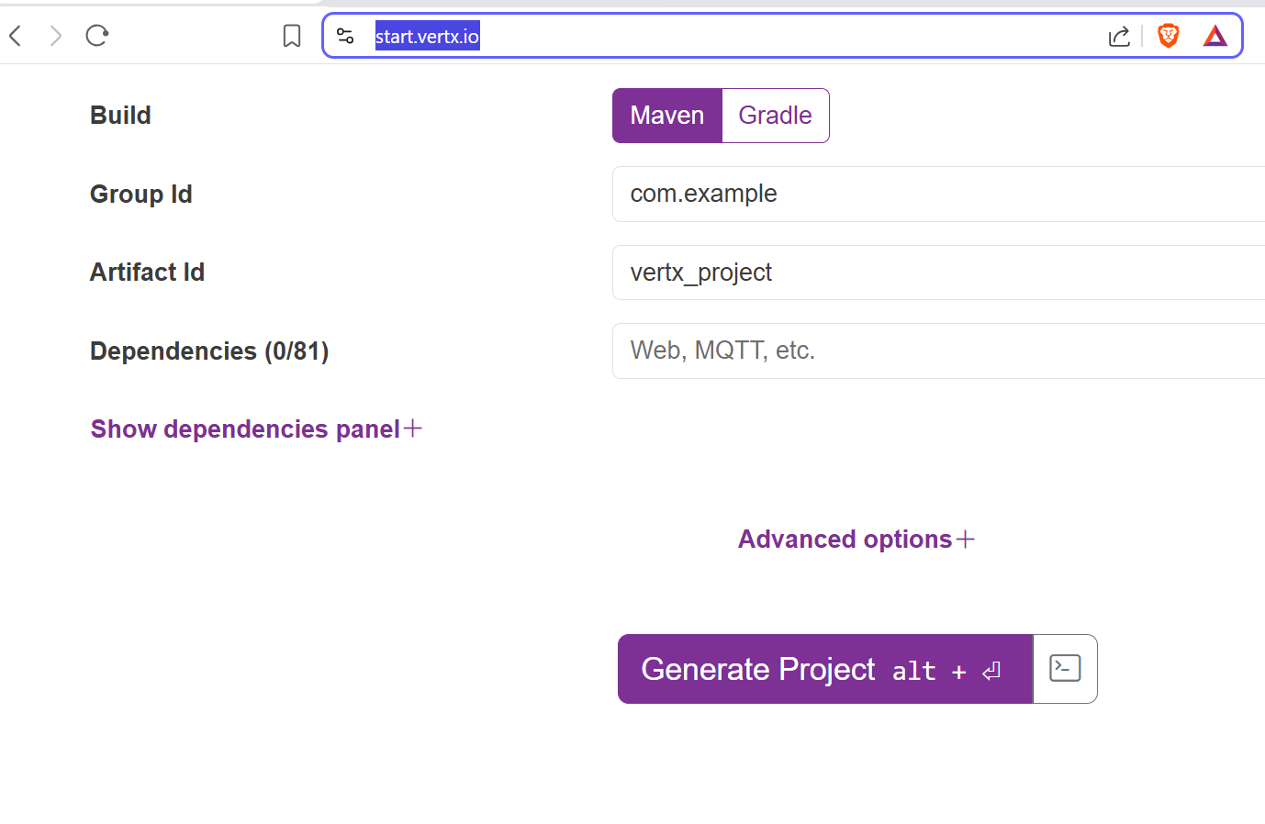
FirstVerticle.java
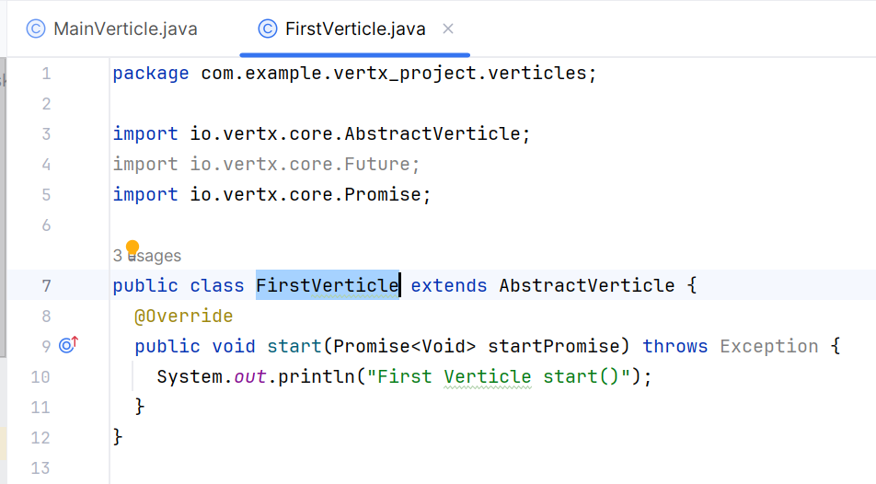

MainVerticle.java
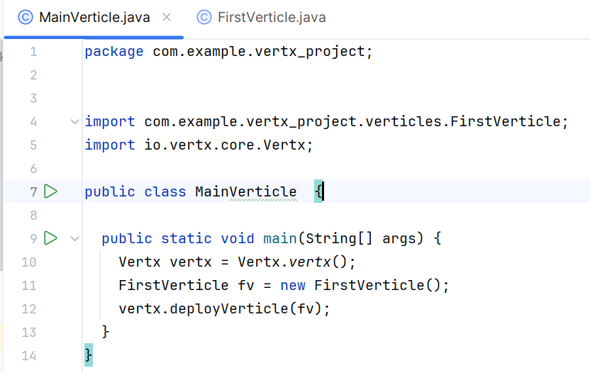

There multiple functions will discover in future
We can also make sure whether the verticle is deployed or not
3. Different types of Verticle
Vertx launcher is inbuilt with vertx core
We will see how to launch the verticle
BoostrapVerticle is like starting all the verticles
There are three ways of deployment
- Full classname with package name
- FirstVerticle.class.getName()
- vertx.deployVerticle(new FirstVerticle());

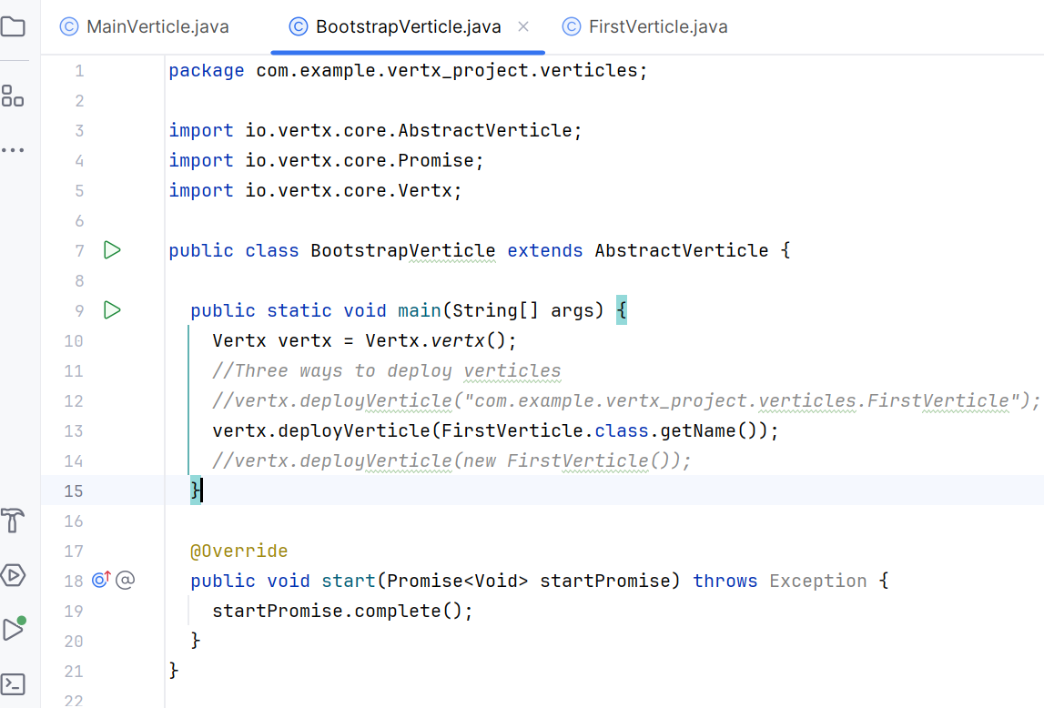

This is way the to launch different verticles
https://vertx.io/docs/vertx-core/java/#_verticles

There are two types of verticles standard and worker verticles

Standard Verticles
These are the most common and useful type - they are always executed using an event loop thread. (Kind of parallel processing)

Worker Verticles
These run using a thread from the worker pool. An instance is never executed concurrently by more than one thread. (Kind of sequentail processing)

4. Vertx Config Retriever
https://vertx.io/docs/vertx-config/java/
<dependency>
<groupId>io.vertx</groupId>
<artifactId>vertx-config</artifactId>
<version>5.1.3</version>
</dependency>

Its like reading the configuration details from the json or hocon file
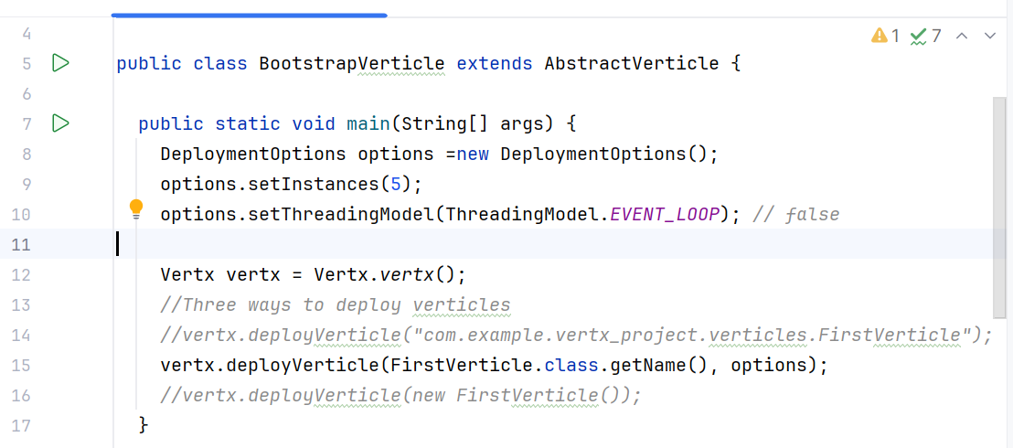
In this case if you want to increase the instance then it will be problem because we will have to hard code it . And that it not the correct way
We should read it from the configuration file and read it
//copy pasting the code snippet from the sources
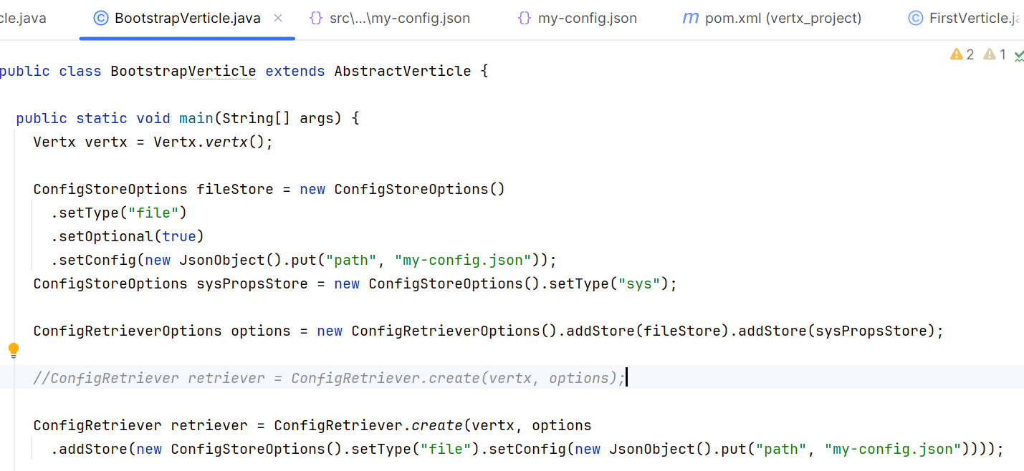
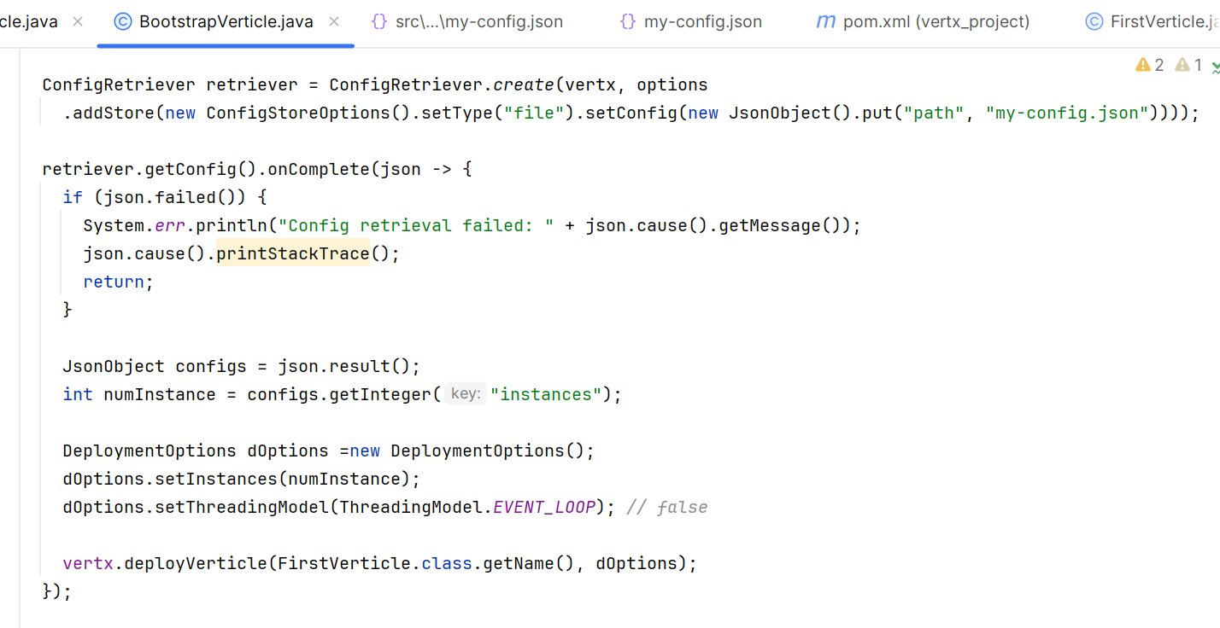
5. Vertx Deployment options
https://vertx.io/docs/vertx-core/java/#_deploying_verticles_programmatically
Launcher -> launching bootstrap verticles -> two verticles
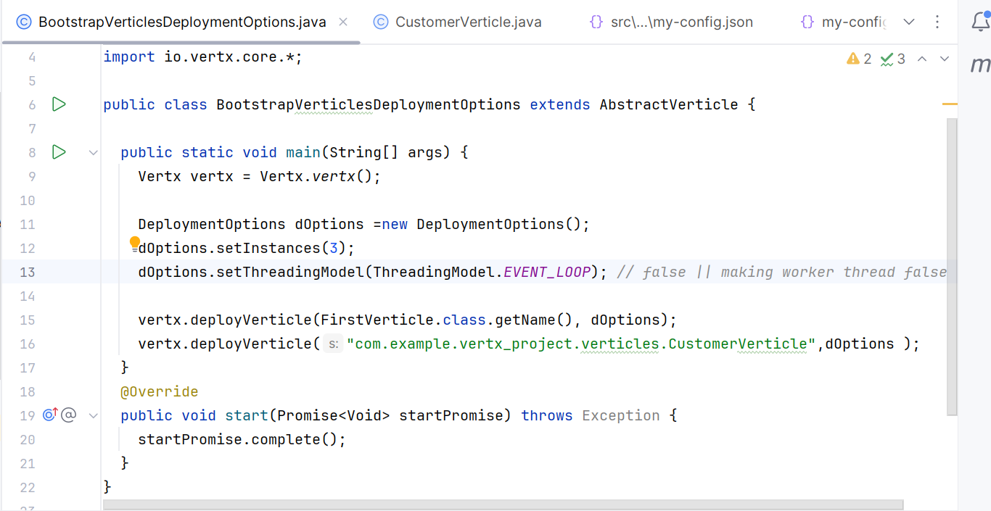
Giving different deployment option like how many instance we can run n all
6. Vertx EventBus
https://vertx.io/docs/vertx-core/java/#event_bus

