Fig no 1: Count of Flight Number by Description

Fig no 2: Count of Flight Number by Airport Code

Fig no 3: Count of Flight Number by Severity

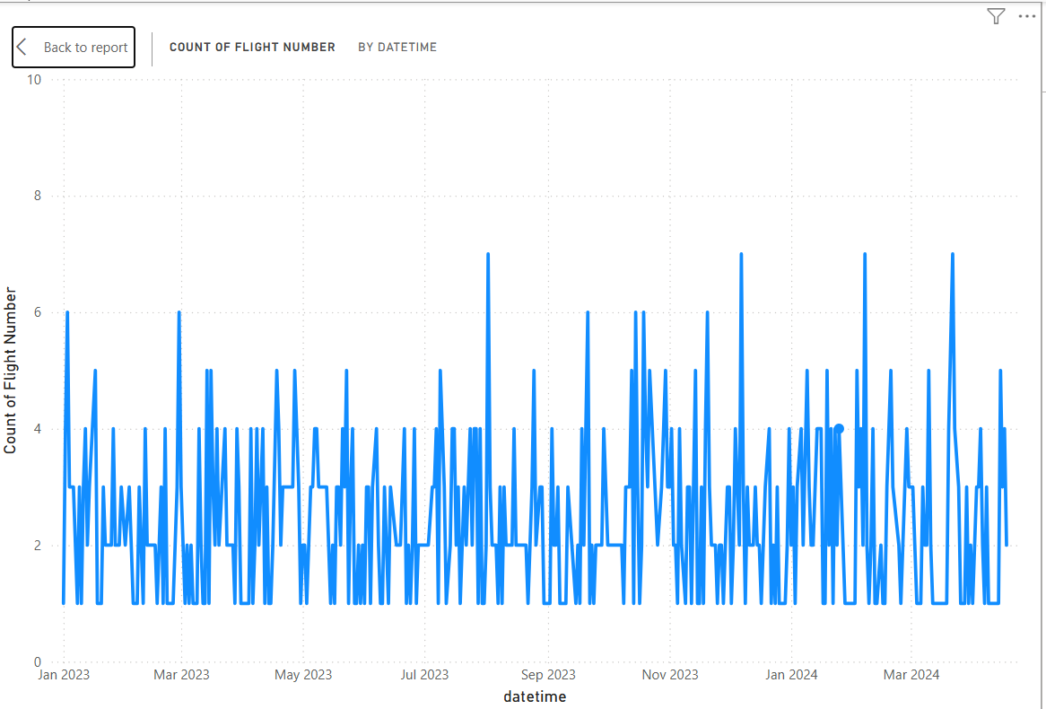  
Fig no 4: Count of Flight Number by dateTime

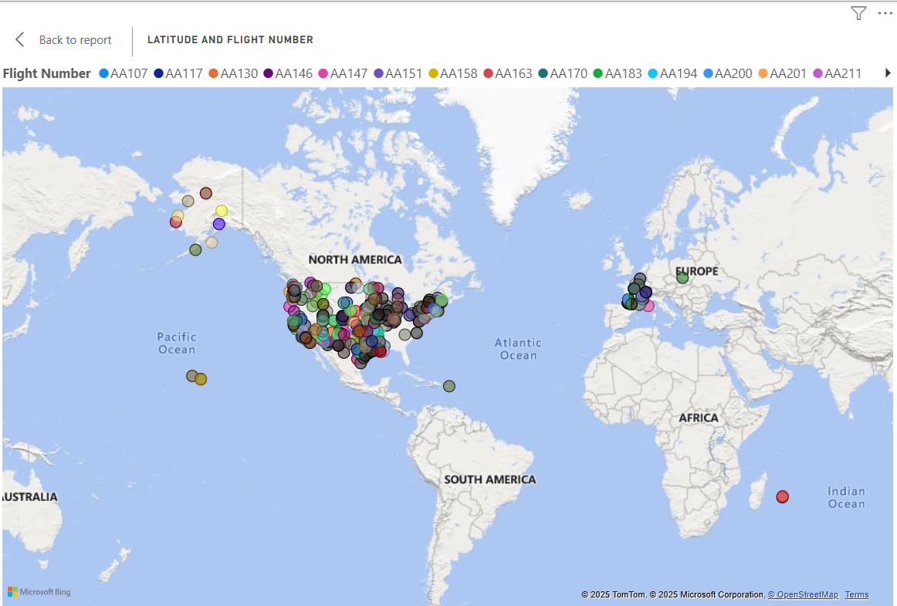  
Fig no 5: Location and Flight Number

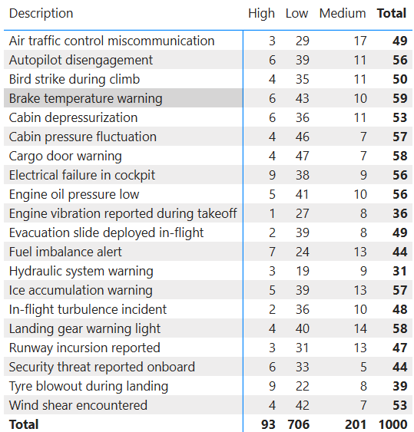  
Fig no 6: Description