A Design Project –I Report

*on*

TIMETABLE SCHEDULING

*by*

Shreyash Rahinj (22110311)

Vishwajeet Desai (22110823)

Revak Pandkar (22110074)

Siddhesh Mali (22110044)



Department of Artificial Intelligence and Data Science

VIIT

**2022-2023**

This is to certify that the project report entitles

**“ TIMETABLE SCHEDULING”**

Submitted by

Shreyash Rahinj Exam No : SEM V

is a bonafide student of this institute and the work has been carried out by him/her under the supervision of **Prof. A. B. C** and it is approved for the partial fulfillment of the requirement for the award of the degree of **Bachelor of Technology** (Artificial Intelligence and Data Science).(12, Sentence case)

**(Prof. Prema Kadam)** **(Dr. P. N. Mahalle)**

Project Guide Head,

Department of AI & DS Department of AI & DS

**ACKNOWLEDGEMENT**

I extend my sincere gratitude and appreciation to all those who contributed to the successful completion of this project on "Timetable Generation Using Genetic Algorithm."

Firstly, I would like to express my deepest thanks to my project guide, Prof. Prema Kadam, for their continuous support, guidance, and encouragement throughout the project. Their expertise and mentorship have been invaluable in shaping the direction of this research.

I am also grateful to the faculty and staff of Vishwakarma Institute of Information Technology for providing the necessary resources, including access to libraries and computing facilities, which greatly facilitated the implementation and testing phases of the project.

Special thanks to my fellow classmates and friends who provided constructive feedback, engaged in insightful discussions, and contributed to the collaborative spirit that fueled the success of this endeavor.

I would like to acknowledge the contributions of Revak Pandkar, Siddhesh Mali, Vishwajeet Desai, who worked closely on specific aspects of the project, bringing diverse skills and perspectives to enhance the overall quality of the timetable generation system.

Finally, I want to express my heartfelt appreciation to my family for their unwavering support and understanding during the course of this project.

This project has been a challenging yet rewarding journey, and the collective efforts of everyone involved have been crucial to its accomplishment.

Shreyash Rahinj

22110311

VIIT , Pune

**ABSTRACT**

The Genetic Algorithm-Based Timetable Scheduler Web Application project emerges as a response to the inherent challenges within manual timetable scheduling processes in educational institutions. Inefficiencies and complexities often accompany traditional methods, necessitating a more streamlined and automated approach. This project seeks to introduce a sophisticated solution by leveraging genetic algorithms to optimize resource allocation, minimize conflicts, and enhance overall scheduling efficiency. With a focus on user satisfaction and adaptability to diverse educational settings, the web application aims to address the time-consuming nature of manual scheduling while aligning with global trends in education technology. By combining advanced algorithms with user-centric design, this project aspires to modernize scheduling practices, foster data-driven decision-making, and ultimately contribute to an improved educational experience for students, faculty, and administrators.

Timetable generation in educational institutions is a complex task that involves scheduling various courses, classrooms, and faculty members while adhering to multiple constraints and preferences. This project introduces a novel approach to tackle this problem by leveraging the power of Genetic Algorithms (GA) in the optimization process.

The proposed system employs a genetic algorithm to evolve and generate optimal timetables that fulfill the diverse requirements of a given academic institution. The genetic algorithm evolves a population of potential timetables through generations, with each timetable representing a possible solution. The fitness of each timetable is evaluated based on the satisfaction of constraints such as room availability, faculty preferences, and class scheduling conflicts.

**Contents**

|  |  |  |  |
| --- | --- | --- | --- |
| **Sr. No.** | **Topic** | | **Page No.** |
|  |  | |  |
| **Chapter-1** | **Introduction** | | 6 |
|  | 1.1 | Introduction | 6 |
|  | 1.2 | Motivation | 6 |
|  | 1.3 | Problem Definition | 7 |
| **Chapter-2** | **Literature Survey** | | 7 |
| **Chapter-3** | Software Requirements Specification | | 8 |
| **Chapter-4** | Functional & nonfunctional Requirements | | 9 |
| **Chapter-5** | Analysis Models: SDLC Model to be applied | | 9 |
| **Chapter-6** | System Implementation Plan | | 10 |
| **Chapter-7** | System Design | | 11 |
|  | System Architecture | | 11 |
|  | Data Flow Diagrams | | 12 |
|  | Entity Relationship Diagrams | | 12 |
|  | UML diagram | | 12 |
| **Chapter-8** | **Conclusion** | | 13 |
|  | **References** | | 13 |

1. **INTRODUCTION**
   1. **INTRODUCTION**

The Genetic Algorithm-Based Timetable Scheduler Web Application project addresses the challenges encountered in manual timetable scheduling processes within educational institutions. Traditional methods often lead to inefficiencies and complexities, prompting the need for a more efficient and automated solution. This project presents a sophisticated approach by employing genetic algorithms to optimize the allocation of resources, reduce conflicts, and improve overall scheduling efficiency. The primary objectives include enhancing user satisfaction, adapting to diverse educational settings, and mitigating the time-consuming aspects associated with manual scheduling. The Genetic Algorithm employed in this Timetable Scheduler acts as a virtual evolutionary process, continuously refining and adapting schedules to better fit the unique constraints and requirements of the educational environment. This dynamic and iterative approach promises to yield schedules that are not only feasible but also highly efficient.

The application places a strong emphasis on aligning with global trends in education technology, aiming to modernize scheduling practices through the integration of advanced algorithms and user-centric design. By doing so, the project seeks to foster data-driven decision-making and contribute to an enhanced educational experience for students, faculty, and administrators. The ultimate goal is to provide a user-friendly, technologically advanced solution that simplifies the scheduling process and brings about positive improvements in the educational landscape.

* 1. **MOTIVATION**

The motivation behind the Genetic Algorithm-Based Timetable Scheduler Web Application project stems from the inefficiencies associated with manual timetable scheduling in educational institutions. Manual processes are time-consuming, and institutions often grapple with complex scheduling rules and constraints. The project aims to address these challenges by automating the scheduling process using a genetic algorithm, which can efficiently handle intricate rules and optimize the utilization of resources, including classrooms and faculty. The goal is to minimize scheduling conflicts, enhance user satisfaction, and provide adaptable solutions that cater to the diverse needs of different educational settings. Additionally, the project aligns with the modernization of educational processes, leveraging advanced technologies to contribute to data-driven decision-making and compliance with regulatory standards. By embracing global trends in education technology, the project seeks to improve academic outcomes and create a more conducive learning environment for students, faculty, and administrators.

* 1. **PROBLEM DEFINITION**

Genetic Algorithm-Based Timetable Scheduler Application, The problem at hand is the inefficiency and complexity of manual timetable scheduling processes in educational institutions. These traditional methods often lead to suboptimal resource utilization, scheduling conflicts, and a lack of adaptability. The manual nature of the process is time-consuming and struggles to promptly adapt to changes or evolving requirements. This project aims to address these challenges by developing a Genetic Algorithm-Based Timetable Scheduler Web Application. The goal is to automate and optimize the scheduling process, ensuring efficient resource allocation, minimizing conflicts, and enhancing overall efficiency, ultimately improving the educational experience for students, faculty, and administrators.

**2. LITERATURE SURVEY**

In the context of genetic algorithms, selection and crossover operations play crucial roles in evolving potential solutions to a problem. The selection process is responsible for choosing individuals from the current population to participate in the reproduction phase, passing their genetic information to the next generation. One common selection method is the Roulette Wheel Selection, where individuals are selected with probabilities proportional to their fitness values. An enhancement to this is Elitism Selection, which preserves the best individuals from the current generation, ensuring their survival in the next.

On the other hand, crossover operations involve combining genetic material from two parent individuals to produce offspring. Single Point Crossover is a basic method where a random point in the parent chromosomes is chosen, and the genetic material beyond that point is swapped between parents. Enhancements like Two Point Crossover and Uniform Crossover offer variations in the way genetic information is exchanged, providing additional diversity in the offspring population.

When dealing with constraints in genetic algorithms, it becomes essential to incorporate domain-specific limitations into the optimization process. In this case, constraints such as the required hours for each subject, the prohibition of faculty members taking two lectures simultaneously, and the differentiation between normal lectures and labs should be considered. Managing these constraints ensures that the evolved solutions are not only fit according to the problem's objective but also adhere to real-world limitations and requirements. This integration of selection, crossover, and constraint management contributes to the effectiveness of genetic algorithms in solving complex optimization problems in diverse domains.

**3. SOFTWARE REQUIREMENTS SPECIFICATIONS**

**3.1 INTERFACE REQUIREMENTS**

* User Interface - Responsive web design - Intuitive and user-friendly interface - Mobile application support - Multilingual support **.**
* Application Programming Interfaces (APIs) - API documentation - API authentication and security - API rate limiting and throttling - API versioning and backward compatibility

**3.2 PERFORMANCE REQUIREMENTS**

* Availability - System uptime of 99.9% - Fault-tolerant and high availability architecture - Redundancy and failover mechanisms
* Scalability – Browser compatibility - Load balancing and clustering - Performance testing and tuning
* Security - Secure communication over HTTPS - User authentication and authorization - Data encryption and decryption - Firewall and intrusion detection and prevention system (IDS/IPS) -Data Backup Recovery.

**3.3 DESIGN CONSTRAINTS**

* Hardware - Web server and database server - Load balancer and clustering hardware - Backup and recovery hardware
* Software - Operating system and web server software - Database management system software - Third-party software and libraries
* Compatibility - Web browser compatibility - Mobile device compatibility - API compatibility with external systems

**4. FUNCTIONAL AND NON-FUNCTIONAL REQUIREMENTS**

**4.1 FUNCTIONAL REQUIREMENTS**

* User Management - User registration and login - Password recovery and reset - User profile management - User roles and permissions.
* Admin Management - Admin login and authentication - Admin dashboard - User and Timetable management - Reporting and analytics.
* Timetable Management - Classroom management - Teacher and class management – Faculty and Class availability.

**4.2 NON-FUNCTIONAL REQUIREMENTS**

* Usability - User experience design (UX) - Accessibility compliance - Help and documentation
* Maintainability - Source code management and version control - Documentation and commenting - Debugging and testing tools.
* Reliability - Error handling and logging - Automated testing and quality assurance - Disaster recovery and business continuity planning.
* Security – User data Encryption and Decryption – Password Authentication – Profile Authorization.

**5. ANALYSIS MODELS: SDLC MODEL TO BE APPLIED**

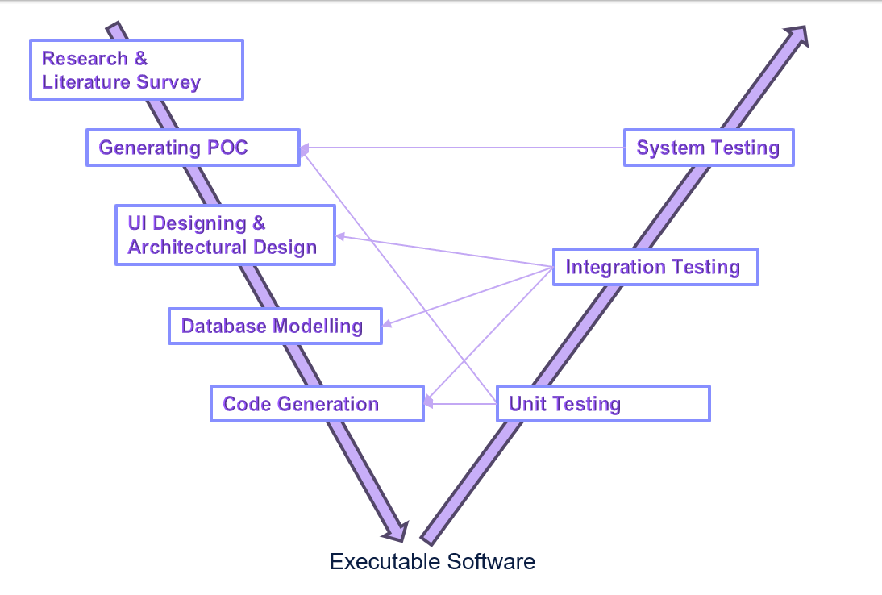

Fig 1

**6. SYSTEM IMPLEMENTATION PLAN**

**6.1 PRE-IMPLEMENTATION ACTIVITIES:**

* Conduct a final review of the application to ensure all features align with requirements.
* Complete testing of the Genetic Algorithm, scheduling algorithms, and user management functionalities.
* Ensure that the application complies with security standards and data protection regulations.

**6.2 DATA MIGRATION**

* Migrate relevant data from the testing environment to the production database.
* Validate the accuracy and completeness of migrated data.

**6.3 USER TRAINING AND DOCUMENTATION**

* Develop user guides and documentation for administrators, teachers, and students.
* Conduct training sessions for users to familiarize them with the application.
* Provide ongoing support channels for user inquiries and assistance.

**6.4 DEPLOYMENT**

* Deploy the Genetic Algorithm-Based Timetable Scheduler Web Application to the production environment.
* Monitor deployment processes to ensure minimal downtime.
* Verify application functionality in the production environment.

**6.5 SECURITY MEASURES**

* Regularly update and patch system components to address security vulnerabilities.
* Monitor and log security events for analysis and response.
* Conduct periodic security audits to ensure ongoing compliance.

**6.6 USER FEEDBACK AND ITERATION**

* Encourage users to provide feedback on the live application.
* Use feedback to identify areas for improvement and plan iterative releases.

**7. SYSTEM DESIGN**

**7.1 SYSTEM ARCHITECTURE**

The architecture encompasses a web-based interface for administrators, teachers, and students, offering user-specific dashboards and functionalities. The core of the system relies on genetic algorithms for automated timetable generation, enabling flexibility to accommodate varying scheduling constraints.

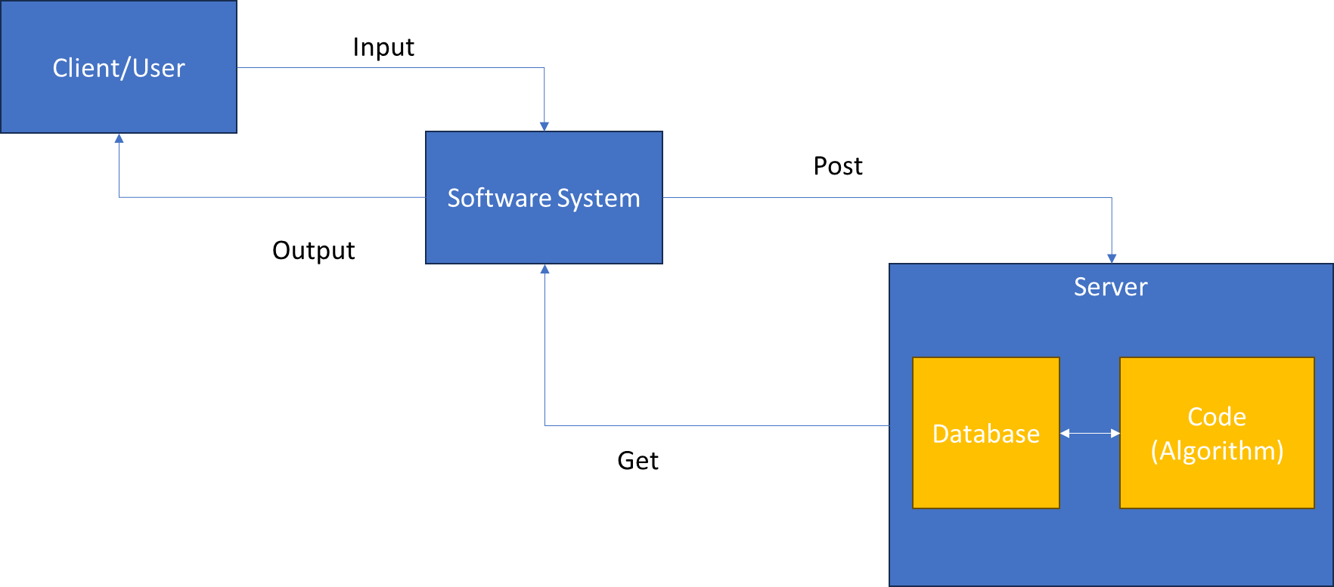

Fig 2

**7.2 DATA FLOW DIAGRAM**

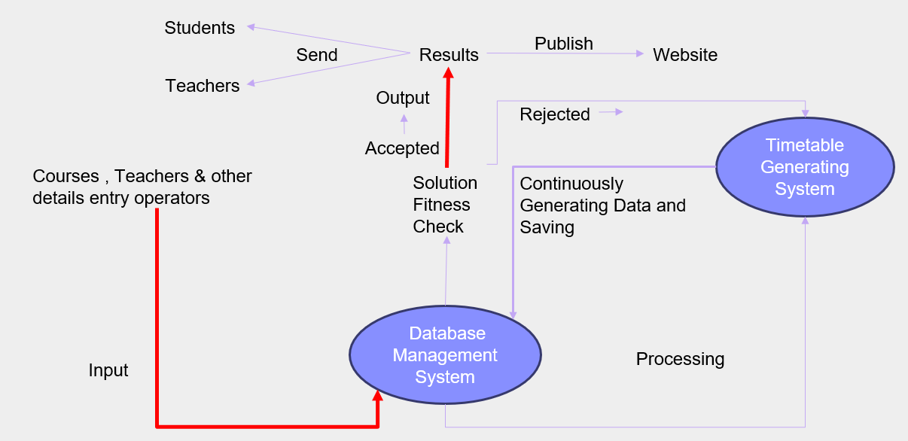

Fig 3

**7.3 ENTITY RELATIONSHIP DIAGRAM**

**7.4 UML DIAGRAMS**

**7.4.1 Use Case Diagram**

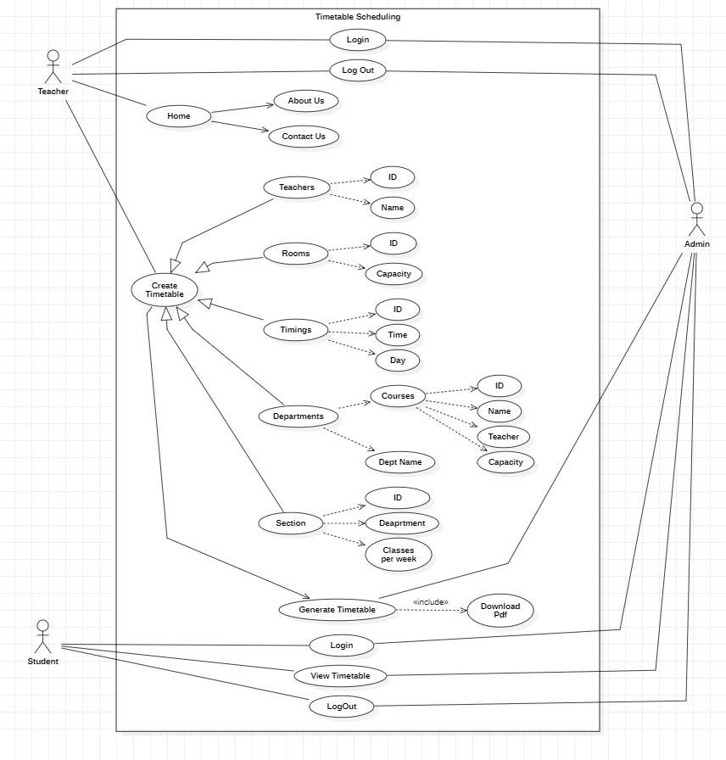

Fig 4

**8. CONCLUSION**

In summary, our Genetic Algorithm-Based Timetable Scheduler Web Application marks a significant step forward in simplifying the complexities of manual timetable scheduling in schools and colleges. By harnessing advanced genetic algorithms, our application efficiently organizes resources and reduces scheduling conflicts. The user-friendly design, catering to administrators, teachers, and students, ensures a smooth and personalized experience. Our iterative development approach allows for continuous improvements, making the system adaptable to changing educational needs. As we roll out this innovative solution, we anticipate not only a more streamlined scheduling process but also an overall enhancement of the educational journey for everyone involved. Our application represents a blend of cutting-edge technology and practical solutions, aimed at making educational management more efficient and user-friendly.

The incorporation of advanced genetic algorithms ensures that the scheduling process is not only automated but also optimized for the best allocation of resources, minimizing conflicts and enhancing overall efficiency.Designed with simplicity and usability in mind, the application provides tailored interfaces for administrators, teachers, and students. This user-centric approach ensures that each stakeholder can navigate and utilize the system effortlessly. The iterative development methodology applied throughout the project allows for ongoing improvements, making the application flexible and responsive to the evolving needs of educational environments.

**9. REFERENCES**

[[1] Automatic Timetable Generation using Genetic Algorithm.](https://www.ijser.org/researchpaper/Automatic-Timetable-Generation-using-Genetic-Algorithm.pdf)

[[2] Genetic algorithms for modelling and optimization.](https://www.sciencedirect.com/science/article/pii/S0377042705000774)

[[3] An introduction to genetic algorithms](https://www.boente.eti.br/fuzzy/ebook-fuzzy-mitchell.pdf)

[[4] Automatic Timetable Generation using Genetic Algorithm](https://www.semanticscholar.org/paper/Automatic-Timetable-Generation-using-Genetic-Mittal-Doshi/a08fddd492660c1dd49c0fd001d2d570373220f0)

[[5] A Study on Genetic Algorithm and its Applications](https://www.researchgate.net/publication/309770246_A_Study_on_Genetic_Algorithm_and_its_Applications)

[[6] A review on genetic algorithm: past, present, and future](https://link.springer.com/article/10.1007/s11042-020-10139-6)

[[7] The Application Research of Genetic Algorithm](https://www.atlantis-press.com/article/25893493.pdf)