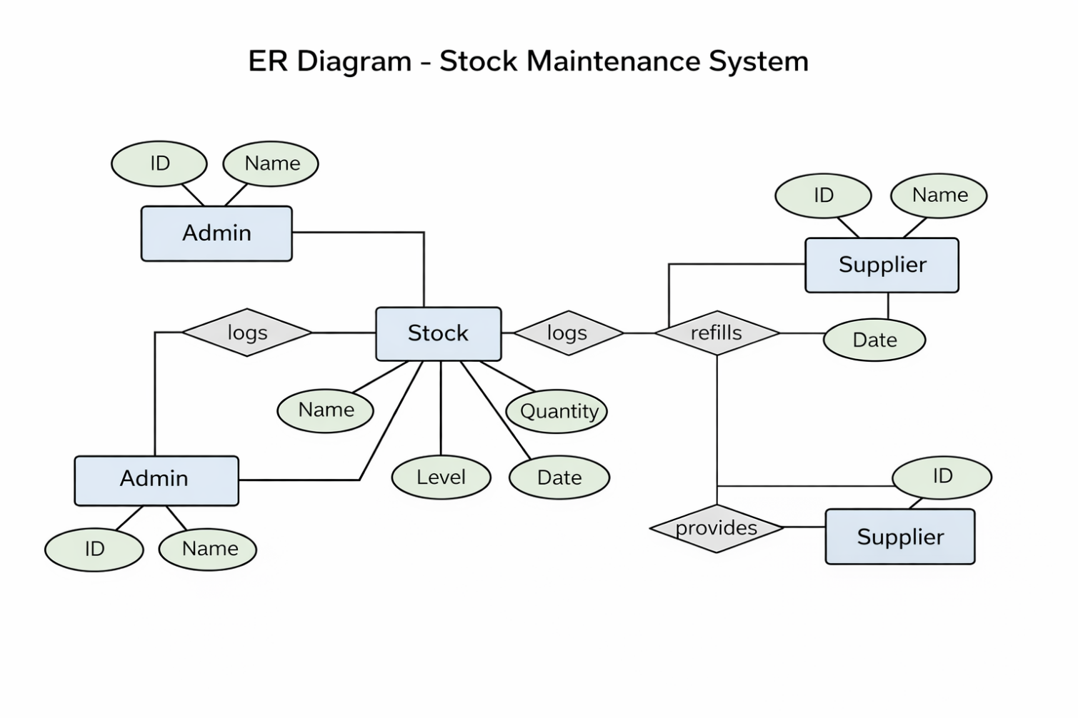
The use case diagram illustrates interactions between users and the system.

