Face Studio Camera — IPCV Project Report
Image Processing and Computer Vision (IPCV) · Section D · Team No. 14 · Topic: Face Studio Camera
Anmol (20231129) · Vansh Gupta (20233303) · Shreyash Kumar Dube (20233567) · Sparsh Singh (20233277)

Abstract
Face Studio Camera is a photo and live-camera studio that combines classical image processing (OpenCV) with deep-learning face analysis (Google MediaPipe). A seven-stage, stackable pipeline applies enhancement, beauty filters, segmentation-based backgrounds, 13 styles, AR overlays and face anonymisation, on photos, batches and live video on a laptop CPU. A 478-point face mesh also gives head pose and blink detection. On 8 test images (20 faces), single-pass BlazeFace found 2 faces and our multi-scale tiling 16, with no false boxes. At 30° rotation BlazeFace found the faces in 6 of 7 images against 1 of 7 for a Haar cascade, at about 5 ms per pass against 150 ms.

1. Introduction
Portrait mode, beauty filters and AR lenses are everyday applications of image processing and computer vision. This project rebuilds them from core techniques so that each effect can be explained and measured. Objectives: a stackable pipeline with presets and a before/after view; face-aware effects driven by detection, a 478-point mesh and segmentation; objective evaluation, including a Haar comparison; real-time live video; and an interactive lab of syllabus operations.
The Viola–Jones Haar cascade (2001) scans hand-crafted rectangle features and returns no landmarks or calibrated confidence. MediaPipe's BlazeFace CNN returns a confidence and 6 keypoints, and FaceLandmarker 478 three-dimensional points (468 surface plus 10 iris); Haar is kept only as a measured baseline.

2. Methodology
The system runs three models once per image and passes their outputs to a seven-stage pipeline (Figure 1). No stage moves pixels geometrically, so these outputs stay valid throughout and are cached.
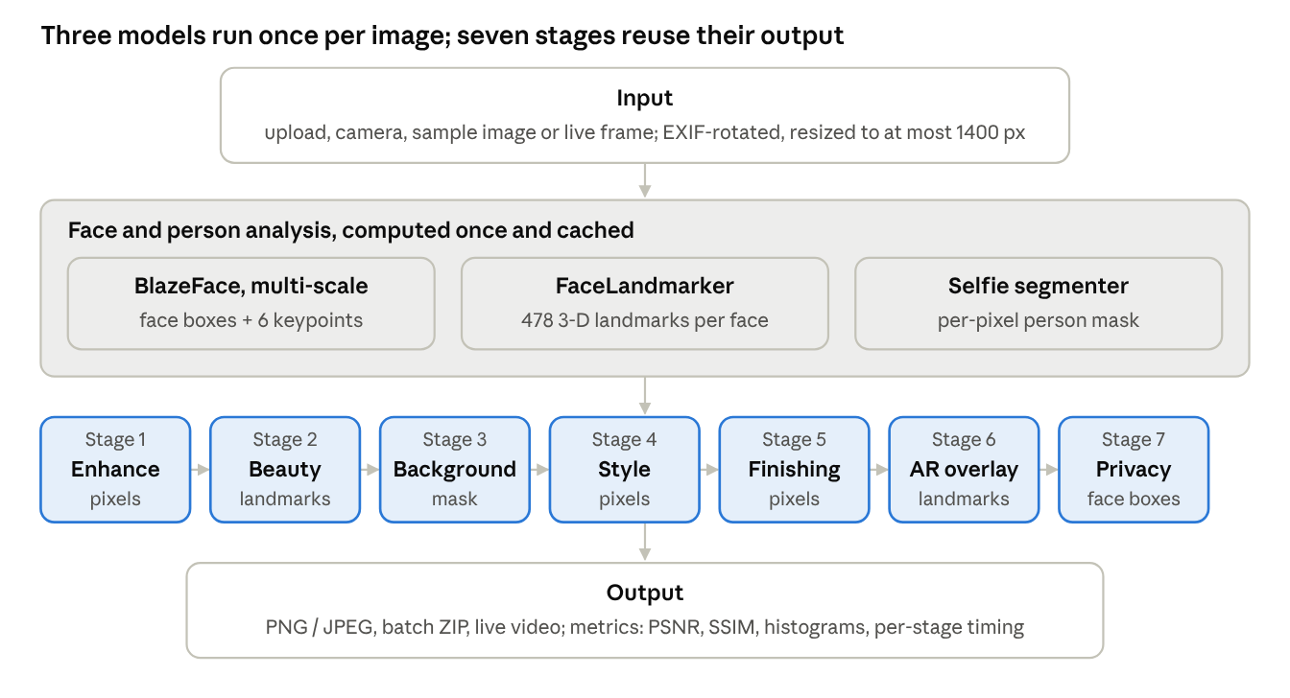
Figure 1 · system architecture of Face Studio Camera
2.1 Enhancement and styles (stages 1, 4, 5). Brightness offsets the V channel of HSV, and saturation scales S. Contrast uses F = 259(c + 255) / (255(259 − c)), and gamma a lookup table s = 255(r/255)^(1/γ). Sharpening is unsharp masking, (1 + a)I − a·Gσ(I), and auto-enhance applies CLAHE to the L channel of LAB. The 13 styles include sepia, noir, cartoon (bilateral filtering, colour quantisation, adaptive-threshold edges), pencil sketch, watercolour and Canny edges; finishing adds a vignette and film grain.
2.2 Face detection and mesh. BlazeFace short-range resizes the frame to 128×128, so it misses faces under about 10% of the frame. For still images we also detect on overlapping 2×2, 3×3 and 4×4 tiles (25% overlap) and keep tile detections with confidence of at least 0.6, merged by non-maximum suppression (IoU > 0.3). Faces the landmarker missed are cropped at twice their box size, enlarged to at least 384 px and landmarked again. Live video uses a single pass.
2.3 Head pose, eyes and mouth. Gram–Schmidt on the 3-D landmarks gives a head frame: x runs along eye corners 33→263, y along forehead 10→chin 152 (orthogonalised), and z = x × y. Yaw, pitch and roll are read from that rotation matrix. The eye aspect ratio is EAR = (‖p2 − p6‖ + ‖p3 − p5‖) / (2‖p1 − p4‖). Below 0.20 the eye counts as closed, and two or more closed frames followed by an open frame count as a blink. A mouth aspect ratio above 0.35 means the mouth is open.
2.4 Segmentation, beauty, AR and privacy (stages 2, 3, 6, 7). The selfie segmenter's person mask α, feathered by a Gaussian, blends the photo I with a background B: O = αI + (1 − α)B. B is a blurred copy, a colour, a photo or a greyscale copy. The skin mask is the face oval minus dilated eye, brow and lip polygons. Skin is bilateral-filtered only inside that mask, and lips and irises are recoloured in HSV while keeping V. AR overlays are drawn in a face-local frame: origin at the eye midpoint, unit length d equal to the inter-ocular distance, axes e1 and e2 along and across the eye line. A point (u, v) maps to origin + d(u·e1 + v·e2), so overlays follow face size and tilt. Privacy mode blurs, pixelates or masks each detected face inside a feathered ellipse.
2.5 Evaluation and implementation. Results are compared with the original by PSNR = 10·log10(255²/MSE) and SSIM (11×11 Gaussian window), plus entropy, sharpness, colourfulness and histograms. Detection was tested on 8 images with known face counts: 7 CMU/MIT test images from OpenCV's test data (one with no faces) plus a NASA portrait. Each image was also tested under the 12 degradations listed in Figure 2. The app uses Python, Streamlit (6 tabs), OpenCV and the MediaPipe Tasks API across 13 modules, with pytest unit tests.

3. Results and Discussion
Timings come from a 4-core CPU without a GPU. 3.1 Face detection. Every box in Table 1 was checked by eye and lies on a real face; no detector fired on the no-face image.
Image (size) | True faces | BlazeFace single pass | BlazeFace multi-scale | Haar cascade
astronaut (512×512) | 1 | 1 | 1 | 1
audrybt1 (280×484) | 1 | 0 | 1 | 1
mona-lisa (520×739) | 1 | 1 | 1 | 1
karen-and-rob (336×484) | 2 | 0 | 2 | 2
waynesworld2 (443×599) | 2 | 0 | 2 | 2
bttf301 (610×395) | 6 | 0 | 6 | 6
addams-family (864×890) | 7 | 0 | 3 | 7
churchill-downs, no faces (564×388) | 0 | 0 | 0 | 0
Total found | 20 | 2 (10%) | 16 (80%) | 20 (100%)
Table 1: Faces found per test image.
A single pass misses group-photo faces because the whole frame is seen at 128×128, where a 40 px face shrinks to about 6 px. Tiling recovers them at about 135 ms per image, against 5 ms for one pass and 150 ms for Haar. These frontal test images favour Haar; Figure 2 shows where each method breaks.
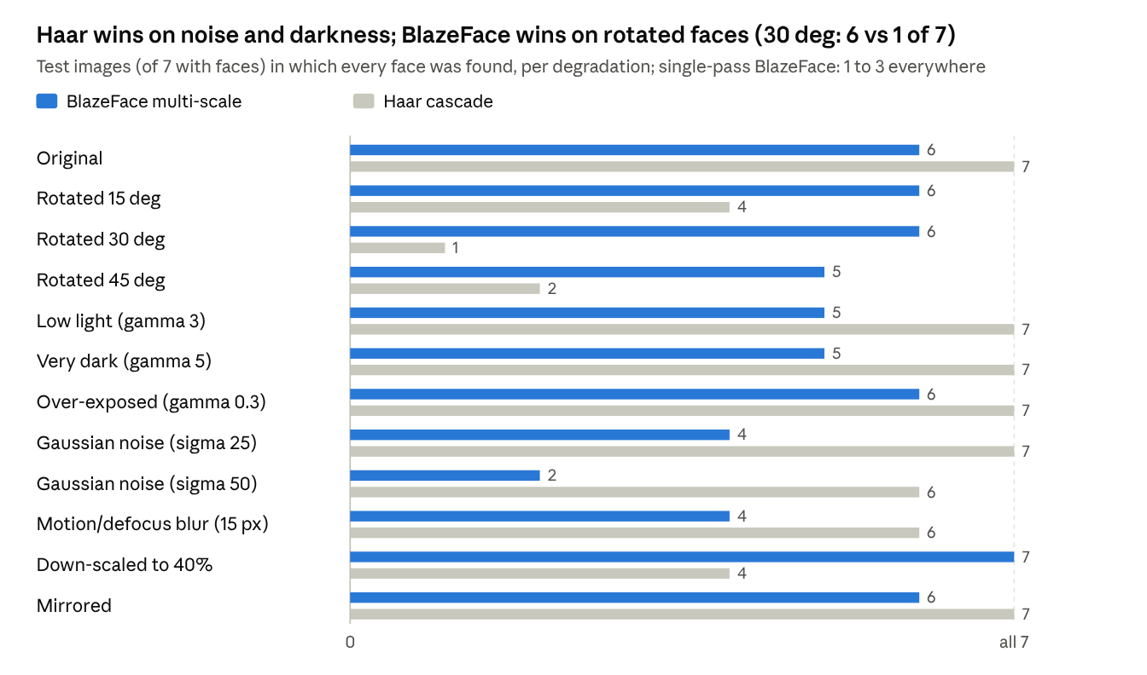
Figure 2 · robustness_by_condition.csv · 7 face images × 12 conditions, from benchmark.py
At 30° rotation, Haar found every face in only 1 of 7 images, because its features are trained on upright faces. BlazeFace stayed at 5–6 of 7 up to 45° and handled 40% downscaling perfectly. Haar was stronger under heavy noise (σ = 50) and darkness, where BlazeFace's confidence fell below the threshold. Single-pass BlazeFace (not drawn) succeeded on 1–3 of 7 images in every condition. Across the 84 trials, tiling produced 13 extra boxes, mostly low-confidence (0.63–0.77) hits on noisy textures; Haar produced 7 and a single pass 0. A sidebar slider raises the tile threshold to trade recall for precision.
3.2 Visual results. The AR overlays scale and rotate with the face (Figure 3). On the frontal sample, head pose read yaw −1°, roll +3° and pitch −12°, with EAR 0.32 for open eyes.
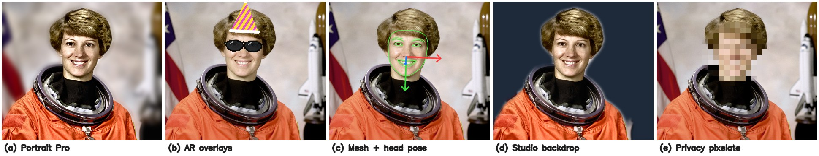
Figure 3: Outputs on the sample portrait: (a) Portrait Pro preset, (b) AR hat and sunglasses, (c) mesh contours with head-pose axes, (d) studio backdrop, (e) privacy pixelation.
3.3 Speed and image quality. On a 512×512 image, segmentation took 13.5 ms, portrait blur with the cached mask 20 ms, AR sunglasses 26 ms, CLAHE 8 ms, skin smoothing 92 ms, cartoon 97 ms and watercolour 296 ms. PSNR and SSIM separate local from global edits: skin smoothing scored 46 dB / 0.998, while background replacement, which rewrites half the frame, scored 9.8 dB / 0.68. Greyscale scores SSIM 1.000 because SSIM is computed on luminance, so these metrics measure change, not quality.
3.4 Limitations. Tiling still missed 4 of 7 small, dark faces (Addams Family) and adds false boxes on noisy images. Hair edges soften in segmentation, pitch shows a bias of about −12°, and 8 test images give indicative results only.

4. Conclusion
Classical operations (point transforms, bilateral and Gaussian filtering, alpha compositing, CLAHE, the FFT) combined with three compact deep-learning models make a real-time camera studio on a laptop CPU. Haar stays competitive on frontal faces, but BlazeFace is far more robust to rotation and about 30× faster per pass, and tiling largely fixes its weakness on small faces. Future work: a full-range detector, temporal smoothing of live landmarks, hair matting and a large labelled test set.
Team contributions. Anmol (20231129): enhancement filters, the seven-stage pipeline, presets and quality metrics. Vansh Gupta (20233303): multi-scale detection, face mesh, head pose and blink detection, and the Haar benchmark. Shreyash Kumar Dube (20233567): segmentation and backgrounds, AR overlays, beauty and privacy filters. Sparsh Singh (20233277): IPCV Lab, live camera, batch mode, user interface, testing and this report.
References
- P. Viola and M. Jones, "Rapid object detection using a boosted cascade of simple features," CVPR, 2001.
- V. Bazarevsky et al., "BlazeFace: Sub-millisecond neural face detection on mobile GPUs," arXiv:1907.05047, 2019.
- Y. Kartynnik et al., "Real-time facial surface geometry from monocular video on mobile GPUs," arXiv:1907.06724, 2019.
- Z. Wang et al., "Image quality assessment: From error visibility to structural similarity," IEEE Trans. Image Processing, 13(4), 2004.
- T. Soukupová and J. Čech, "Real-time eye blink detection using facial landmarks," CVWW, 2016.
- R. C. Gonzalez and R. E. Woods, Digital Image Processing, 4th ed., Pearson, 2018.
- Google, MediaPipe Solutions guide (Face Detector, Face Landmarker, Image Segmenter), developers.google.com/edge/mediapipe.

