PROJECT FOR WEB SCRAPING

**Web Scraping of Apple Macbook From Flipkart**

**Institute Name:- ITvedant Education Pvt.Ltd**

**Name:- Shreyash Narendra Sakpal**

**Email Address:- shreyashsakpal19@gmail.com**

**Date Of Submission:-03 Dec 2023**

AIM OF THE PROJECT

The aim of this project is to create a Python Web scraping to extract specific details of the Apple Macbook from flipkart .

Using BeautifulSoup and Requests libraries, the objective is to gather essential information such as product names, prices, customer reviews, ratings, and comments associated with the Apple Macbook listings



Description:-

Web scraping of Flipkart products involves programmatically extracting information about various products listed on the Flipkart e-commerce platform. This process allows users to gather data such as product names, prices, ratings and reviews available on Flipkart's product pages.

To perform web scraping on Flipkart, you'd typically utilize tools, programming languages, or libraries like Python's Beautiful Soup. These tools can simulate human browsing behavior, sending requests to Flipkart's servers, retrieving the HTML content of product pages, and then parsing the HTML to extract the desired product information.

Project Steps :-

● **URL Retrieval**: You've defined the URL for the Apple Macbook product page on Flipkart. HTTP Request: Using the requests library, you've fetched the HTML content from the URL.

● **Parsing HTML:** Utilizing BeautifulSoup, you've parsed the HTML content to navigate and extract specific elements.

● **Data Extraction**: Extracted data includes product prices, customer names,comments, reviews, ratings, filtering.

● **Data Manipulation**: You've stored extracted data into lists and a pandas DataFrame.

● **Data Export**: Exported the DataFrame containing the extracted data to a

CSV file.

Project Benefits:-

Market Analysis and Pricing Strategy: Extracting product details, pricing information, discounts, and stock availability helps in analyzing market trends, understanding competitor pricing strategies, and adjusting your own pricing strategy accordingly.

Competitor Monitoring: Regularly scraping Flipkart's product listings allows for tracking competitors' product ranges, availability, and pricing changes. This information helps in identifying gaps in the market or potential niches to explore.

Product Research and Development: Scraping Flipkart can provide insights into customer reviews, ratings, and feedback on products. This data aids in understanding customer preferences, identifying popular features, and guiding product development decisions.

Sales and Marketing Insights: Extracting data on product descriptions, specifications, and customer reviews can guide marketing campaigns, content creation, and SEO strategies by understanding what features or aspects customers value the most.

Price Comparison and Adjustment: Scraping Flipkart allows for comparing prices of similar products across different vendors. This enables businesses to adjust their pricing strategies to stay competitive in the market.

Consumer Behavior Analysis: Analyzing data from Flipkart's product reviews and ratings can provide valuable insights into consumer behavior, preferences, and sentiments toward certain products or brands.

Personalized Customer Experience: Insights gained from scraping Flipkart can be used to tailor product offerings, customer service, and shopping experiences to meet specific customer needs and preferences.

**Output Format:**

The scraped data is stored in a structured format, such as CSV or JSON, for easy

integration with downstream processes.

**Analysis of project:**

Based on our analysis we conclude that this project has most sales in the Macbook in Flipkart as this product has no negative review and has average of 4.8

**Apple Macbook Web Scraping from Flipkart Code command:**

1. **Access Flipkart web site by using import requests URL and BeautifulSoup library.**

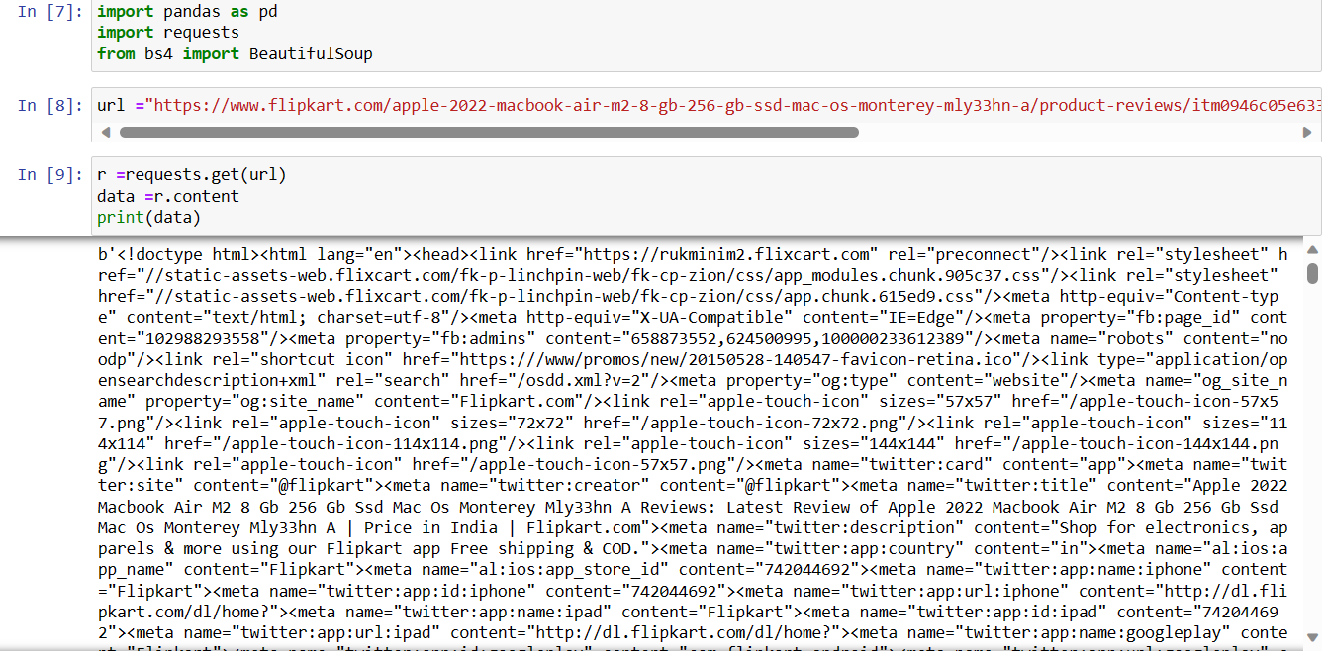

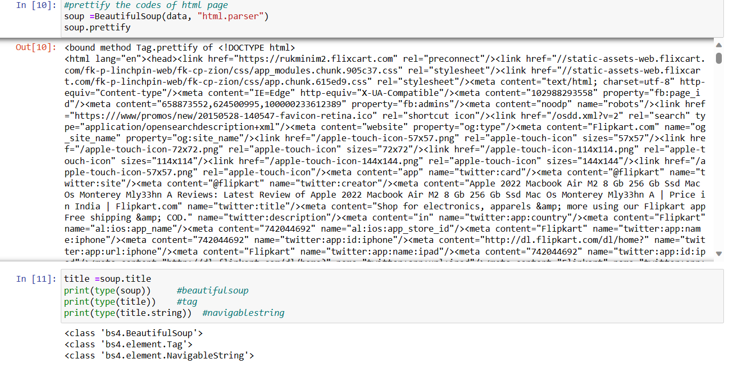

1. **To access Apple Macbook price by using this class.**

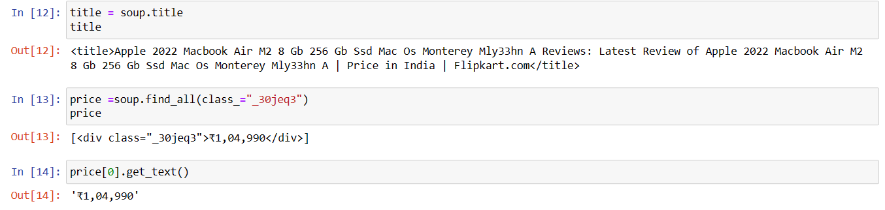

1. **To access Apple Macbook Customer Name by using the respective class from its HTML content.**

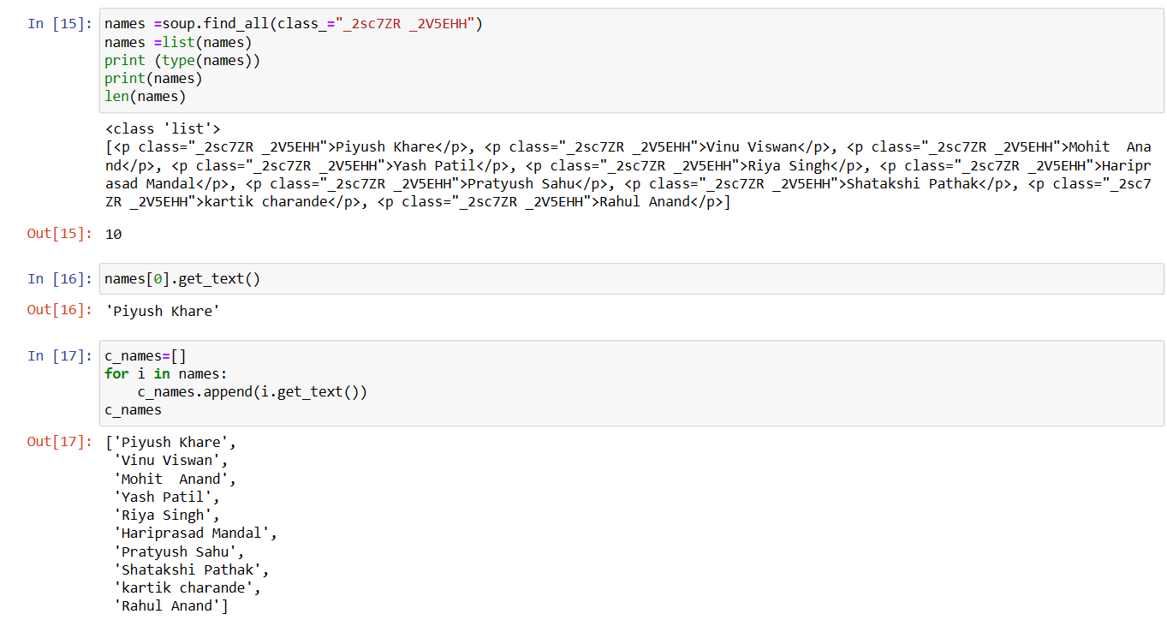

1. **To access Apple Macbook Customer Comment by using the respective class.**

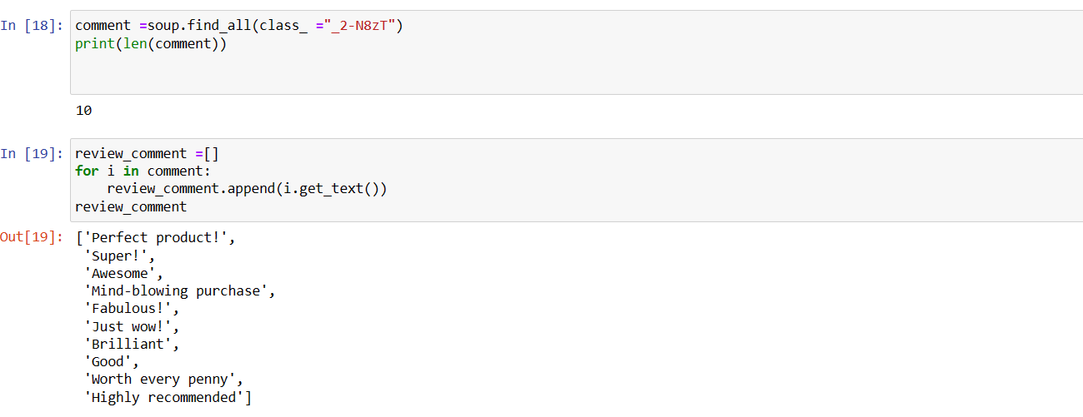

**(5)To access Apple Macbook Customer Review star by using the respective class.**

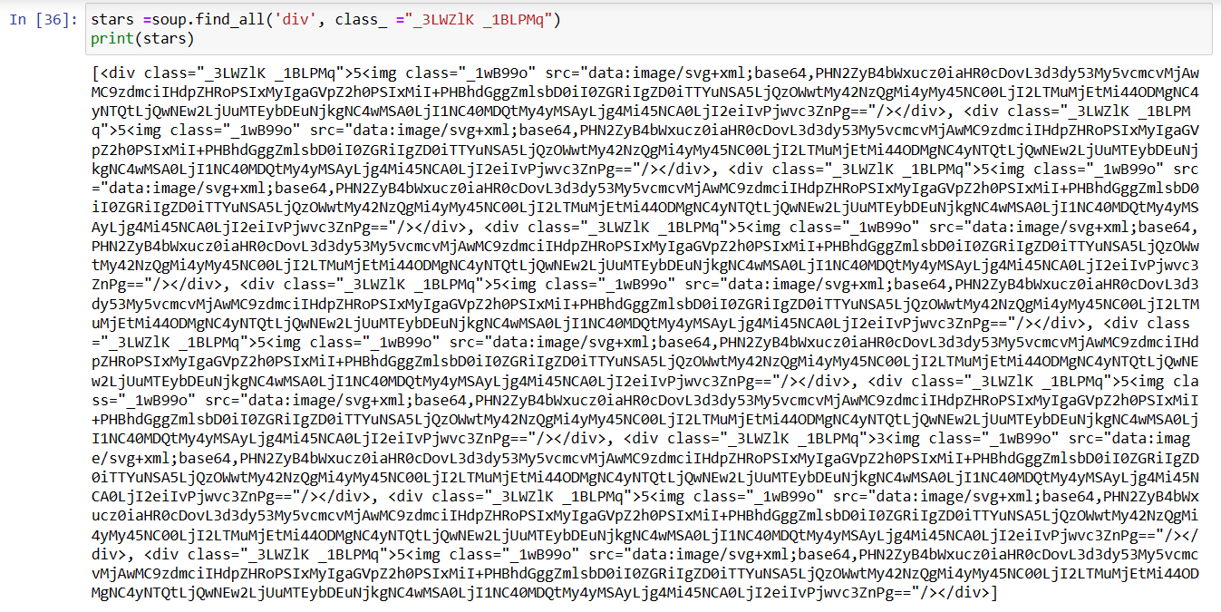

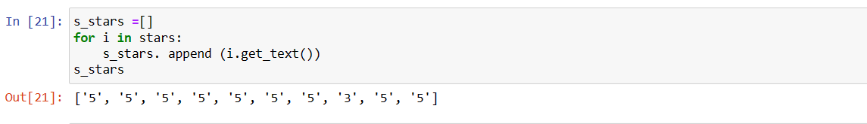

**(6)To access Apple Macbook Customer Comment by using the respective class.**

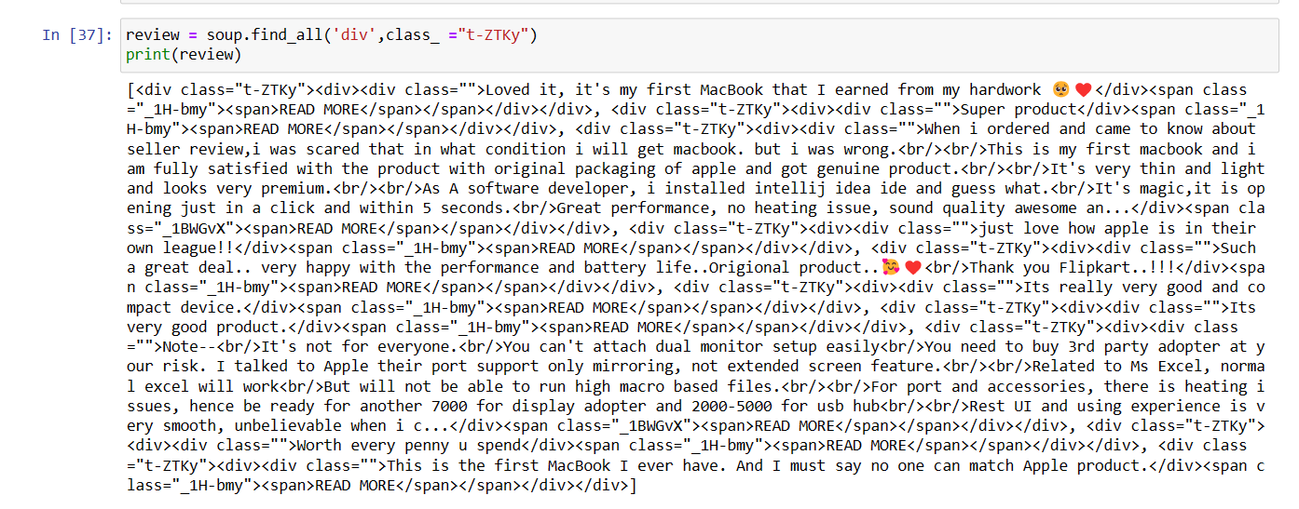

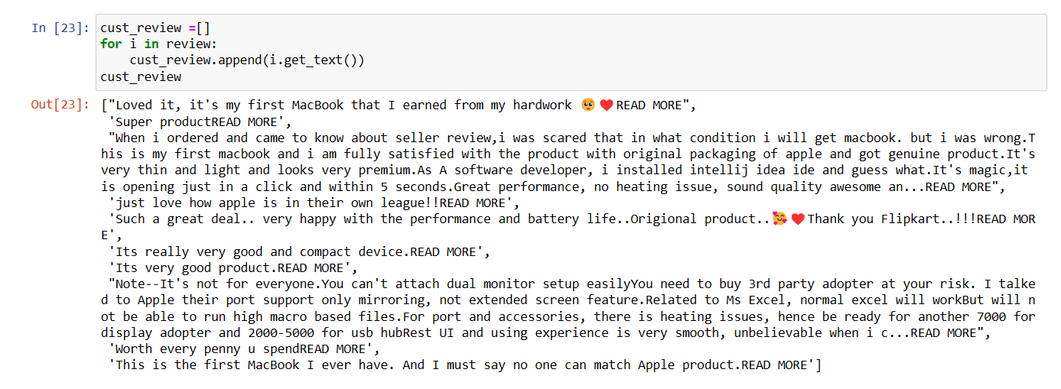

**(7) To arrange properly in column all above data by using -Pandas library**

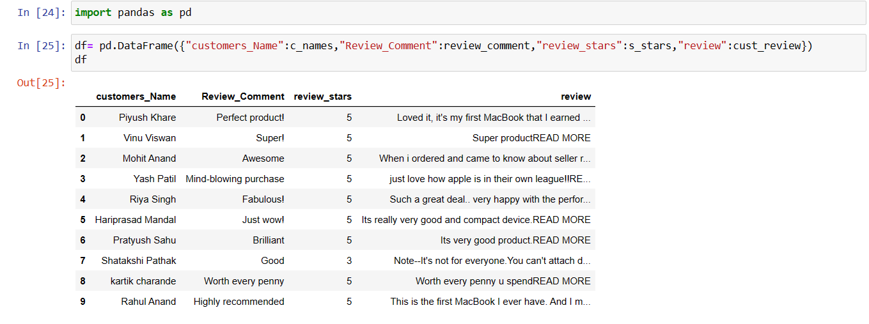

**(8) To see quick overview of the central tendency, spread, and distribution of the data in the DataFrame.**

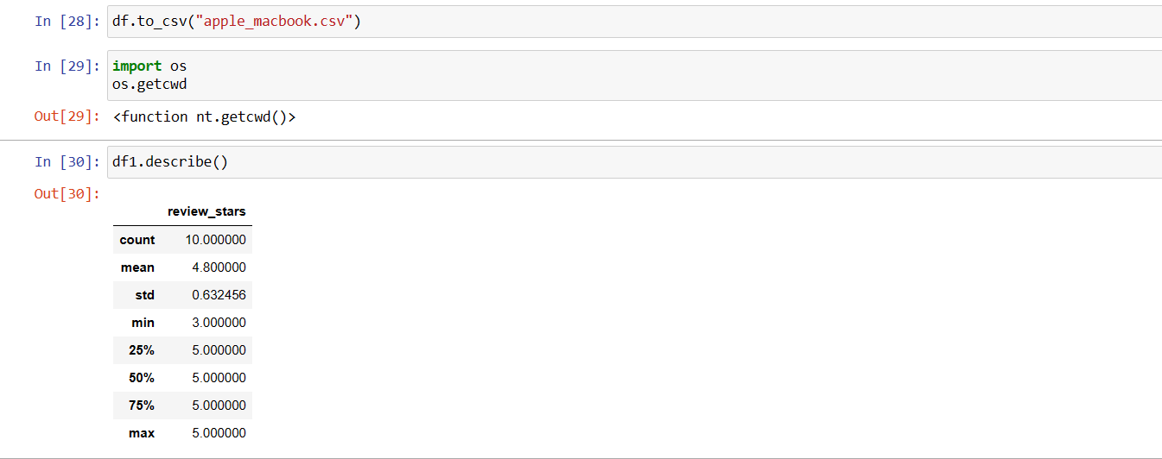

**This summary can help in identifying outliers, understanding the range of values, and getting a general sense of the data distribution for further analysis**

**(9) Then store above all data in CSV file and again open this file in application.**

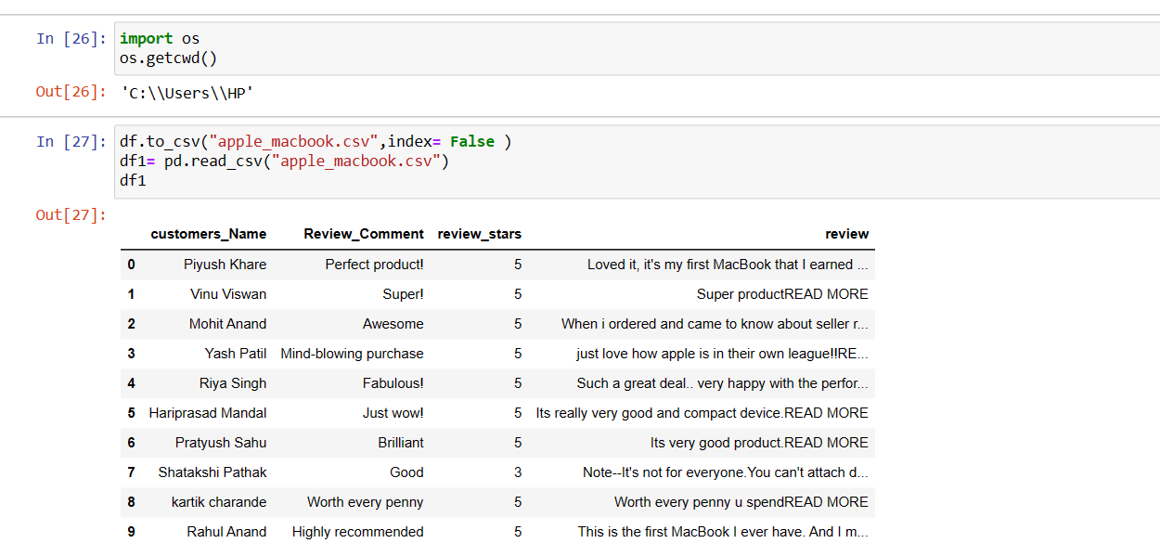

**(10) Find max,mean,min etc**

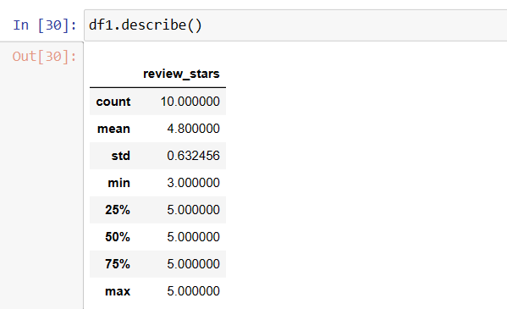

**(11) Find INFO of data**

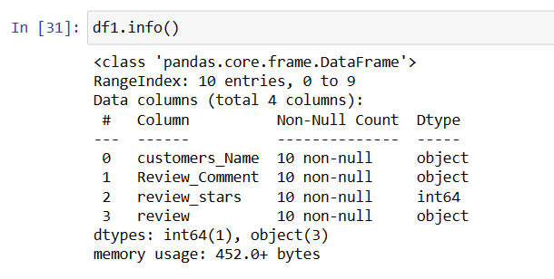

**(13) sort the name of Customer in Ascending order**

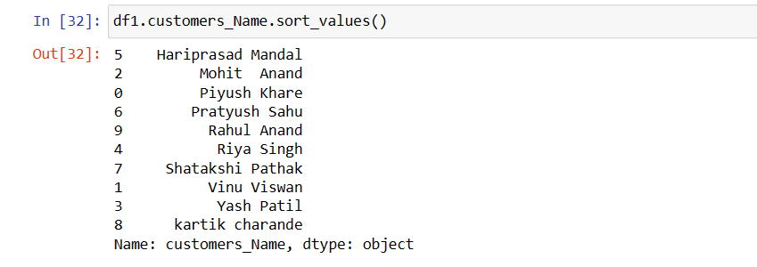

**(14) Sort the Names of Customer in Descending order**

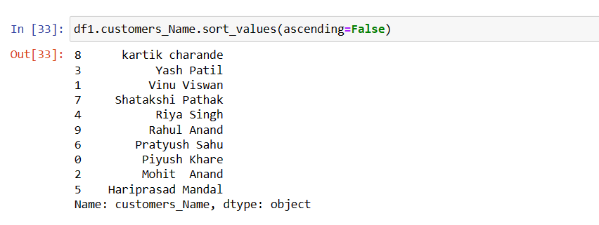

**(15) Find who had given full rating**

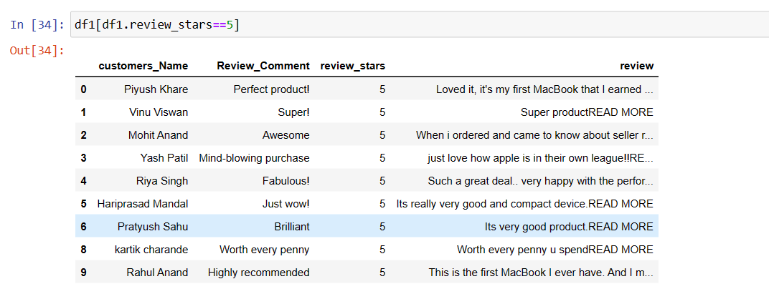

**(16) Find who gave less than 5 rating**

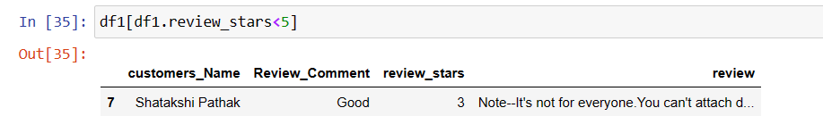

CONCLUSION

The web scraping process for the **Apple Macbook** Flipkart product page was

successful, The extracted data can be used for further analysis and revealed

customer sentiments, and product popularity metrics. Regular monitoring and

maintenance are recommended to adapt to any changes in the website

structure.