Effect of Spreading Factor on DSSS Performance under Narrowband Jamming
1.Gauri Changdev Khalkar 2. Shravani Vasant Gavate 3. Shreyasi Walmik Pawar
Department of Electronics and Telecommunication of Engineering
MVPS's KBT College of Engineering Nashik, Maharashtra, India
gaurikhalkar4@gmail.com
shravanigavate612@gmail.com
pawarshreyasi13@gmail.com

Abstract. Direct-sequence spread spectrum (DSSS) is used in wireless communication to reduce the effect of interference. This paper studies how the spreading factor affects the bit error rate (BER) of a BPSK-DSSS system when a narrowband jammer is present. A Python-based Monte Carlo simulation is used with spreading factors of 7, 15 and 31 chips per bit. The system is first tested with AWGN only and then tested with a single-tone jammer at different jammer-to-signal ratios (J/S). Without jamming, all three spreading factors show almost the same BER, which agrees with the expected BPSK performance. Under jamming, the larger spreading factors give lower BER. At J/S = 5 dB, the BER decreases from 8.99×10−2 for L = 7 to 6.82×10−3 for L = 31. The results show that increasing the spreading factor improves resistance to the tested narrowband jammer, although the benefit becomes smaller when the jammer becomes very strong. The conclusions are limited to the simulated single-tone jamming condition.
Keywords: Direct-Sequence Spread Spectrum, Processing Gain, Narrowband Jamming, BPSK, Bit Error Rate, Monte Carlo Simulation.

1 Introduction
Wireless communication systems often operate in the presence of unwanted interference. In some cases, the interference can be strong enough to increase the error rate and affect communication quality. Direct-sequence spread spectrum (DSSS) is one technique used to make a communication link more resistant to interference [1], [2]. In DSSS, each data bit is multiplied by a faster pseudo-noise (PN) sequence. This spreads the signal over a wider bandwidth. At the receiver, the same PN sequence is used to despread the signal and recover the original data.
An important part of DSSS is the spreading factor, which is the number of chips used for one data bit. A higher spreading factor gives a higher processing gain and can improve the rejection of narrowband interference. However, it also increases the required bandwidth. The improvement is mainly useful against interference; it does not give the same benefit when the system is affected only by thermal noise.
This study focuses on a simple BPSK-DSSS system with spreading factors L = 7, 15 and 31. The system is simulated in Python under AWGN and a single-tone narrowband jammer. The main aim is to see how the BER changes as the spreading factor and jammer-to-signal ratio are changed. The study uses simulation results rather than proposing a new anti-jamming technique.

2 Related Work
DSSS performance under interference has been studied in many earlier works. Pickholtz et al. [1] provide a basic treatment of spread-spectrum communication, while Proakis and Salehi [2] discuss DSSS performance under different types of interference. More recent studies have examined single-tone and multi-tone jamming, different spreading codes, and jammer-suppression methods.
Gharkan et al. [3] studied DSSS under single-tone jamming (STJ) and multi-tone jamming (MTJ) using MATLAB-Simulink. They compared error performance for different Eb/N0 and J/S values and reported that increasing the processing gain can reduce the effect of jamming. In another study, Gharkan et al. [4] compared Gold and Walsh codes and found differences in their performance under jamming.
Ranjith and Muniraj [5] studied jammer suppression using independent component analysis (ICA). Their approach is more complex than the simple correlation receiver used in this paper. Navas et al. [6] also studied the use of spreading sequences for improving resistance to insider jamming in IoT networks.
Wang and Zhou [7] examined the use of processing gain for anti-jamming performance in underwater acoustic DSSS systems. Wang et al. [8] further studied single-frequency interference with short PN sequences and showed that jammer frequency and phase can affect the receiver output. These studies support the use of random jammer frequency and phase in the present simulation.

2.1 Research Gap and Study Scope
The previous studies cover analytical methods, different code families and more advanced jammer-suppression techniques. For this work, a smaller and easier-to-reproduce experiment is considered. The study focuses on one BPSK-DSSS model, three spreading factors, AWGN and one single-tone jammer. The aim is to clearly show the practical effect of spreading factor on BER. No new anti-jamming algorithm is proposed.

3 DSSS System Model
The basic DSSS system used in the simulation is shown in Fig. 1. A random binary sequence is first converted to BPSK symbols. Each symbol is then multiplied by a PN sequence of length L, so one data bit is represented by L chips.
x[kL+m] = bₖ c[m], m = 0, 1, …, L−1 (1)
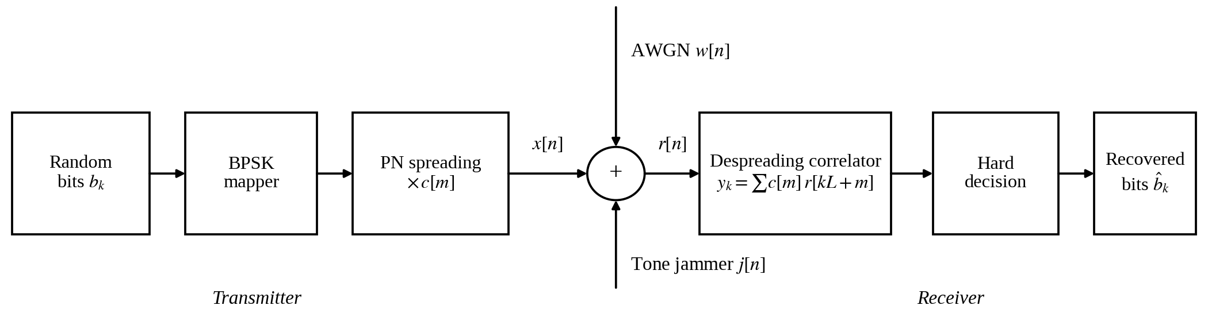
Fig. 1. Block diagram of the simulated BPSK-DSSS link. The summing node adds AWGN and the single-tone jammer to the DSSS chips.
The chip duration is shorter than the bit duration, so spreading increases the signal bandwidth. The spreading factor is also used as the processing gain. For the three values used in this study, the corresponding processing gains are 8.45 dB, 11.76 dB and 14.91 dB.
Gₚ = L, Gₚ(dB) = 10 log₁₀(L) (2)
At the receiver, the incoming signal is multiplied by the same PN sequence and summed over one bit period. The wanted signal adds together, while an uncorrelated narrowband jammer is reduced by the despreading process. Therefore, a larger L generally gives better protection against the jammer used in this study, at the cost of increased bandwidth.

4 Methodology

4.1 Modulation and Spreading
The data bits are generated with equal probability and mapped to +1 and −1 for BPSK. Maximal-length PN sequences (m-sequences) are used for L = 7, 15 and 31. The corresponding primitive polynomials are x³ + x² + 1, x⁴ + x³ + 1 and x⁵ + x³ + 1. One complete PN sequence is used for each bit and repeated for the next bits. The simulation uses one real sample per chip and assumes ideal chip and bit synchronisation.

4.2 Jamming Model
The jammer is modelled as a single unmodulated sinusoidal tone added to the received DSSS signal:
r[n] = x[n] + w[n] + j[n] (3)
j[n] = A cos(2πfⱼn + φ) (4)
Here, J/S represents the jammer power relative to the signal power at the receiver input. For every 100-bit frame, the jammer frequency and phase are selected randomly. This makes the reported BER an average over different jammer conditions instead of a result for only one fixed tone.

4.3 Noise Model and BER
AWGN is added to the received signal to represent normal channel noise. The receiver uses the same PN sequence for despreading and then makes a hard decision based on the sign of the correlation output. In simple form, the receiver operation can be written as:
yₖ = Σ c[m] r[kL+m], b̂ₖ = sign(yₖ) (5)
y_{k} = Σ_{m=0…L−1} c[m] r[kL+m] = L b_{k} + n_{k} + i_{k}, b̂_{k} = sgn(y_{k}) (6)
The BER is calculated by comparing the transmitted bits with the detected bits. For the no-jamming case, the three spreading factors are expected to give similar BER because the spreading factor mainly helps against interference rather than AWGN. The main comparison in this paper is therefore the change in BER when the jammer power is increased.
For the jammed case, the simulation directly measures the BER and the jammer effect at the receiver. A detailed theoretical BER expression is not used as a main part of the study because the jammer is a single tone and its effect depends on frequency and phase. The simulation results are therefore used as the main evidence.

4.4 Simulation Parameters
Table 1. Simulation parameters.
Item | Setting
Modulation / receiver | BPSK; correlation (despreading) receiver; hard decision on sgn(y_{k})
Spreading code | m-sequences, one period per bit; L = 7, 15, 31 chips/bit
Processing gain G_{p} | 8.45 dB, 11.76 dB, 14.91 dB
Signal model | Chip-rate baseband; one sample per chip; ideal synchronisation
Noise | AWGN
Jammer | Single tone; random frequency and phase; changed every 100-bit frame
Experiment 1 | Eb/N0 = 0 to 12 dB; no jammer; up to 200 errors or 2×10⁷ bits
Experiment 2 | Eb/N0 = 8 dB; J/S = −5, 0, 5, 10, 15 dB; 4×10⁶ bits per point
Software | Python 3 with NumPy; fixed random seed (2026)

Two experiments were carried out. In Experiment 1, BER was measured against Eb/N0 without intentional jamming to check the basic operation of the simulated DSSS link. In Experiment 2, Eb/N0 was fixed at 8 dB and J/S was changed from −5 to 15 dB. Each simulation point used the number of bits given in Table 1. All numerical results reported in this paper were obtained directly from the Python simulation using the fixed random seed 2026.

5 Results and Analysis

5.1 DSSS Performance in AWGN
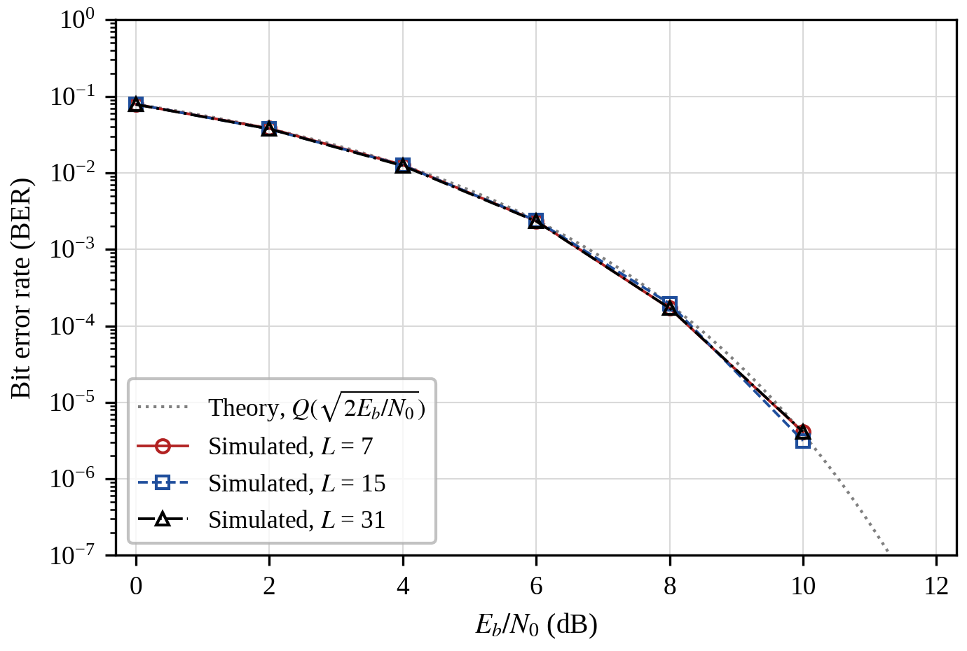
Fig. 2. BER versus E_{b}/N₀ for BPSK-DSSS without intentional jamming, L = 7, 15, 31 (simulation), with the theoretical BPSK curve. Points with fewer than 50 observed errors are not plotted.
Fig. 2 shows the BER of the three DSSS systems when no intentional jammer is present. The three curves are almost the same and follow the expected BPSK trend. This shows that changing L does not provide a major BER improvement in AWGN alone. The result also confirms that the simulation is working as expected before the jammer is added.
The main advantage of a larger spreading factor appears when interference is present. A higher L gives more processing gain, so the narrowband jammer has less effect after despreading. This is why the three curves are almost identical without jamming but separate clearly when the jammer is introduced.

5.2 Effect of J/S and Processing Gain
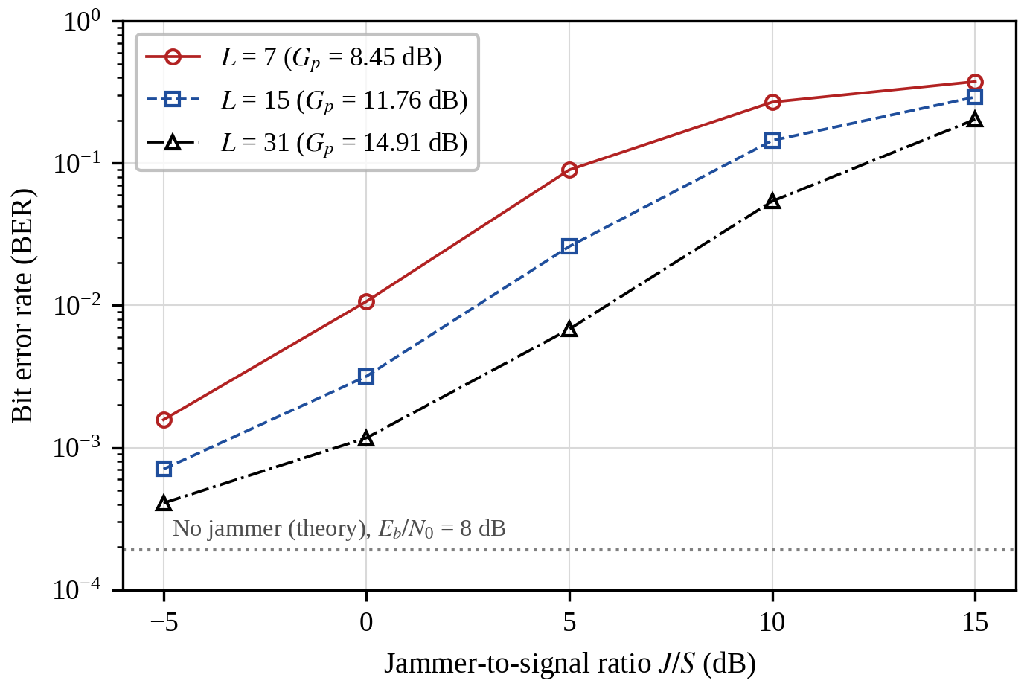
Fig. 3. BER versus J/S under single-tone narrowband jamming at E_{b}/N₀ = 8 dB for L = 7, 15 and 31. Tone frequency and phase are random for each 100-bit frame. The dotted line is the theoretical jammer-free BER.
Fig. 3 shows BER against J/S at Eb/N0 = 8 dB. The BER increases as the jammer becomes stronger for all three spreading factors. However, the system with L = 31 consistently gives the lowest BER, followed by L = 15 and then L = 7. At J/S = 5 dB, the simulated BER is 8.99×10−2 for L = 7, 2.60×10−2 for L = 15 and 6.82×10−3 for L = 31. This clearly shows the benefit of increasing the spreading factor under the tested jammer.
Table 2. Simulated BER at Eb/N0 = 8 dB under different J/S values.
L | G_{p} (dB) | Value | No jammer | J/S = 0 dB | J/S = 5 dB | J/S = 10 dB | J/S = 15 dB
7 | 8.45 | Sim. | 1.94×10⁻⁴ | 1.07×10⁻² | 8.99×10⁻² | 0.269 | 0.375
15 | 11.76 | Sim. | 1.90×10⁻⁴ | 3.18×10⁻³ | 2.60×10⁻² | 0.145 | 0.292
31 | 14.91 | Sim. | 1.99×10⁻⁴ | 1.17×10⁻³ | 6.82×10⁻³ | 5.41×10⁻² | 0.203
The values in Table 2 are specific to this simulation setup and should not be treated as general performance limits for all DSSS systems. The no-jammer results are included as a reference for comparison.
At J/S = 0 dB, the BER decreases from 1.07×10−2 for L = 7 to 1.17×10−3 for L = 31. At J/S = 5 dB, the improvement is even clearer, with the BER dropping from 8.99×10−2 to 6.82×10−3. As the jammer becomes very strong, the difference between the spreading factors becomes smaller because the interference starts to dominate the receiver output. At J/S = 15 dB, all three systems have BER above 0.2.
The results also show that the useful improvement is not the same at every jammer level. The larger spreading factor gives the best improvement in the middle range of J/S tested here. This is consistent with the basic idea of processing gain: increasing L makes the system more resistant to a narrowband jammer, but it cannot completely remove the effect of a very strong jammer.

5.3 Discussion
The results can be understood without using a detailed BER derivation. When the jammer is weak, normal AWGN has a larger effect, so the three systems behave similarly. As the jammer becomes stronger, the benefit of higher spreading becomes more visible. For the present simulation, a BER close to 10−2 is reached at about 0 dB J/S for L = 7 and about 6 dB for L = 31. This improvement comes at the cost of higher bandwidth.
In practical terms, the L = 31 system can tolerate a stronger narrowband jammer than the L = 7 system under the same simulated conditions. The improvement is useful, but it is not free: a larger spreading factor needs more bandwidth. Therefore, the choice of L depends on how much interference protection is required and how much bandwidth is available.

5.4 Comparison with Earlier Studies
The overall trend agrees with earlier studies [3], [7], [8], which report that increasing processing gain can improve DSSS resistance to interference. The present work is different in scope because it uses a simple BPSK-DSSS model and focuses only on the effect of spreading factor. The numerical values should not be directly compared with the cited papers because their codes, channel models and jammer conditions are different.

6 Limitations
The simulation uses a simplified chip-rate model with rectangular chips. Carrier effects, pulse shaping, timing recovery, fading and multipath are not included. Perfect synchronisation and knowledge of the PN code are assumed. Only m-sequences of lengths 7, 15 and 31 are tested. The jammer is limited to a single tone with random frequency and phase, so the results do not cover wideband, pulsed, multi-tone or code-aware jammers. Only AWGN is considered and no channel coding is used. The study is simulation-based and does not include hardware measurements.

7 Future Scope
The work can be extended by testing multi-tone, partial-band and pulsed jammers. Other spreading codes such as Gold and Walsh codes and longer PN sequences can also be compared. Fading, multipath and channel coding can be added to make the model more realistic. A simple notch or narrowband interference filter could also be tested before the correlator. Finally, the simulation can be implemented on software-defined radio hardware for practical verification.

8 Conclusion
A BPSK-DSSS system with spreading factors of 7, 15 and 31 was studied using Python simulation. Without intentional jamming, all three systems showed nearly the same BER. When a single-tone narrowband jammer was added, the larger spreading factors gave lower BER at all tested J/S values. At J/S = 5 dB, BER decreased from 8.99×10−2 for L = 7 to 6.82×10−3 for L = 31. The improvement became smaller at very high jammer power, where all systems were strongly affected. Overall, the simulation shows that increasing the spreading factor improves resistance to the tested narrowband jammer, while also requiring more bandwidth. These conclusions apply only to the simulation conditions used in this study.

References
[1] R. L. Pickholtz, D. L. Schilling, and L. B. Milstein, “Theory of spread-spectrum communications—A tutorial,” IEEE Trans. Commun., vol. COM-30, no. 5, pp. 855–884, May 1982.
[2] J. G. Proakis and M. Salehi, Digital Communications, 5th ed. New York, NY, USA: McGraw-Hill, 2008.
[3] S. K. Gharkan, A. A. Noori, and S. L. Mohammed, “Performance of direct sequence spread spectrum system (DSSSS) in presence of single and multi tone jamming,” Eng. Technol. J., vol. 31, no. 4A, pp. 677–691, 2013, doi: 10.30684/etj.31.4A.6.
[4] S. K. Gharkan, S. L. Mohammed, and A. A. Noori, “Performance comparison of two codes in direct sequence spread spectrum (DSSS) system under the effect of jamming,” J. Eng. Sustain. Dev., vol. 17, no. 5, Nov. 2013.
[5] J. Ranjith and N. J. R. Muniraj, “Jammer suppression in spread spectrum communication using novel independent component analysis approach,” AEU—Int. J. Electron. Commun., vol. 70, no. 8, pp. 998–1005, Aug. 2016, doi: 10.1016/j.aeue.2016.03.016.
[6] R. E. Navas, F. Cuppens, N. Boulahia Cuppens, L. Toutain, and G. Z. Papadopoulos, “Physical resilience to insider attacks in IoT networks: Independent cryptographically secure sequences for DSSS anti-jamming,” Comput. Netw., vol. 187, Art. no. 107751, Mar. 2021, doi: 10.1016/j.comnet.2020.107751.
[7] X. Wang and Q. Zhou, “Analytical technique leveraging processing gain for evaluating the anti-jamming potential of underwater acoustic direct sequence spread spectrum communication systems,” Symmetry, vol. 15, no. 9, Art. no. 1710, 2023, doi: 10.3390/sym15091710.
[8] X. Wang, Y. Wei, and Q. Ma, “Research on anti-single-frequency interference ability of underwater acoustic DSSS communication system with short-period PN sequences,” Appl. Sci., vol. 15, no. 9, Art. no. 5191, May 2025, doi: 10.3390/app15095191.

