Sample Predictions:

1.jpg: 🔮 Predicted - dog

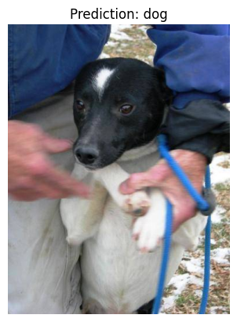

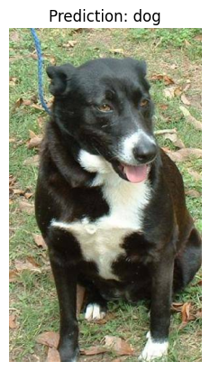

10000.jpg: 🔮 Predicted - dog

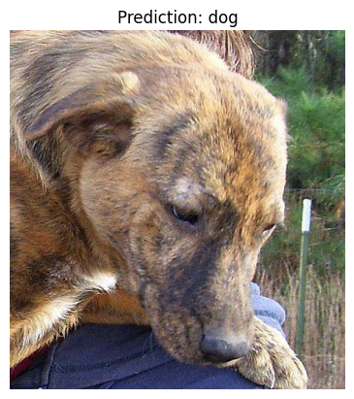

10001.jpg: 🔮 Predicted - cat

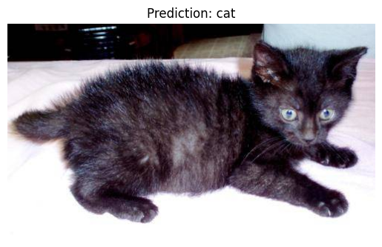

10002.jpg: 🔮 Predicted - cat

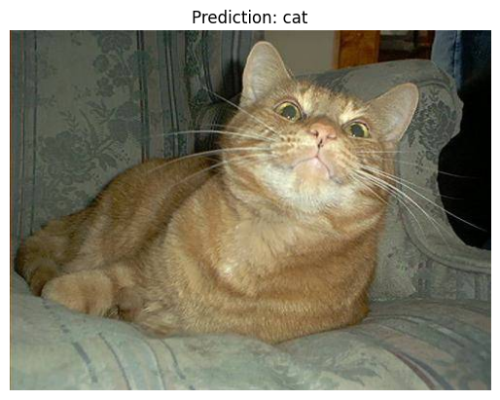

10003.jpg: 🔮 Predicted - dog

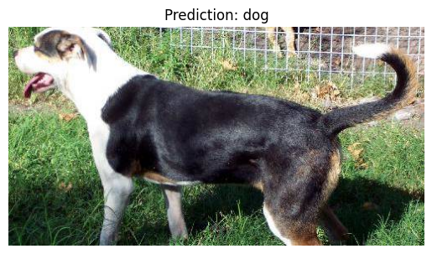

10004.jpg: 🔮 Predicted - cat

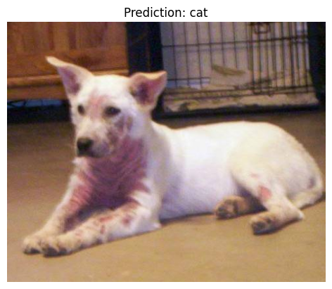

10005.jpg: 🔮 Predicted - cat

