|  |  |
| --- | --- |
| **Ex No: 5**  **Date: 04-092024** | **Image Classification with MobileNetV2** |

**Objective:**

How to use an input image and a pre-trained MobileNetV2 model from TensorFlow Hub for classification of the input image and compare it with the ground truth or check for the accuracy of the model.

**Descriptions:**

In this experiment, we used MobileNetV2 model from TensorFlow Hub to predict an image’s class label. MobileNetV2 is a light deep learning model which is applied to classify images especially on devices with less computational power.  
In this experiment the used image was scaled and later normalized before being inputted in the model for classification. The output from the model which is a vector of logits was then passed through another step to decode it and determine the predicted class label. Last but not the least it determines the accuracy of the prediction based on the predicted label and the actual label.

**Model:**

* **Model Used**: Pre-trained MobileNetV2 from TensorFlow Hub
* **Input Shape**: (224, 224, 3)
* **Frozen Layers**: All layers (model is used without additional training)

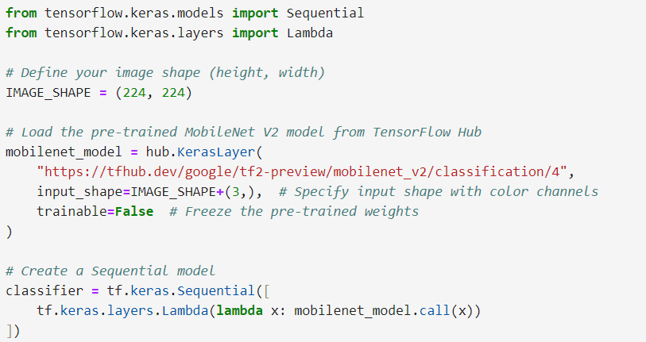

|  |  |
| --- | --- |
| **Ex No: 5**  **Date: 04-092024** | **Custom Flower Classification Using Transfer Learning** |

**Objective:**

To create a custom classifier for flower images using transfer learning, leveraging a pre-trained MobileNetV2 model, and retraining the top layer to recognize specific flower classes from a custom dataset.

**Description:**

In this experiment, we applied transfer learning to classify images of flowers into five distinct categories: sunflower, rose, dahlia, dandelion, and tulip. MobileNetV2 model was used in this work as feature extractor, and then a new dense layer was added to fine-tune the model for this specific classification.  
  
The dataset that was used in this case was the TensorFlow flowers dataset that was used as both the training and testing data. The dataset includes images that can be classified into the previously mentioned flower categories. The MobileNetV2 model which has been pre-trained on ImageNet was fine-tuned on these particular flower classes by retraining only the last layer of the neural network.

**Data Preprocessing**

* Images were resized to (224, 224) pixels.
* Pixel values were normalized to the [0, 1] range.
* The dataset was split into training and testing sets.

**Model**

* **Model Used**: Pre-trained MobileNetV2 from TensorFlow Hub (used as a feature extractor)
* **Input Shape**: (224, 224, 3)
* **Custom Output Layer**: A dense layer with 5 units for classifying the flowers.

The model evaluation results for your custom flower classifier are as follows:

* **Loss:** 0.3853
* **Accuracy:** 86.38%

**GitHub Link:** [**https://github.com/Shreyasinha7/cnn_transfer_learning-.git**](https://github.com/Shreyasinha7/cnn_transfer_learning-.git)