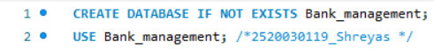

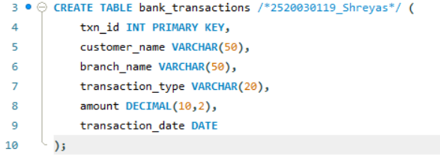
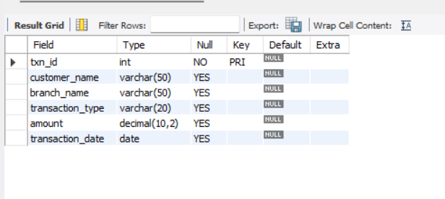

SECTION 2 : DML (DATA MANIPULATION LANGUAGE)

