Stock Prediction Report
Stock Price and Daily Return Graphs:
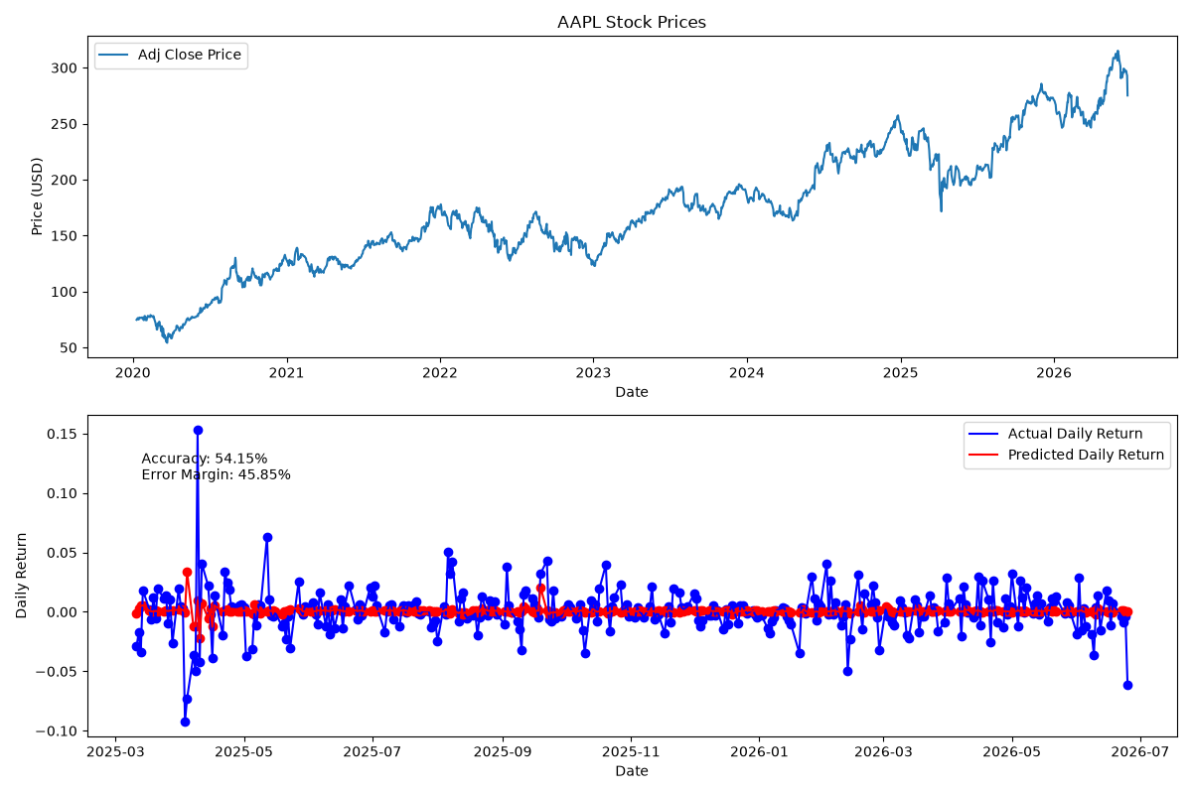
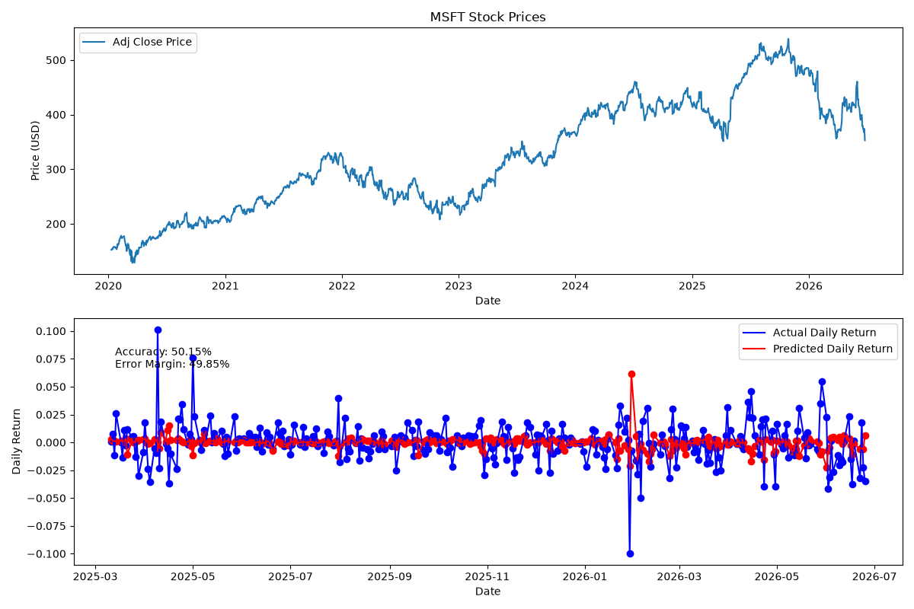
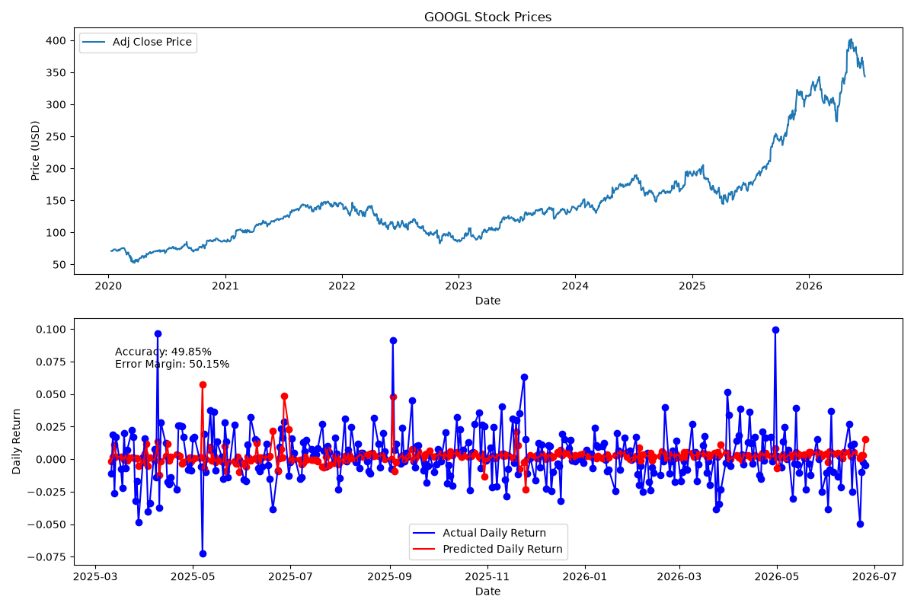
Note: Price ranges are printed with currency names (USD, EUR, INR).
Stock Symbol | MSE | Accuracy | Next Day Range (USD) | Next Day Range (EUR) | Next Day Range (INR)
AAPL | 0.0004 | 54.15% | $258.32 - $282.69 | €240.23 - €262.90 | ₹21181.99 - ₹23180.21
MSFT | 0.0003 | 50.15% | $333.51 - $388.58 | €310.17 - €361.38 | ₹27347.92 - ₹31863.94
GOOGL | 0.0004 | 49.85% | $331.66 - $361.38 | €308.44 - €336.08 | ₹27196.17 - ₹29633.10

