PROGRESSIVE EDUCATION SOCIETY’S
MODERN COLLLEGE OF ARTS, SCIENCE AND COMMERCE,SHINAJINAGAR,PUNE-05


Department of Computer Science
A Project Report on “Online Notice Board”
2024-2025
Under the Guidance of:
Prof. Mr. Kiran Kulkarni

Project By:
- Shreya Nagnath Soma
Enrollment No:2200599

- Swanandi Nitin Shirode
Enrollment No: 2200601

- Pranali Rajendra Nevase
Enrollment No:2200605
ACKNOWLEDGEMENT
I would like to thank Mr. Kiran Kulkarni Sir, our project guide for providing us the opportunity to work on this project, which significantly broadened our knowledge on website development. I thank him for continuously providing the feedback, help and support to complete the project successfully.
In addition, I would like to thank Deshmukh Sir (Head of Computer Science Department) for continuous motivation.
Lastly, I also acknowledge with a deep sense of reverence, my gratitude towards staff and faculty members of Computer Science Department for their valuable suggestions given to us in completing this project.
PROBLEM DEFINITION
In educational institutions, it is crucial for students, teachers, and administrators to stay updated with important notices, announcements, and other communications. However, the process ofdistributing and managing notices often lacks centralization, resulting in missed information, delayed updates, and difficulties in tracking notices.
The problem is to develop an efficient and user-friendly "Online Notice Board" system where:
- Teachers can post notices based on their department, which will go through approval from the Admin.
- Admins have the rights to approve, edit, or delete notices and ensure they are visible to all students.
- Students can view notices based on their department and receive notifications about important updates via email.
- Notices will be color-coded based on their importance and expiration date, and expired notices will be archived.
The goal of the project is to streamline communication within educational institutions by providing a web-based platform for notice management with clear roles and responsibilities for each user type (Admin, Teacher, and Student).

NEED FOR COMPUTERIZATION
- Centralized Access to Information: Traditional methods of notice distribution, such as physical notice boards, are often limited in reach and may not be accessible to everyone at all times. With a computerized system, students, teachers, and administrators can access notices from any location, ensuring everyone stays informed.
- Efficient Notice Management: Manual tracking and management of notices can be time-consuming and prone to errors. A computerized system allows for automated notice posting, approval, and archiving, making the process faster, more reliable, and easier to manage.
- Real-Time Updates: Physical notice boards are often updated infrequently, leading to delays in communicating important information. A computer-based notice board can display real-time updates, allowing for immediate access to the latest information.
- Role-Based Access Control: A computerized system allows for clear role-based access (Admin, Teacher, Student), ensuring that only authorized users can post, edit, approve, or view notices. This helps in preventing unauthorized access and maintaining the integrity of the information.
- Improved Organization and Searchability: Notices can be categorized and archived in a computerized system, allowing for easy search and retrieval of past notices. This reduces the time spent looking for specific notices and ensures that important information is never lost.
SCOPE OF PROPOSED SYSTEM
- User Roles:
  - Students: Students will be able to view approved notices related to their department. They will have limited access, allowing them to only view the notices posted by teachers and approved by admins.
  - Teachers: Teachers will be able to post new notices, which will be sent to the admin for approval. Teachers can only post notices related to their department and have no control over the visibility or editing of the notices.
  - Admins: Admins will have complete control over the system. They can approve, edit, delete, or archive notices. Admins can also manage user roles (teachers and students) and approve the notices posted by teachers.
- Notice Management:
  - Notices will be categorized by department and importance, with the option to color-code notices (e.g., red for urgent notices, different colors for annual notices, etc.).
  - Notices will be linked to their expiration date. Once a notice expires, it will either be archived or deleted based on the admin’s preference.
  - Teachers will submit notices for approval, and only approved notices will be visible to students.

- Department-Specific Notices:
  - Notices will be department-specific. A student will only be able to view notices relevant to their department. Similarly, teachers will only post notices related to their respective departments.
- User Authentication and Authorization:
  - A secure login and registration system will ensure that users can only access functionality appropriate to their roles. Users will be required to register with specific fields depending on their role (student, teacher, or admin).
  - Role-based access will control who can post, approve, edit, or view notices.
- Database Integration:
  - The system will use a PostgreSQL database to store and manage user data, notices, and roles. All data will be securely stored and managed within the database.
The scope of the system ensures that the proposed solution will streamline communication, improve organization, and provide a centralized, efficient way for students, teachers, and administrators to manage notices and updates in educational institutions.

OBJECTIVES OF THE PROPOSED SYSTEM
- Centralized Notice Management
- Role-Based Access Control
- Streamlined Notice Posting and Approval
- Department-Specific Notices
- Expiry and Archiving of Notices
- Secure Authentication and Authorization
- Easy Management of Notices
To design the system with scalability in mind, ensuring it can be expanded in the future to support additional features such as multi-language support, integration with other systems, and advanced analytics.
These objectives aim to address the needs of educational institutions for efficient communication, notice management, and role-based access control, ultimately leading to improved organization and user experience.

FEASIBILITY STUDY
1. Technical Feasibility:
The system is being built using technologies like PHP for the backend, HTML, CSS, and JavaScript for the frontend, and PostgreSQL for the database. This stack is well-established, widely used, and supported by many hosting providers. PHP is known for its ease of use and ability to handle a variety of web-based applications, while PostgreSQL is a powerful, open-source database system that ensures scalability and data integrity.
2. Operational Feasibility:
The user interface of the system is designed to be simple and user-friendly, allowing users (students, teachers, and admins) to interact with the system effortlessly. The role-specific views ensure that each user sees only the relevant information, reducing confusion. The system allows easy management of notices based on roles (admin, teacher, student), ensuring that all users can perform tasks specific to their needs.
3. Economic Feasibility:
Since the project relies on open-source technologies (PHP, PostgreSQL), the overall development cost is minimal and also none, with the main costs being associated with development time and any web hosting services (which can be quite affordable for a small to medium-scale project).
The project does not require significant hardware investments, and it can run on a basic server or hosting plan, reducing infrastructure costs.
Hardware And Software
SOFTWARE:
- Operating System: Ubuntu Linux/Windows
- Frontend: HTML and CSS
- Backend: JAVA,PostgreSQL

HARDWARE:
- Processor: 11th Gen Intel Core i5 with 2.42 GHz speed
- RAM: 4.00 GB
Analysis Specification

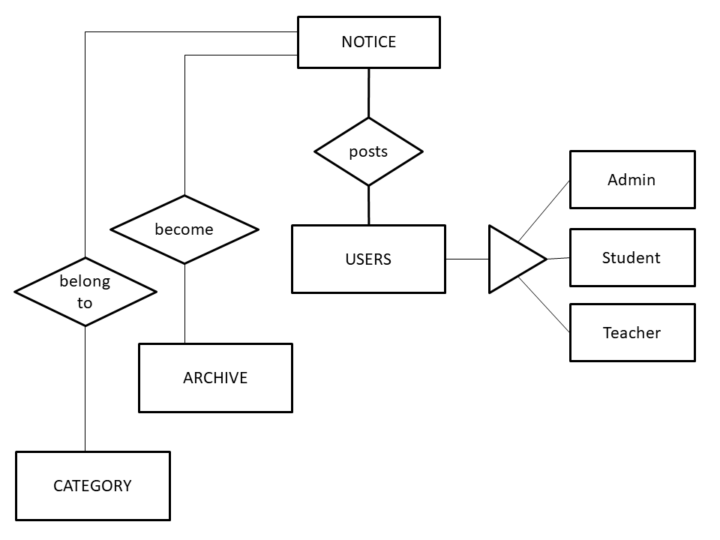
DATA DICTIONARY
USERS TABLE:
Field name | Data type | Constraint | Description
user_id | serial | primary key | user id
name | char | not null | name
email | varchar | not null | email
password | varchar | not null | password
role | char | not null | role of user (student, teacher,admin)

STUDENT TABLE:
Field name | Data type | Constraint | Description
student_id | serial | primary key | student id
user_id | int | foreign key | user id
student_roll_no | int | not null | student roll number
student_class | char | not null | student class
student_department | char | not null | student department
course | char | not null | course

TEACHER TABLE:
Field name | Data type | Constraint | Description
teacher_id | serial | primary key | teacher id
user_id | int | foreign key | user id
teacher_emp_id | int | not null | teacher employee id
teacher_department | char | not null | teacher department
teacher_subject | char | not null | teacher subject

ADMIN TABLE:
Field name | Data type | Constraint | Description
admin_id | serial | primary key | admin id
user_id | int | foreign key | user id
admin_department | char | not null | admin department

NOTICE TABLE:
Field name | Data type | Constraint | Description
notice_id | serial | primary key | notice id
title | char | not null | title
description | text | not null | description
category | char | not null | category
status | char | not null | status (default: pending)
date | timestamp | not null | date
expiry_date | date | not null | expiry date/ archive date
department | char | not null | department
attachment | char | not null | attachment

Design Specification

USE CASE DIAGRAM:

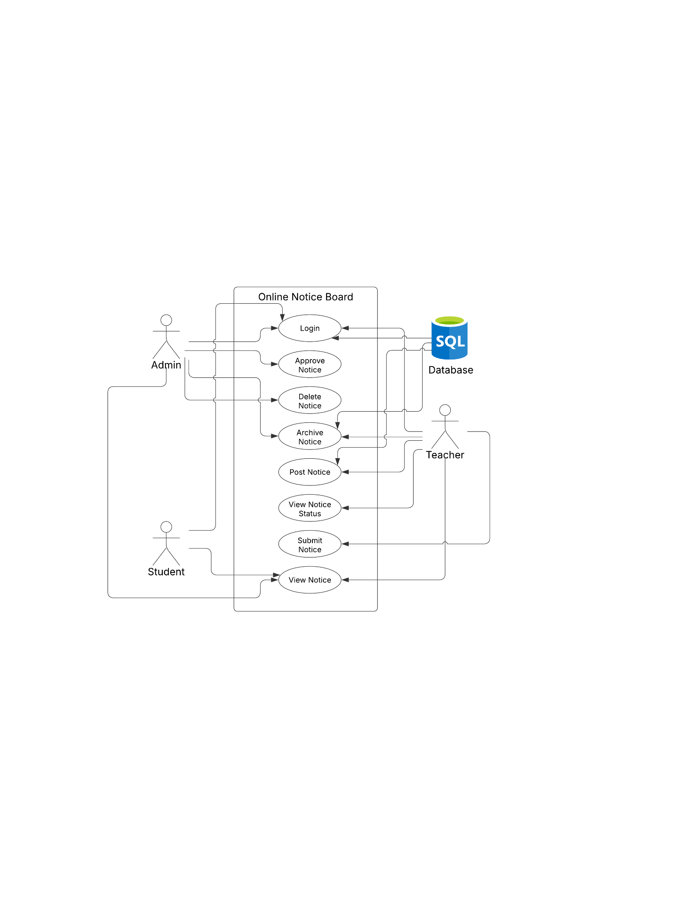

ACTIVITY DIAGRAM:
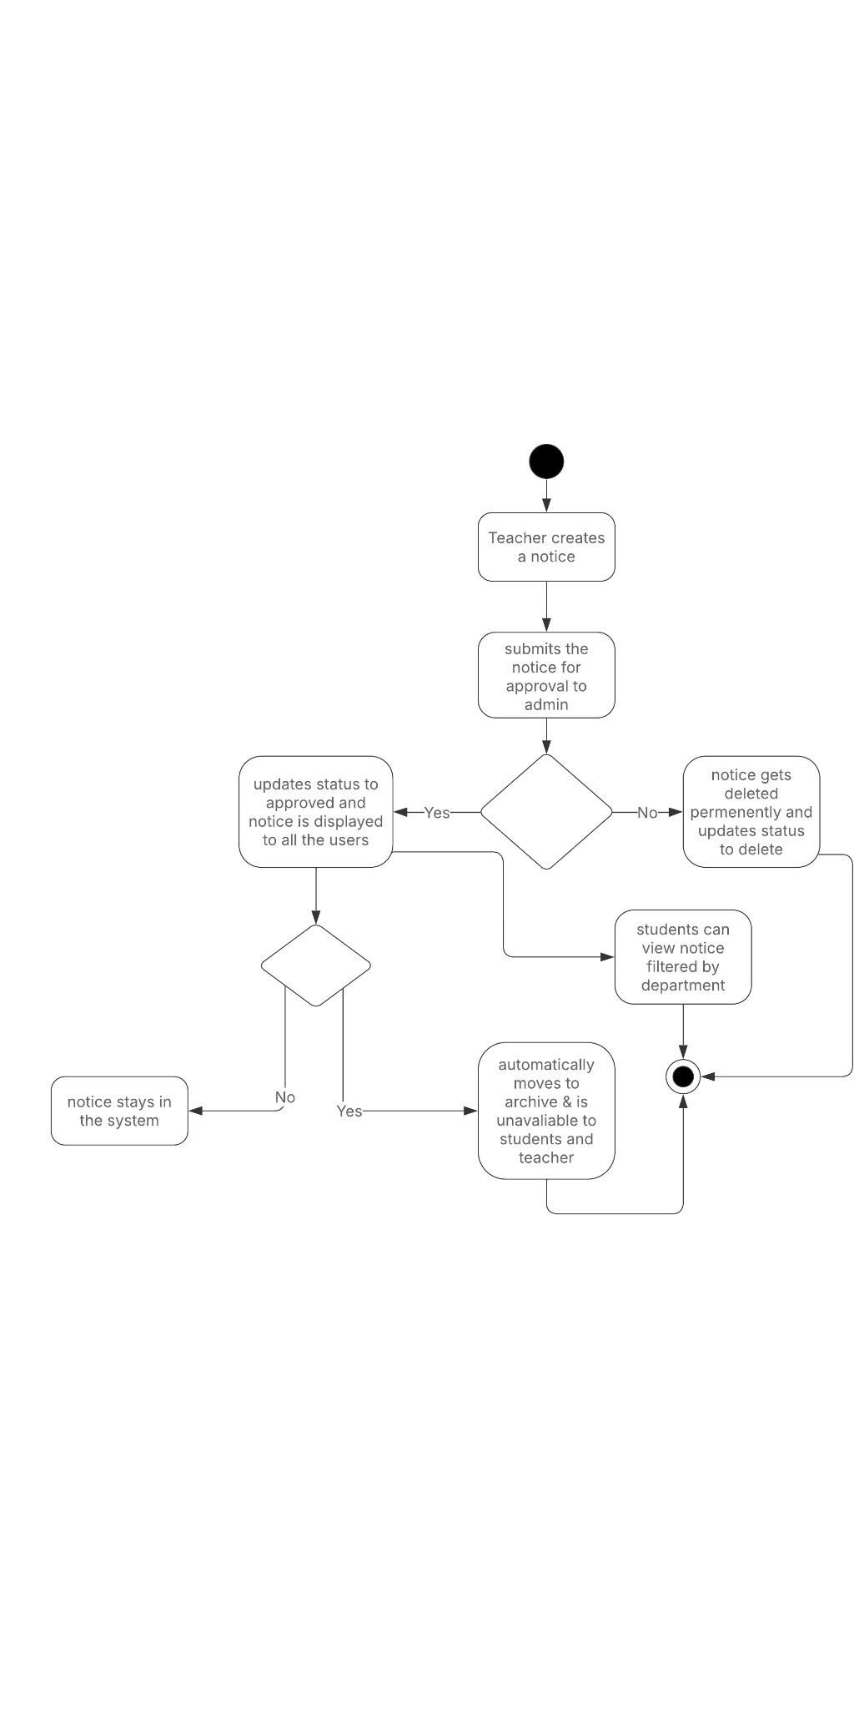
CLASS DIAGRAM:
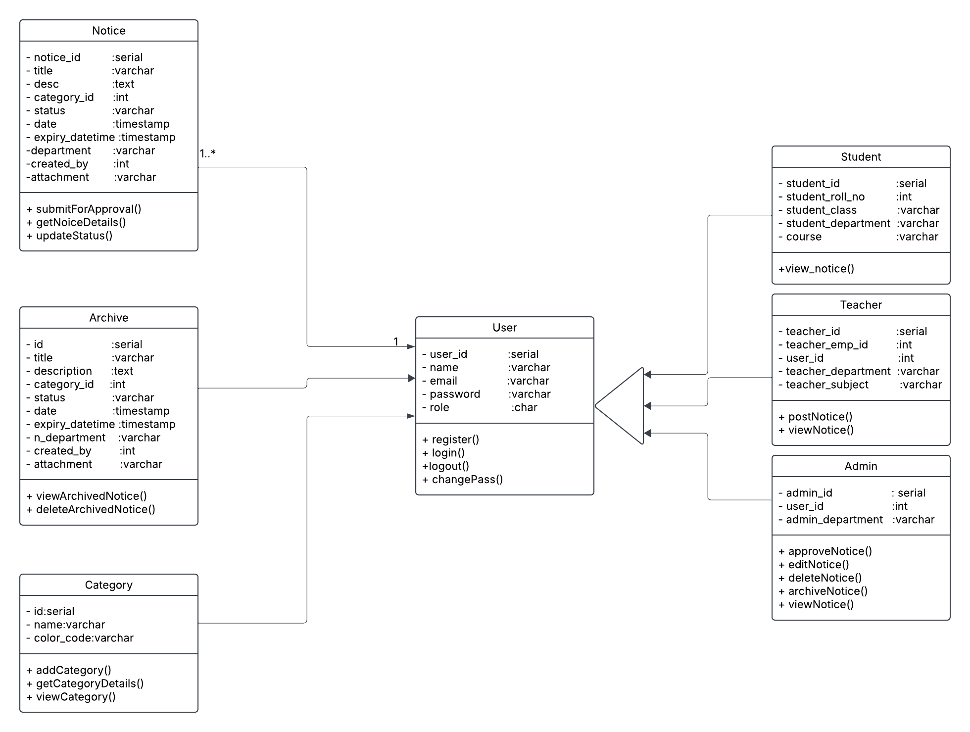
SEQUENCE DIAGRAM:
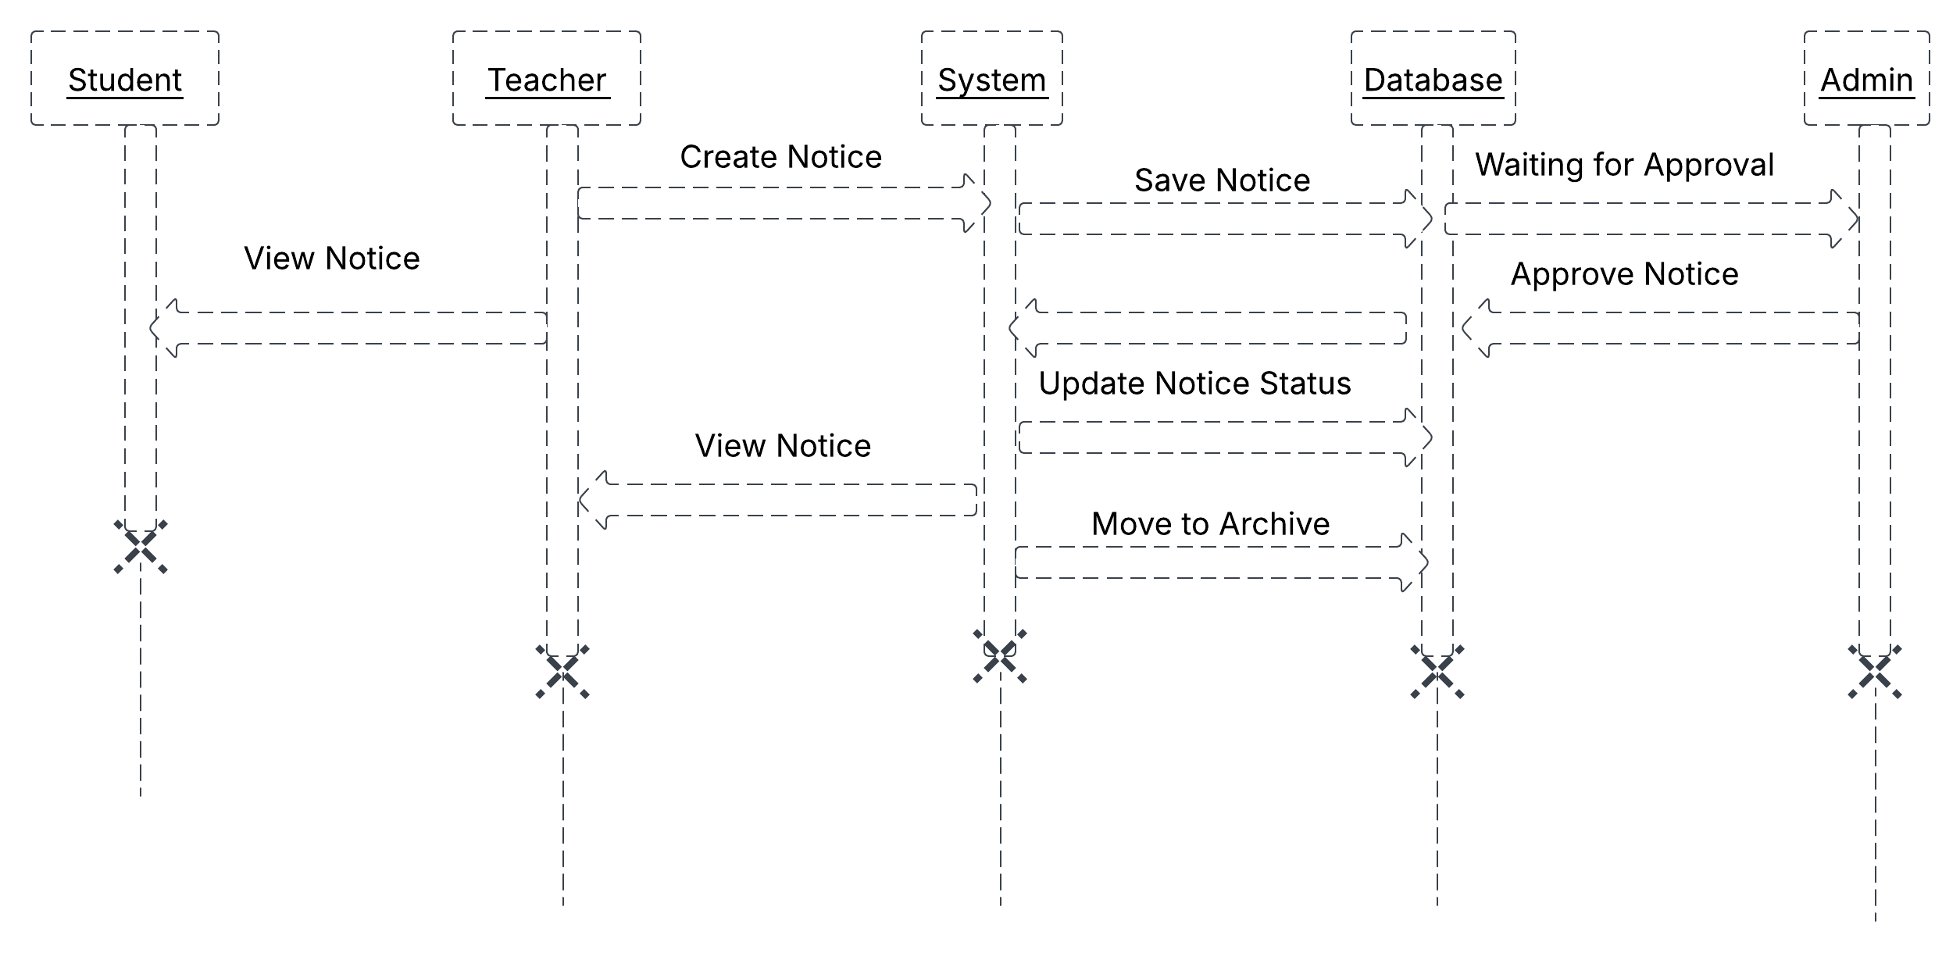
IMPLEMENTATION STRATEGIES
1. System Design and Planning:
- Requirement Analysis: We gathered and analysed detailed requirements from all stakeholders (students, teachers, and admins). This will help to ensure that the system meets the needs of its users.
- Database Design: We planned the structure of the database, including tables for users (students, teachers, admins), notices, and other relevant data. Created an Entity-Relationship Diagram (ERD) to visualize the relationships between the different entities in the system, designed the user interface (UI) for each role (student, teacher, admin).
- Define System Architecture: Based on the requirements, we designed the overall architecture of the system, which includes the backend (PHP), frontend (HTML, CSS, JavaScript), and database (PostgreSQL).
2. Development Phase:
- Backend Development:
  - Setted up server environment of PHP and PostgreSQL
  - Created necessary database schemas and tables
  - Developed backend logic for user registration,login and role management
  - Implemented the functionality for posting, viewing, editing, and archiving notices for teachers and admins.

- Frontend Development:
  - Created HTML forms for user signup, login, notice submission, and notice viewing.
  - Used CSS to ensure the UI is visually appealing and user-friendly.
  - Used JavaScript for client-side validation and to enhance interactivity (e.g., for showing/hiding form fields based on role).
- User Authentication and Authorization:
  - Implemented login functionality that checks user credentials against the database.
  - Set up session management to ensure users are authenticated and authorized to access their respective dashboards.
  - Implemented role-based access control (RBAC) to ensure each user sees only the relevant data and actions.

TESTING STRATEGIES
To ensure the reliability, functionality, and usability of the Travel and Accommodation Management System, a comprehensive testing strategy is essential.
1.Unit Testing:
The unit tests for individual components, such as login authentication, form validation, and database queries, were successfully executed. The system correctly validates user inputs, ensures required fields are filled, and securely handles database interactions. All unit test cases passed, confirming the core functionalities work as expected.
2.Integration Testing:
The integration tests between different modules, such as teacher notice submission and admin approval, were successful. The workflow from login to notice posting and approval functioned smoothly, with proper data flow between the database and frontend. Email notifications and session management were also verified, ensuring seamless user interactions.
3.System Testing:
System testing validated the overall functionality of the application, including user role-based access, notice visibility, and security measures. Each user type (student, teacher, admin) was able to perform their intended actions without errors. The application correctly enforced notice expiry, color coding, and role-specific privileges, confirming a stable and user-friendly system.

4.Black Box Testing:
Black box testing was successfully performed to validate system functionality without looking at the internal code. The system was tested by providing different inputs, checking error handling, and verifying expected outputs. Features such as login, notice submission, approval, and role-based access were thoroughly tested. The system correctly responded to valid and invalid inputs, ensuring a user-friendly experience.

SAMPLE INPUT/OUTPUT SCREENS

HOME PAGE

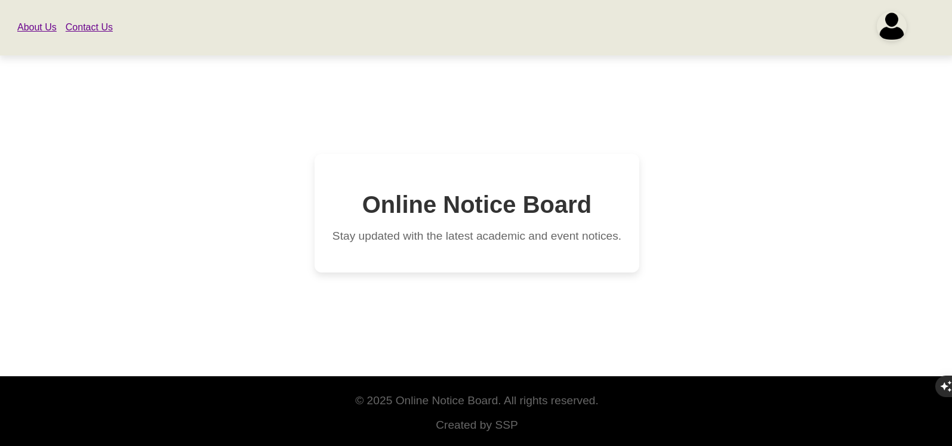

ABOUT US
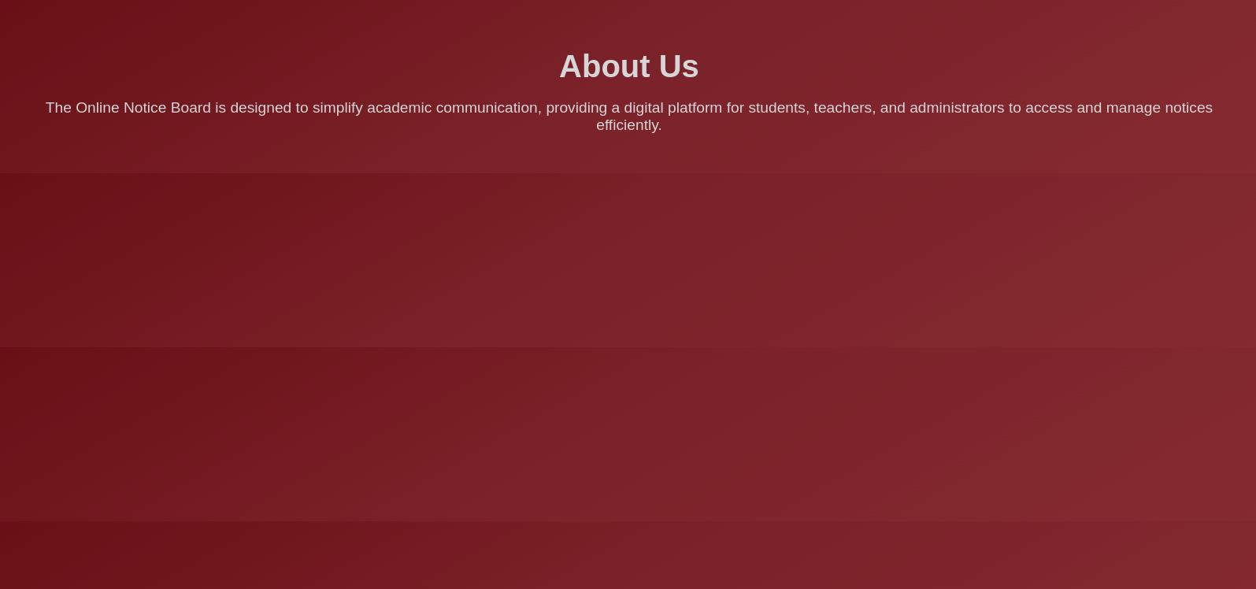
CONTACT US
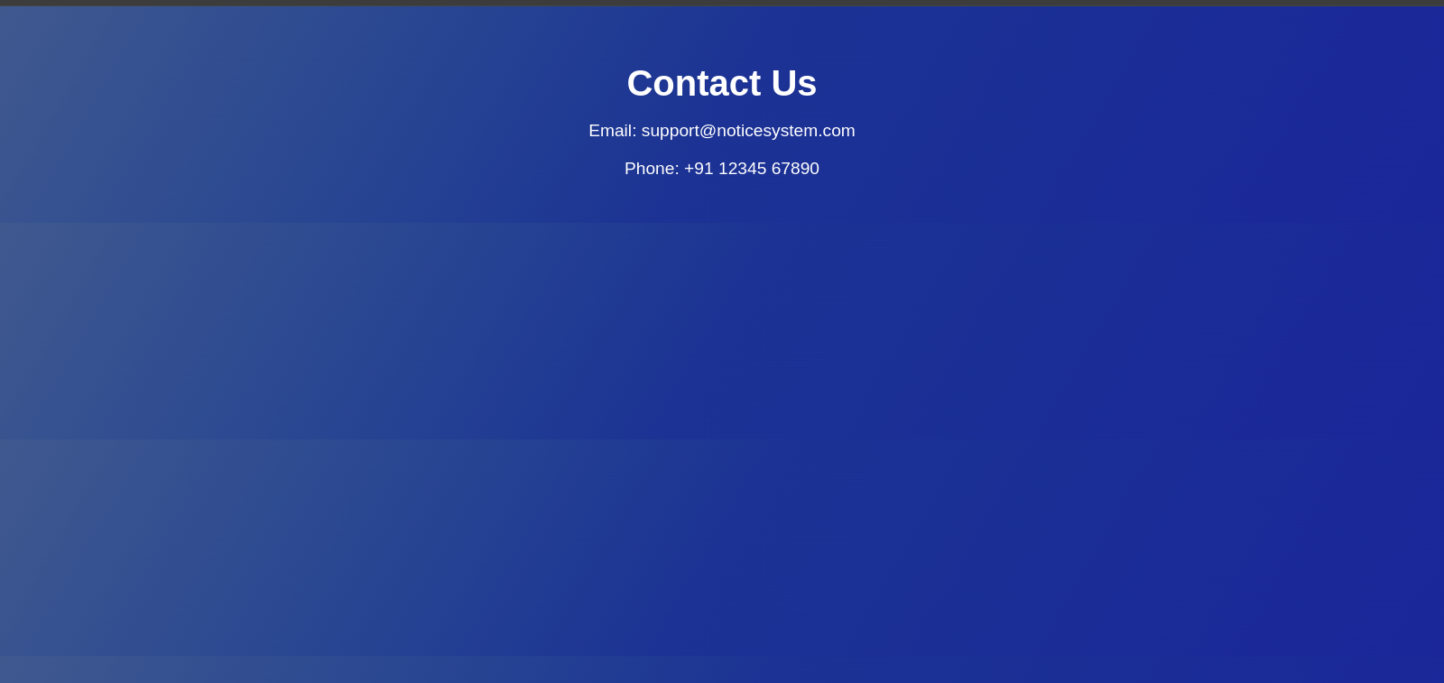

STUDENT LOGIN
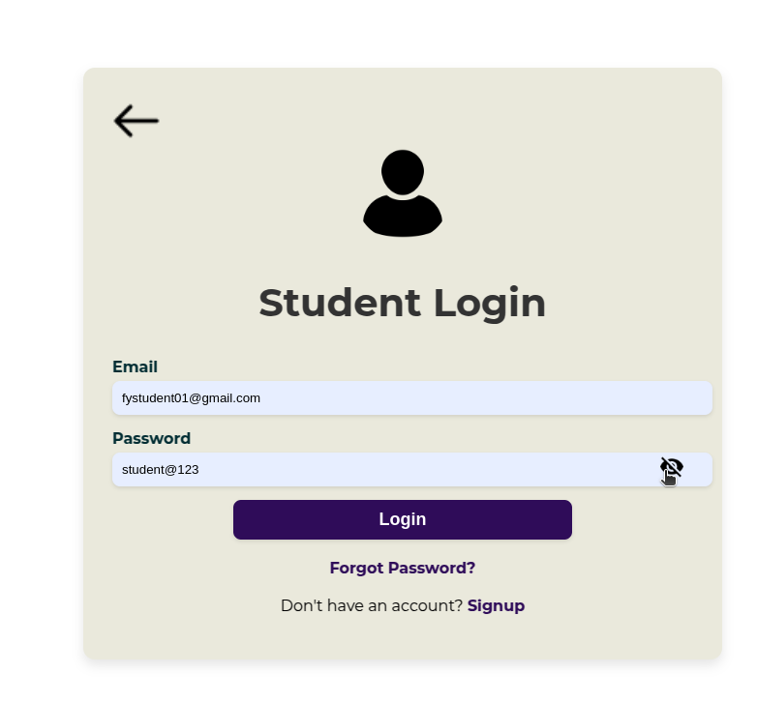

TEACHER LOGIN
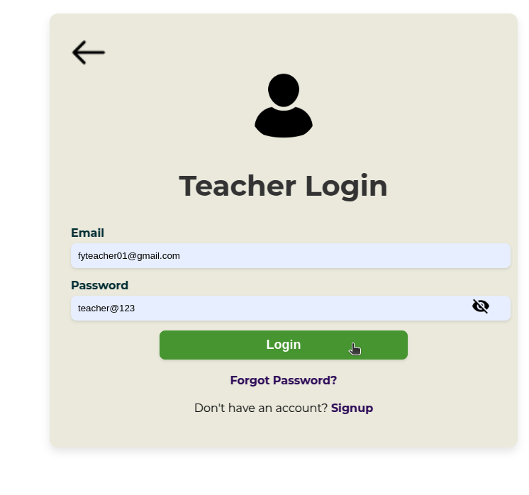

STUDENT DASHBOARD

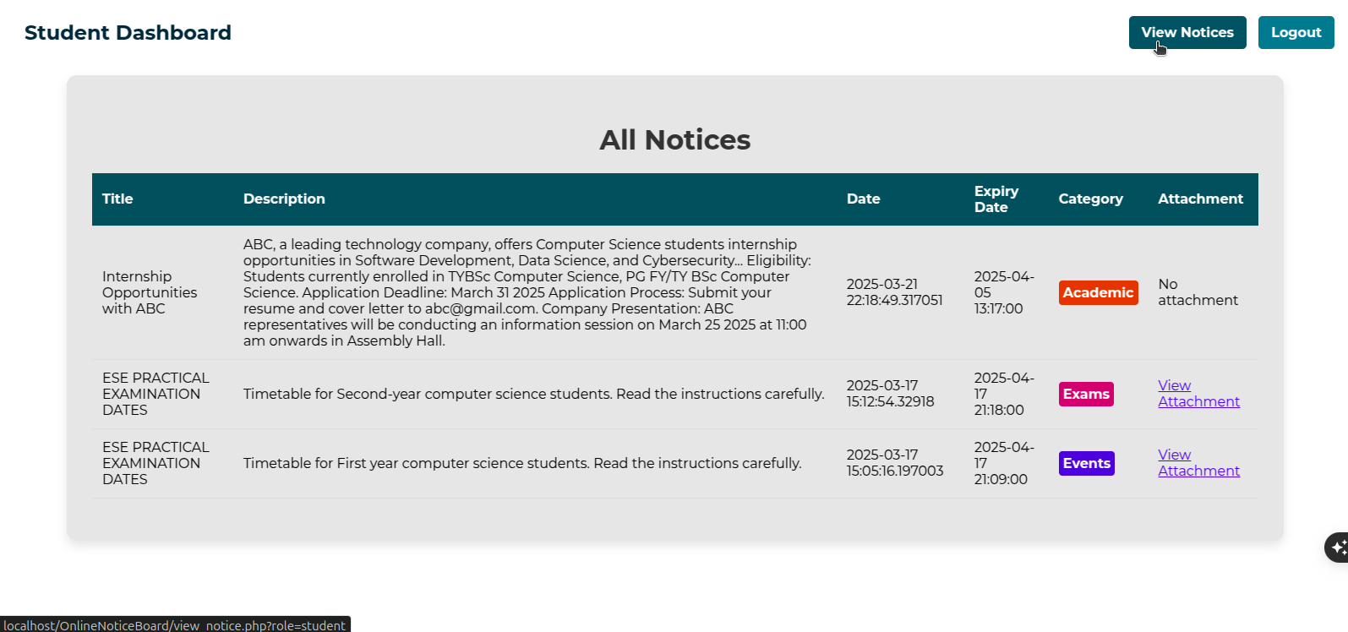

TEACHER DASHBOARD

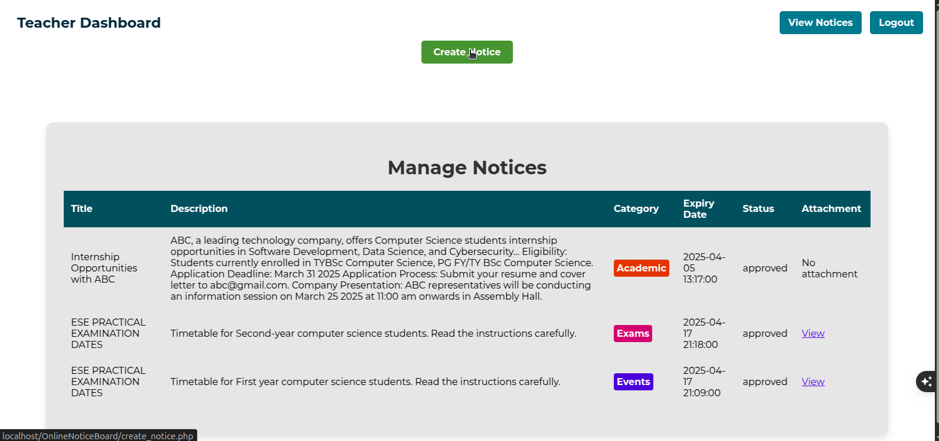

TEACHER DASHBOARD --> CREATE NOTICE

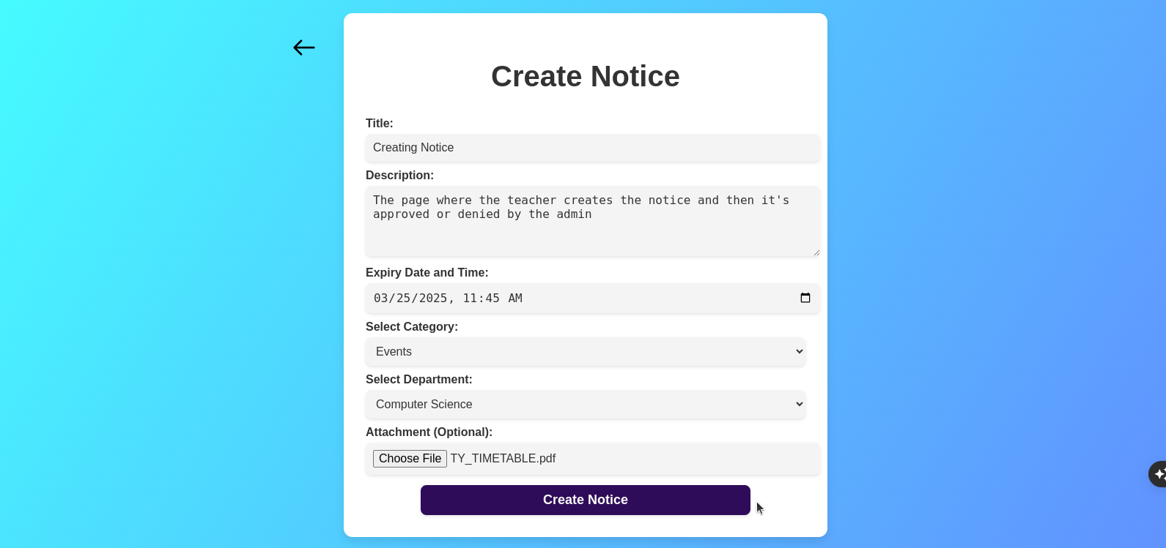

ADMIN LOGIN

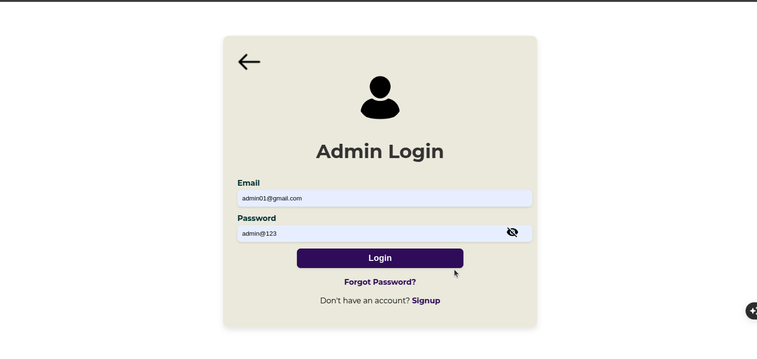

ADMIN DASHBOARD :ACTIVE NOTICE

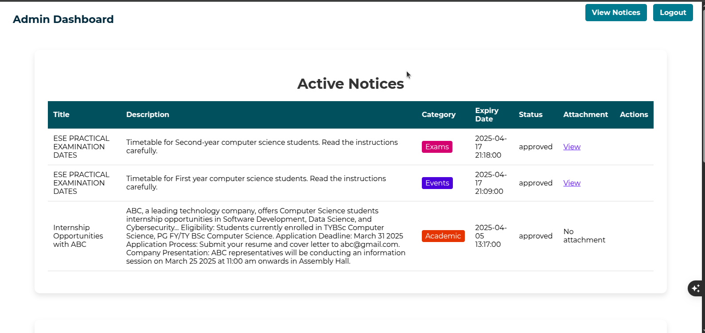

ADMIN DASHBOARD :ARCHIVE NOTICE

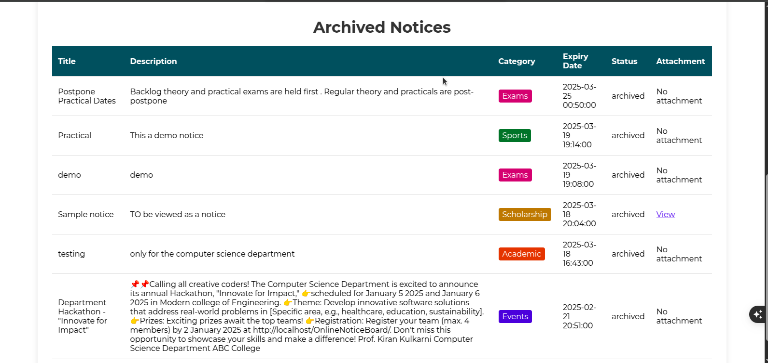

VIEW NOTICE

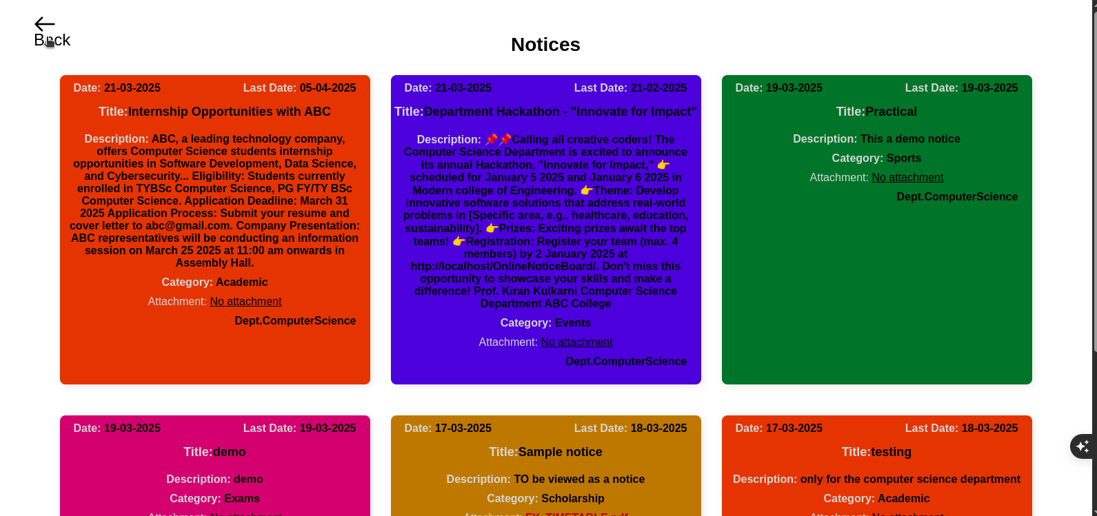

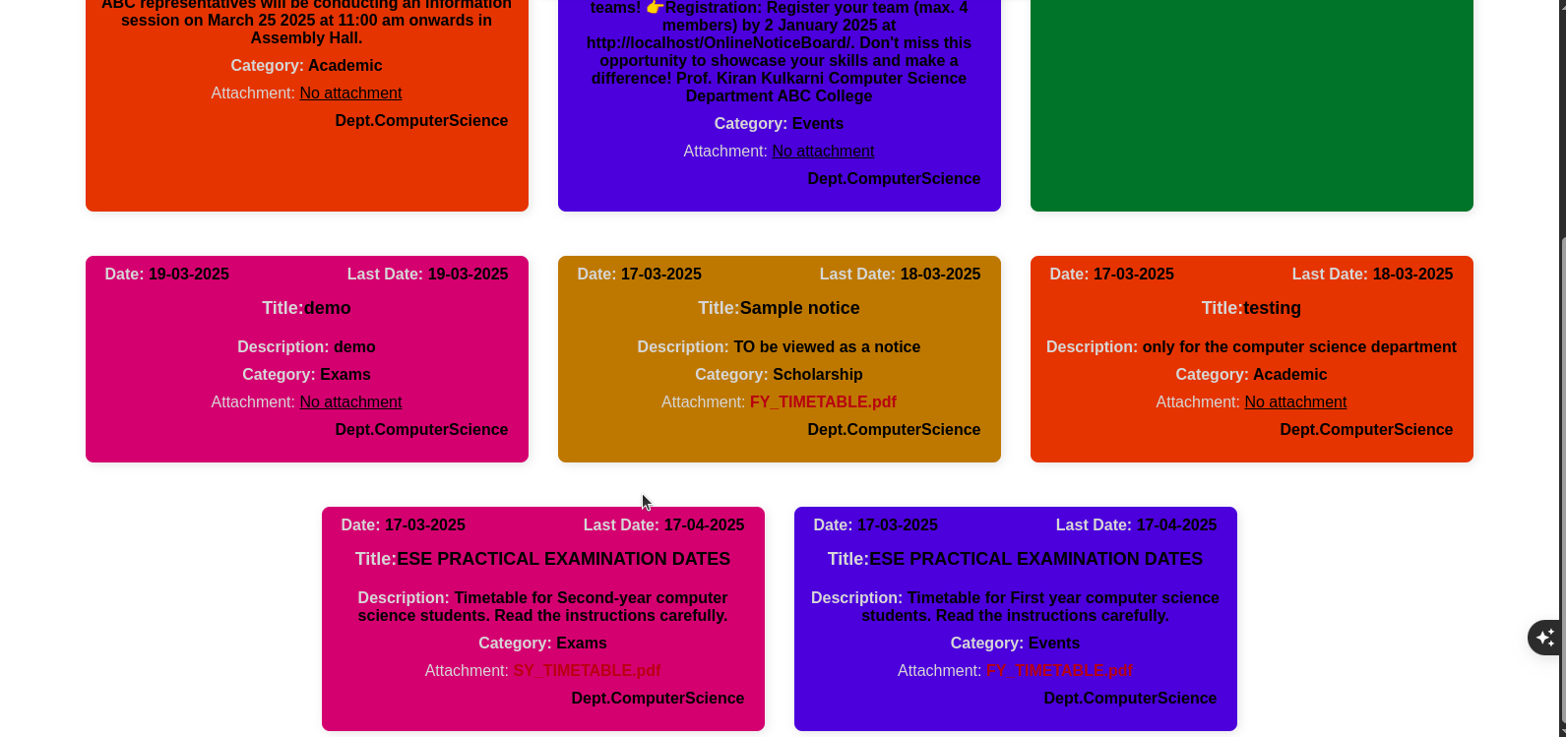

CONCLUSION
The "Online Notice Board" project aims to streamline communication between students, teachers, and administrators by providing a digital platform for posting, viewing, and managing notices. The system enhances the efficiency of information sharing by allowing teachers to submit notices, which are then approved by admins, and made available to students based on their respective departments. The role-based access ensures that each user can perform only the actions authorized to them, ensuring both security and usability.
The project was successfully implemented using PHP for the backend, PostgreSQL for the database, and HTML, CSS, and JavaScript for the frontend. The system is robust, scalable, and secure, offering a user-friendly interface for teachers, students, and administrators. Features like notice approval, expiry handling, and departmental filtering contribute to a smooth user experience.
In conclusion, the Online Notice Board project successfully fulfills its objectives, providing an efficient, secure, and user-friendly solution for notice management, which can be extended and improved further as required in future iterations.

FUTURE ENHANCEMENTS
- Provide search bars with filters for students to easily find notices
- Mobile-friendly design
- Push notifications
- Add calendar for notices like exams, etc
- Feedback systems

REFERENCES AND BIBLIOGRAPHY
- Books:
- Software Engineering: A Practitioner’s Approach – Roger S. Pressman, McGraw Hill (8th edition)
- Programming PHP – Rasmus Lerdorf and Kevin Tatroe O’Reilly publication
- Object Oriented Software Engineering Pearson Education INC – Ivar Jacobson
- Websites:
- PHP Manual: https://www.php.net/manual/en/
- PostgreSQL Documentation: https://www.postgresql.org/docs/
- W3Schools: HTML, CSS, and JavaScript tutorials: https://www.w3schools.com/
- YouTube:
- Khizar Shahal Technical
- Funda of Web IT
- Bro code

