Library Management System
2. Create Database
DROP DATABASE IF EXISTS library_management_system;
CREATE DATABASE IF NOT EXISTS library_management_system;
USE library_management_system;
3. Create members Table
CREATE TABLE members (
member_id INT PRIMARY KEY AUTO_INCREMENT,
member_name VARCHAR(100) NOT NULL,
email VARCHAR(150) NOT NULL UNIQUE,
phone VARCHAR(15) UNIQUE,
age INT CHECK (age >= 18),
gender VARCHAR(10) CHECK (gender IN ('Male', 'Female', 'Other')),
city VARCHAR(50),
registration_date DATE DEFAULT (CURRENT_DATE)
);
4. Create authors Table
CREATE TABLE authors (
author_id INT PRIMARY KEY AUTO_INCREMENT,
author_name VARCHAR(100) NOT NULL,
email VARCHAR(150) NOT NULL UNIQUE,
genre VARCHAR(100) NOT NULL,
years_active INT CHECK (years_active >= 0)
);
5. Create books Table
CREATE TABLE books (
book_id INT PRIMARY KEY AUTO_INCREMENT,
title VARCHAR(100) NOT NULL UNIQUE,
category VARCHAR(50) NOT NULL,
loan_period_days INT CHECK (loan_period_days > 0),
price DECIMAL(10,2) CHECK (price >= 0),
author_id INT,
CONSTRAINT fk_book_author
FOREIGN KEY (author_id)
REFERENCES authors(author_id)
);
6. Create borrowings Table
CREATE TABLE borrowings (
borrowing_id INT PRIMARY KEY AUTO_INCREMENT,
member_id INT NOT NULL,
book_id INT NOT NULL,
borrow_date DATE DEFAULT (CURRENT_DATE),
status VARCHAR(20) DEFAULT 'BORROWED'
CHECK (status IN ('BORROWED', 'RETURNED', 'LOST')),
review_score DECIMAL(5,2)
CHECK (review_score IS NULL OR (review_score >= 0 AND review_score <= 100)),
rating CHAR(1)
CHECK (rating IS NULL OR rating IN ('A', 'B', 'C', 'D', 'F')),
CONSTRAINT fk_borrowing_member
FOREIGN KEY (member_id)
REFERENCES members(member_id)
ON DELETE CASCADE,
CONSTRAINT fk_borrowing_book
FOREIGN KEY (book_id)
REFERENCES books(book_id),
CONSTRAINT uk_member_book
UNIQUE (member_id, book_id)
);
7. Insert authors
INSERT INTO authors
(author_name, email, genre, years_active)
VALUES
('Rahul Sharma', 'rahul@library.com', 'Fiction', 8),
('Priya Singh', 'priya@library.com', 'Science', 6),
('Amit Kumar', 'amit@library.com', 'History', 10),
('Sneha Das', 'sneha@library.com', 'Self-Help', 7);

SELECT * FROM authors;
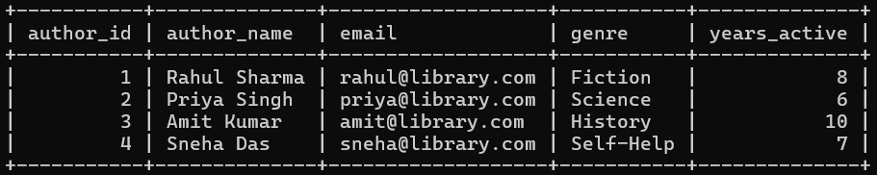
8. Insert books
INSERT INTO books
(title, category, loan_period_days, price, author_id)
VALUES
('The Silent River', 'Fiction', 14, 450, 1),
('Wonders of Physics', 'Science', 14, 550, 2),
('Empires of the East', 'History', 21, 650, 3),
('The Habit Blueprint', 'Self-Help', 14, 400, 4),
('Beyond the Horizon', 'Fiction', 21, 500, 3);
9. Insert members
INSERT INTO members
(member_name, email, phone, age, gender, city)
VALUES
('Arjun Mehta', 'arjun@gmail.com', '9876543210', 22, 'Male', 'Kolkata'),
('Neha Roy', 'neha@gmail.com', '9876543211', 23, 'Female', 'Delhi'),
('Rahul Das', 'rahul.das@gmail.com', '9876543212', 21, 'Male', 'Kolkata'),
('Priya Sen', 'priya.sen@gmail.com', '9876543213', 24, 'Female', 'Mumbai'),
('Amit Roy', 'amit.roy@gmail.com', '9876543214', 25, 'Male', 'Delhi'),
('Sneha Paul', 'sneha.paul@gmail.com', '9876543215', 22, 'Female', 'Kolkata');
10. Insert borrowings
INSERT INTO borrowings
(member_id, book_id, borrow_date, status, review_score, rating)
VALUES
(1, 1, '2026-01-10', 'RETURNED', 85, 'A'),
(1, 3, '2026-01-15', 'RETURNED', 92, 'A'),
(2, 2, '2026-02-01', 'RETURNED', 78, 'B'),
(2, 4, '2026-02-10', 'BORROWED', NULL, NULL),
(3, 3, '2026-01-20', 'RETURNED', 88, 'A'),
(3, 5, '2026-02-05', 'BORROWED', NULL, NULL),
(4, 1, '2026-01-12', 'RETURNED', 72, 'B'),
(4, 4, '2026-02-15', 'BORROWED', NULL, NULL),
(5, 2, '2026-03-01', 'BORROWED', NULL, NULL),
(6, 3, '2026-01-25', 'RETURNED', 95, 'A');
11. Basic SELECT Display all students
SELECT * FROM members;
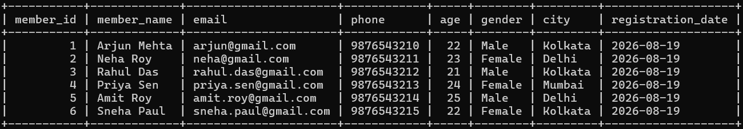
Select specific columns
SELECT member_id, member_name, email FROM members;
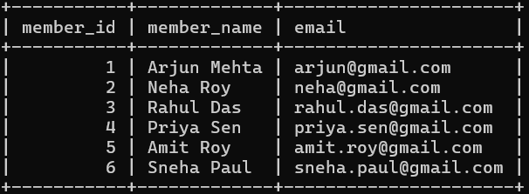
Using aliases
SELECT member_name AS name, email AS email_address FROM members;
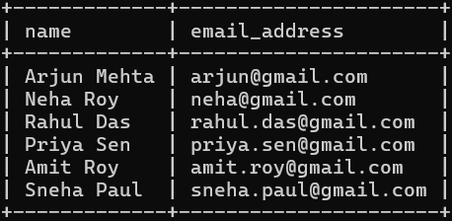
12. WHERE Clause
SELECT * FROM members WHERE city = 'Kolkata';
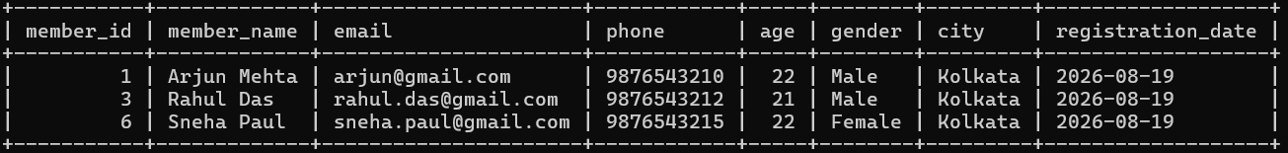
SELECT * FROM members WHERE age > 22;
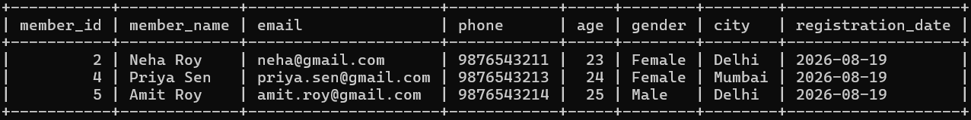
SELECT * FROM members WHERE city = 'Kolkata' AND age >= 22;
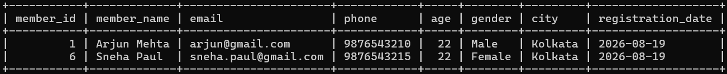

SELECT * FROM members WHERE city = 'Kolkata' OR city = 'Delhi';
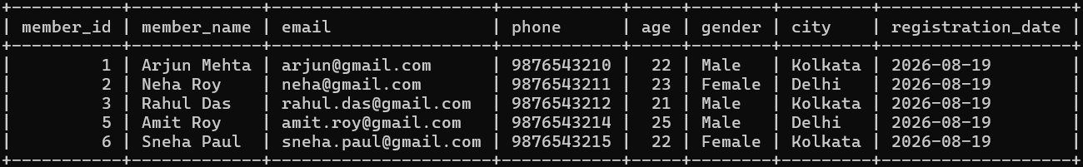
13. BETWEEN
SELECT * FROM members WHERE age BETWEEN 21 AND 23;
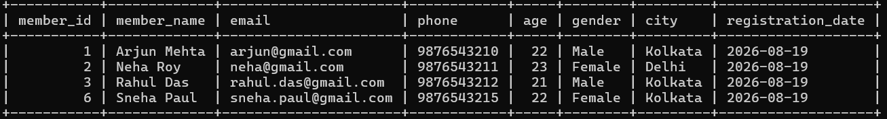
14. IN
SELECT * FROM members WHERE city IN ('Kolkata', 'Delhi');
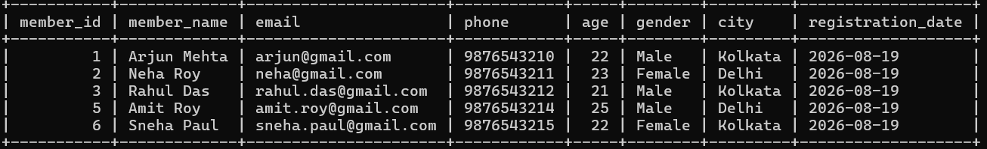
15. LIKE
SELECT * FROM members WHERE member_name LIKE 'A%';
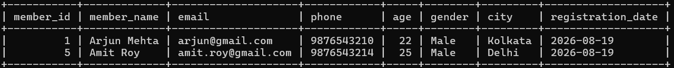
SELECT * FROM members WHERE member_name LIKE '%a';
SELECT * FROM members WHERE member_name LIKE '%Roy%';
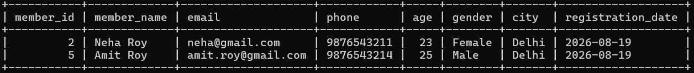
16. ORDER BY
SELECT * FROM members ORDER BY age ASC;
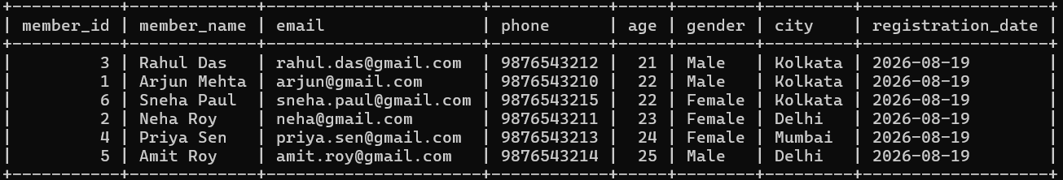
SELECT * FROM members ORDER BY age DESC;
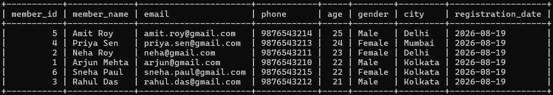
SELECT * FROM members ORDER BY city ASC, age DESC;
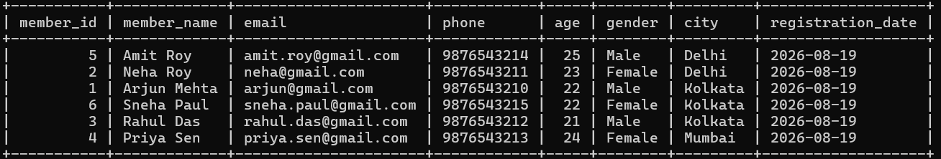
17. LIMIT
SELECT * FROM members ORDER BY age DESC LIMIT 3;
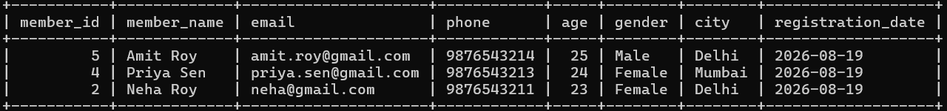
18. DISTINCT
SELECT DISTINCT city FROM members;
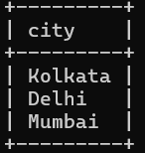
19. UPDATE
UPDATE members SET city = 'Bangalore' WHERE member_id = 1;
20. DELETE
DELETE FROM members WHERE member_id = 6;

