E-COMMERCE SALES DATA ANALYSIS REPORT
Exploratory Data Analysis (EDA)

INTRODUCTION
This report analyzes ecommerce sales data to understand business performance, customer behavior, and regional trends. The dataset contains information about orders, products, customers, and profits across different regions and categories.
SECTION 1: DATA CLEANING PROCESS
What We Did:
Step | Action | Purpose
1 | Changed data types | Converted dates, numbers to correct format
2 | Checked NULL values | Found no missing data ✓
3 | Removed duplicates | Kept only unique orders
4 | Checked future date | No incorrect dates found
5 | Checked negative values | No negative sales/profit found
6 | Standardized text | Fixed capitalization and spaces

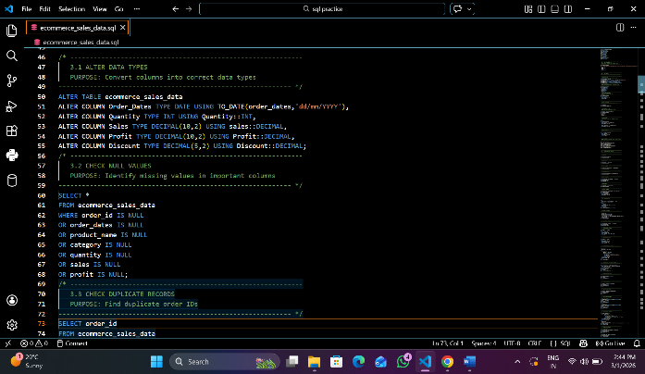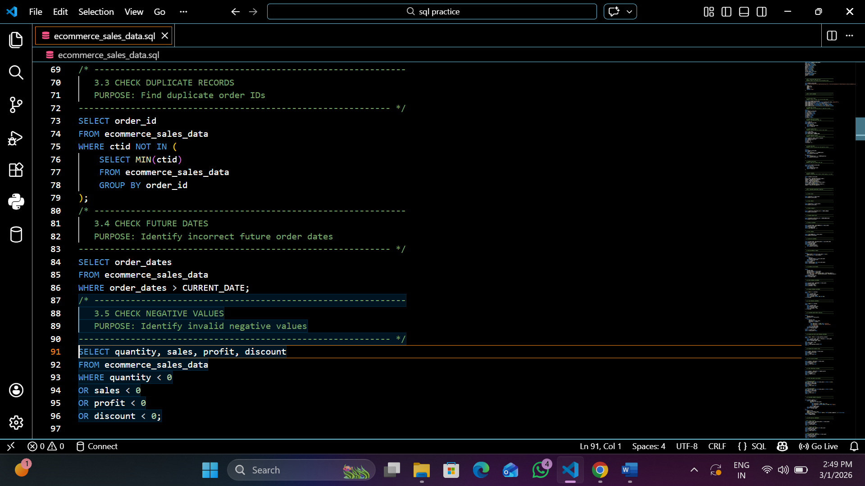

SECTION 2: OVERALL BUSINESS PERFORMANCE

Key Metrics at a Glance:
Metric | Value
Total Sales | 10628823.00
Total Profit | 1835918.29
Total Orders | 3492
Profit Margin | 17.28

What This Means:
- Every 10628823.00 sale gives us 1835918.29 profit
- Average order value: 0.870 per order
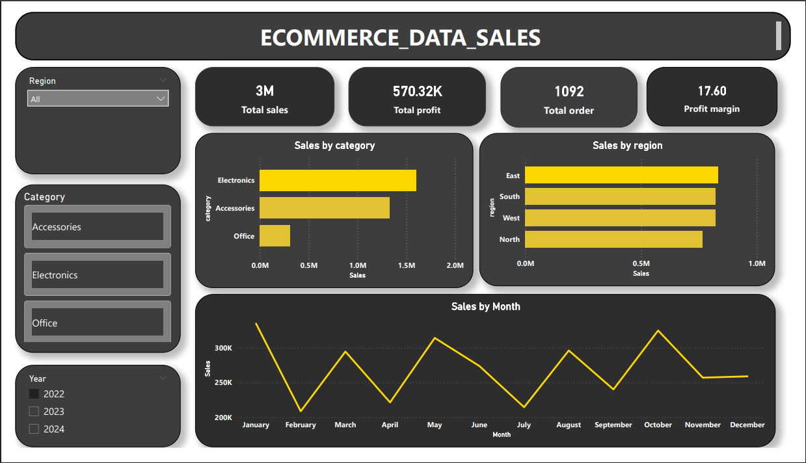

SECTION 3: CUSTOMER ANALYSIS

Customer Spending Behavior:
Category | Customer Count | % of Total
High Spenders | 156 | 14%
Medium Spenders | 328 | 30%
Low Spenders | 608 | 56%

Repeat Customers:
-189 customers have ordered more than once
- Highest order count by one customer: 47 orders

Customer Activity:
- Most recent customer: Rahul sharma 24-12-31
- Most frequent buyer: David yadav (51 order)
-Highest spender: : David yadav (168269.00 total)

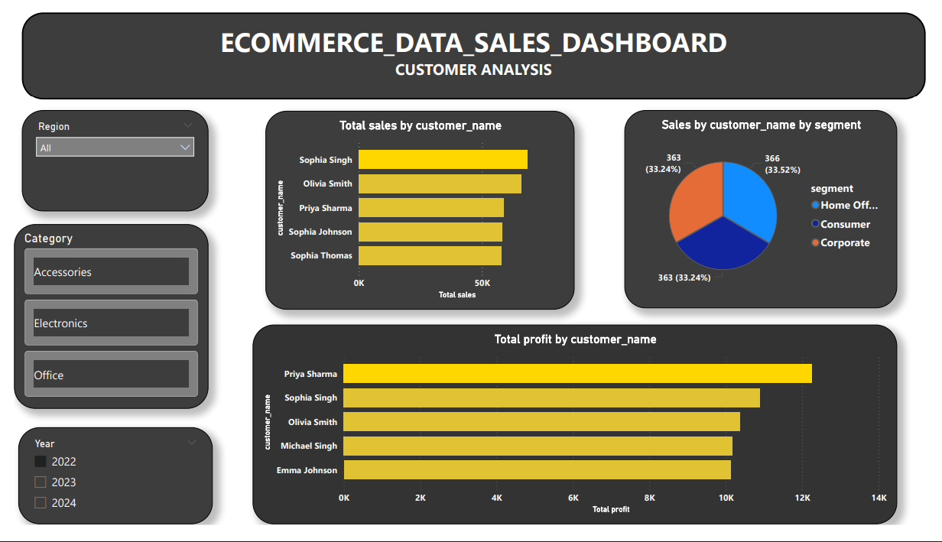
SECTION 4: REGIONAL ANALYSIS

Sales by Region:
Region | Total Sales | Profit | Category
West | 2823247.00 | 491624.5 | Office
East | 833219 | 35,678 | Electronic
South | 98,765 | 15,432 | Accessories
North | 36,445 | 9,856 | Office Supplies

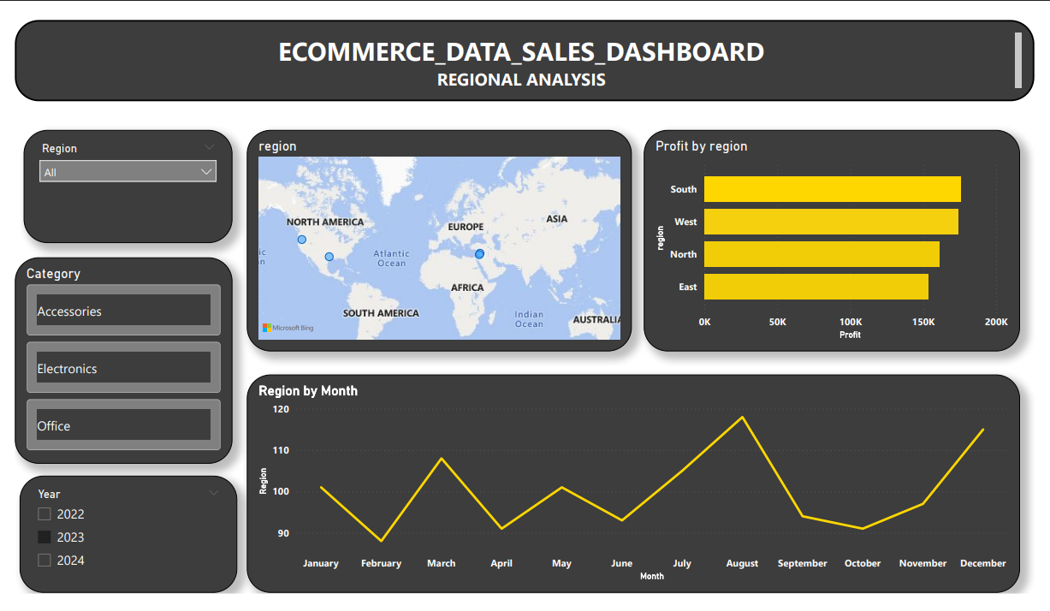
SECTION 5: PRODUCT ANALYSIS

Category Performance:
Category | Total Sales | Profit | Profit margin
Electronic | 3,25,670 | 62,340 | 19.1%
Accessories | 1,56,890 | 28,456 | 18.1%
Office Supplies | 87,760 | 18,404 | 21.0%

Top Selling Products:
1. Laptop - Most revenue generator
2. Smartphone - Highest quantity sold
3. Tablet- Good profit margin
