E-Commerce Sales Data Analysis
Complete Data Story

1️⃣ Business Problem
For e-commerce companies, understanding sales performance, customer behavior, and regional demand is essential for making strategic business decisions. By analyzing data, companies can identify which products sell the most, which regions generate the highest profits, and which customers make repeat purchases.
This project aims to analyze e-commerce sales data to generate meaningful insights.
The main objectives of this project are:
- To analyze overall sales performance
- To understand customer spending behavior
- To identify regional sales trends
- To evaluate product category performance
These insights help the business make data-driven decisions and improve overall performance.

2️⃣ Dataset Overview
This analysis uses an E-Commerce Sales Dataset that contains information about customer orders and transactions.
Key columns in the dataset include:
- Order ID
- Order Date
- Product Name
- Category
- Sub-Category
- Customer Name
- Region
- Country / State
- Quantity
- Sales
- Profit
- Discount
- Customer Segment
The dataset includes thousands of transactions, representing the company's business activities across multiple regions and product categories.

3️⃣ Data Cleaning Process
Before performing the analysis, the dataset was cleaned to ensure accurate and reliable results.
The following data cleaning steps were performed:
1️⃣ Data Type Conversion
Dates and numerical fields were converted into appropriate formats.
2️⃣ Checking for Missing Values
No missing values were found in the dataset.
3️⃣ Removing Duplicate Records
Duplicate order records were identified and removed to ensure data consistency.
4️⃣ Future Date Validation
The dataset was checked to ensure that no future dates existed.
5️⃣ Negative Value Validation
Sales, profit, and quantity values were checked to ensure there were no negative values.
6️⃣ Text Standardization
Category names, region names, and customer names were cleaned and formatted consistently.
After completing these steps, the dataset became analysis-ready.

4️⃣ Data Analysis Tools
Multiple tools were used in this project to perform analysis and visualization:
SQL
SQL was used for:
- Data cleaning
- Writing business queries
- Performing aggregations and calculations
Power BI
Power BI was used for:
- Data visualization
- Creating interactive dashboards
- Identifying trends and patterns

5️⃣ Overall Business Performance
After analyzing the dataset, the following key metrics were identified:
- Total Sales: 10,628,823
- Total Profit: 1,835,918
- Total Orders: 3,492
- Profit Margin: 17.28%
Insight
The company generates strong revenue and maintains a healthy profit margin, which indicates that the business is financially stable and profitable.

6️⃣ Customer Behavior Analysis
Customer spending behavior was analyzed and customers were segmented into three categories:
Customer Type | Percentage
High Spenders | 14%
Medium Spenders | 30%
Low Spenders | 56%
Key Findings
- The majority of customers belong to the low-spending segment.
- 189 customers made repeat purchases, indicating customer loyalty.
- The highest number of orders placed by a single customer was 47 orders.
Insight
The company has a loyal customer base, but there is also an opportunity to convert low-spending customers into higher-value customers.
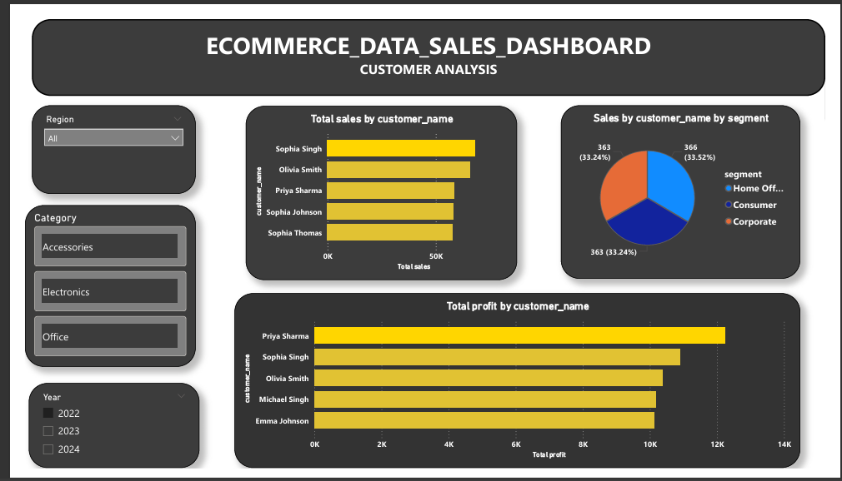

7️⃣ Regional Sales Analysis
Regional sales performance analysis revealed the following insights:
- The West region generates the highest total sales
- East and South regions show moderate performance
- The North region generates comparatively lower sales
Insight
The West region acts as the primary revenue driver for the business.
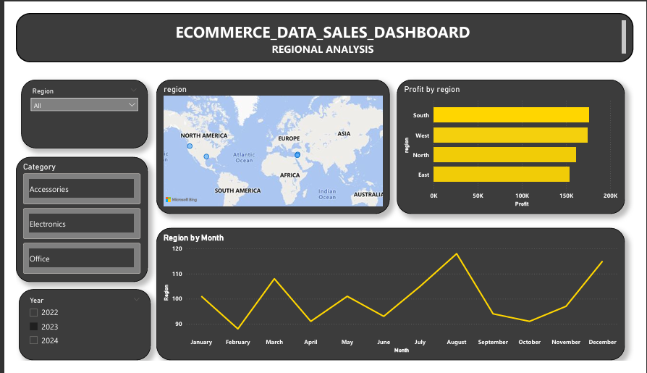

8️⃣ Product Category Analysis
The analysis of product categories showed the following performance:
Category | Profit Margin
Electronics | 19.1%
Accessories | 18.1%
Office Supplies | 21.0%
Top-performing products include:
1️⃣ Laptop – highest revenue generator
2️⃣ Smartphone – highest quantity sold
3️⃣ Tablet – strong profit margin
Insight
The Electronics category generates strong revenue and high demand products significantly contribute to business growth.
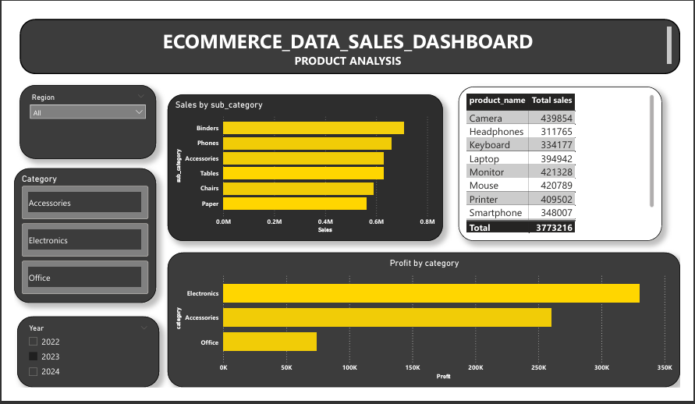

Hypothesis Testing
Research Question
Does providing discounts increase product sales?

Null Hypothesis (H₀)
Discount does not affect product sales.

Alternative Hypothesis (H₁)
Providing discounts increases product sales.

Statistical Test (Hypothesis Testing)
Research Question
Does providing discounts increase product sales?

Null Hypothesis (H₀)
Providing discounts does not affect product sales.

Alternative Hypothesis (H₁)
Providing discounts increase product sales.

Statistical Method
A correlation analysis was conducted to examine the relationship between discount levels and total sales using the dataset.
Correlation analysis helps determine whether two variables move together and how strongly they are related.
The correlation coefficient ranges between -1 and +1.
- +1 → Strong positive relationship
- 0 → No relationship
- -1 → Strong negative relationship

Analysis
The discount and total sales columns from the dataset were analyzed using a correlation formula in Excel.
The analysis examined whether products with higher discounts generated higher sales volumes.

Observation
The analysis showed a positive relationship between discount levels and sales values, indicating that higher discounts tend to attract more customer purchases.

Result
The correlation result suggests that discount levels and product sales move in the same direction, meaning that as discounts increase, sales also tend to increase.

Conclusion
The analysis supports the alternative hypothesis (H₁).
This indicates that providing discounts can positively influence product sales and help increase overall revenue.

🔟 Business Recommendations
Based on the analysis, the following recommendations are suggested:
1️⃣ Target High-Value Customers
Introduce loyalty programs and personalized offers for high-spending customers.
2️⃣ Focus on Electronics Category
This category generates significant revenue and should be prioritized in marketing campaigns.
3️⃣ Improve Marketing in Low-Performing Regions
Targeted promotional campaigns can be implemented in regions with lower sales.
4️⃣ Optimize Discount Strategies
Limited-time discounts and promotional offers can help boost product sales.

1️⃣1️⃣ Conclusion
This project analyzed E-commerce sales data using SQL and Power BI to uncover meaningful business insights.
Key learnings from the analysis include:
- The business maintains a 17% profit margin, indicating strong profitability.
- Customer segmentation plays a significant role in understanding purchasing behavior.
- Regional demand varies, highlighting the importance of location-based strategies.
- Product category performance strongly influences business growth.
By using data-driven insights, the company can improve marketing strategies, enhance customer engagement, and drive revenue growth.

1️⃣2️⃣ SQL Queries Used
Query 1 — Total Sales by Region
SELECT region, SUM(sales) AS total_sales
FROM orders
GROUP BY region
ORDER BY total_sales DESC;

Query 2 — Top Products by Sales
SELECT product_name, SUM(sales) AS total_sales
FROM orders
GROUP BY product_name
ORDER BY total_sales DESC
LIMIT 10;

Query 3 — Customer Purchase Count
SELECT customer_name, COUNT(order_id) AS total_orders
FROM orders
GROUP BY customer_name
ORDER BY total_orders DESC;

Query 4 — Sales by Product Category
SELECT category, SUM(sales) AS total_sales
FROM orders
GROUP BY category;

