Given the **n integers** of a singly linked list, return the ***middle*** node of the linked list.

If there are two middle nodes, return **the second middle** node.  
  
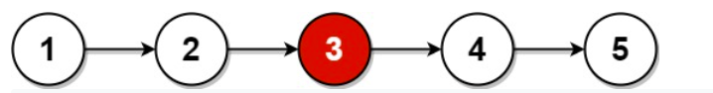  
  
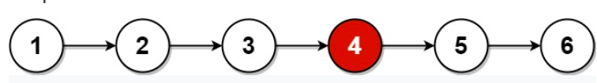  
  
**Input Format:**  
The input contains two lines, the first line contains a single integer **n,**and the next line contains **n space-separated integers.  
  
Output Format:**

Single integer, representing the middle of the linked list.  
  
**Example:  
Input:**5  
2 3 4 5 6

**Output:**

4