

Kannada Sangha Pune’s
Kaveri College of Arts, Science and Commerce, Pune

A PROJECT REPORT ON

Tourism Package Booking System
SYBSC(CS) (SEM –IV)
2025-26

By

Name1: Sanskruti Dhumal Seat No: = 13
Name2: Shreyas Vispute Seat No: = 21

In partial fulfilment of B. Sc. (Computer Science)

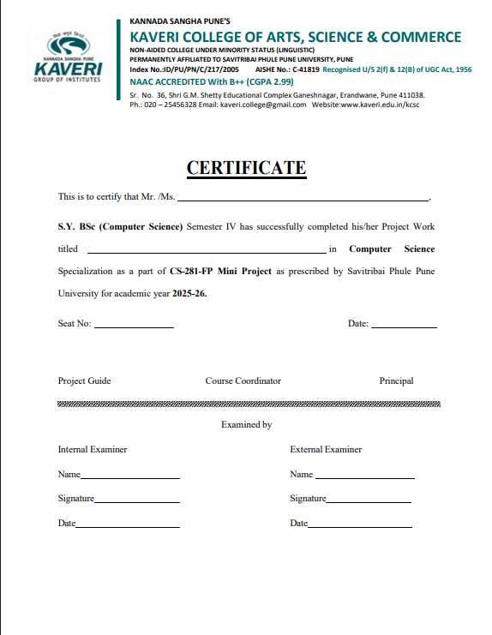

S.Y.B.Sc. (Computer Science)
Mini Project Academic Year (20 - 20 )

Project Title :

Team members:
- Name :

Roll No : Exam Seat No :

- Name :

Roll No : Exam Seat No :

Project Guide Name :

Project Guide Signature :

Start Date: / / Completion Date: / /

DEPARTMENT OF COMPUTER SCIENCE
CERTIFICATE

This is to certify that Ms./Mr.
have successfully and satisfactorily completed and submitted the field project titled
in partial fulfilment of S.Y.B.Sc.(CS) Lab course CS-281-FP Mini Project Semester IV prescribed by Savitribai Phule Pune University during the academic year

(Project Guide) | (H.O.D. Computer Science)
INTERNAL EXAMINER | EXTERNAL EXAMINER

Index

Serial No | Topic | Page No
1 | Introduction
2 | Abstract
3 | Feasibility
4 | Software & Hardware Requirement
5 | Project Plan, System design, System analysis
6 | Implementation Details
7 | User Interface
8 | Database
9 | Diagrams
10 | Conclusion
11 | Future Enhancement
12 | References

Introduction

The Tourism Booking System is a web-based application designed to simplify and modernize the process of booking travel services. In traditional systems, users had to visit travel agencies, which was time-consuming and inefficient. This system provides an online platform where users can explore destinations, compare packages, and make bookings easily.
It allows users to access real-time information about hotels, transport, and pricing from anywhere at any time. The system is developed using technologies like HTML, CSS, Python, and a database such as Psycopg2 or PostgreSQL to store and manage data efficiently.
The system reduces manual work, minimizes errors, and improves accuracy. It provides a user-friendly interface and ensures secure handling of user information through proper authentication. It also supports multiple users and maintains organized records of bookings.
Overall, the Tourism Booking System offers a convenient, efficient, and reliable solution for managing travel services while enhancing user experience and supporting digital transformation.

Abstract

The Tourism Package Booking System is a web-based application designed to simplify the process of booking travel services. It allows users to explore different tourism packages, compare options, and make bookings online without the need to visit travel agencies. This system improves convenience and saves time by providing access to travel services anytime and anywhere.
The system is developed using HTML and CSS for the frontend, Python for backend processing, and Psycopg2 for database management. It stores and manages user and booking information efficiently. Key features include user registration, login, package viewing, booking, and cancellation.
The system reduces manual work, minimizes errors, and ensures faster processing of information. It is designed to be user-friendly, secure, and capable of handling multiple users. Overall, this project demonstrates the effective use of web technologies to create a reliable and efficient tourism management solution.

Feasibility Study

The feasibility study evaluates whether the Tourism Booking System is practical and achievable.
Technical Feasibility :
The system uses simple technologies like HTML, CSS, Python, and Psycopg2, which are easy to implement and widely available. It does not require advanced hardware or software.
Economic Feasibility :
The project is cost-effective as it uses free and open-source tools. Development and maintenance costs are low, making it affordable.
Operational Feasibility :
The system is user-friendly and easy to operate. Users can book packages online without technical knowledge, making it convenient and efficient.
Schedule Feasibility :
The project can be completed within the given academic timeframe as it follows a structured development process.
Legal Feasibility :
The system follows standard guidelines and ensures data security, making it legally acceptable.

Software and Hardware Requirements

The system requires basic hardware such as a computer with sufficient RAM and internet connectivity. Software requirements include a web browser and development tools. The frontend is developed using HTML and CSS, while Python is used for backend processing. Psycopg2 is used as the database system. The system must support multiple users without performance issues. Security features like login authentication are necessary. Proper configuration ensures smooth operation. These requirements ensure efficiency and reliability of the system.

Project plan

The main objective of the Tourism Package Booking System is to develop a user-friendly and efficient web-based platform that simplifies the process of planning and booking travel services. The system aims to provide users with easy access to various tourism packages, enabling them to view, compare, and book trips conveniently from anywhere.
Another objective is to reduce the manual effort involved in traditional booking systems by automating processes such as registration, login, package selection, and booking management. The system also focuses on maintaining accurate records of users and bookings using a structured database.
Additionally, the project aims to integrate frontend technologies like HTML and CSS with backend technologies such as Python and MySQL to demonstrate practical implementation of full-stack development concepts. It ensures data security, reliability, and scalability while improving overall user experience.
Overall, the objective is to create a modern, efficient, and accessible tourism management solution that enhances convenience for users and supports digital transformation in the travel industry.

System Analysis

System analysis is a fundamental phase in the software development life cycle that focuses on understanding user needs and system requirements in detail. It involves studying the existing system, identifying its limitations, and proposing effective solutions. This phase acts as a foundation for designing and developing a successful and efficient system.
During system analysis, analysts examine the current manual or computerized system to identify problems, errors, and inefficiencies. Information is gathered through methods such as interviews, questionnaires, observations, and document analysis. This helps in clearly understanding how the system works and what improvements are required.
System analysis also includes studying user behaviour, expectations, and requirements to ensure the system is user-centered. It involves defining system objectives and identifying both functional and non-functional requirements. Functional requirements describe system operations, while non-functional requirements focus on performance, security, usability, and reliability.
Overall, system analysis plays a key role in reducing development errors and risks. It ensures that the final system meets user needs and performs efficiently. A proper analysis improves system quality, usability, and performance, leading to successful system development and implementation.

System Design

System design is a crucial stage in the software development life cycle that focuses on how a system will be structured and developed. It acts as a link between system requirements and the actual coding process. In this phase, a detailed plan is created to guide developers in building the system effectively.
It includes designing the system architecture, which defines the overall structure of hardware, software, and network components. Database design is also an essential part, where data is organized into tables and relationships to ensure efficient storage and retrieval. Proper database design helps in reducing redundancy and maintaining data integrity.
Various diagrams such as Data Flow Diagrams (DFDs), Use Case Diagrams, and Entity-Relationship (ER) Diagrams are used to represent system components and their interactions. These diagrams make it easier to understand the system and improve communication among developers and stakeholders.
The system is divided into smaller modules, each handling a specific task. This modular approach improves maintainability, scalability, and flexibility. It also makes testing and debugging easier.
User Interface (UI) design is another important aspect, focusing on creating simple and user-friendly interfaces. Additionally, system design considers performance, security, and reliability to ensure smooth functioning.
Overall, system design acts as a blueprint that helps in developing an efficient, accurate, and high-quality system.

Implementation

Implementation is the process of developing the system using programming languages. The frontend is designed using HTML and CSS to create user-friendly pages. The backend is developed using Python to handle logic. Postgres is used for database management. Features like login, booking, and data storage are implemented. Integration ensures smooth functioning. Testing is performed to remove errors. The system is made efficient and reliable. Implementation converts design into a working system.
Frontend Implementation
The frontend is developed using HTML and CSS to create an attractive and user-friendly interface. It includes web pages such as the home page, registration page, login page, package display page, and booking form. CSS is used to design layouts, colors, and responsiveness, making the system visually appealing and easy to navigate. Forms are used to collect user input, such as personal details and booking information.
Code:

<script>
let isLogin = true;
function toggleMode() {
isLogin = !isLogin;
document.getElementById('phone').style.display = isLogin ? 'none' : 'block';
document.getElementById('phone').required = !isLogin;
document.getElementById('loginBtn').style.display = isLogin ? 'block' : 'none';
document.getElementById('regBtn').style.display = isLogin ? 'none' : 'block';
document.querySelector('.toggle-text').innerText = isLogin ? "Need an account? Register here." : "Have an account? Login here.";
}
</script>

Backend Implementation
The backend is developed using Python, which handles the core logic of the system. It processes user requests, manages login authentication, and performs operations such as booking and cancellation. The backend connects the frontend with the database and ensures that data is processed correctly. It also handles validation to ensure that only valid data is stored.
Code:
@app.route('/', methods=['GET', 'POST'])
def login():
if request.method == 'POST':
username = request.form['username']
password = request.form['password']
phone = request.form.get('phone', '') # Only used during registration

Database Implementation
Psycopg2 is used as the database management system. It is lightweight and does not require a separate server, making it suitable for small-scale applications. Tables such as Users, Bookings, and Packages are created to store data. SQL queries are used to insert, update, and retrieve information efficiently.
Code:
CREATE TABLE users (
id SERIAL PRIMARY KEY,
username VARCHAR(100) UNIQUE NOT NULL,
password VARCHAR(100) NOT NULL, -- Storing as plain text for simplicity, but needs hashing in production
phone VARCHAR(20) NOT NULL
);

Integration
All components are integrated so that data entered through the frontend is processed by the backend and stored in the Psycopg2 database. The system provides appropriate output back to the user, ensuring smooth interaction.

User Interface
The user interface is designed to be simple and interactive. It allows users to navigate easily. Forms are provided for registration and booking. Clear buttons and menus improve usability. The interface is responsive and works on different devices. It enhances user experience. Visual design makes the system attractive. A good interface encourages users to use the system. It plays a key role in system success.

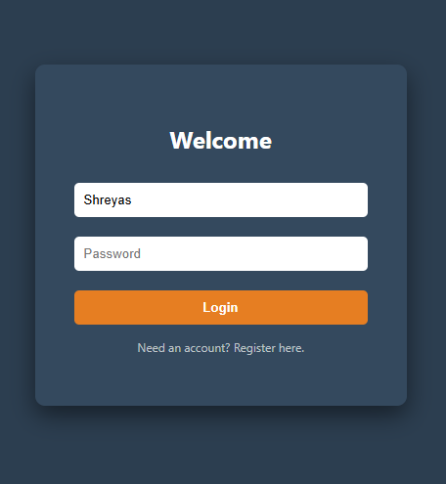

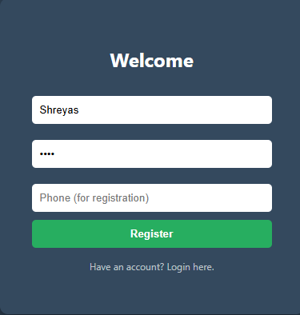

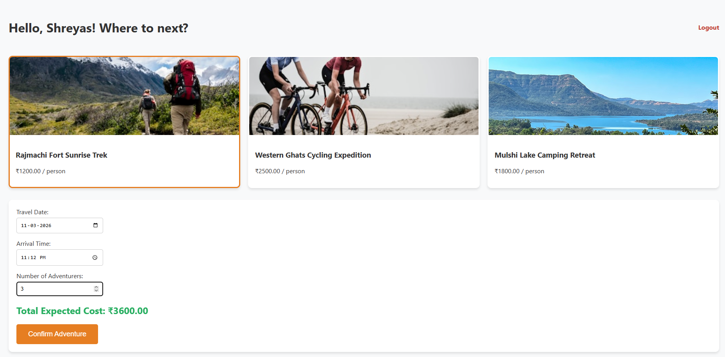



Database Design

Database design ensures efficient storage and management of data in the Tourism Package Booking System. Postgres is used as the database to store information related to users, bookings, and packages.
The system includes tables such as Users, Bookings, and Packages, with proper relationships defined using primary and foreign keys. SQL queries are used to insert, update, and retrieve data efficiently. Indexing improves performance, especially when handling multiple users.
Security measures and data validation help maintain data integrity, while regular backups ensure data safety. A well-designed database improves the overall efficiency and reliability of the system.
Users Table
Field Name | Data Type | Description
user_id (PK) | INT | Unique user ID
name | VARCHAR(100) | User full name
email | VARCHAR(100) | User email
password | VARCHAR(100) | User password
phone | VARCHAR(15) | Contact number
Address | TEXT | User address
Packages Table
Field Name | Data Type | Description
package_id (PK) | INT | Unique package ID
package_name | VARCHAR(100) | Name of package
destination | VARCHAR(100) | Travel destination
price | DECIMAL | Package price
duration | VARCHAR(50) | Duration of trip
description | TEXT | Package details

Bookings Table
Field Name | Data Type | Description
booking_id (PK) | INT | Unique booking ID
user_id (FK) | INT | References Users table
package_id (FK) | INT | References Packages table
booking_date | DATE | Date of booking
travel_date | DATE | Travel date
number_of_people | INT | Number of travelers
total_amount | DECIMAL | Total cost
status | VARCHAR(50) | Booking status

ER Diagram

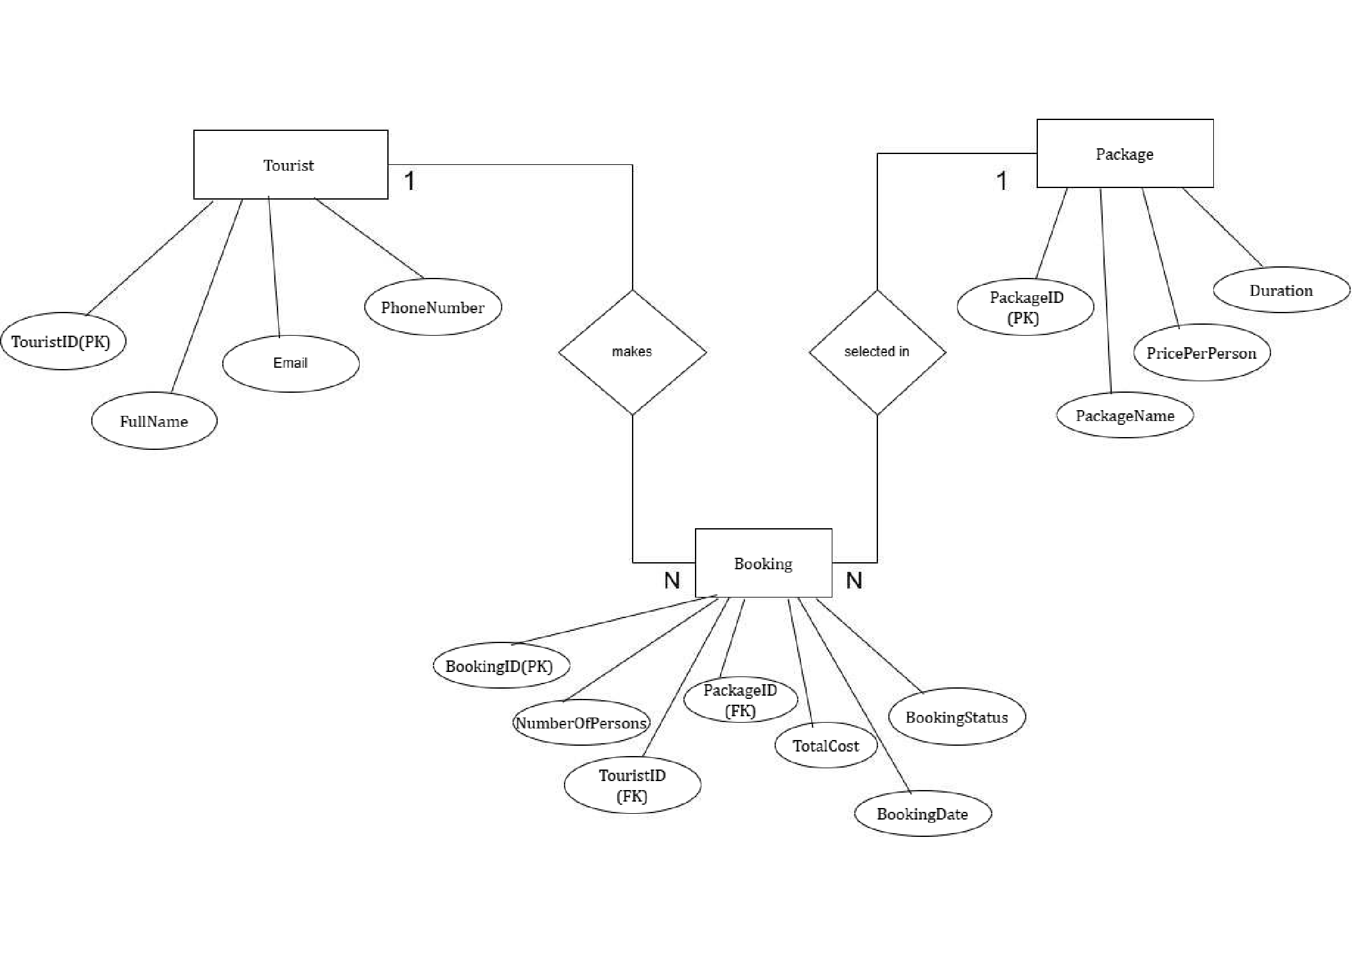

Class diagram

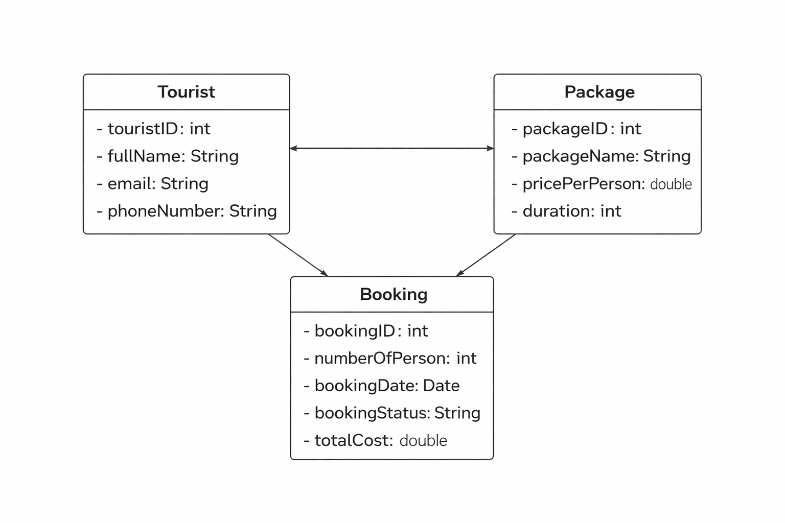

Data Flow Diagram (DFD)

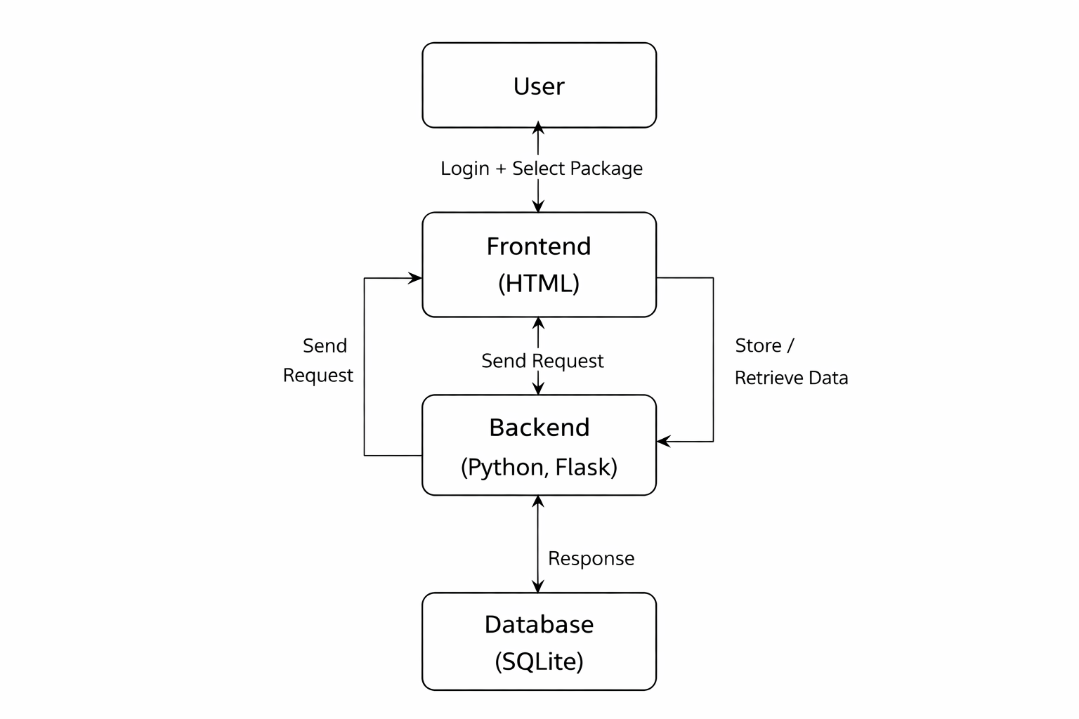

Use Case Diagram

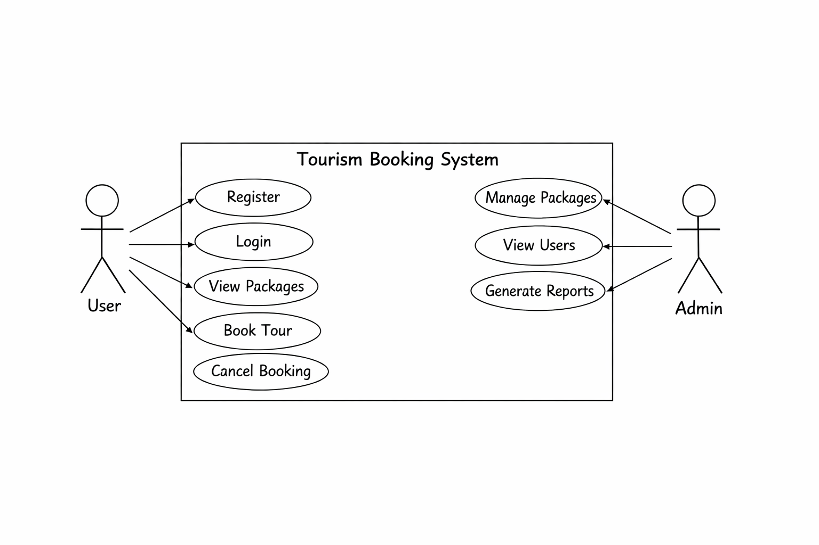

Conclusion

The Tourism Package Booking System successfully provides an efficient and modern solution for managing travel and tourism services. It simplifies the traditional booking process by allowing users to explore, select, and book travel packages online without the need for physical visits to travel agencies. This significantly reduces time, effort, and manual work while improving the overall accuracy of operations.
The system offers a user-friendly interface that enhances the user experience and makes navigation easy even for non-technical users. Features such as user registration, secure login, package viewing, booking, and cancellation ensure smooth functionality. The use of technologies like HTML, CSS, Python, and Psycopg2 demonstrates the practical implementation of web development and database management concepts.
In addition, the system ensures proper data management and security through authentication mechanisms, making it reliable and safe for users. It is also scalable, meaning it can handle multiple users and can be expanded with additional features in the future. The project contributes to the digital transformation of the tourism industry by providing a convenient and accessible platform.
Overall, the Tourism Package Booking System meets its objectives and proves to be a useful, efficient, and reliable solution. With further enhancements such as online payment integration, mobile application support, and advanced features, the system can be made even more powerful and user-centric in the future.

Future Enhancements

The Tourism Package Booking System can be further enhanced by adding a secure online payment gateway, which will allow users to complete bookings and transactions directly through the system. This will improve convenience and reduce dependency on manual payment methods.
A mobile application can also be developed to make the system more accessible, enabling users to book packages anytime and anywhere. AI-based recommendation features can be introduced to provide personalized travel suggestions based on user preferences and past activities, improving the overall user experience.
Real-time notifications and alerts can be added to keep users informed about booking confirmations, cancellations, and special offers. Security features can be strengthened by implementing advanced authentication methods such as OTP verification and data encryption.
Additionally, the system can be integrated with external services like hotel booking, transport services, and maps to provide a more complete travel solution. Improvements in user interface design can make the system more interactive and visually appealing.
Overall, these enhancements will make the system more efficient, user-friendly, secure, and scalable for future use.

References
References include online resources and documentation used during development. Websites like Google and GitHub provide useful information. Tutorials help in understanding concepts. Documentation ensures correct implementation. References support learning and development. They provide reliable information. Proper referencing improves project credibility.

https://www.codewithharry.com
https://www.apnacollege.in
https://www.techwithtim.net

