**Project SRS Report**

**Project Name : Easy Pay App**

**Project Mentor:**

Sunandha Ma’am

**Project Members:**

Shubham Waghchoure(230360820052) Shreyas Kamble(230360820049)

**Table of Contents**

1. Project Objective:-
2. Introduction:-
3. Intended User:- Intended Audience and Reading Suggestion:-
4. Definations and Acronyms:-
5. Assumption and Dependencies:-
6. How to use app:-
7. Requirements:-
   1. Functional Requirements
   2. Non Functional Requirements
8. Technologies Used:-
9. Use Case Diagram:- 10.Activity Diagram:-

**Project:**

**Web application using spring framework**

**Project name:**

**Easy Pay App**

# Project Objective:

The app should enable users to recharge their mobile balances and avail various services with minimal effort. It should present users with intuitive options for selecting plans and customizing their recharge preferences.The app should offer a seamless and pleasant user experience. It should have an intuitive user interface, quick loading times, and responsive design to cater to a diverse range of devices and screen sizes.Users should be able to access their transaction history within the app. This feature enhances transparency and allows users to keep track of their recharges and expenditures. Push notifications will inform users of successful transactions, provide recharge confirmations, and update users about ongoing promotions and offers.

# Introduction:

The primary objective of the Mobile Recharge App is to provide users with a convenient, user-friendly platform for recharging their mobile phone balances, purchasing data plans, and availing various telecom services. This app aims to streamline the process of mobile recharge, making it efficient, secure, and accessible to a wide range of users.

# Intended User:- Intended Audience and Reading Suggestion:-

**Intended Audience:** The intended audience for your mobile recharge app is likely to be diverse, including both tech-savvy and non-tech-savvy users. You'll want to cater to a wide range of demographics, including:

* **Smartphone Users:** This includes individuals who are comfortable using smartphones and mobile apps to manage various aspects of their lives.
* **Young Adults:** Young adults who frequently use mobile phones for communication, social media, and online activities.
* **Busy Professionals:** People with hectic schedules who need a quick and convenient way to recharge their phones without spending too much time on the process.
* **Elderly Users:** A user-friendly interface and clear instructions will be crucial for elderly users who might not be as familiar with technology.
* **Rural Users:** Individuals in rural areas who rely heavily on mobile phones for communication and may not have easy access to physical recharge options.
* **Frequent Travelers:** People who travel frequently and need a reliable app to recharge their phones while on the go.

### Reading Suggestions:

* **Web Development Articles and Tutorials**: Explore online resources, tutorials, and articles that specifically focus on web applications. These resources can provide insights into various techniques, frameworks, and libraries that can be utilized for different functionalities in web development.
* **Web Development Best Practices and Case Studies:** Familiarize yourself with web development best practices, including front-end and back-end technologies, user experience (UX) design principles, and performance optimization**.**
* **UX Design and User Research:** Dive into resources related to UX design principles, user research, and user-centered design methodologies. This knowledge will help you ensure that your web application is intuitive, user-friendly, and addresses the specific needs and pain points of the target users.
* **Web Development Communities and Forums**: Engage with online communities, forums, and social media platforms focused on web development. Participating in discussions, asking questions, and sharing experiences with fellow developers can provide valuable insights and practical related to Web Devlopment.

# Definations and Acronyms:-

1. UI=User Interface
2. DTO=Data Transfer objects
3. DAO=Data Access Object
4. MVC=Model View Controller

# Assumptions and Dependencies:-

### Assumptions:

* **User Devices**: It's assumed that users will have smartphones with internet access to use the mobile recharge app. The app will be developed for major mobile platforms such as Android and iOS.
* **Internet Connectivity:** Users are expected to have reliable internet connectivity to access the app and initiate recharge transactions. The app will not function properly without a stable internet connection.
* **User Accounts:** The system assumes that users will need to create accounts or profiles to use the app. These accounts will store transaction history, payment details, and user preferences.
* **User Security:** Assumption is made that the app will incorporate security measures like encryption, secure authentication, and data protection to ensure user data and payment information are safeguarded.
* **App Stores Approval**: It's assumed that the app will need to go through the approval processes of app stores (Google Play Store, Apple App Store) before being made available to users. The approval process might introduce delays or requirements.

### Dependencies:

* **Database Management System:** The system depends on a robust and scalable database management system to store user data, transaction history, and other relevant information.
* **Mobile Operating Systems:** The system's compatibility and performance depend on the behavior of the chosen mobile operating systems (Android, iOS) and their respective versions.
* **Internet Service Providers:** The system's usability relies on users having access to reliable internet service providers. Any downtime or connectivity issues might impact user experience.
* **App Store Guidelines:** The system's availability to users depends on meeting the guidelines and requirements set by app stores, including design standards, security measures, and content policies.
* **Development Frameworks and Tools:** The system's development and maintenance depend on the use of specific development frameworks, programming languages, and tools.

# How to use app:

* **First step:**First We need choose that we have to login as user or admin.
* **Second Step:** For User Logins, User will register himself first and then proceed with login.And for Admin We Have Fixed Credentials for admin.
* **Third Step:**After Successfully login as user we will be having access of 3 tools which are as follows:
  + a)**Offers:**Where You Can Choose Your Plans
  + b)**Recharge**:Where You Can Recharge Selected Plans From Above
  + c) **See Your Bills:** Here You Can See The History Of Your Recharges.
* **Fourth step:-** After Successfully login as user we will be having access of 2 tools which are as follows:
  + a)**AddOffer:**Where Admin Can Add Offer By Giving Plan Validity And Benefits
  + b)**ViewOffers:**Here Admin Can See The Listed Offer.
  + c) **Update Offers**:Here Admin can update any Changes In Offer.
  + d)**Delete Offer:** Here Admin can delete any Offer.
* **Fifth step**:At The End We Can Logout The application

# Requirements:

## Functional Requirements:

* Welcome Page For Admin And User
* Register page for new users.
* Login page for already registered users.
* Forgot Password Option For User
* After Login As User ,User Home Page Will PopUp
* Recharge Page
* Bills Page And Offer Page
* Login Page For Admin
* Add Offer Page For Admin
* View Offer Page For Admin
* LogOut

## Non-Functional Requirements:

### Usability:

Usability of application will be easy so that new customer can use it without anydifficulty.

### Maintainability:

Application would build up in such a way that classifications of errors and maintenancebecome easy.

### Security:

No one can use this application without a registered username and password. Safe andsecure.

### Reliability:

The System will support 7 X 24 operations.

### Performance:

Authorization will complete within one minute 90% of the time. Average authorization confirmation time will not exceed 30 seconds.

### Access:

Software will accessible over the internet.

# Technologies Used

## Front-end Development:

* + HTML5, CSS3: These are fundamental technologies for building theuser interface and interactivity of the web application.
  + Bootstrap, Material-UI: CSS frameworks that provide pre-designed components and responsive layouts for faster and consistent UI development.

## Back-end Development:

* + Spring
  + Hibernate

## Database:

* + MySQL: Relational database management systemscommonly used for web applications.

## Deployment and Infrastructure:

* + Amazon Web Services (AWS), Microsoft Azure, Google Cloud Platform: Cloud service
  + providers that offer infrastructure and hosting services for web applications.
  + Docker, Kubernetes: Containerization and orchestration tools for deploying and managing application containers.

**USE CASE DIAGRAM :-**

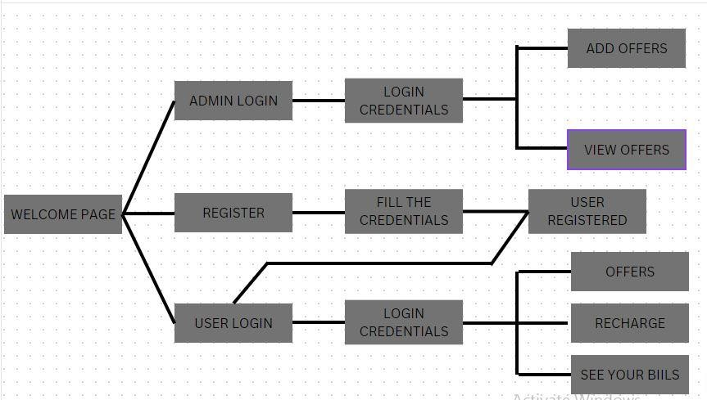

# Activity Diagram:

LOGOUT

OPEN APPLICATION

VIEW APPLICATION

Not Interested



Yes Interested to use application

LOGIN

SIGN UP

USER

ADMIN

Incorrect Details

Login Successully

USER

ADMIN

LOGIN SUCCESSFULL

Recharge successful



RECHARGE

OFFERS

VIEW OFFERS

ADD OFFERS



SEE YOUR BIILS

**THANK YOU …..!**