HPL 2026
WEEK 1 — BACKEND
Technical Design & Architecture Document
HPL 2026 • SMVITM Bantakal • in association with Code Troopers
TEAM | PROJECT | TRACK | WEEK
Bits and Bytes | Sahayak | Backend | 1

Team Members
Sheregar Shivani Babu — Team Lead
Spandana Aithal — Frontend
Dhanya — Backend
Shreya Takoor — AI/ML
Sudeeksha — UI/UX

Purpose of this document: This is the team's Week 1 backend design for Sahayak. It makes the architecture, data model, business logic, APIs, security boundaries, and important backend processes easy for a judge to understand and evaluate.
Judge-first principle: Diagrams, tables, concise decisions, and concrete examples are used throughout instead of generic architecture prose, so a judge can trace an important requirement from workflow → business rule → API → database.

1. System Overview
Item | Details
Backend Responsibility | Owns all persistent data, business logic, and REST APIs for Sahayak: senior citizen / volunteer / police accounts, authentication, RBAC, volunteer verification workflow, assistance-request lifecycle, and emergency escalation logging. It does not own speech recognition or urgency classification — those belong to the Voice/AI track — the backend only exposes a stable intake API that consumes structured request data from that layer.
Primary actors / roles | Senior Citizen, Volunteer, Police Admin (plus a system/voice-webhook actor for automated intake)
Functional Decomposition | Auth & User Management · Volunteer Registration & Verification · Request Management · Emergency Escalation · Audit Logging
Main entities | User, SeniorCitizen, Volunteer, Organisation, PoliceAdmin, VerificationRecord, AssistanceRequest, EmergencyEscalation, AuditLog

2. Backend Architecture
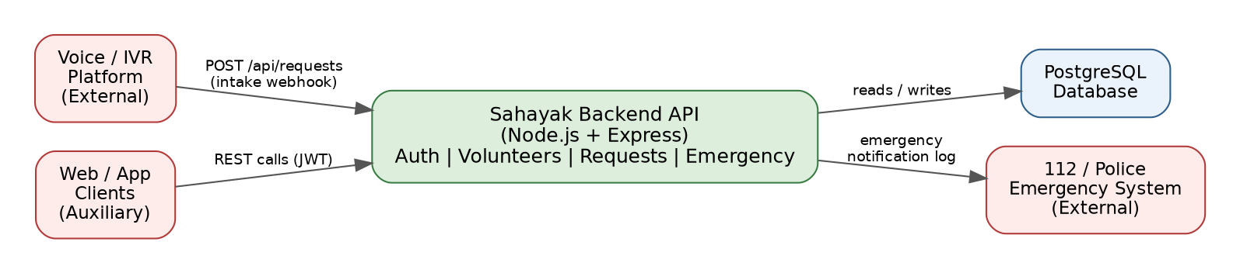
Figure 1 — High-level backend architecture

Components
Component | Responsibility | Technology
API / Server | Exposes all REST endpoints, enforces RBAC, applies business rules, orchestrates the request and verification workflows | Node.js + Express.js
Database | Owns all persistent state: users, volunteers, requests, verification records, escalations, audit trail | PostgreSQL
Background worker | Not used in Evaluation 1 | None
Cache / queue | Not used in Evaluation 1 | None
External service | Voice/IVR platform sends structured request data via webhook; 112/police emergency handling is logged, not automated in Eval 1 | Voice/IVR platform (AI/ML track), 112 emergency system

Key Architecture Decisions
ID | Decision | Reason | Trade-off / Limitation
AD-01 | Modular monolith — one Express app split into auth/, volunteers/, requests/, and emergency/ modules | One-week evaluation timeline and a small team; fastest path to a working, demoable end-to-end prototype | Harder to scale individual modules independently later; acceptable at current volume
AD-02 | PostgreSQL with foreign-key constraints as the single source of truth | Data is inherently relational (senior citizen ↔ request ↔ volunteer ↔ escalation) and status transitions need transactional integrity | Schema changes require migrations; no built-in horizontal write scaling
AD-03 | Stateless JWT authentication (15-min access token + 7-day refresh token) | Simplest to implement in the time available; works uniformly for web, app, and future clients | Revoking a compromised token before it expires is harder; mitigated with a short access-token lifetime
AD-04 | Voice/IVR integration through a single intake webhook rather than backend-owned speech processing | Speech recognition and urgency detection are owned by the AI/ML track; the backend only needs a stable contract for structured payloads | Backend correctness depends on the external voice service calling the webhook with a valid payload

3. Core Backend Workflows

3.1 Volunteer Registration & Verification
Figure 2 — Volunteer moves from self-registration to Active only after Police Admin review

3.2 Assistance Request Lifecycle
Figure 3 — A request is routed to the routine flow or the emergency flow at intake

3.3 Emergency Escalation
Figure 4 — Emergency requests create a separate, police-reviewable escalation record

4. Data Model
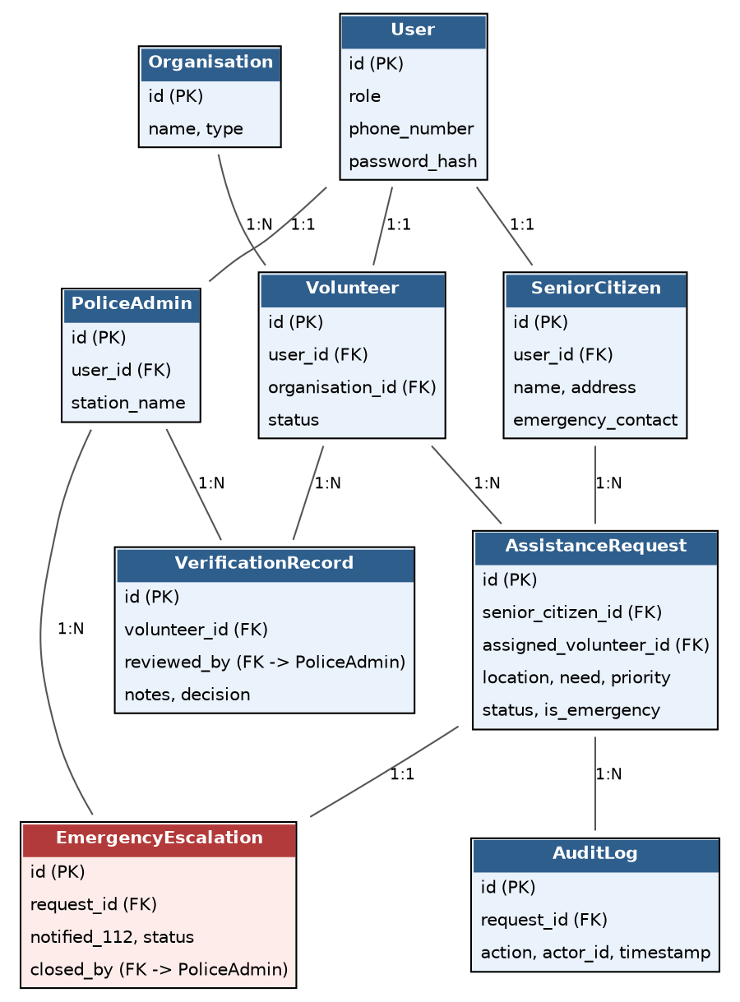
Figure 5 — Entity relationships across users, requests, verification, and escalation

Database Schema

TABLE: users
Column | Type | PK/FK | Nullable | Default | Description
id | UUID | PK | No | generated | Unique user identifier
role | ENUM | — | No | — | senior_citizen / volunteer / police_admin
phone_number | VARCHAR(15) | — | No | — | Unique login identifier; also used for voice-call lookup
password_hash | VARCHAR(255) | — | Yes | NULL | Bcrypt hash; senior citizens have none — they authenticate via voice/phone lookup only
created_at | TIMESTAMP | — | No | now() | Account creation time

TABLE: senior_citizens
Column | Type | PK/FK | Nullable | Default | Description
id | UUID | PK | No | generated | Unique senior citizen identifier
user_id | UUID | FK → users.id | No | — | Linked account
name | VARCHAR(100) | — | No | — | Full name
address | TEXT | — | No | — | Used for volunteer dispatch/proximity
emergency_contact | VARCHAR(15) | — | Yes | NULL | Backup contact used during escalation
created_at | TIMESTAMP | — | No | now() | Record creation time

TABLE: organisations
Column | Type | PK/FK | Nullable | Default | Description
id | UUID | PK | No | generated | Unique organisation identifier
name | VARCHAR(150) | — | No | — | e.g. Lions Club Shirva
type | VARCHAR(50) | — | No | — | Lions Club / NGO / Corporate / Independent
created_at | TIMESTAMP | — | No | now() | Record creation time

TABLE: volunteers
Column | Type | PK/FK | Nullable | Default | Description
id | UUID | PK | No | generated | Unique volunteer identifier
user_id | UUID | FK → users.id | No | — | Linked account
organisation_id | UUID | FK → organisations.id | Yes | NULL | Independent volunteers may have none
name | VARCHAR(100) | — | No | — | Full name
status | ENUM | — | No | 'registered' | registered / under_review / verified / active / rejected
created_at | TIMESTAMP | — | No | now() | Record creation time

TABLE: verification_records
Column | Type | PK/FK | Nullable | Default | Description
id | UUID | PK | No | generated | Unique verification record identifier
volunteer_id | UUID | FK → volunteers.id | No | — | Volunteer under review
reviewed_by | UUID | FK → police_admins.id | Yes | NULL | NULL until a police admin picks it up
notes | TEXT | — | Yes | NULL | Background-check notes
decision | ENUM | — | No | 'pending' | pending / approved / rejected
decided_at | TIMESTAMP | — | Yes | NULL | Set when a decision is recorded

TABLE: police_admins
Column | Type | PK/FK | Nullable | Default | Description
id | UUID | PK | No | generated | Unique police admin identifier
user_id | UUID | FK → users.id | No | — | Linked account
station_name | VARCHAR(100) | — | No | — | e.g. Shirva Police Station
badge_id | VARCHAR(50) | — | No | — | Official identifier for audit trail

TABLE: assistance_requests
Column | Type | PK/FK | Nullable | Default | Description
id | UUID | PK | No | generated | Unique request identifier
senior_citizen_id | UUID | FK → senior_citizens.id | No | — | Requester
assigned_volunteer_id | UUID | FK → volunteers.id | Yes | NULL | Set once assigned
location | TEXT | — | No | — | Where assistance is needed
need | TEXT | — | No | — | e.g. medicines from pharmacy
priority | ENUM | — | No | 'routine' | routine / urgent
is_emergency | BOOLEAN | — | No | false | True routes the request to the emergency flow
status | ENUM | — | No | 'open' | open / assigned / in_progress / completed / escalated / cancelled
created_at | TIMESTAMP | — | No | now() | Request creation time

TABLE: emergency_escalations
Column | Type | PK/FK | Nullable | Default | Description
id | UUID | PK | No | generated | Unique escalation record identifier
request_id | UUID | FK → assistance_requests.id | No | — | One-to-one with the originating request
notified_112 | BOOLEAN | — | No | true | Confirms 112/police were informed
status | ENUM | — | No | 'escalated' | escalated / closed
closed_by | UUID | FK → police_admins.id | Yes | NULL | Set when a police admin closes the record
created_at | TIMESTAMP | — | No | now() | Escalation creation time

TABLE: audit_logs
Column | Type | PK/FK | Nullable | Default | Description
id | UUID | PK | No | generated | Unique log entry identifier
request_id | UUID | FK → assistance_requests.id | Yes | NULL | NULL for non-request actions, e.g. volunteer verification
actor_id | UUID | FK → users.id | No | — | Who performed the action
action | VARCHAR(100) | — | No | — | e.g. STATUS_CHANGE: open→assigned
created_at | TIMESTAMP | — | No | now() | When the action occurred

5. Business Logic & Rules

Business Rules
ID | Rule | Enforced By
BR-01 | Only volunteers with status Verified or Active may be assigned to a request | Service layer check before PATCH /assign
BR-02 | A request with status Completed or Cancelled cannot be modified | Service-layer state-machine guard
BR-03 | A volunteer can only update requests currently assigned to them | Authorization middleware compares assigned_volunteer_id to the JWT subject
BR-04 | An emergency request (is_emergency = true) must have exactly one EmergencyEscalation record created atomically with it | Database transaction in the request-creation service
BR-05 | Only a Police Admin can change a volunteer's status to Verified or Rejected | RBAC middleware (role check)
BR-06 | A Completed request cannot be reopened; corrections require a new request | Service-layer state-machine guard

State / Workflow Transitions
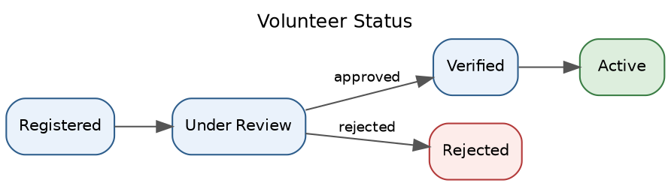
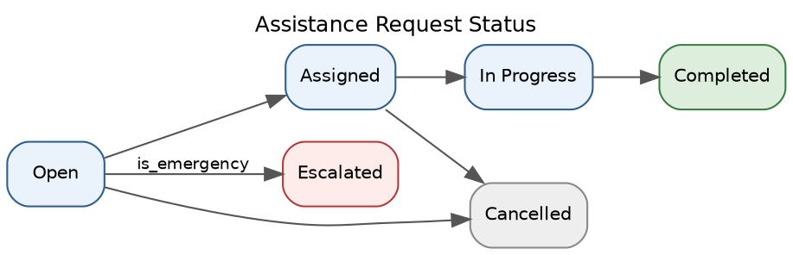

6. API Design

API Summary
ID | Method | Endpoint | Auth | Role | Purpose
API-01 | POST | /api/auth/register | Public | Volunteer / Police Admin | Register a new account
API-02 | POST | /api/auth/login | Public | All | Authenticate and issue a JWT
API-03 | POST | /api/volunteers | Public | Volunteer | Submit volunteer registration
API-04 | GET | /api/volunteers | Required | Police Admin | List volunteers, filterable by status
API-05 | PATCH | /api/volunteers/:id/review | Required | Police Admin | Add verification notes, move to Under Review
API-06 | PATCH | /api/volunteers/:id/verify | Required | Police Admin | Approve or reject a volunteer
API-07 | POST | /api/requests | Required (API key / JWT) | System (Voice) / Senior Citizen | Create a new assistance request
API-08 | GET | /api/requests | Required | Police Admin / Volunteer | List requests, scoped by role
API-09 | PATCH | /api/requests/:id/assign | Required | Police Admin / System | Assign the nearest verified volunteer
API-10 | PATCH | /api/requests/:id/accept | Required | Volunteer | Volunteer accepts an assigned request
API-11 | PATCH | /api/requests/:id/complete | Required | Volunteer | Mark a request as completed
API-12 | POST | /api/emergencies | Required (API key) | System | Log an emergency escalation for a request
API-13 | GET | /api/emergencies | Required | Police Admin | View all emergency escalation records
API-14 | PATCH | /api/emergencies/:id/close | Required | Police Admin | Close an emergency record after 112 response

Detailed Endpoint Contracts

API-03 — POST /api/volunteers
Field | Details
Purpose | Submit a new volunteer registration for police verification
Authentication | Public (self-registration)
Authorization | None — resulting record always starts as status = Registered
Parameters | None (body only)
Validation | name and phone_number required; phone_number must be unique; organisation_id must exist if provided
Success status | 201
Error statuses | 400 (missing/invalid field), 409 (phone number already registered)

Request example
{
"name": "Ramesh Kumar",
"phone_number": "9880012345",
"organisation_id": "org-1234"
}
Response example
{
"success": true,
"data": { "id": "vol-5678", "status": "registered" }
}

API-07 — POST /api/requests
Field | Details
Purpose | Create a new assistance request from a senior citizen, via voice intake or web
Authentication | Required (system API key for the voice webhook; JWT for web/app)
Authorization | System role or Senior Citizen role only
Parameters | None (body only)
Validation | senior_citizen_id, location, need required; priority defaults to 'routine'; is_emergency defaults to false
Success status | 201
Error statuses | 400 (missing/invalid field), 404 (senior citizen not found)

Request example
{
"senior_citizen_id": "sc-1001",
"location": "Shirva Main Road",
"need": "medicines from pharmacy",
"priority": "routine",
"is_emergency": false
}
Response example
{
"success": true,
"data": { "id": "req-2001", "status": "open" }
}

API-12 — POST /api/emergencies
Field | Details
Purpose | Log that a request has been flagged as an emergency and escalated to 112
Authentication | Required (system API key)
Authorization | System role only
Parameters | None (body only)
Validation | request_id required and must reference an existing request with is_emergency = true
Success status | 201
Error statuses | 400 (missing/invalid field), 404 (request not found), 409 (escalation already exists for this request)

Request example
{
"request_id": "req-2001",
"notified_112": true
}
Response example
{
"success": true,
"data": { "id": "esc-3001", "status": "escalated" }
}

7. Authentication & Authorization

Authentication
Item | Implementation
Authentication mechanism | JWT — senior citizens interact only via voice or the system API key, not direct login
Credential storage | Bcrypt password hashing (cost factor 12) for Volunteer and Police Admin accounts
Token / session lifetime | Access token: 15 minutes. Refresh token: 7 days
Refresh mechanism | POST /api/auth/refresh exchanges a valid refresh token for a new access token

RBAC Matrix
Action | Senior Citizen | Volunteer | Police Admin | System (Voice)
Create Request | ✗ | ✗ | ✗ | ✓
View Request | ✗ (voice only) | ✓ (assigned only) | ✓ (all) | ✓
Assign Request | ✗ | ✗ | ✓ | ✓
Accept / Complete Request | ✗ | ✓ (own only) | ✗ | ✗
Verify / Reject Volunteer | ✗ | ✗ | ✓ | ✗
Close Emergency Record | ✗ | ✗ | ✓ | ✗

Security Controls
Control | Approach
Input validation | Zod schema validation on every request body before it reaches business logic
Authorization | Express middleware checks the JWT role claim plus resource-ownership (e.g. assigned_volunteer_id === req.user.id) before the handler runs
Password security | Bcrypt, cost factor 12; passwords are never logged or returned in API responses
Sensitive data | Phone numbers and addresses are restricted to Police Admin and the owning user in API responses; the voice-webhook API key is stored as an environment secret, never in the database
Rate limiting | express-rate-limit on /api/auth/* and the voice-intake webhook (20 requests/min per IP) to prevent abuse

8. Background Processing & Services
None for Evaluation 1. All processing in this evaluation is synchronous within the request/response cycle; no queue, worker, or cron job is used.

9. External Integrations
ID | Service | Purpose | Direction | Data exchanged | Failure Behaviour
EXT-01 | Voice / IVR Platform (AI/ML track) | Convert a spoken request into structured text and an urgency classification | Service → Backend | senior_citizen_id (or phone lookup), transcribed need, urgency flag | If the webhook call fails or times out, the voice layer retries up to 3 times; after that the call is logged for manual follow-up
EXT-02 | 112 / Police Emergency System | Human notification of a genuine emergency; the backend only records that an escalation occurred | Backend → Service (logged, not automated) | Request location, senior citizen name and phone, nature of emergency | Not applicable in Evaluation 1 — the call to 112 itself is not automated; only the fact of escalation is logged

10. Error Handling & Reliability

Standard Error Response
{
"success": false,
"error": {
"code": "RESOURCE_NOT_FOUND",
"message": "Resource does not exist"
}
}

HTTP Status Conventions
Situation | Status | Example
Invalid input | 400 | Missing 'phone_number' in a registration request
Unauthenticated | 401 | Missing or expired JWT
Unauthorized | 403 | A volunteer attempts to close an emergency record
Not found | 404 | Request ID does not exist
Conflict | 409 | Duplicate phone number, or volunteer status is already 'active'
Server failure | 500 | Unhandled database connection error

Important Failure Scenarios
ID | Failure | Expected Backend Behaviour
ERR-01 | Database failure (PostgreSQL unreachable) | Return 500 with a generic error message; every status change is wrapped in a transaction so no partial writes occur; error is logged for on-call review
ERR-02 | External service unavailable (malformed voice/IVR payload) | Return 400 with validation details so the voice layer can retry with a corrected payload; the raw payload is logged for debugging
ERR-03 | Invalid state transition (e.g. completing an already-Completed request) | Reject with 409 Conflict; state remains unchanged
ERR-04 | Duplicate request/operation (e.g. escalation created twice for the same request) | Reject the second attempt with 409 and return the existing escalation record

11. Testing Strategy
REQ-01: Volunteer registration & verification · REQ-02: RBAC enforcement · REQ-03: Request lifecycle transitions · REQ-04: Emergency escalation logging
Test ID | Requirement / Flow | Scenario | Expected Result
T-01 | REQ-01 | Valid volunteer registration | 201; volunteer status = Registered
T-02 | REQ-01 | Registration missing phone_number | 400 validation error
T-03 | REQ-02 | A volunteer attempts to verify another volunteer | 403 rejection
T-04 | REQ-03 | Attempt to complete a Cancelled request | 409 Conflict; state unchanged
T-05 | REQ-04 | An emergency request is created | Escalation record auto-created with notified_112 = true

Critical Test Coverage
- Authentication / unauthenticated access
- Role-based authorization
- Resource ownership / assignment restrictions
- Validation and malformed input
- Important state transitions
- Critical database relationships and constraints
- External-service (voice webhook) failure handling

