FILE SHARING website
A minor project submitted for partial fulfillment of the requirements for the award of the degree of
Bachelor of Computer Applications
In
Information technology

Submitted by :
Shreya verma 245UCA080
Shivani singh 245UCA072
Dhruv singh 245UCA021
Nitin kohli 245UCA035
Supervised by:
Dr. Shiromani Balmukund Rahi
SCHOOL OF INFORMATION AND COMMUNICATION TECHNOLOGY
GAUTAM BUDDHA UNIVERSITY
GREATER NOIDA -201312, UTTAR PRADESH, INDIA
DATE : /02/2026

DECLARATION
I hereby declare that the minor project “File Sharing System Using Python Flask AND HTML” is an original work carried out by me under the guidance of [Dr. Shiromani Balmukund Rahi], [Gautam Buddha University].
This project report is submitted in partial fulfillment of the requirements for the award of [Bachelor Of Computer Application]. I further declare that this work has not been submitted previously to any other university or institution for the award of any degree, diploma, or certificate.
The information presented in this report is true to the best of my knowledge and belief.
Student Name:
Shreya Verma: 245UCA080
Shivani Singh: 245UCA072
Dhruv Singh:245UCA021
Nitin Kohli: 245UCA035
Signature: _____ _____ _____ _____

ACKNOWLEDGEMENT
I would like to express my sincere gratitude to my project guide for their valuable guidance, encouragement, and continuous support throughout the completion of my minor project “file sharing using python and Flask.” Their suggestions and feedback helped me understand the concepts clearly and complete the project successfully. I am also thankful to the Head of Department and all faculty members of [GAUTUM BUDDHA UNIVERSITY] for providing the necessary resources and academic environment to carry out this work.
I extend my heartfelt thanks to my friends and family for their motivation, cooperation, and moral support during the development of this project. Finally, I am grateful to everyone who directly or indirectly contributed to the successful completion of this project.

Shreya verma (245UCA080)
SHIVANI SINGH (245UCA072)
DHRUV SINGH (245UCA021)
NITIN KOHLI (245UCA035)

ABSTRACT
The File Sharing System Using Python and Flask is a web-based application developed to provide a simple and secure platform for uploading, storing, and downloading files online. The main objective of this project is to enable users to share files efficiently through a centralized system instead of using traditional methods such as email or physical storage devices.
The system is developed using Python with the Flask framework for backend processing, HTML and CSS for the user interface, and an SQL database for storing user and file information. It includes features such as user authentication, file upload, file storage on the server, and file download functionality.
This project demonstrates the practical implementation of web development concepts, database connectivity, and file handling techniques. The developed system is suitable for small organizations, educational institutions, and personal use, and it can be further enhanced with advanced security and cloud integration features.

CERTIFICATE
This is to certify that [SHREYA VERMA 245UCA080, DHRUV SINGH 245UCA021, SHIVANI SINGH 245UCA072, NITIN KOHLI 245UCA035], a student of, [ BCA / IT / Sem IV ] at [GAUTAM BUDDHA UNIVERSITY ], has successfully completed the minor project “File Sharing System Using Python and Flask” during the academic year [2026] under my supervision.
During the project, the student demonstrated good understanding, sincerity, and dedication in designing and developing the web-based file sharing system, including implementation, testing, and documentation.
I wish the student success in future academic and professional pursuits.
Project Guide Signature: ____________
Name: Dr. Shiromani balmukund
Date: /02/2026
Head of Department: Dr. Neeta Singh

TABLE OF CONTENTS

- Introduction
- System requirement
- System architecture
- Flowchart
- Implementation
- Results
- Future scope
- Conclusion
- References

INTRODUCTION
With the increasing use of digital platforms, file sharing has become an essential requirement in educational institutions and organizations. Traditional methods like USB drives or email attachments are slow and inefficient. A web-based file sharing system Lack centralized storage and secure solution.
- Problem Statement
Existing file sharing methods:
- Lack centralized storage
- Are not secure enough
- Make file access difficult
- Hence, a secure online file sharing platform is needed.
- Objectives
To build a web-based file sharing system:
    - To allow users to upload and download files.
    - To provide user authentication.
    - To store file information in a database.
    - To create a simple and user-friendly interface.
- Scope of Project
This system can be used in:
- User registration and login authentication
- Colleges for assignment submission
- Offices for document sharing
- Personal cloud storage systems
- Database integration for storing user and file information
- Basic input validation and error handling.
The developed system can be extended in the future by adding cloud storage integration, file sharing through links, role-based access control, email notifications, and enhanced security mechanisms.
SYSTEM REQUIREMENT
- The proposed system is a web application where
- Users register/login
- Upload files to the server
- View uploaded files
- Download shared files

- System Architecture
- Frontend: HTML, CSS
- Backend: Python Flask
- Database: SQL (SQLite/MySQL)
- Server: Localhost / Web server
- Flow: User → Browser → Flask Server → Database → File Storage
- Modules
- User Authentication Module.
- File Upload Module.
- File Download Module.
- Database Management Module
- Database Design
  - Table1: User_id, User_name, password
  - Table2: Files_id, File_name, File_path
- Purpose
- To store login credentials
- To authenticate users
- To identify who uploaded files
- To store file details
- To link file with user
- To manage downloads
- Database flow
- User registers → Data stored in USERS table
- User logs in → Credentials verified from USERS table
- User uploads file → File stored in server folder
- File details saved in FILES table
- User downloads file → Data retrieved using FILES table
Flowchart
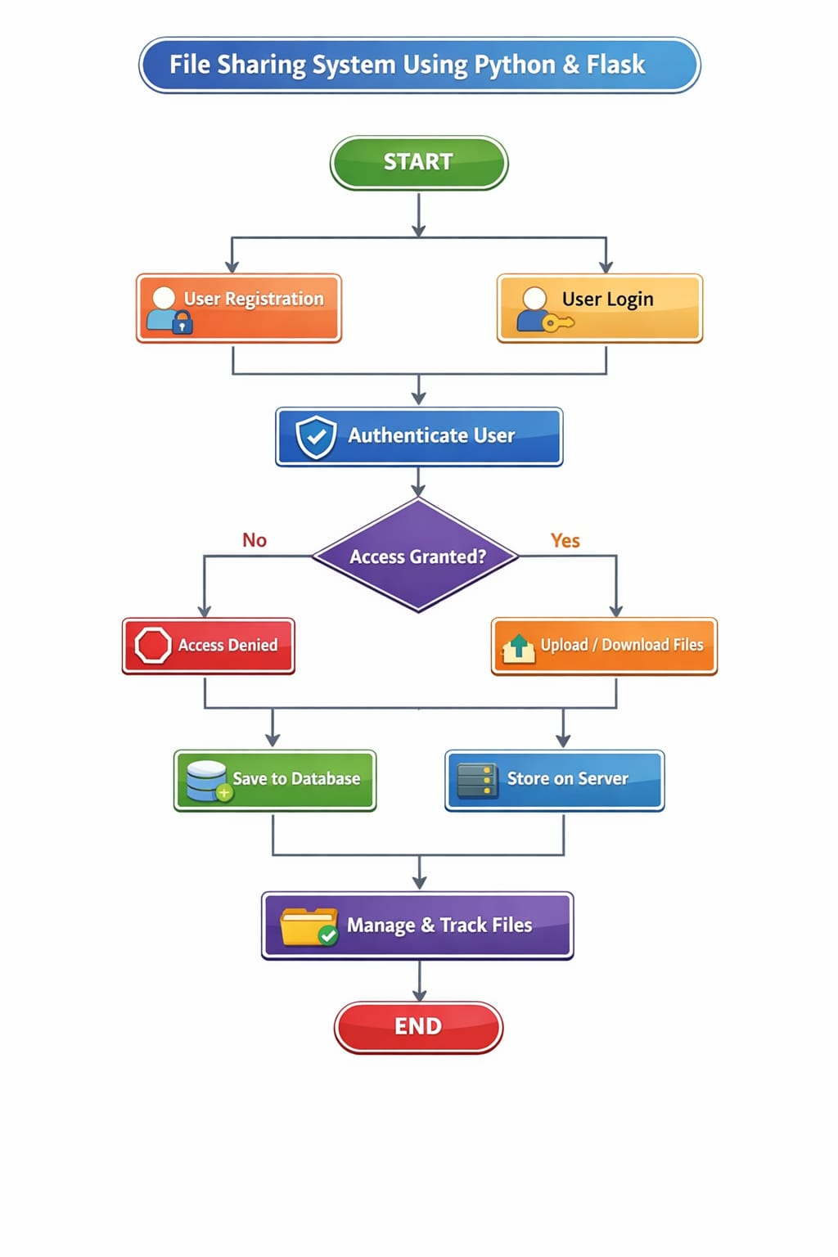

IMPLEMENTATION
- Tools and Technologies Used
- Python
- Flask Framework
- HTML/CSS
- SQL Database
- VS Code
- Working Process:
- User opens the website
- Registers or logs in
- Uploads file using upload form
- Flask saves file in server folder
- File details stored in database
- Files displayed on dashboard
- User downloads files when needed
- Sample Functionalities:
- Login page validation
- Secure file upload handling
- File storage in server directory
- Database connection using flask
RESULT
- Output
- Login page works successfully
- File upload completed without errors
- Uploaded files visible in dashboard
- Download functionality works correctly
- Testing
- Tested multiple file uploads
- Tested login authentication
- Tested invalid input handling

FUTURE SCOPE
- Add file size limits
- This feature restricts users from uploading files beyond a specified size limit.
- It helps prevent server overload and saves storage space.
- The limit can be set in Flask configuration for better performance control.
❖ Add Cloud Storage Integration
- Files can be stored on cloud platforms instead of a local server.
- This improves scalability, reliability, and accessibility from anywhere.
- It also ensures better backup and data security management.
❖ Add Email Notification Feature
- Users receive email alerts after file upload or sharing.
- It improves communication and keeps users informed instantly.
- This can be implemented using email services integrated with the backend.
❖ Add File Sharing via Links
- Users can generate unique links to share files with others.
- The link can include expiry time or password protection.
- This makes file sharing faster and more convenient.
❖ Improve UI Design
- Enhancing the interface makes the system more attractive and user-friendly.
- Better layouts, colors, and navigation improve user experience.
- Responsive design ensures proper display on all devices.
❖ Mobile App Version
- A mobile application allows users to access files on smartphones.
- It increases accessibility and convenience for users on the go.
- The app can connect to the same backend API used by the web system.

CONCLUSION
The File Sharing System was successfully designed and implemented using Python and Flask. The system allows users to upload, store, and download files securely. It demonstrates the integration of frontend design, backend processing, and database management. The project meets its objectives and provides a strong foundation for future enhancements like cloud integration, advanced security features, and improved user interface design. The project demonstrates the practical application of web development concepts, including user authentication, database connectivity, and server-side file handling.

References
- Python Official Documentation
- Flask Documentation
- SQL Database Tutorials
- Web Development Learning Resources

