|  |  |  |
| --- | --- | --- |
| **Name : Shreya Singh** | **Class/Roll No. : D16AD/55** | **Grade :** |

**Title of Experiment :**

To implement the following programs using Map Reduce:

a. Word Count

b. matrix-vector multiplication

**Objective of Experiment :**

a. Word Count using MapReduce:

Implement the Word Count program using the MapReduce paradigm to

efficiently calculate the frequency of each word in a given text corpus.

b. Matrix-Vector Multiplication using MapReduce:

Develop a MapReduce solution for performing matrix-vector multiplication,

aiming to efficiently compute the product of a matrix and a vector by

distributing the computation across a cluster of nodes.

**Outcome of Experiment :**

Implementation of WordCount and Matrix-Vector Multiplication programs using Map Reduce in Hadoop

**Problem Statement :**

a. Word Count using MapReduce:

Develop a MapReduce program to analyze a large text dataset and determine the

frequency of each unique word present in the corpus. The program should take

advantage of parallel processing to efficiently handle the computation and provide

an accurate count of word occurrences.

b. Matrix-Vector Multiplication using MapReduce:

Create a MapReduce solution to perform matrix-vector multiplication. Given a

matrix and a vector, the program should distribute the computation across multiple

nodes, effectively calculating the product and generating the resulting vector.

**Description / Theory :**

Hadoop MapReduce:

Hadoop MapReduce is a programming model and processing framework designed to

handle large-scale data processing tasks across clusters of computers. It's used to

efficiently process and analyze vast amounts of data in parallel, making it suitable for

tasks like data transformation, aggregation, and more. Here's a concise explanation of

how Hadoop MapReduce works:

Input Splitting: The input data is divided into smaller chunks called "input

splits." Each split is processed independently by a separate mapper task.

Mapping: The mapper task takes an input split and applies a user-defined "map"

function to it. The map function transforms the input data into a set of key-value

pairs.

Shuffling and Sorting: The framework groups and sorts the output of all mappers

based on the keys. This step ensures that all values associated with the same key

are brought together, preparing them for the next phase.

Reducing: The reducer tasks take the sorted key-value pairs and apply a user-

defined "reduce" function to them. This function performs operations like

aggregation, summarization, or any other processing needed. Reducers process

data for each key, producing final results.

Output: The final results of the reduced tasks are collected and saved as output

files, which can then be used for further analysis or storage.

Hadoop MapReduce's power lies in its ability to distribute the processing of data across

multiple nodes in a cluster, making it highly scalable and fault-tolerant. The map and

reduce functions are written by the user, allowing customization for specific processing

needs. While MapReduce is effective for batch processing tasks, it's worth noting that

other frameworks like Apache Spark have evolved to provide more advanced

capabilities and optimizations for various data processing scenarios.4

**Program**:

A. To implement the Word Count

import java.io.IOException;

import java.util.StringTokenizer;

import org.apache.hadoop.conf.Configuration;

import org.apache.hadoop.fs.Path;

import org.apache.hadoop.io.IntWritable;

import org.apache.hadoop.io.Text;

import org.apache.hadoop.mapreduce.Job;

import org.apache.hadoop.mapreduce.Mapper;

import org.apache.hadoop.mapreduce.Reducer;

import org.apache.hadoop.mapreduce.lib.input.FileInputFormat;

import org.apache.hadoop.mapreduce.lib.output.FileOutputFormat;

public class WordCount {

public static class TokenizerMapper

extends Mapper<Object, Text, Text, IntWritable>{

private final static IntWritable one = new IntWritable(1);

private Text word = new Text();

public void map(Object key, Text value, Context context

) throws IOException, InterruptedException {

StringTokenizer itr = new StringTokenizer(value.toString());

while (itr.hasMoreTokens()) {

word.set(itr.nextToken());

context.write(word, one);

}

}

}

public static class IntSumReducer

extends Reducer<Text,IntWritable,Text,IntWritable> {

private IntWritable result = new IntWritable();

public void reduce(Text key, Iterable<IntWritable> values,

Context context

) throws IOException, InterruptedException {

int sum = 0;

for (IntWritable val : values) {

sum += val.get();

}

result.set(sum);

context.write(key, result);

}

}

public static void main(String[] args) throws Exception {

Configuration conf = new Configuration();

Job job = Job.getInstance(conf, "word count");

job.setJarByClass(WordCount.class);

job.setMapperClass(TokenizerMapper.class);

job.setCombinerClass(IntSumReducer.class);

job.setReducerClass(IntSumReducer.class);

job.setOutputKeyClass(Text.class);

job.setOutputValueClass(IntWritable.class);

FileInputFormat.addInputPath(job, new Path(args[0]));

FileOutputFormat.setOutputPath(job, new Path(args[1]));

System.exit(job.waitForCompletion(true) ? 0 : 1);

}

}

**Output**:

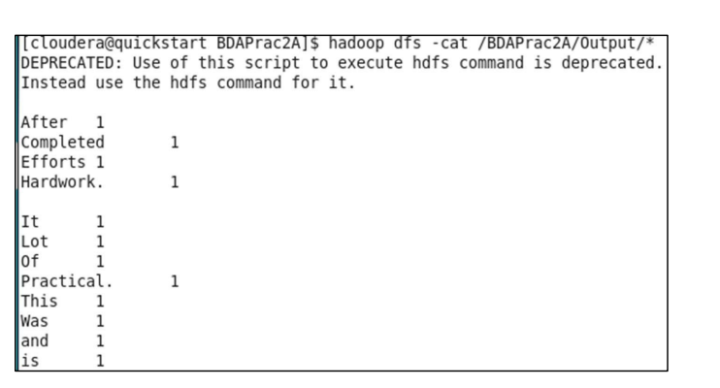

B. **Matrix-Vector multiplication**

Program:

public class MatrixVectorMultiplication {

public static void main(String[] args) {

// Define the matrix and vector

int[][] matrix = {{1, 2, 3}, {4, 5, 6}, {7, 8, 9}};

int[] vector = {2, 3, 4};

// Check if matrix and vector dimensions are compatible

int matrixRows = matrix.length;

int matrixCols = matrix[0].length;

int vectorSize = vector.length;

if (matrixCols != vectorSize) {

System.out.println("Matrix and vector dimensions are not compatible for

multiplication.");

return;

}

// Perform matrix-vector multiplication

int[] result = new int[matrixRows];

for (int i = 0; i < matrixRows; i++) {

for (int j = 0; j < matrixCols; j++) {

result[i] += matrix[i][j] * vector[j];

}

}

// Display the result

System.out.println("Result of matrix-vector multiplication:");

for (int i = 0; i < matrixRows; i++) {

System.out.println(result[i]);

}

}

}

**Output**:

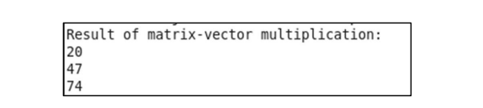

**Results and Discussions:**

MapReduce is a parallel processing model for large-scale data.

Word Count:

Result: Efficiently counts word occurrences in texts.

Discussion: Map phase splits text, emits (word, 1). Reduce phase aggregate counts. Scales well for basic tasks.

Matrix-Vector Multiplication:

Result: Computes matrix-vector product.

Discussion: Mappers process matrix rows to emit (col, partial) pairs. Reduce combines partials for results. Shows distributed linear algebra.

Overall Discussion:

MapReduce simplifies parallel processing, automating distribution and fault tolerance. While powerful, newer models like Apache Spark offer more features and speed