

Artificial Intelligence and Data Science Department

Big Data Analytics/Odd Sem 2023-23/Experiment 3

| Name: Heramb Ramakant Pawar | Class/Roll No.: D16AD/67 | Grade: |
| --- | --- | --- |

Title of Experiment: Use Sqoop to load data from RDBMS (weblog/ transactions data) and analyze it using HIVE/PIG.

Objective of Experiment:

The objective of this project is to use Sqoop, Hive, and Pig to efficiently extract, transform, and analyze data from a relational database management system (RDBMS), specifically weblog or transactional data

Outcome of Experiment:

Thus we use Sqoop to load data from RDBMS( MySql) and analyzed it using HIVE/PIG

Problem Statement:

The challenge is to efficiently extract, transform, and analyze large volumes of weblog or transactional data from a relational database using Sqoop, Hive, and Pig within a scalable and performance-optimized Hadoop ecosystem, ensuring data quality and delivering valuable insights for informed decision-making

Description / Theory:

Hadoop Eco-System:

The Hadoop ecosystem is a collection of open-source software tools and frameworks designed to process, store, and analyze large volumes of data in a distributed computing environment. Here's a brief overview of some key components within the Hadoop ecosystem:

1. HDFS (Hadoop Distributed File System) 2. MapReduce

3. YARN (Yet Another Resource Negotiator) 4. Apache Spark

5. Hive

6. Pig

7. HBase

8. ZooKeeper 9. Sqoop

10. Flume



Artificial Intelligence and Data Science Department

Big Data Analytics/Odd Sem 2023-23/Experiment 3

Hive:

Hive is like a translator for Hadoop. It allows you to write queries in a language similar to SQL (called HiveQL) and then translates those queries into MapReduce jobs that can be executed on a Hadoop cluster.

It's great for data analysts who are familiar with SQL because they can use Hive to query and analyze data stored in Hadoop's distributed file system (HDFS).

Pig:

Pig is a platform that simplifies the process of writing data transformations for Hadoop. Instead of writing complex Java code for MapReduce, you can use a simple scripting language called Pig Latin.

Pig is handy when you need to process and clean large amounts of data before analyzing it. It's especially useful for ETL (Extract, Transform, Load) tasks.

Sqoop:

Sqoop is a tool for efficiently transferring data between Hadoop and relational databases (like MySQL or Oracle). It helps you import data from databases into Hadoop or export data from Hadoop back to databases.

Sqoop is essential when you have data in traditional databases that you want to analyze with Hadoop. It makes the data import/export process straightforward and automated.



Artificial Intelligence and Data Science Department

Big Data Analytics/Odd Sem 2023-23/Experiment 3

Output:

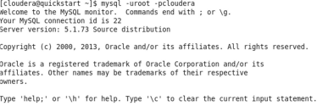





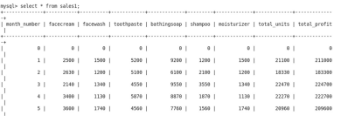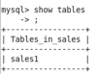



Artificial Intelligence and Data Science Department

Big Data Analytics/Odd Sem 2023-23/Experiment 3

Importing tables from RDMS to HDFS using Sqoop:

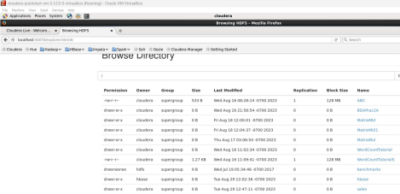

Importing Table From HDFS to HIVE:

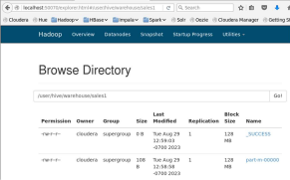



Artificial Intelligence and Data Science Department

Big Data Analytics/Odd Sem 2023-23/Experiment 3

Going to Hue Editor, Importing table, Writing Query And Doing Visualization. Running Some Queries:





Artificial Intelligence and Data Science Department

Big Data Analytics/Odd Sem 2023-23/Experiment 3

Result and Discussion:

We began by accessing MySQL on Cloudera and creating a database and table to serve as our source of data. Next, we employed Sqoop to seamlessly import this data into the Hadoop Distributed File System (HDFS), facilitating easy access and processing. Once the data resided in HDFS, we leveraged HIVE to import the data into its structured tables, making it readily available for querying and analysis.

Finally, using the Hue editor, we crafted SQL queries and performed visualizations to gain insights from the imported data. This experiment enabled us to seamlessly bridge the gap between traditional RDBMS data and Hadoop's distributed processing capabilities, showcasing the power of Sqoop as a data ingestion tool and the analytical prowess of HIVE and PIG.

In conclusion, our experiment successfully demonstrated the efficient transfer of data from an RDBMS to HDFS using Sqoop, followed by the analysis of this data through HIVE and PIG. This process showcased the versatility of Hadoop in handling large-scale data analysis tasks and emphasized the importance of data integration and analysis tools like Sqoop, HIVE, and PIG in today's data-driven landscape.