|  |  |  |
| --- | --- | --- |
| **Name : Shreya Singh** | **Class/Roll No. : D16AD/55** | **Grade :** |

**Title of Experiment :**

3) Apply any of the following learning algorithms to learn the

parameters of the supervised single layer feed forward neural

network.

o Stochastic Gradient Descent

o Mini Batch Gradient Descent

o Momentum GD

o Nestorev GD

o Adagrad GD

o Adam Learning GD

4) Implement a backpropagation algorithm to train a DNN with at least 2 hidden layers.

5) Design and implement a fully connected deep neural network with at least hidden layers for a classification application. Use appropriate Learning Algorithm, output function and loss function.

**Objective of Experiment :** To implement various training algorithms for feedforward neural networks.

To design deep learning models for supervised, unsupervised and sequence learning.

**Outcome of Experiment :** Design and train feedforward neural networks using various learning algorithms**.**

**Description / Theory :**

FEED FORWARD NN:

A feedforward neural network is a fundamental type of artificial neural network where the connections between nodes (neurons) do not form any cycles. It consists of an input layer, one or more hidden layers, and an output layer. The information flows through the network in one direction, from the input layer through the hidden layers to the output layer. Each neuron in a layer is connected to every neuron in the subsequent layer.

SGD:

Stochastic Gradient Descent (SGD) is an optimization algorithm commonly used in training machine learning models, particularly in scenarios where the dataset is large and it's not feasible to compute the gradient of the entire dataset at each iteration. Instead of using the entire dataset, SGD processes individual or small subsets of data (mini-batches) to update the model parameters, which can lead to faster convergence and reduced computational requirements. However, due to the random nature of selecting mini-batches, the optimization process becomes stochastic in nature.

Mini-Batch GD:

In Mini-Batch GD, the training dataset is divided into smaller subsets called mini-batches. Instead of updating the model parameters after each data point (Stochastic GD) or after the entire dataset (Batch GD), Mini-Batch GD updates the parameters after processing each mini-batch. Adam-Learning GD The key idea behind the Adam optimizer is to maintain an exponentially moving average of both the gradients and the squared gradients (similar to RMSProp). This allows the optimizer to adaptively adjust the learning rates for each parameter based on their historical gradients. Additionally, Adam incorporates bias correction mechanisms to counteract the effect of the moving average initialization.

**Program And Output:**

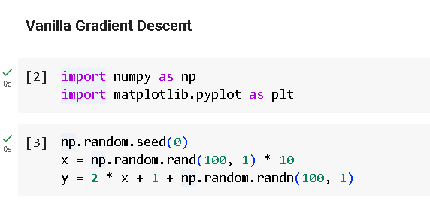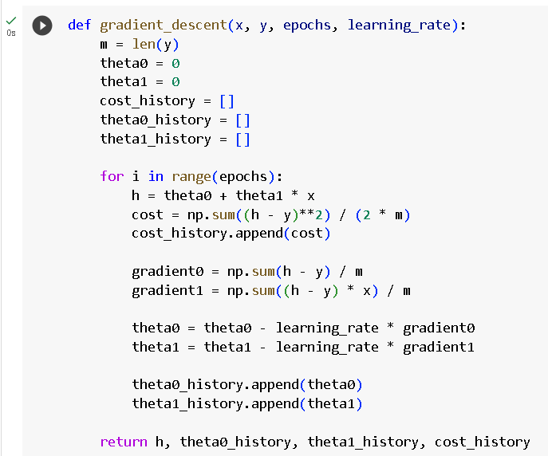

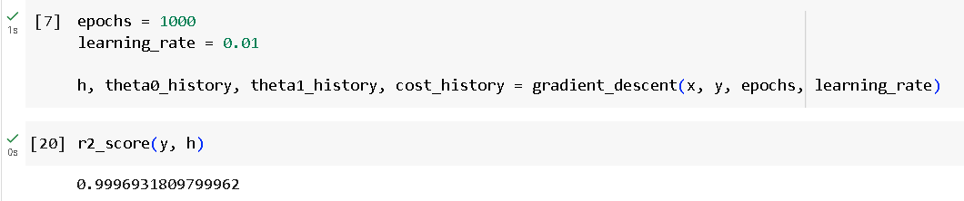

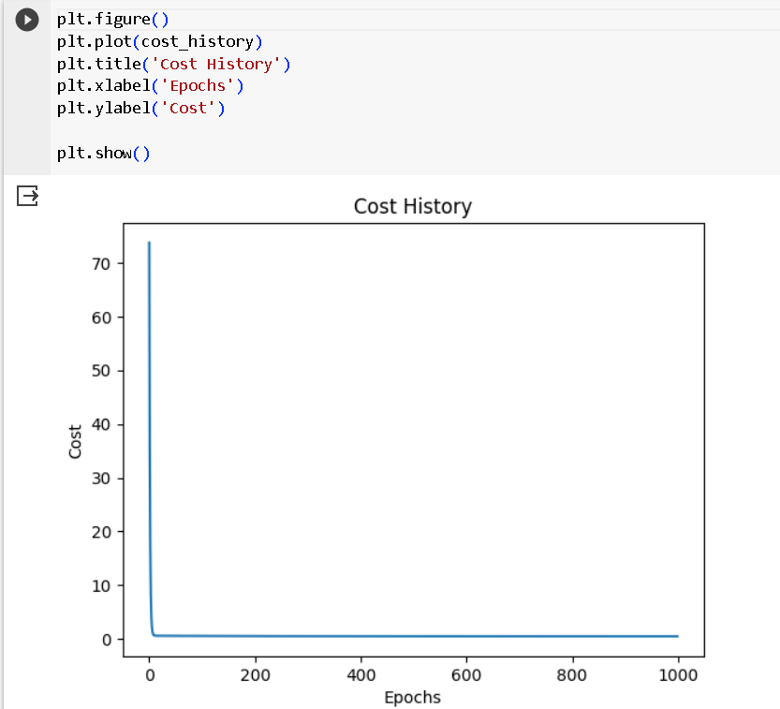

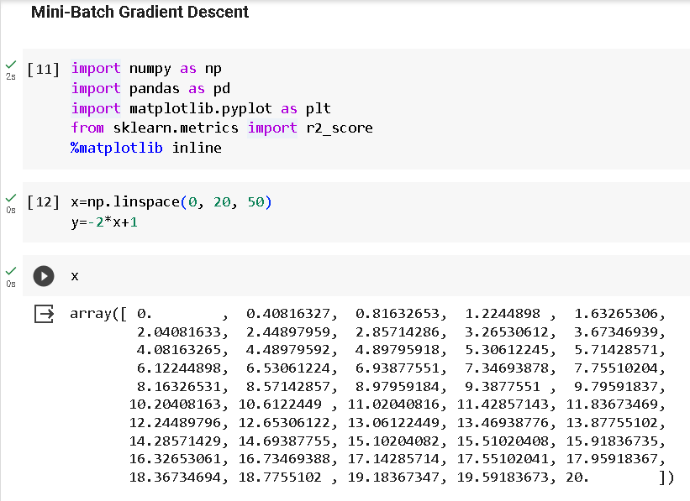

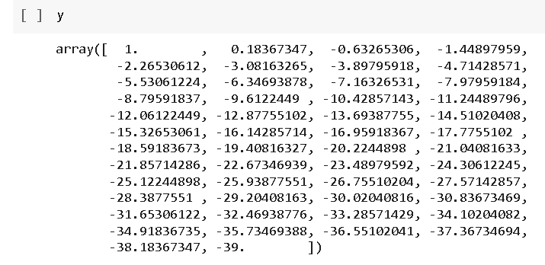

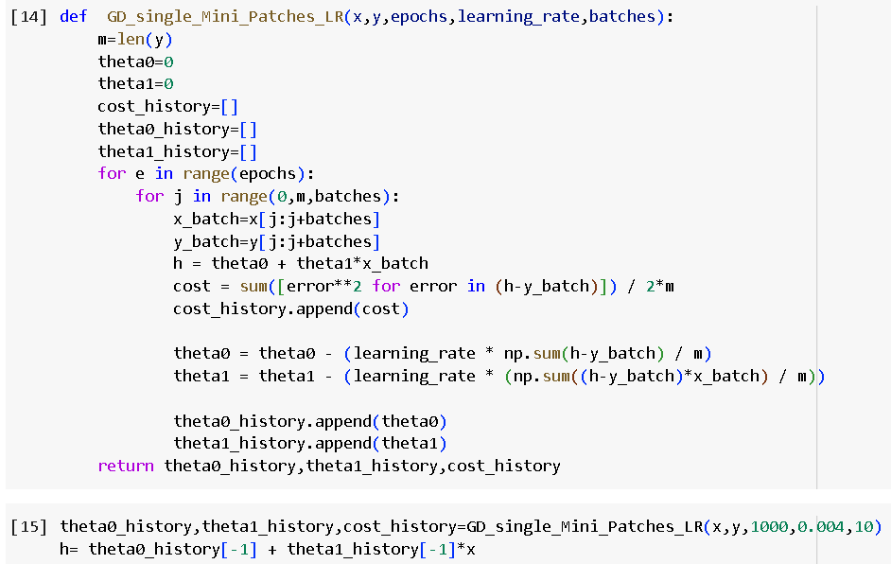

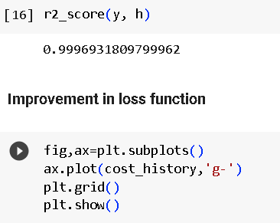

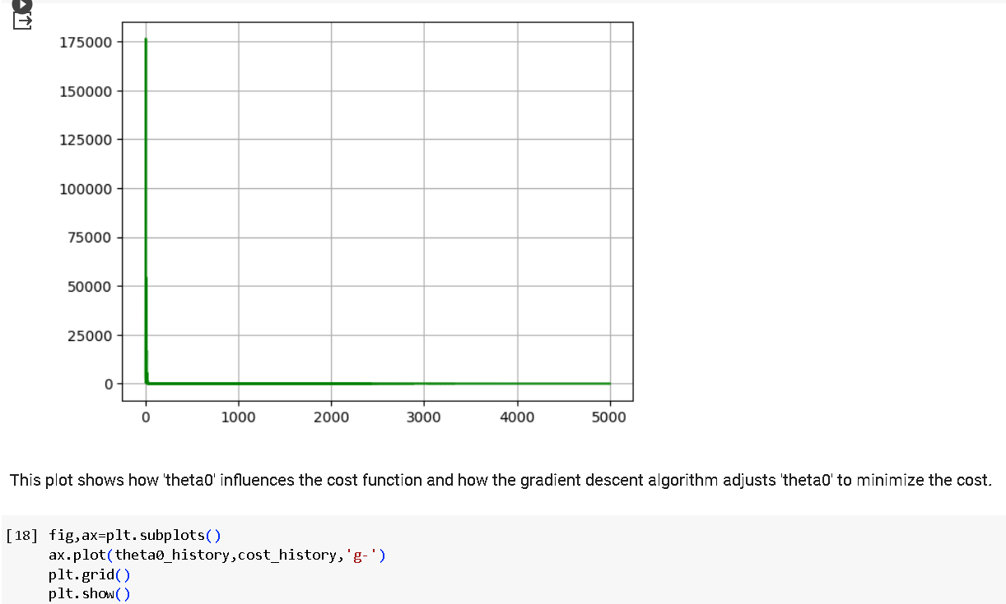

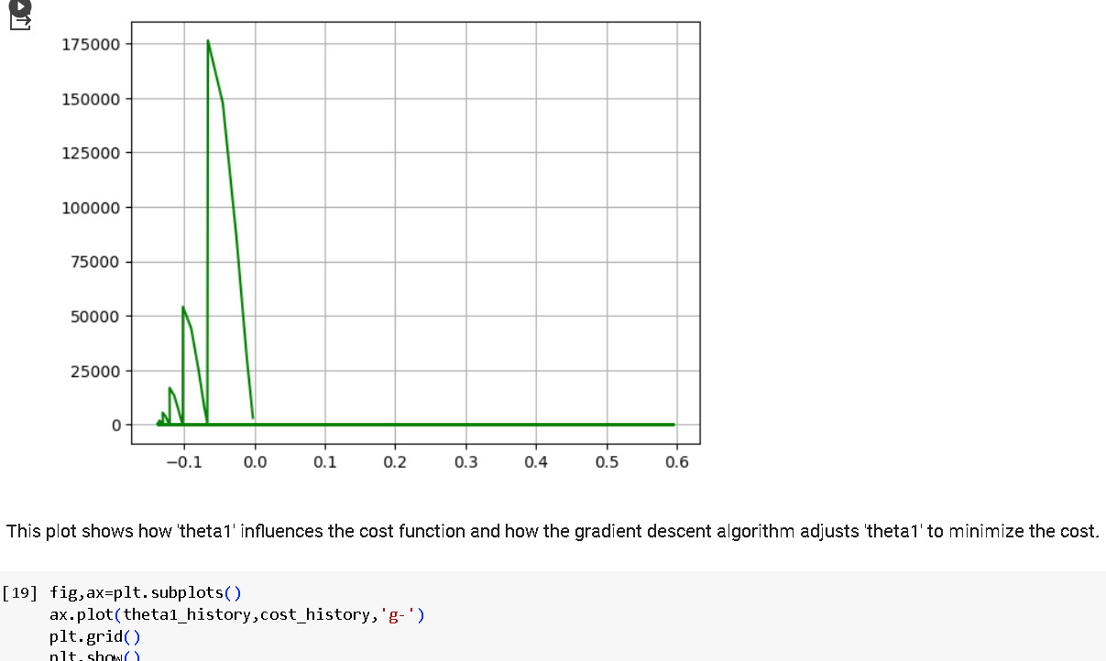

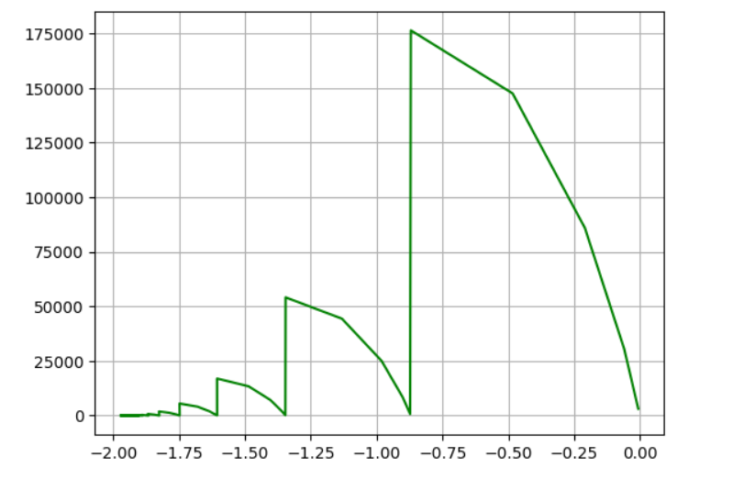

**Results and Discussions :**

The trained feedforward neural networks exhibited varying performances across different learning algorithms. Gradient Descent demonstrated slower convergence compared to Stochastic Gradient Descent and Mini-batch Gradient Descent, highlighting the importance of efficient optimization methods. Adaptive algorithms like Adam showed faster convergence and superior generalization. Hyperparameter tuning significantly impacted model outcomes; smaller learning rates often led to smoother convergence, while larger rates risked overshooting. Regularization techniques, like dropout, effectively mitigated overfitting, improving validation accuracy. Interpretability challenges arose due to the complex nature of neural networks. Future work should explore advanced architectures and address ethical considerations related to bias and fairness