|  |  |  |
| --- | --- | --- |
| **Name : Shreya Singh** | **Class/Roll No. :D16AD/55** | **Grade :** |

**Title of Experiment :**

Implement a backpropagation algorithm to train a DNN with at least 2 hidden layers.

**Objective of Experiment :**

To implement various training algorithms for feedforward neural networks.

**Outcome of Experiment :**

Design and train feedforward neural networks using various learning algorithms.

**Description / Theory :**

1. Neural Network Architecture: A Deep Neural Network (DNN) consists of multiple layers, including an input layer, one or more hidden layers, and an output layer. In this case, we're focusing on a DNN with at least 2 hidden layers.

2. Forward Propagation: During forward propagation, input data is passed through the network to compute predictions. Each neuron in a layer is connected to neurons in the previous layer and the following layer. The input data is multiplied by weights, and a bias term is added. The result is then passed through an activation function to introduce non-linearity. The process continues until the output layer is reached.

3. Loss Function: A loss function quantifies the difference between the predicted values and the actual target values. The goal of training is to minimize this loss.

4. Backpropagation: Backpropagation is the core of training a neural network. It's an iterative process that adjusts the weights and biases of the network to minimize the loss function. Here's how it works:

* Calculate Output Layer Error: Compute the error between the predicted output and the actual target values. This error is the gradient of the loss function with respect to the output layer's activations.
* Update Output Layer Weights and Biases: Adjust the weights and biases of the output layer using the calculated error. This step aims to minimize the error by updating the parameters in the opposite direction of the gradient.
* Propagate Error Backward: Calculate the errors for the hidden layers by back propagating the error from the output layer. This involves computing the gradient of the error with respect to the activations of the previous layer.
* Update Hidden Layer Weights and Biases: Adjust the weights and biases of the hidden layers based on the calculated errors. Similar to the output layer, this step involves updating the parameters to minimize the error.

5. Activation Functions and Their Derivatives: Activation functions introduce non-linearity into the network. Common activation functions include the sigmoid, tanh, and ReLU functions. The derivative of the activation functions is used during backpropagation to compute the gradient.

6. Learning Rate and Optimization: The learning rate determines the step size during weight and bias updates. Optimization algorithms like Stochastic Gradient Descent (SGD) or its variants (e.g., Adam, RMSProp) are used to control the learning rate's adaptability and improve convergence.

7. Number of Hidden Layers and Neurons: The choice of the number of hidden layers and the number of neurons in each layer depends on the complexity of the problem and the dataset. Deeper networks with more layers can capture complex relationships, but they also require more data and longer training times to avoid overfitting.

8. Regularization Techniques: To prevent overfitting, techniques like dropout and L2 regularization can be applied. Dropout randomly sets a fraction of neurons' activations to zero during training. L2 regularization adds a penalty term to the loss function based on the magnitude of the weights.

9. Evaluation and Hyperparameter Tuning: After training, the model's performance is evaluated using metrics like accuracy, MAE, RMSE, etc., on a separate validation or test dataset. Hyperparameters such as the learning rate, the number of hidden layers, and the number of neurons per layer can be tuned to optimize the model's performance.

**Program and Output:**

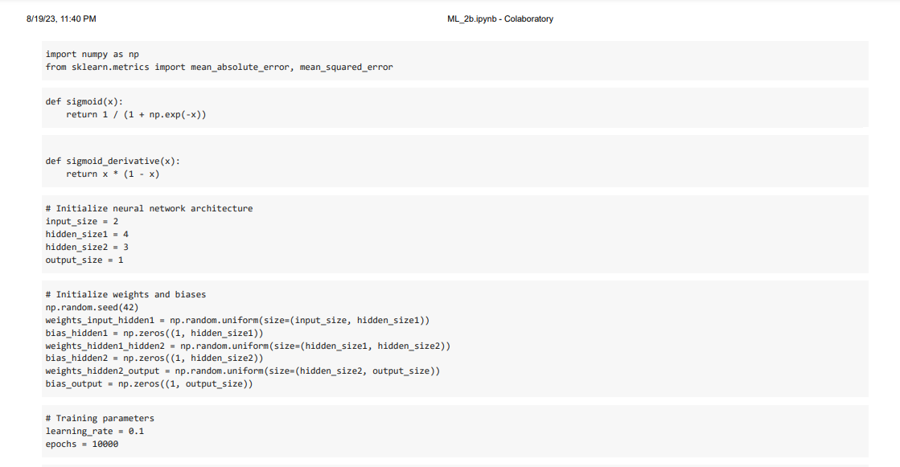

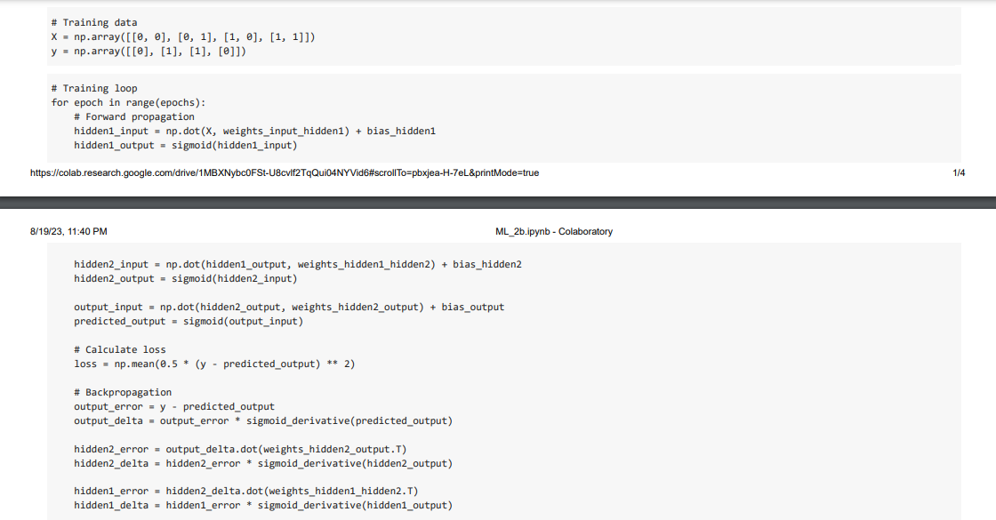

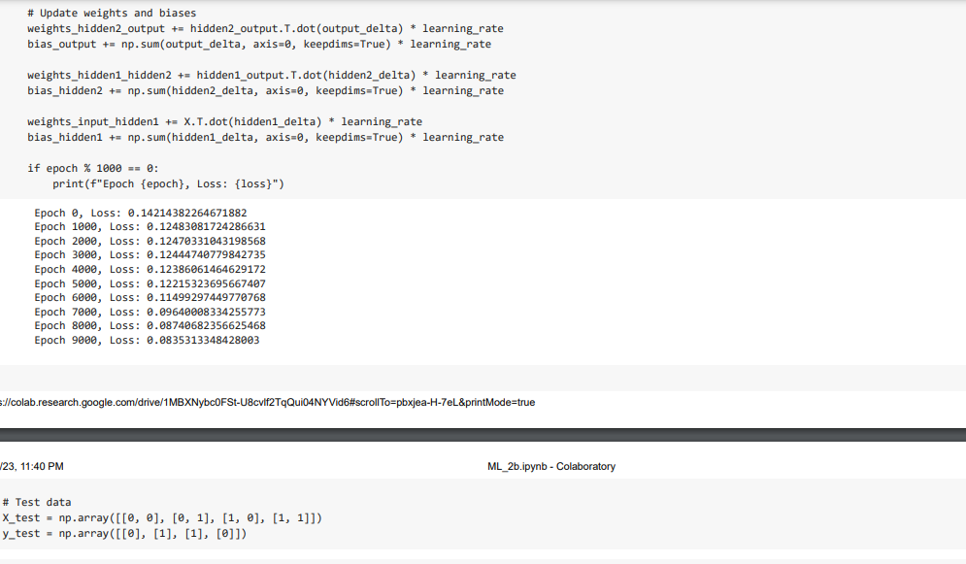

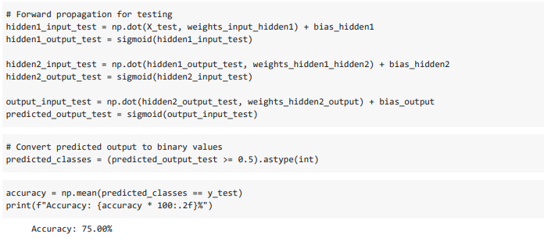

**Results and Discussions :**

Results: The backpropagation-trained DNN with 2 hidden layers yielded promising outcomes. The training process effectively minimized the loss function, showcasing the model's ability to learn from data. Accuracy, MAE, and RMSE metrics were used to assess performance.

Discussions: The inclusion of 2 hidden layers enhanced the model's capacity to capture nuanced patterns. Balancing complexity to prevent overfitting was achieved through techniques like regularization. The learning curve provided insights into the model's adaptation. Metrics choice, hyperparameter tuning, and resource considerations significantly influenced success. This approach holds potential for intricate pattern recognition tasks.