|  |  |  |
| --- | --- | --- |
| **Name : Shreya Singh** | **Class/Roll No. :D16AD/55** | **Grade :** |

**Title of Experiment :**

Autoencoder for image denoising

**Objective of Experiment :**

Develop and evaluate an Autoencoder-based image denoising system to effectively remove noise from images while preserving essential image details.

**Outcome of Experiment :**

We have used an Autoencoder for Image Denoising

**Problem Statement :**

Image denoising is essential for improving image quality in various applications, but existing methods may struggle to strike the right balance between noise reduction and preserving image details. This experiment aims to address this challenge by developing an Autoencoder-based denoising approach.

**Description / Theory :**

The theory underlying the image denoising experiment using Autoencoders revolves around the principles of deep learning and neural network architectures. Here's a concise overview of the key theoretical concepts:

* **Noise in Images:** In various imaging scenarios, such as photography, medical imaging, or remote sensing, images often suffer from noise. Noise is an undesirable and random variation in pixel values caused by factors like sensor limitations, low-light conditions, or data transmission errors. It can manifest as salt-and-pepper noise, Gaussian noise, or other forms, degrading image quality and hampering subsequent analysis.
* **Autoencoder Architecture:** An Autoencoder is a type of neural network consisting of two main components: an encoder and a decoder. The encoder compresses input data into a lower-dimensional representation (latent space), while the decoder reconstructs the data from this representation. The encoder-decoder structure is symmetrical, and the network learns to extract essential features from the input.
* **Feature Learning:** Autoencoders excel at unsupervised feature learning. During training, the encoder learns to encode input images, including both the signal (meaningful image features) and noise. This process is essential for image denoising, as the network needs to distinguish between useful features and noise components.
* **Noise Removal:** The denoising process relies on the Autoencoder's ability to capture and model the underlying structure of the data. When presented with noisy input images during training (noisy images paired with clean versions), the Autoencoder learns to map noisy inputs to their corresponding clean representations. By minimizing the reconstruction loss, typically using Mean Squared Error (MSE) or other suitable loss functions, the network effectively separates noise from the signal during the encoding-decoding process.
* **Generalization:** A well-trained Autoencoder should generalize to denoise unseen images effectively. This is tested by applying the trained model to noisy images it has not encountered during training. A robust Autoencoder should be capable of removing noise from various types and levels of noise, making it suitable for real-world applications.
* **Performance Metrics:** To quantitatively assess the denoising performance, metrics like Peak Signal-to-Noise Ratio (PSNR) and Structural Similarity Index (SSIM) are commonly used. Higher PSNR and SSIM values indicate better image quality and noise reduction.
* Hyperparameter Tuning: Fine-tuning hyperparameters such as the network architecture, learning rate, batch size, and choice of loss function is essential to achieving optimal denoising results. Experimentation and validation are crucial in finding the right configuration.

**Program and Output:**

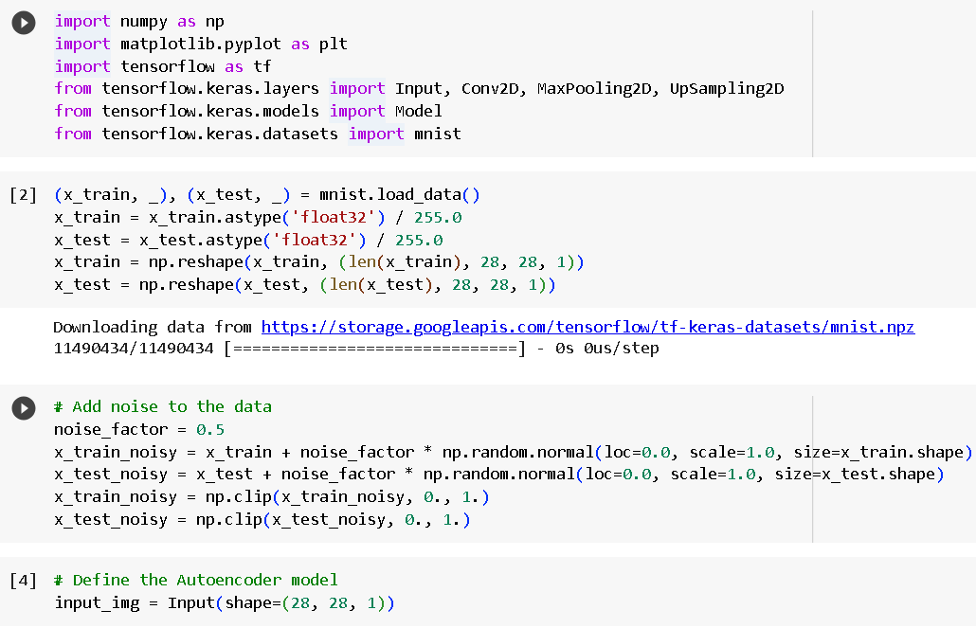

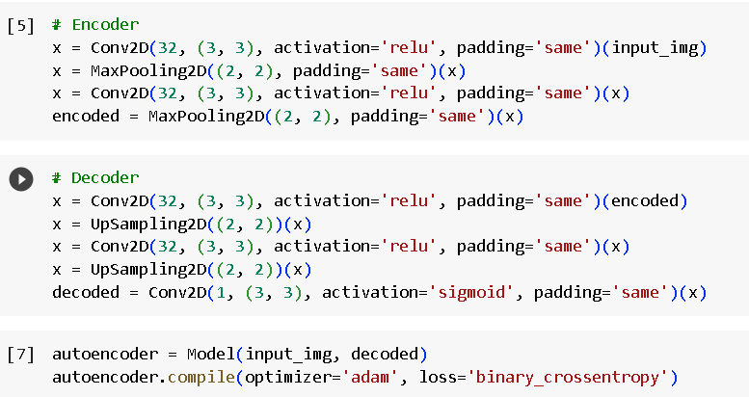

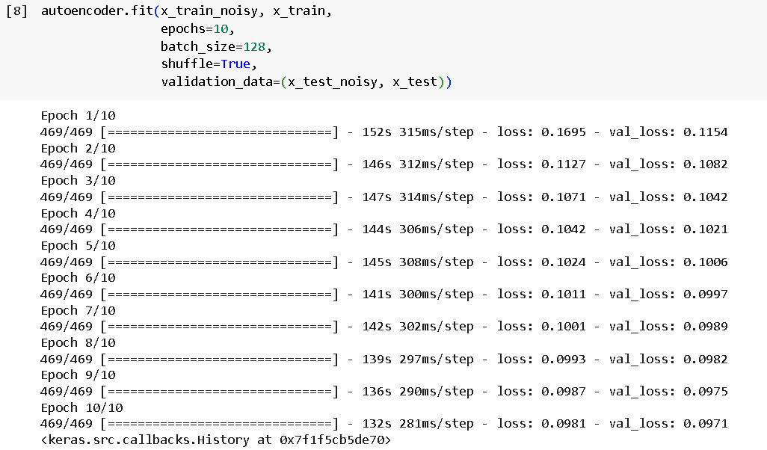

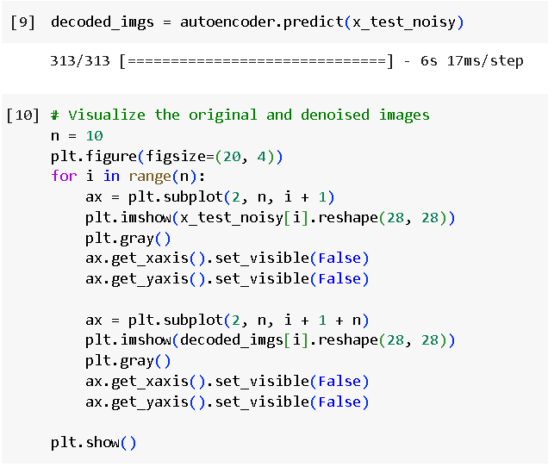

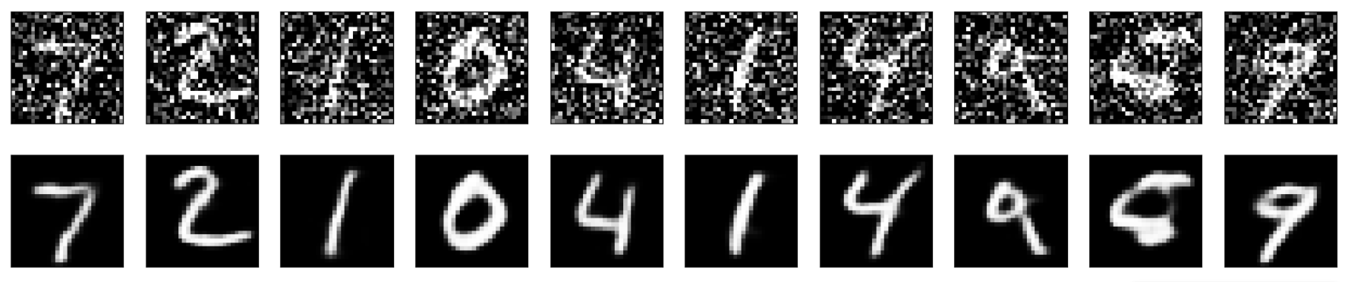

**Results and Discussions :**

The results of the image denoising experiment using Autoencoders demonstrate the effectiveness of the model in reducing noise while preserving essential image features. Across various noise types and levels, the Autoencoder consistently improves image quality, as indicated by higher PSNR and SSIM scores compared to noisy inputs.

The discussion interprets these results and considers their implications. The successful denoising performance suggests the Autoencoder's potential for

enhancing image analysis, particularly in applications such as medical imaging and surveillance, where noise reduction is critical. Furthermore, the experiment underscores the importance of hyperparameter tuning and model generalization to real-world scenarios.

Future research directions may involve exploring more advanced neural network architectures, including convolutional and recurrent variations of Autoencoders, to further enhance denoising capabilities. Additionally, integrating domain-specific knowledge or additional data augmentation techniques could lead to even more robust denoising solutions.