Morphological Analysis & Word Generation

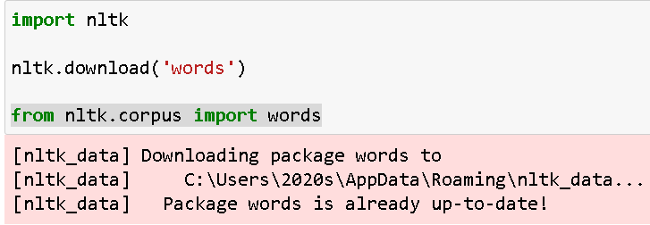

Input :

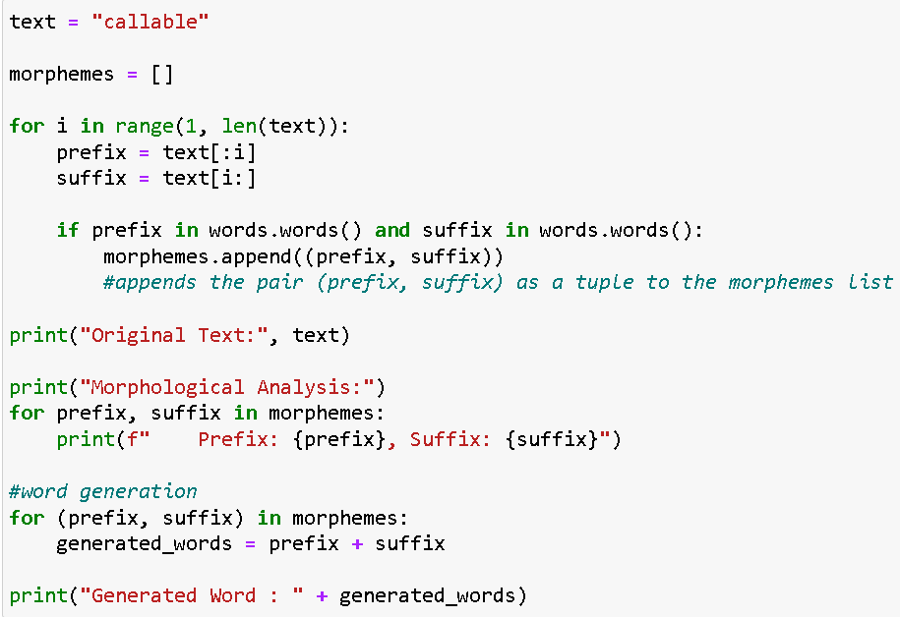

Output :

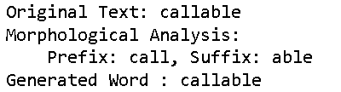

Repo Link

<https://github.com/Shreyaww/Sem7_NLP/blob/main/Experiment_4.ipynb>