N-Gram

1) Display the list of unigram , bigram and trigram possibilities for the chosen corpus text

Input –

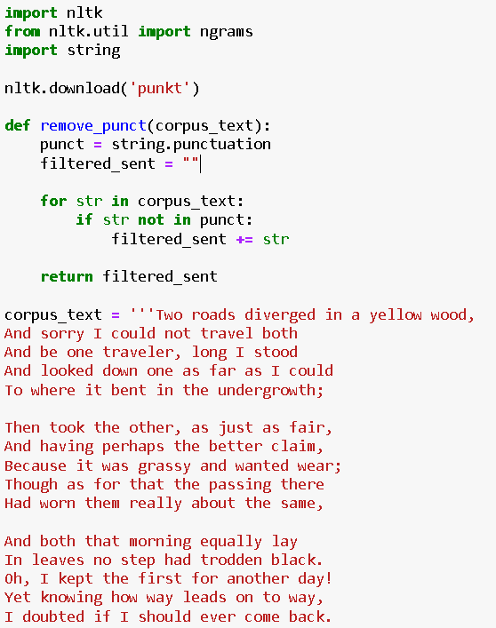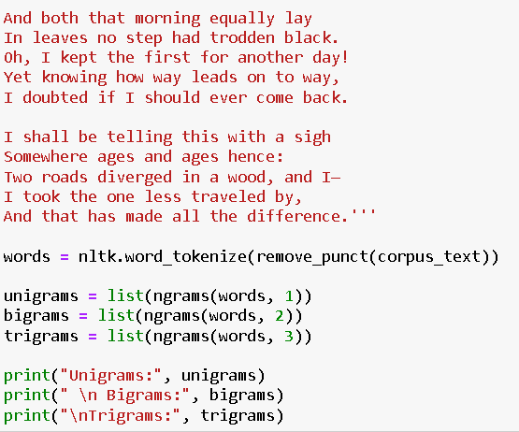

Output –

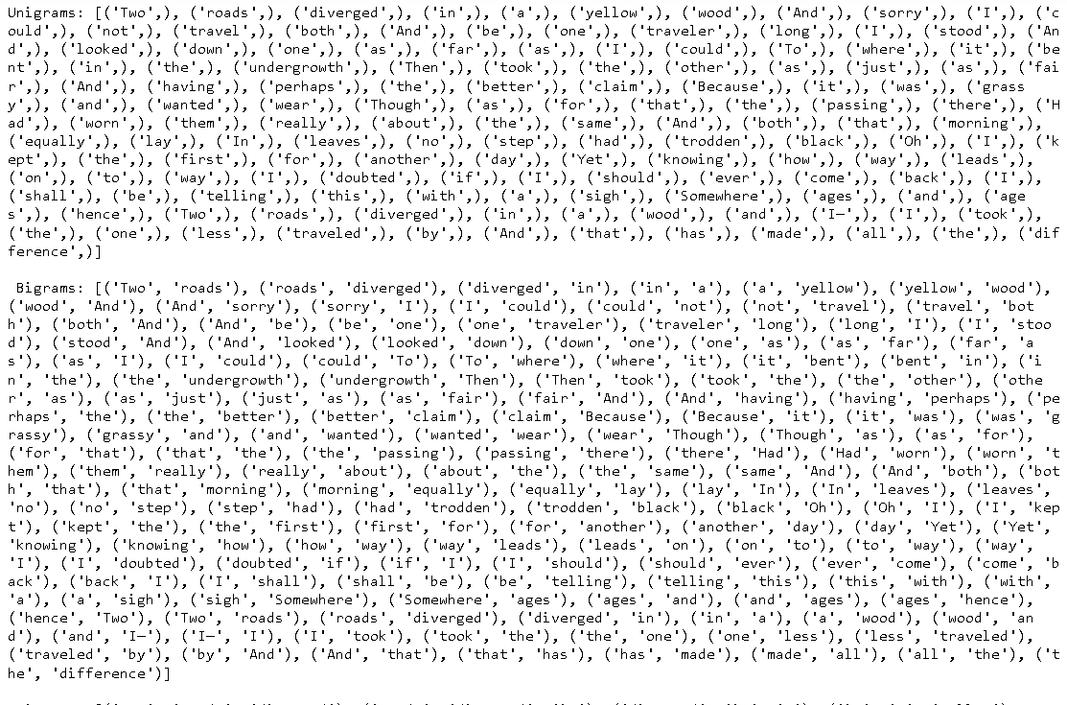

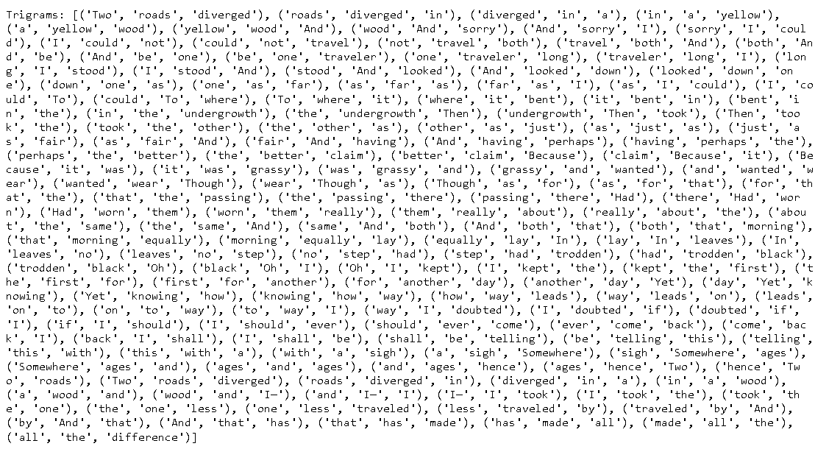

2) Display the bigram probability table 1st table bigram counts 2nd table bigram probabilities

Input –

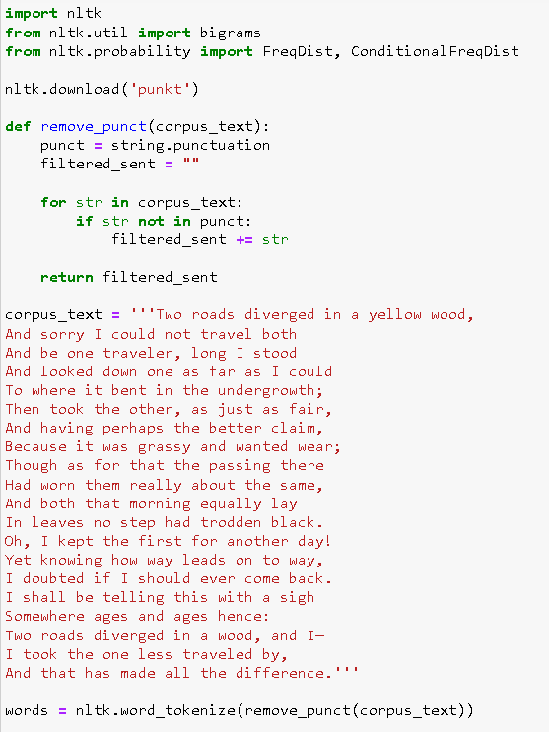

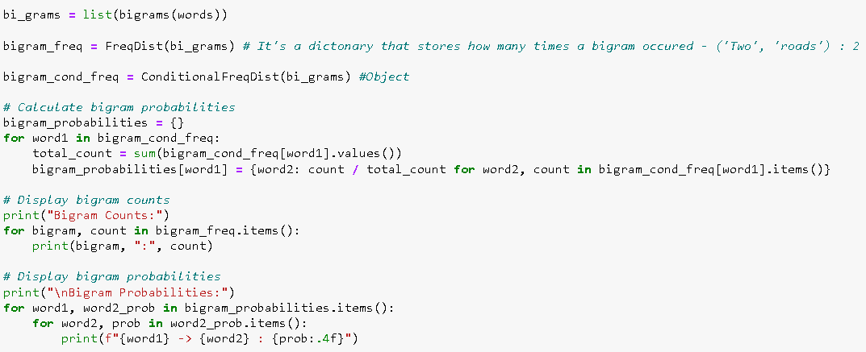

Output –

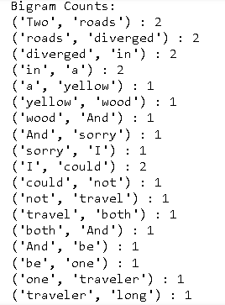

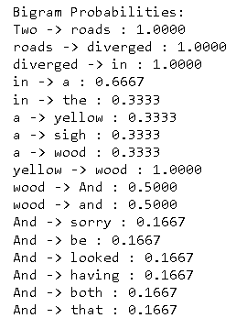

Repo Link

<https://github.com/Shreyaww/Sem7_NLP/blob/main/Experiment_5_N-gram.ipynb>