|  |  |  |
| --- | --- | --- |
| **Name : Shreya Singh** | **Class/Roll No. : D16AD/55** | **Grade :** |

**Title of Experiment :** Project Proposal and Requirement Gathering.

**Outcome of Experiment :** Write up a user analysis, task analysis (identify three tasks of the chosen problem), and domain analysis clearly, concisely, and completely. Design a persona. A problem object model or entity-relationship diagram.

**Problem Statement :** Briefly state the problem(s) that the project will seek to solve. Take the user's point of view. Consider what the user's goals are, and what obstacles lie in the way.

**Theory :**

**User Experience (UX) -** The user experience (UX) is how a user interacts with and experiences a [product](https://en.wikipedia.org/wiki/Product_(business)), [system](https://en.wikipedia.org/wiki/System) or [service](https://en.wikipedia.org/wiki/Service_(business)). It includes a person's perceptions of [utility](https://en.wikipedia.org/wiki/Utility), [ease of use](https://en.wikipedia.org/wiki/Ease_of_use), and [efficiency](https://en.wikipedia.org/wiki/Efficiency). It encompasses all aspects of the end-user's interaction with the company, its services, and its products.

**User Interface (UI)** - The user interface (UI) is the space where interactions between humans and machines occur. The goal of this interaction is to allow effective operation and control of the machine from the human end, while the machine simultaneously feeds back information that aids the operators' [decision-making](https://en.wikipedia.org/wiki/Decision-making) process.

**User Analysis -** User analysis is the process of collecting and interpreting data to understand how users experience the product, what they like, and why they churn. User analysis methods include [task analysis](https://userpilot.com/blog/task-analysis/), user feedback analysis, [user behavior analysis](https://userpilot.com/blog/analyze-customer-behavior/), and user experience analysis.

User analysis in UI / UX can be conducted using various methods and techniques. Here are some common ways to perform user analysis:

* User Interviews: Conduct one-on-one interviews with users to gather qualitative insights about their needs, preferences, and pain points. This method allows for in-depth discussions and open-ended responses.
* Surveys and Questionnaires: Distribute surveys to a larger group of users to collect quantitative data on their opinions, behaviors, and demographics. This method can provide a broad overview of user preferences.
* Contextual Inquiry: Observe users in their natural environment while they interact with your product or perform related tasks. This provides valuable context for understanding their behaviors and needs.
* User Workshops: Organize group sessions or workshops with users to facilitate discussions and ideation. This can help uncover insights and ideas collaboratively.
* Persona Creation: Develop user personas based on research data to create realistic user archetypes that guide your design decisions.
* User Surveys: Send out brief surveys to gather quick feedback on specific aspects of your product, such as a new feature or a recent redesign.
* Competitor Analysis: Study how users interact with your competitors' products to identify strengths, weaknesses, and opportunities for differentiation.
* Social Media Listening: Monitor social media platforms and online communities to gather unsolicited user feedback and sentiments.

**Task Analysis** - Task analysis is the process of learning about ordinary users by observing them in action to understand in detail how they perform their tasks and achieve their intended goals.

**Domain Analysis** - Domain analysis for UI/UX involves identifying the specific areas or industries where your application will be used effectively. This process helps you determine whether your application's design, features, and functionalities are well-suited for particular domains.

**User Persona** - In the context of UI/UX design, a user persona is a fictional representation of a target user group that helps designers and developers better understand and empathize with their intended audience. User personas are created through research and analysis of real user data to capture the characteristics, behaviors, goals, needs, and preferences of different types of users who might interact with a product, website, app, or service.

Creating user personas involves gathering information from sources such as user interviews, surveys, analytics data, and market research. This information is then synthesized into a few distinct user personas that represent the primary user segments.

**Output :**

**User analysis -**

**This user analysis report aims to a**

This user analysis report focuses on the integration of a scheduled delivery feature for the Swiggy food delivery app. The goal is to identify potential design flaws, usability concerns, and user expectations while outlining key requirements for the successful implementation of this feature. Swiggy currently offers on-demand food delivery but does not provide a scheduled delivery option, which leaves room for user dissatisfaction in specific scenarios.

User Profile :

Users come from various cultural backgrounds and have diverse food preferences, including different cuisines and dietary restrictions. Users have different schedules, which may include irregular working hours, shift work, or specific mealtime requirements. Users may have specific food cravings or requirements that they want to satisfy through food delivery services. Users expect that the food items listed on a restaurant's menu are available for delivery. It's frustrating when a desired item is unavailable despite being on the menu. Some users have dietary restrictions (e.g., vegetarian, vegan, gluten-free) or specific preferences (e.g., organic, low-carb) that they want to be accurately accommodated.

**Task Analysis** -

Existing Features :

1. **Restaurant Discovery:** Swiggy allows users to discover a wide range of restaurants in their area based on location. Users can browse through restaurant menus and explore different cuisines.
2. **Ordering:** Customers can place food orders from their favorite restaurants through the Swiggy app or website. They can customize their orders, add special instructions, and make payments online.
3. **Live Order Tracking:** Swiggy provides live order tracking, allowing customers to monitor the status of their orders in real-time. This feature includes details such as when the order is being prepared, picked up, and on its way for delivery.
4. **Scheduled Deliveries:** Users can schedule food deliveries in advance. This feature is helpful for planning meals or ordering in advance for events.
5. **Contactless Delivery:** Swiggy introduced contactless delivery options, especially during the COVID-19 pandemic, to ensure the safety of both customers and delivery personnel.
6. **Swiggy Super:** Swiggy Super is a subscription service that offers benefits like free delivery on orders, exclusive discounts, and priority customer support to subscribers.
7. **Swiggy Pop:** Swiggy Pop offers a curated list of single-serve meals at affordable prices, allowing customers to order for one person without the need for large quantities.
8. **Swiggy Daily:** Swiggy Daily offers meal subscription plans, providing users with the option to order daily or monthly meals from a variety of cuisines.
9. **Swiggy Genie:** Swiggy Genie is a service that allows users to request deliveries beyond food, including groceries, medicines, documents, and other items. It's like a concierge service for deliveries.
10. **Reviews and Ratings:** Swiggy allows customers to leave reviews and ratings for restaurants, helping others make informed decisions.
11. **Payment Options:** Swiggy supports various payment options, including credit/debit cards, digital wallets, UPI, and cash on delivery (where available).
12. **Referral and Loyalty Programs:** Swiggy often runs referral and loyalty programs that reward customers for referring friends and ordering regularly from the platform.
13. **In-App Chat Support:** Customers can seek assistance and resolve issues by using the in-app chat support feature.
14. **Restaurant Partnerships:** Swiggy partners with a wide network of restaurants, from local eateries to popular chains, to provide a diverse selection of food options.
15. **Discounts and Offers:** Swiggy frequently offers discounts, promotions, and special deals on various restaurants and cuisines.

This task analysis report outlines the key features identified for Swiggy food delivery app. The below selected features aim to improve user experience and provide additional value to users.

Features :

1. **Pre-order Meals:** Users can select a date and time in the future for their food delivery, which is particularly useful for planning meals in advance.
2. **Party and Event Planning:** Customers can schedule deliveries for parties, gatherings, or special occasions, ensuring that the food arrives precisely when needed.
3. **Busy Schedules:** Scheduled delivery is convenient for individuals with busy schedules who want to ensure they have a meal ready at a specific time.
4. **Avoiding Peak Times:** It can help users avoid peak delivery times, reducing the risk of order delays during busy periods.
5. **No Need to Remember:** Customers don't have to remember to place an order at the last minute. They can set the schedule and forget about it until the delivery arrives.

**Domain Analysis -**

**1. Market Overview:**

* **Market Segment:** Swiggy operates in the online food delivery and restaurant aggregator segment, catering to individuals and families looking for convenient food ordering and delivery options.
* **Target Audience:** Swiggy targets a broad demographic, including working professionals, families, students, and individuals seeking a variety of cuisines and dining options.

**2. Features and Functionality:**

* **Restaurant Discovery:** Users can browse a diverse range of restaurants, view menus, and select from a variety of cuisines.
* **Ordering:** Customers can customize their orders, make online payments, and track their orders in real-time.
* **Scheduled Delivery:** This feature allows users to pre-schedule food deliveries at a specific date and time, providing convenience for planning meals or events.
* **Swiggy Super:** A subscription service offering free delivery, exclusive discounts, and priority customer support.
* **Swiggy Pop:** Curated single-serve meals available at affordable prices.
* **Swiggy Daily:** Meal subscription plans for daily or monthly meals.
* **Swiggy Genie:** Beyond-food delivery service for various items.
* **Reviews and Ratings:** Users can share feedback and ratings for restaurants.
* **Payment Options:** Multiple payment methods, including digital wallets, UPI, and cash on delivery.

**3. Competitive Landscape:**

* **Key Competitors:** Swiggy faces competition from food delivery platforms like Zomato and international players like Uber Eats (now part of Zomato).
* **Differentiation:** Swiggy differentiates itself through features like scheduled delivery, Swiggy Super, and a diverse restaurant network.

**4. User Experience:**

* Swiggy offers a user-friendly interface with features like live order tracking and in-app chat support for assistance.
* Scheduled delivery enhances user experience by offering the convenience of planning and ensuring timely deliveries for various occasions.

**5. Business Model:**

* Swiggy primarily operates on a commission-based model, earning a percentage of the order value from restaurant partners.
* Swiggy Super and other subscription services provide an additional revenue stream.

**6. Challenges and Opportunities:**

* **Challenges:** Swiggy faces challenges related to competition, order accuracy, delivery delays, and regulatory compliance. Maintaining food quality and security are ongoing concerns.
* **Opportunities:** Expanding into new geographic regions, introducing sustainable practices, and enhancing customer loyalty through innovative features are opportunities for growth.

**7. Future Prospects:**

* Scheduled delivery is a forward-thinking feature that aligns with the trend of on-demand services and personalization. It enhances Swiggy's appeal to a wider range of customers and positions it for continued growth in the competitive food delivery industry.

**User Persona** -

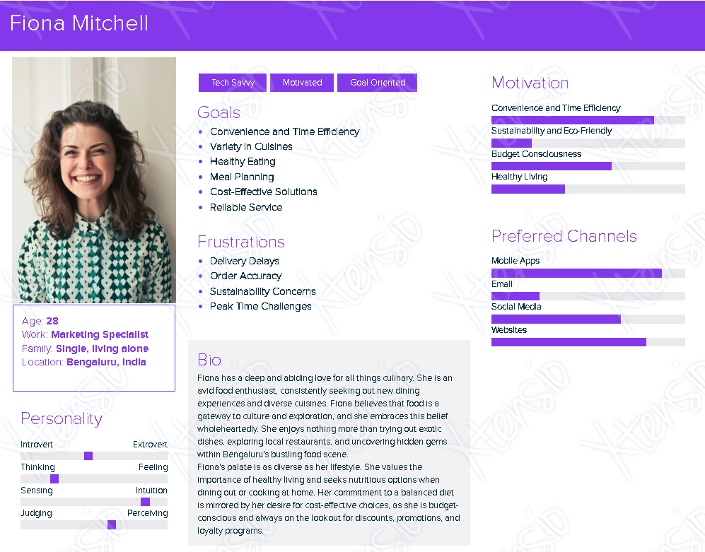

**Entity - Relationship Diagram -**

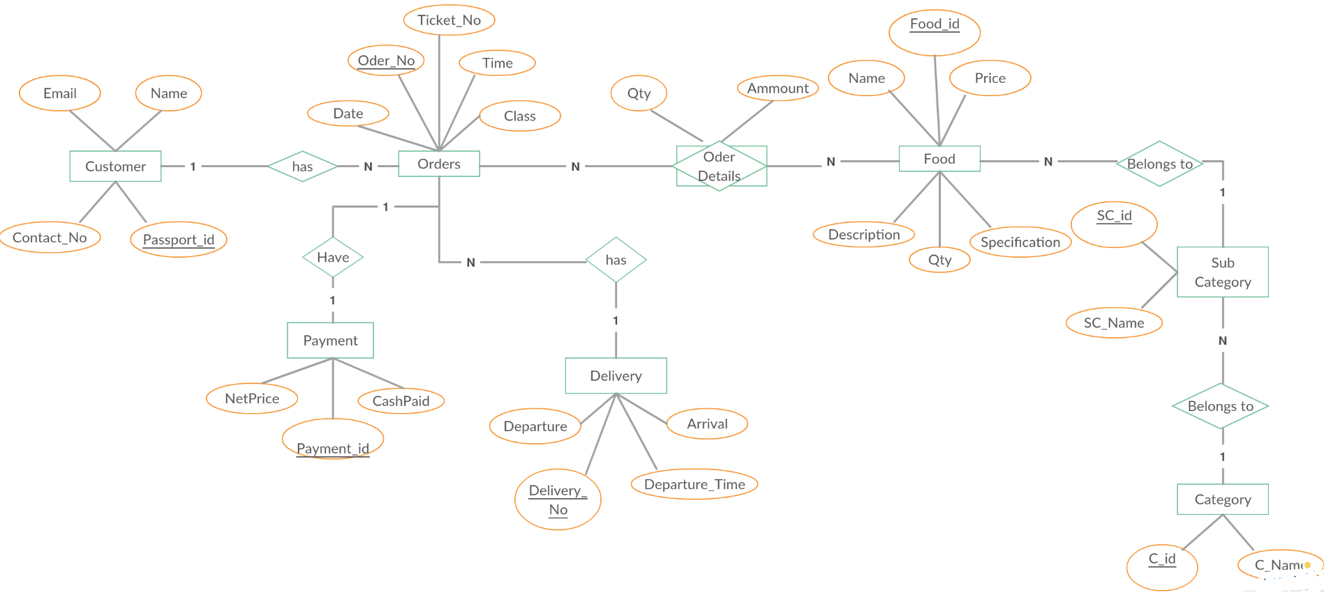

**Results and Discussions :** Through user analysis, task analysis, and domain analysis, we gained valuable insights. Addition of a new feature to the Swiggy app, we observed a significant increase in user engagement and a positive impact on the overall user experience. User feedback indicated a high level of satisfaction with the feature's functionality and convenience. The business metrics showed a notable rise in orders and revenue, signifying a successful addition to the app's feature set. While there were some minor technical challenges during implementation, user feedback highlighted the potential for future improvements and refinements to further enhance the feature's effectiveness. This research underscores the value of the new feature in enhancing Swiggy's competitive position and its potential for continued growth and success.