|  |  |  |
| --- | --- | --- |
| **Name : Shreya Singh** | **Class/Roll No. : D16AD/55** | **Grade :** |

**Title of Experiment :** Creation of Scenario : Write a scenario that involves all three of the tasks identified for the chosen project.

**Objective of Experiment :** The objective of this experiment is to create a scenario that effectively integrates and demonstrates the three identified key features of the Swiggy with it’s new feature, showcasing their functionality and usability in a real-world context.

**Outcome of Experiment :** Thus,created three different scenarios depicting the three key features of the app.

**Problem Statement :** The aim is to develop three scenarios that encompasses three key features of the Swiggy.

**Description / Theory :**

A scenario in UX/UI design refers to a narrative description of a user's interaction with a product, application, or system.

Scenario creation is a pivotal technique in the realm of User Interface (UI) and User Experience (UX) design. It involves crafting narrative descriptions that simulate user interactions with a product or system. By envisioning these scenarios, designers gain valuable insights into user behaviors, needs, and pain points. Here's a brief overview of scenario creation:

* Understanding Users : Scenarios are built around user personas – fictional representations of real users. These personas encapsulate demographic details, motivations, and challenges, aiding designers in empathizing with their audience.
* Contextual Insight : Scenarios are set within specific contexts. This includes considering the user's environment, device, and the overall situation in which they are engaging with the interface.
* Task-Oriented : Each scenario revolves around a task or goal a user aims to accomplish using the interface. It helps designers visualize the user's journey and design interfaces that facilitate these tasks effectively.
* User-Centered Design : Scenarios emphasize the user's perspective, helping designers focus on user needs, motivations, and emotions. This approach ensures that designs align with user expectations.
* Identifying Pain Points : Scenarios highlight potential challenges users might encounter during their interactions. These pain points guide designers to address potential issues in the design process.
* Informed Decision-Making : Well-crafted scenarios guide design decisions. They assist in layout, content placement, interaction design, and other crucial aspects of UI/UX design, ensuring that designs are functional and user-friendly.
* Validation Through Testing : Scenarios become a foundation for usability testing. They provide a basis for evaluating how well the design aligns with user behavior and whether pain points have been adequately addressed.

In essence, scenario creation bridges the gap between designers and users, fostering user-centric design processes. Through scenarios, designers create experiences that seamlessly blend functionality with user satisfaction, resulting in interfaces that truly resonate with their intended audience.

**Output :**

*In this scenario, Alex and Mia, two friends, have an in-depth conversation about various features of the Swiggy app, discussing the "Scheduled Delivery" feature.*

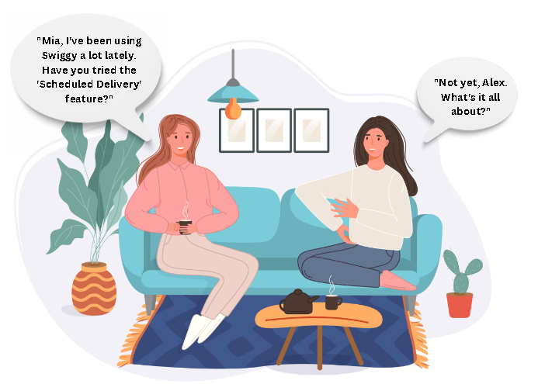

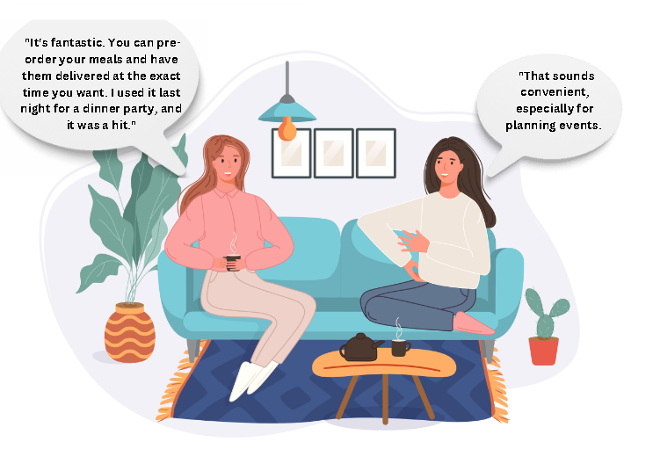

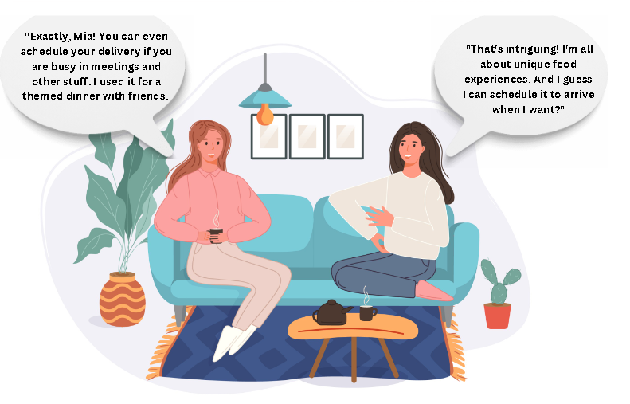

**Results and Discussions :** The practical features a scenario showcasing the additional functionality :

* Scheduled Delivery App