RUNGTA COLLEGE OF ENGINEERING AND TECHNOLOGY
PROJECT REPORT
- TOPIC- BANK LOAN ANALYSIS
- Submitted by: Shreya Yadav, Vinay Sahu
- Semester: 5th Semester
- Academic Session: 2026
1. Introduction: Bank Loan Analysis uses SQL and Power BI to analyze loan applications, credit grades, loan purposes, and regional distribution, helping identify useful trends and insights
2. Problem Statement: To analyze bank loan data and identify patterns in loan applications, credit grades, and regional distribution.
3. Objectives: Analyze loan application data, Compare loan purposes and credit grades, Visualize regional loan distribution, Create a Power BI dashboard.
4. Scope: The project analyzes loan applications, credit grades, interest rates, and regions to identify useful trends.
5. Tools and Technologies: Power BI: Data visualization, MySQL Workbench: SQLanalysis, CSV: Dataset
6. Dataset Description: The dataset contains loan IDs, loan purposes, credit grades, interest rates, and regional details.
7. Methodology: Import the dataset, Analyze data using SQL, Create charts in Power BI, Interpret the results.
8. Dashboard Design:
Page 1: Loan Overview
Page 2: Loan Purpose
Page 3: Credit Grade
Page 4: Regional Analysis
9. Key Findings:
Grade B: 541 applications.
Grade G: 99 applications.
Grade G: Highest average interest rate (13.41%).
Grade C: Lowest average interest rate (12.50%).

10. Recommendations: Monitor high-interest-rate loans and use credit grade and regional trends for better loan analysis.
11. Limitations: The analysis depends on the dataset's accuracy and available information.
12. Conclusion: The project uses SQL and Power BI to analyze bank loan data and present useful insights through an interactive dashboard.
13. References
- Bank Loan Dataset (CSV)
- MySQL Workbench
- Microsoft Power BI
Dashboard Screenshots

Figure 1: Loan Overview
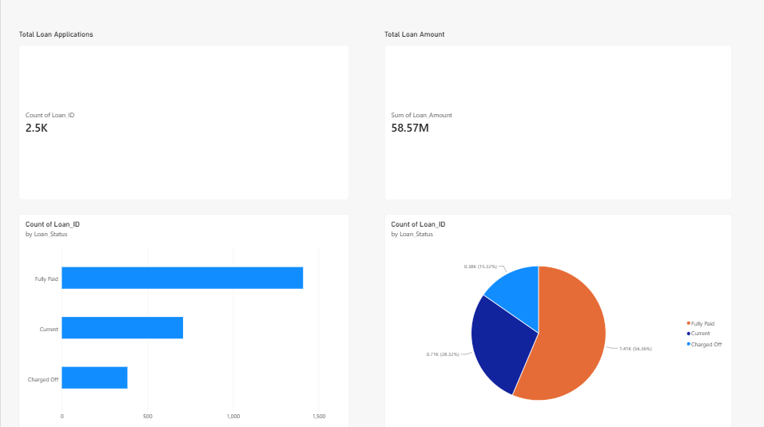

Figure 2: Loan Purpose
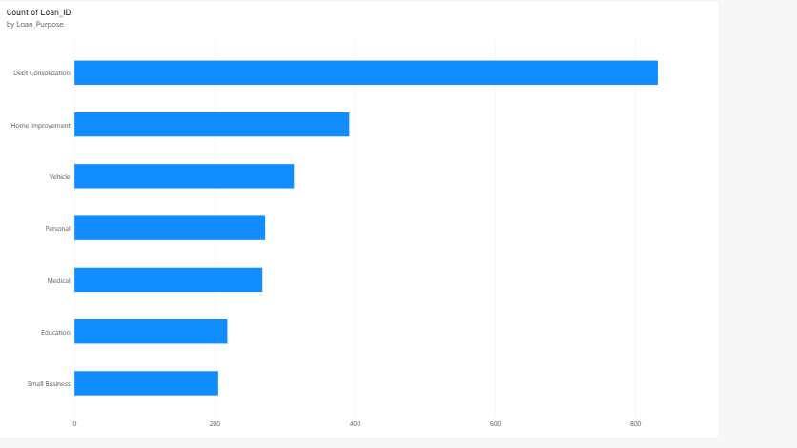Figure 3: Credit Grade
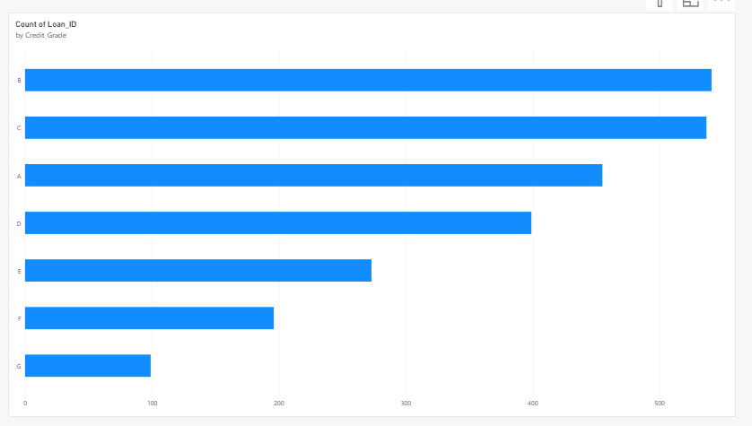

Figure 4: Regional Analysis
