**CURRICULUM VITAE**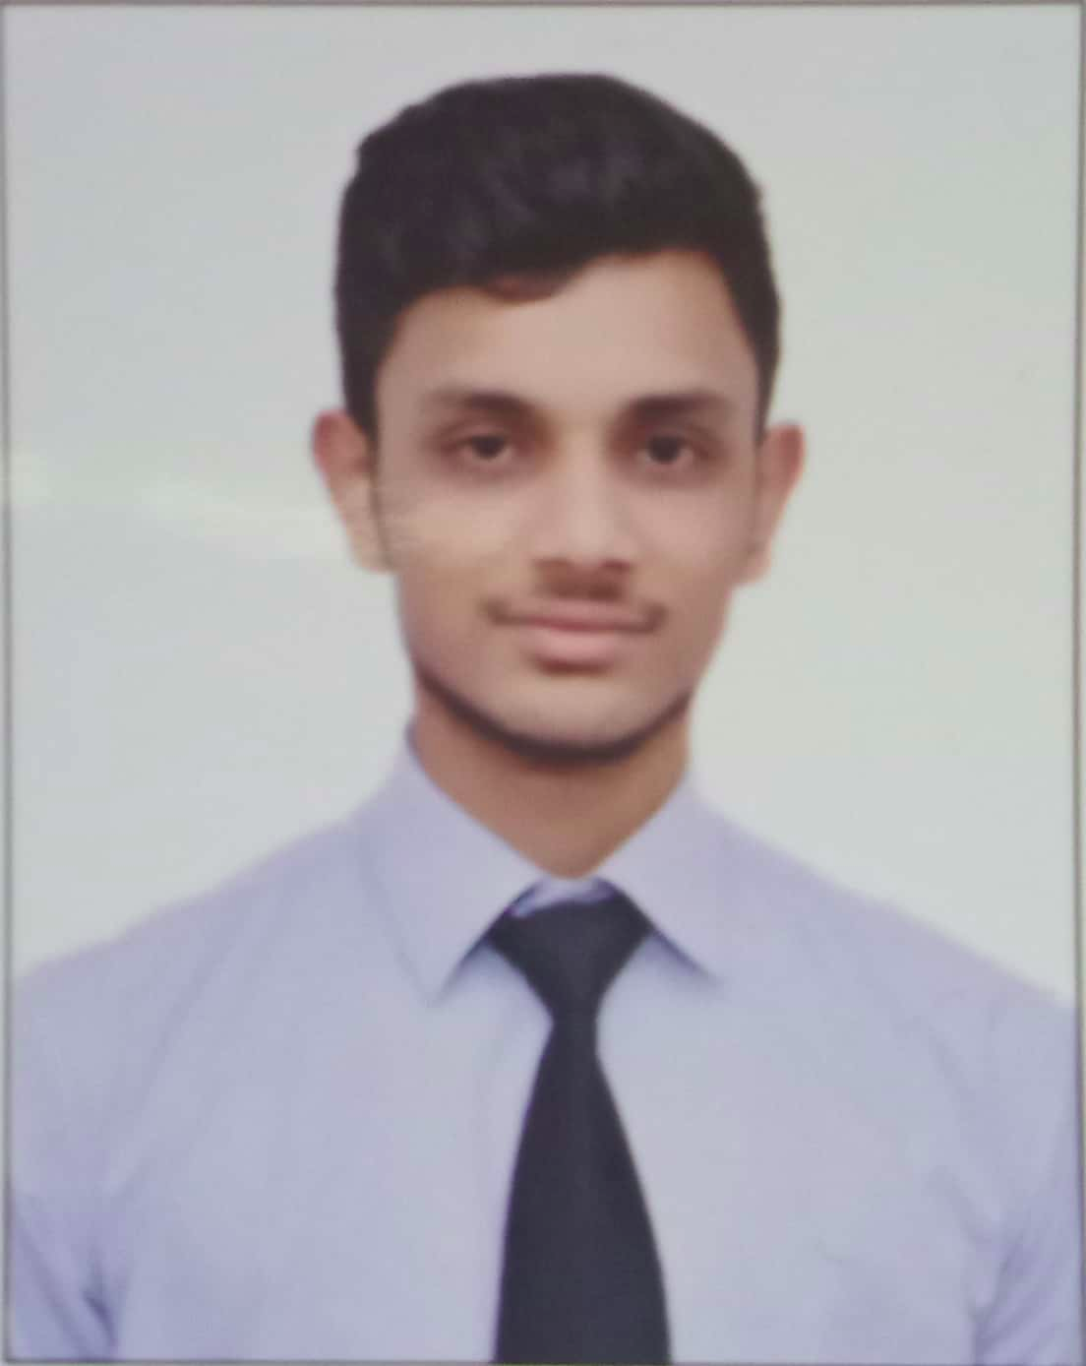

**SHREY JAIN**

**MOBILE: +91-9911009051**

**EMAIL: shreyjain203@gmail.com**



**CAREER OBJECTIVE**

To thrive in the dynamic IT industry by continuously developing and leveraging my strong analytical and technical skills. Also, to associate with a progressive organization that gives me scope to learn and apply my skills.

**EDUCATION**

|  |  |  |  |  |
| --- | --- | --- | --- | --- |
| **QUALIFICATION** | **INSTITUTION** | **UNIVERSITY/**  **BOARD** | **PERCENTAGE**  **(%)** | **YEAR OF PASSING** |
| B.Tech (IT) | Maharaja Agrasen Institute Of Technology, Rohini, Delhi | G.G.S.I.P.U. | 67.16 (upto 4th semester) | 2020 |
| 12th | Vanasthali Public school, New Delhi | C.B.S.E. | 89.60 | 2016 |
| 10th | Vanasthali Public School, New Delhi | C.B.S.E. | 85.5  (CGPA-9.0) | 2014 |

**KEY EXPERTISE/SKILLS**

* **Languages:** C , C++, Core Java, HTML, CSS
* **Operating System:** Windows XP/7/8/10, ubuntu 18.04.1, Mac OS, Fedora 29
* **Database:** SQL, MySQL, Firebase
* **Software:** Android Studio, Hadoop(Beginner)

**INTERNSHIP and TRAINING**

* **Harman Connected Services Pvt. Ltd**

**Period: J**une 11, 2018-July 31, 2018

**Key Skills:** Networking and internet protocols

**Description:**

Tested POLYCOM RMX MANAGER project which provides a fully developed hardware and software combination for a high quality video conferencing and content sharing platform.

* **Introduction to BIG DATA and hadoop**

**Institute Name:** University of California, San Diego

**Period:** Sept 1,2018-till now

**Description:**

Attained knowledge about BIG DATA and HADOOP platform during the training period.



**ACHIEVEMENTS**

* **Amcat Score:** 2055

**For full result:** <https://drive.google.com/file/d/11FODjYkVJaTp_N2cKwbh5IdnFviqSWuJ/view?usp=sharing>

* **FNAT Percentile:** 70%

**CO-CURRICULAR ACTIVITIES**

* Ex-member of the Computer society of India.
* Organized events in the technical and cultural fest of the college in 1st, 2nd, 3rd year.
* Attend various hackathons held in various colleges across Delhi NCR.
* Actively participated in school speech competition.

**WORK SAMPLES**

**GitHub Profile:**

[**https://github.com/Shreyjain203?tab=repositories**](https://github.com/Shreyjain203?tab=repositories)



**PERSONAL DETAILS**

|  |  |  |
| --- | --- | --- |
|  | **Father’s Name** | : Mr. Shripal Jain |
|  | **Mother’s Name** | : Mrs. Anju Jain |
|  | **Address** | : 20-B, Pocket B8, Mayur vihar Phase 3, Delhi-110096 |
|  | **Date of Birth** | : 20th March, 1999 |
|  | **Nationality** | : Indian |
|  | **Languages Known** | : English, Hindi |



**STRENGTHS**

* Work with positive attitude to contribute for the healthy functionality of the organization.
* Analyzing every angle of a project before working on it.
* Willingness to learn.
* Adaptability to change in the environment.



**Declaration:**

I hereby declare that the information furnished above is true to the best of my knowledge and I am also confident of my ability to work in a team.

**SHREY JAIN**

**JULY 28, 2019**