advertising

Shrey

2024-11-26

## R Markdown

This is an R Markdown document. Markdown is a simple formatting syntax for authoring HTML, PDF, and MS Word documents. For more details on using R Markdown see <http://rmarkdown.rstudio.com>.

When you click the **Knit** button a document will be generated that includes both content as well as the output of any embedded R code chunks within the document. You can embed an R code chunk like this:

library(dplyr)

##   
## Attaching package: 'dplyr'

## The following objects are masked from 'package:stats':  
##   
## filter, lag

## The following objects are masked from 'package:base':  
##   
## intersect, setdiff, setequal, union

library(ggplot2)  
library(forecast)

## Registered S3 method overwritten by 'quantmod':  
## method from  
## as.zoo.data.frame zoo

library(fpp)

## Loading required package: fma

## Loading required package: expsmooth

## Loading required package: lmtest

## Loading required package: zoo

##   
## Attaching package: 'zoo'

## The following objects are masked from 'package:base':  
##   
## as.Date, as.Date.numeric

## Loading required package: tseries

library(fpp2)

##   
## Attaching package: 'fpp2'

## The following objects are masked from 'package:fpp':  
##   
## ausair, ausbeer, austa, austourists, debitcards, departures,  
## elecequip, euretail, guinearice, oil, sunspotarea, usmelec

library(UsingR)

## Loading required package: MASS

##   
## Attaching package: 'MASS'

## The following objects are masked from 'package:fma':  
##   
## cement, housing, petrol

## The following object is masked from 'package:dplyr':  
##   
## select

## Loading required package: HistData

## Loading required package: Hmisc

##   
## Attaching package: 'Hmisc'

## The following objects are masked from 'package:dplyr':  
##   
## src, summarize

## The following objects are masked from 'package:base':  
##   
## format.pval, units

##   
## Attaching package: 'UsingR'

## The following object is masked from 'package:fma':  
##   
## chicken

library(TTR)  
  
  
Advertising_data <- read.csv("H:\\advertising.csv")  
Sales_data <- Advertising_data$Sales  
summary(Sales_data)

## Min. 1st Qu. Median Mean 3rd Qu. Max.   
## 1.60 11.00 16.00 15.13 19.05 27.00

is.na(Advertising_data)

## TV Radio Newspaper Sales  
## [1,] FALSE FALSE FALSE FALSE  
## [2,] FALSE FALSE FALSE FALSE  
## [3,] FALSE FALSE FALSE FALSE  
## [4,] FALSE FALSE FALSE FALSE  
## [5,] FALSE FALSE FALSE FALSE  
## [6,] FALSE FALSE FALSE FALSE  
## [7,] FALSE FALSE FALSE FALSE  
## [8,] FALSE FALSE FALSE FALSE  
## [9,] FALSE FALSE FALSE FALSE  
## [10,] FALSE FALSE FALSE FALSE  
## [11,] FALSE FALSE FALSE FALSE  
## [12,] FALSE FALSE FALSE FALSE  
## [13,] FALSE FALSE FALSE FALSE  
## [14,] FALSE FALSE FALSE FALSE  
## [15,] FALSE FALSE FALSE FALSE  
## [16,] FALSE FALSE FALSE FALSE  
## [17,] FALSE FALSE FALSE FALSE  
## [18,] FALSE FALSE FALSE FALSE  
## [19,] FALSE FALSE FALSE FALSE  
## [20,] FALSE FALSE FALSE FALSE  
## [21,] FALSE FALSE FALSE FALSE  
## [22,] FALSE FALSE FALSE FALSE  
## [23,] FALSE FALSE FALSE FALSE  
## [24,] FALSE FALSE FALSE FALSE  
## [25,] FALSE FALSE FALSE FALSE  
## [26,] FALSE FALSE FALSE FALSE  
## [27,] FALSE FALSE FALSE FALSE  
## [28,] FALSE FALSE FALSE FALSE  
## [29,] FALSE FALSE FALSE FALSE  
## [30,] FALSE FALSE FALSE FALSE  
## [31,] FALSE FALSE FALSE FALSE  
## [32,] FALSE FALSE FALSE FALSE  
## [33,] FALSE FALSE FALSE FALSE  
## [34,] FALSE FALSE FALSE FALSE  
## [35,] FALSE FALSE FALSE FALSE  
## [36,] FALSE FALSE FALSE FALSE  
## [37,] FALSE FALSE FALSE FALSE  
## [38,] FALSE FALSE FALSE FALSE  
## [39,] FALSE FALSE FALSE FALSE  
## [40,] FALSE FALSE FALSE FALSE  
## [41,] FALSE FALSE FALSE FALSE  
## [42,] FALSE FALSE FALSE FALSE  
## [43,] FALSE FALSE FALSE FALSE  
## [44,] FALSE FALSE FALSE FALSE  
## [45,] FALSE FALSE FALSE FALSE  
## [46,] FALSE FALSE FALSE FALSE  
## [47,] FALSE FALSE FALSE FALSE  
## [48,] FALSE FALSE FALSE FALSE  
## [49,] FALSE FALSE FALSE FALSE  
## [50,] FALSE FALSE FALSE FALSE  
## [51,] FALSE FALSE FALSE FALSE  
## [52,] FALSE FALSE FALSE FALSE  
## [53,] FALSE FALSE FALSE FALSE  
## [54,] FALSE FALSE FALSE FALSE  
## [55,] FALSE FALSE FALSE FALSE  
## [56,] FALSE FALSE FALSE FALSE  
## [57,] FALSE FALSE FALSE FALSE  
## [58,] FALSE FALSE FALSE FALSE  
## [59,] FALSE FALSE FALSE FALSE  
## [60,] FALSE FALSE FALSE FALSE  
## [61,] FALSE FALSE FALSE FALSE  
## [62,] FALSE FALSE FALSE FALSE  
## [63,] FALSE FALSE FALSE FALSE  
## [64,] FALSE FALSE FALSE FALSE  
## [65,] FALSE FALSE FALSE FALSE  
## [66,] FALSE FALSE FALSE FALSE  
## [67,] FALSE FALSE FALSE FALSE  
## [68,] FALSE FALSE FALSE FALSE  
## [69,] FALSE FALSE FALSE FALSE  
## [70,] FALSE FALSE FALSE FALSE  
## [71,] FALSE FALSE FALSE FALSE  
## [72,] FALSE FALSE FALSE FALSE  
## [73,] FALSE FALSE FALSE FALSE  
## [74,] FALSE FALSE FALSE FALSE  
## [75,] FALSE FALSE FALSE FALSE  
## [76,] FALSE FALSE FALSE FALSE  
## [77,] FALSE FALSE FALSE FALSE  
## [78,] FALSE FALSE FALSE FALSE  
## [79,] FALSE FALSE FALSE FALSE  
## [80,] FALSE FALSE FALSE FALSE  
## [81,] FALSE FALSE FALSE FALSE  
## [82,] FALSE FALSE FALSE FALSE  
## [83,] FALSE FALSE FALSE FALSE  
## [84,] FALSE FALSE FALSE FALSE  
## [85,] FALSE FALSE FALSE FALSE  
## [86,] FALSE FALSE FALSE FALSE  
## [87,] FALSE FALSE FALSE FALSE  
## [88,] FALSE FALSE FALSE FALSE  
## [89,] FALSE FALSE FALSE FALSE  
## [90,] FALSE FALSE FALSE FALSE  
## [91,] FALSE FALSE FALSE FALSE  
## [92,] FALSE FALSE FALSE FALSE  
## [93,] FALSE FALSE FALSE FALSE  
## [94,] FALSE FALSE FALSE FALSE  
## [95,] FALSE FALSE FALSE FALSE  
## [96,] FALSE FALSE FALSE FALSE  
## [97,] FALSE FALSE FALSE FALSE  
## [98,] FALSE FALSE FALSE FALSE  
## [99,] FALSE FALSE FALSE FALSE  
## [100,] FALSE FALSE FALSE FALSE  
## [101,] FALSE FALSE FALSE FALSE  
## [102,] FALSE FALSE FALSE FALSE  
## [103,] FALSE FALSE FALSE FALSE  
## [104,] FALSE FALSE FALSE FALSE  
## [105,] FALSE FALSE FALSE FALSE  
## [106,] FALSE FALSE FALSE FALSE  
## [107,] FALSE FALSE FALSE FALSE  
## [108,] FALSE FALSE FALSE FALSE  
## [109,] FALSE FALSE FALSE FALSE  
## [110,] FALSE FALSE FALSE FALSE  
## [111,] FALSE FALSE FALSE FALSE  
## [112,] FALSE FALSE FALSE FALSE  
## [113,] FALSE FALSE FALSE FALSE  
## [114,] FALSE FALSE FALSE FALSE  
## [115,] FALSE FALSE FALSE FALSE  
## [116,] FALSE FALSE FALSE FALSE  
## [117,] FALSE FALSE FALSE FALSE  
## [118,] FALSE FALSE FALSE FALSE  
## [119,] FALSE FALSE FALSE FALSE  
## [120,] FALSE FALSE FALSE FALSE  
## [121,] FALSE FALSE FALSE FALSE  
## [122,] FALSE FALSE FALSE FALSE  
## [123,] FALSE FALSE FALSE FALSE  
## [124,] FALSE FALSE FALSE FALSE  
## [125,] FALSE FALSE FALSE FALSE  
## [126,] FALSE FALSE FALSE FALSE  
## [127,] FALSE FALSE FALSE FALSE  
## [128,] FALSE FALSE FALSE FALSE  
## [129,] FALSE FALSE FALSE FALSE  
## [130,] FALSE FALSE FALSE FALSE  
## [131,] FALSE FALSE FALSE FALSE  
## [132,] FALSE FALSE FALSE FALSE  
## [133,] FALSE FALSE FALSE FALSE  
## [134,] FALSE FALSE FALSE FALSE  
## [135,] FALSE FALSE FALSE FALSE  
## [136,] FALSE FALSE FALSE FALSE  
## [137,] FALSE FALSE FALSE FALSE  
## [138,] FALSE FALSE FALSE FALSE  
## [139,] FALSE FALSE FALSE FALSE  
## [140,] FALSE FALSE FALSE FALSE  
## [141,] FALSE FALSE FALSE FALSE  
## [142,] FALSE FALSE FALSE FALSE  
## [143,] FALSE FALSE FALSE FALSE  
## [144,] FALSE FALSE FALSE FALSE  
## [145,] FALSE FALSE FALSE FALSE  
## [146,] FALSE FALSE FALSE FALSE  
## [147,] FALSE FALSE FALSE FALSE  
## [148,] FALSE FALSE FALSE FALSE  
## [149,] FALSE FALSE FALSE FALSE  
## [150,] FALSE FALSE FALSE FALSE  
## [151,] FALSE FALSE FALSE FALSE  
## [152,] FALSE FALSE FALSE FALSE  
## [153,] FALSE FALSE FALSE FALSE  
## [154,] FALSE FALSE FALSE FALSE  
## [155,] FALSE FALSE FALSE FALSE  
## [156,] FALSE FALSE FALSE FALSE  
## [157,] FALSE FALSE FALSE FALSE  
## [158,] FALSE FALSE FALSE FALSE  
## [159,] FALSE FALSE FALSE FALSE  
## [160,] FALSE FALSE FALSE FALSE  
## [161,] FALSE FALSE FALSE FALSE  
## [162,] FALSE FALSE FALSE FALSE  
## [163,] FALSE FALSE FALSE FALSE  
## [164,] FALSE FALSE FALSE FALSE  
## [165,] FALSE FALSE FALSE FALSE  
## [166,] FALSE FALSE FALSE FALSE  
## [167,] FALSE FALSE FALSE FALSE  
## [168,] FALSE FALSE FALSE FALSE  
## [169,] FALSE FALSE FALSE FALSE  
## [170,] FALSE FALSE FALSE FALSE  
## [171,] FALSE FALSE FALSE FALSE  
## [172,] FALSE FALSE FALSE FALSE  
## [173,] FALSE FALSE FALSE FALSE  
## [174,] FALSE FALSE FALSE FALSE  
## [175,] FALSE FALSE FALSE FALSE  
## [176,] FALSE FALSE FALSE FALSE  
## [177,] FALSE FALSE FALSE FALSE  
## [178,] FALSE FALSE FALSE FALSE  
## [179,] FALSE FALSE FALSE FALSE  
## [180,] FALSE FALSE FALSE FALSE  
## [181,] FALSE FALSE FALSE FALSE  
## [182,] FALSE FALSE FALSE FALSE  
## [183,] FALSE FALSE FALSE FALSE  
## [184,] FALSE FALSE FALSE FALSE  
## [185,] FALSE FALSE FALSE FALSE  
## [186,] FALSE FALSE FALSE FALSE  
## [187,] FALSE FALSE FALSE FALSE  
## [188,] FALSE FALSE FALSE FALSE  
## [189,] FALSE FALSE FALSE FALSE  
## [190,] FALSE FALSE FALSE FALSE  
## [191,] FALSE FALSE FALSE FALSE  
## [192,] FALSE FALSE FALSE FALSE  
## [193,] FALSE FALSE FALSE FALSE  
## [194,] FALSE FALSE FALSE FALSE  
## [195,] FALSE FALSE FALSE FALSE  
## [196,] FALSE FALSE FALSE FALSE  
## [197,] FALSE FALSE FALSE FALSE  
## [198,] FALSE FALSE FALSE FALSE  
## [199,] FALSE FALSE FALSE FALSE  
## [200,] FALSE FALSE FALSE FALSE

data_ts <- ts(Sales_data, start=c(2000, 12), frequency=12)  
data_ts

## Jan Feb Mar Apr May Jun Jul Aug Sep Oct Nov Dec  
## 2000 22.1  
## 2001 10.4 12.0 16.5 17.9 7.2 11.8 13.2 4.8 15.6 12.6 17.4 9.2  
## 2002 13.7 19.0 22.4 12.5 24.4 11.3 14.6 18.0 17.5 5.6 20.5 9.7  
## 2003 17.0 15.0 20.9 18.9 10.5 21.4 11.9 13.2 17.4 11.9 17.8 25.4  
## 2004 14.7 10.1 21.5 16.6 17.1 20.7 17.9 8.5 16.1 10.6 23.2 19.8  
## 2005 9.7 16.4 10.7 22.6 21.2 20.2 23.7 5.5 13.2 23.8 18.4 8.1  
## 2006 24.2 20.7 14.0 16.0 11.3 11.0 13.4 18.9 22.3 18.3 12.4 8.8  
## 2007 11.0 17.0 8.7 6.9 14.2 5.3 11.0 11.8 17.3 11.3 13.6 21.7  
## 2008 20.2 12.0 16.0 12.9 16.7 14.0 7.3 19.4 22.2 11.5 16.9 16.7  
## 2009 20.5 25.4 17.2 16.7 23.8 19.8 19.7 20.7 15.0 7.2 12.0 5.3  
## 2010 19.8 18.4 21.8 17.1 20.9 14.6 12.6 12.2 9.4 15.9 6.6 15.5  
## 2011 7.0 16.6 15.2 19.7 10.6 6.6 11.9 24.7 9.7 1.6 17.7 5.7  
## 2012 19.6 10.8 11.6 9.5 20.8 9.6 20.7 10.9 19.2 20.1 10.4 12.3  
## 2013 10.3 18.2 25.4 10.9 10.1 16.1 11.6 16.6 16.0 20.6 3.2 15.3  
## 2014 10.1 7.3 12.9 16.4 13.3 19.9 18.0 11.9 16.9 8.0 17.2 17.1  
## 2015 20.0 8.4 17.5 7.6 16.7 16.5 27.0 20.2 16.7 16.8 17.6 15.5  
## 2016 17.2 8.7 26.2 17.6 22.6 10.3 17.3 20.9 6.7 10.8 11.9 5.9  
## 2017 19.6 17.3 7.6 14.0 14.8 25.5 18.4

plot(data_ts)

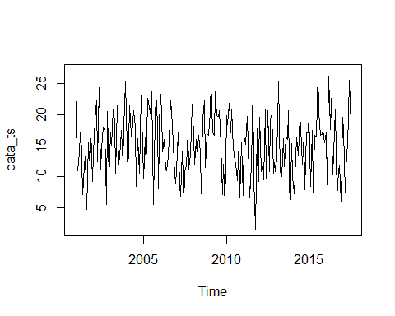

summary(data_ts)

## Min. 1st Qu. Median Mean 3rd Qu. Max.   
## 1.60 11.00 16.00 15.13 19.05 27.00

boxplot(data_ts)

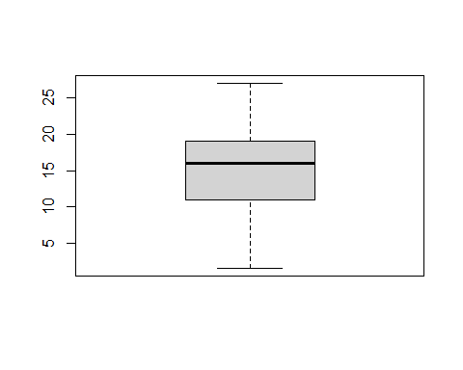

acf(data_ts)

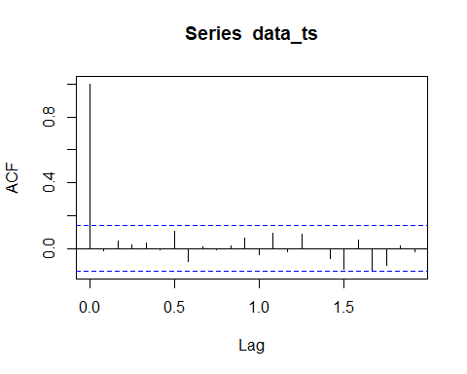

#NAIVE_FORECAST  
naive_forecast <- naive(data_ts,12)  
plot(naive_forecast)

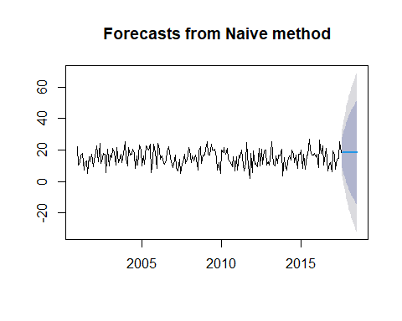

naive_forecast

## Point Forecast Lo 80 Hi 80 Lo 95 Hi 95  
## Aug 2017 18.4 8.7661239 28.03388 3.666258 33.13374  
## Sep 2017 18.4 4.7756418 32.02436 -2.436658 39.23666  
## Oct 2017 18.4 1.7136371 35.08636 -7.119590 43.91959  
## Nov 2017 18.4 -0.8677522 37.66775 -11.067484 47.86748  
## Dec 2017 18.4 -3.1420018 39.94200 -14.545649 51.34565  
## Jan 2018 18.4 -5.1980807 41.99808 -17.690150 54.49015  
## Feb 2018 18.4 -7.0888403 43.88884 -20.581817 57.38182  
## Mar 2018 18.4 -8.8487165 45.64872 -23.273316 60.07332  
## Apr 2018 18.4 -10.5016283 47.30163 -25.801226 62.60123  
## May 2018 18.4 -12.0649911 48.86499 -28.192183 64.99218  
## Jun 2018 18.4 -13.5519523 50.35195 -30.466294 67.26629  
## Jul 2018 18.4 -14.9727257 51.77273 -32.639180 69.43918

naive_residual <- naive_forecast$residuals  
naive_fitted <- naive_forecast$fitted  
plot(naive_residual, ylab="Residual")

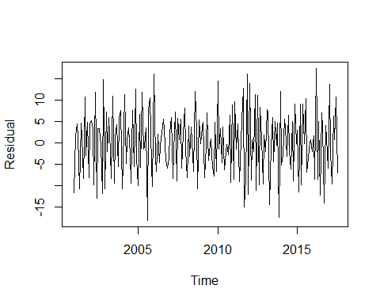

hist(naive_residual, xlab="Residual")

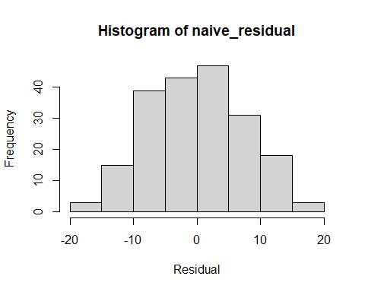

plot(naive_fitted,naive_residual,xy.labels = FALSE,xy.lines = FALSE)

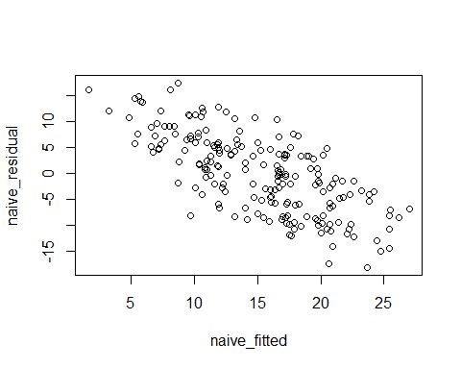

plot(naive_fitted, naive_residual)  
  
#MA_FORECAST  
ma_forecast_1 = ma(data_ts,order=3)  
ma_forecast_2 = ma(data_ts,order=6)  
ma_forecast_3 = ma(data_ts,order=9)  
  
plot(data_ts)  
lines(ma_forecast_1, col="red")  
lines(ma_forecast_2, col="green")  
lines(ma_forecast_3, col="blue")

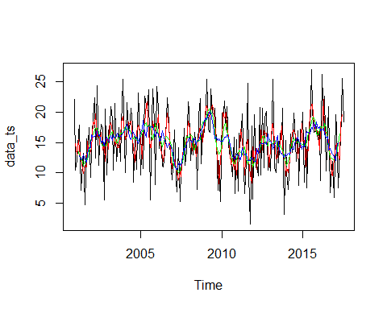

#MEAN_FORECAST  
mean_forecast <- meanf(data_ts,12)  
plot(mean_forecast)

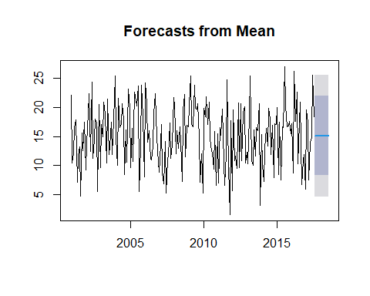

print(mean_forecast)

## Point Forecast Lo 80 Hi 80 Lo 95 Hi 95  
## Aug 2017 15.1305 8.3194 21.9416 4.684878 25.57612  
## Sep 2017 15.1305 8.3194 21.9416 4.684878 25.57612  
## Oct 2017 15.1305 8.3194 21.9416 4.684878 25.57612  
## Nov 2017 15.1305 8.3194 21.9416 4.684878 25.57612  
## Dec 2017 15.1305 8.3194 21.9416 4.684878 25.57612  
## Jan 2018 15.1305 8.3194 21.9416 4.684878 25.57612  
## Feb 2018 15.1305 8.3194 21.9416 4.684878 25.57612  
## Mar 2018 15.1305 8.3194 21.9416 4.684878 25.57612  
## Apr 2018 15.1305 8.3194 21.9416 4.684878 25.57612  
## May 2018 15.1305 8.3194 21.9416 4.684878 25.57612  
## Jun 2018 15.1305 8.3194 21.9416 4.684878 25.57612  
## Jul 2018 15.1305 8.3194 21.9416 4.684878 25.57612

mean_residual <- mean_forecast$residuals  
mean_fitted <- mean_forecast$fitted  
plot(mean_residual, ylab="Residual")

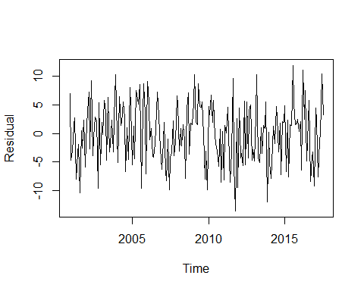

hist(mean_residual, xlab="Residual")

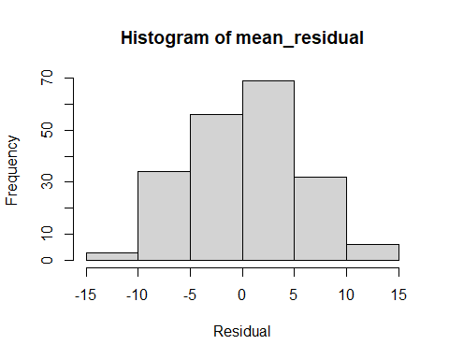

plot(mean_fitted,mean_residual,xy.labels = FALSE,xy.lines = FALSE)

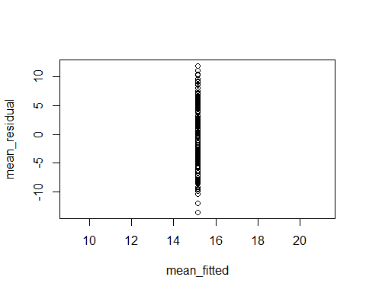

plot(mean_fitted, mean_residual)  
  
  
#Exponential Smoothing Methods  
ets_forecast <- ets(data_ts)  
plot(ets_forecast)

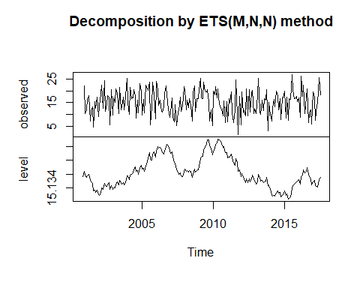

ets_forecast

## ETS(M,N,N)   
##   
## Call:  
## ets(y = data_ts)  
##   
## Smoothing parameters:  
## alpha = 1e-04   
##   
## Initial states:  
## l = 15.1357   
##   
## sigma: 0.35  
##   
## AIC AICc BIC   
## 1730.542 1730.665 1740.437

ets_residual <- ets_forecast$residuals  
ets_fitted <- ets_forecast$fitted  
plot(ets_residual, ylab="Residual")

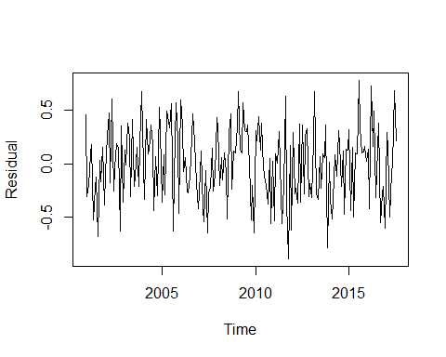

hist(ets_residual, xlab="Residual")

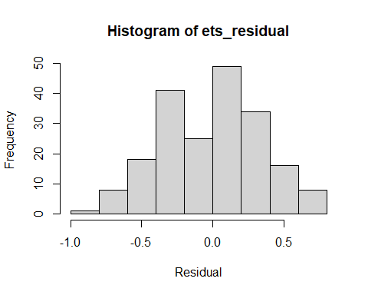

plot(ets_fitted,ets_residual,xy.labels = FALSE,xy.lines = FALSE)

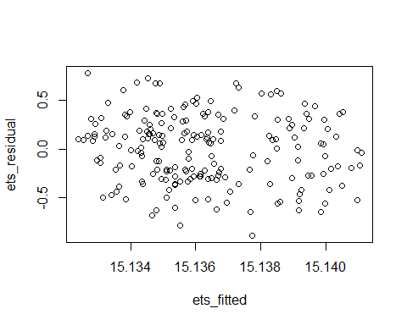

plot(ets_fitted, ets_residual)  
  
  
  
#Simple Smoothing Equations  
ses_forecast <- ses(data_ts,12)  
plot(ses_forecast)

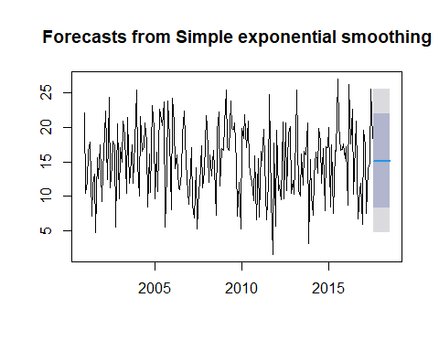

ses_forecast

## Point Forecast Lo 80 Hi 80 Lo 95 Hi 95  
## Aug 2017 15.13059 8.341597 21.91959 4.747719 25.51347  
## Sep 2017 15.13059 8.341597 21.91959 4.747719 25.51347  
## Oct 2017 15.13059 8.341597 21.91959 4.747719 25.51347  
## Nov 2017 15.13059 8.341597 21.91959 4.747719 25.51347  
## Dec 2017 15.13059 8.341597 21.91959 4.747719 25.51347  
## Jan 2018 15.13059 8.341597 21.91959 4.747718 25.51347  
## Feb 2018 15.13059 8.341597 21.91959 4.747718 25.51347  
## Mar 2018 15.13059 8.341597 21.91959 4.747718 25.51347  
## Apr 2018 15.13059 8.341597 21.91959 4.747718 25.51347  
## May 2018 15.13059 8.341597 21.91959 4.747718 25.51347  
## Jun 2018 15.13059 8.341597 21.91959 4.747718 25.51347  
## Jul 2018 15.13059 8.341597 21.91959 4.747718 25.51347

ses_residual <- ses_forecast$residuals  
ses_fitted <- ses_forecast$fitted  
plot(ses_residual, ylab="Residual")

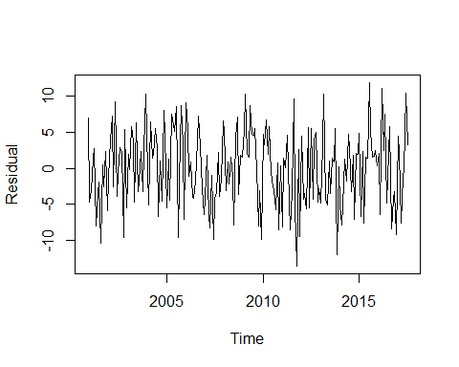

hist(ses_residual, xlab="Residual")

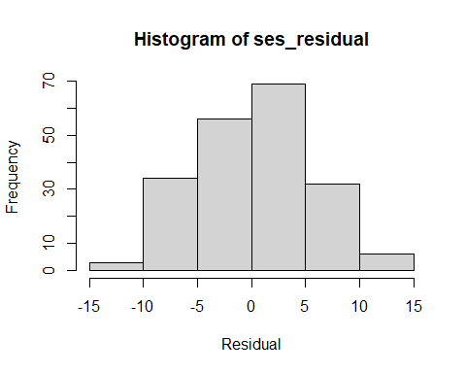

plot(ses_fitted,ses_residual,xy.labels = FALSE,xy.lines = FALSE)

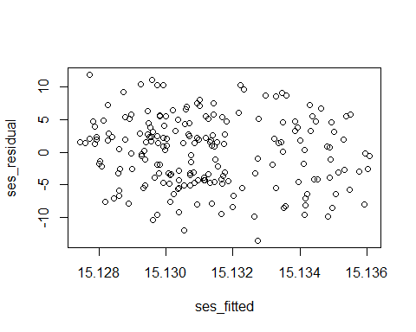

plot(ses_fitted, ses_residual)  
  
#HOLTWINTER   
hw_forecast <- hw(data_ts,12)  
plot(hw_forecast)

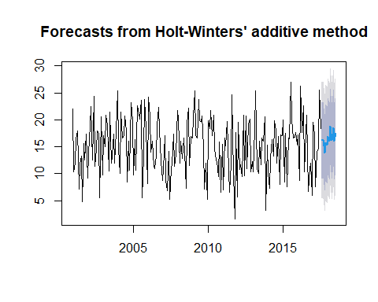

hw_forecast

## Point Forecast Lo 80 Hi 80 Lo 95 Hi 95  
## Aug 2017 16.17327 9.073515 23.27302 5.315132 27.03141  
## Sep 2017 16.27331 9.173059 23.37355 5.414415 27.13220  
## Oct 2017 13.90031 6.799403 21.00123 3.040408 24.76022  
## Nov 2017 15.74076 8.638990 22.84254 4.879539 26.60199  
## Dec 2017 15.32246 8.219599 22.42532 4.459573 26.18534  
## Jan 2018 16.90416 9.799969 24.00835 6.039237 27.76908  
## Feb 2018 16.04661 8.940808 23.15241 5.179225 26.91399  
## Mar 2018 18.77101 11.663301 25.87871 7.900708 29.64131  
## Apr 2018 16.14182 9.031882 23.25176 5.268107 27.01554  
## May 2018 18.51642 11.403893 25.62894 7.638750 29.39408  
## Jun 2018 16.02300 8.907514 23.13848 5.140806 26.90519  
## Jul 2018 17.51581 10.396964 24.63465 6.628477 28.40313

hw_residual <- hw_forecast$residuals  
hw_fitted <- hw_forecast$fitted  
plot(hw_residual, ylab="Residual")

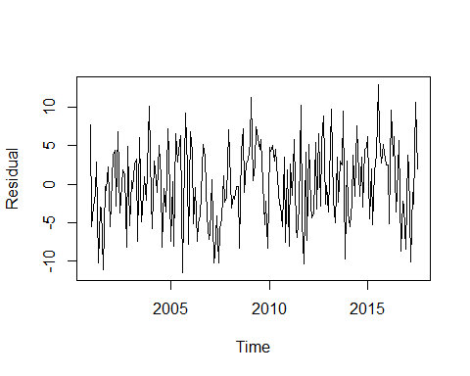

hist(hw_residual, xlab="Residual")

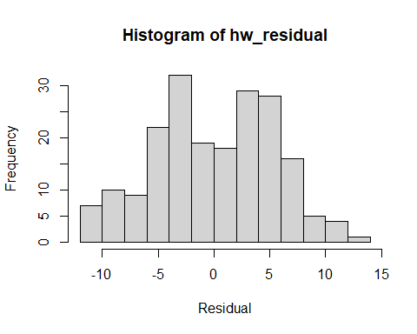

plot(hw_fitted,hw_residual,xy.labels = FALSE,xy.lines = FALSE)

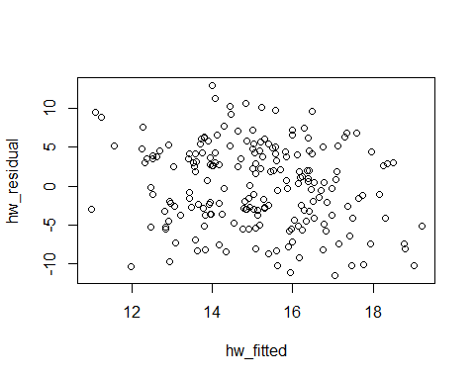

plot(hw_fitted, hw_residual)  
  
  
  
  
  
#DECOMPOSITION   
data_decomp <- stl(data_ts,s.window ="periodic")  
plot(data_decomp)

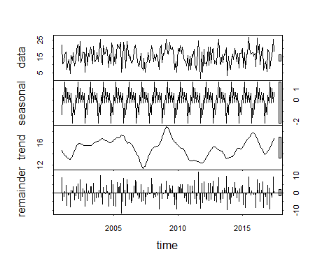

#SEASONAL ADJUSTMENT   
SATS <- seasadj(data_decomp,12)  
plot(SATS)

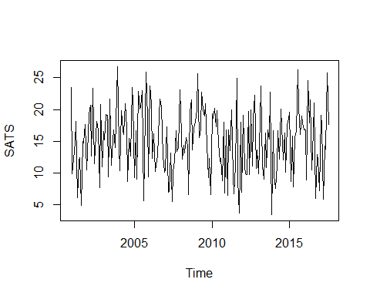

SATS

## Jan Feb Mar Apr May Jun Jul  
## 2000   
## 2001 9.934942 12.244189 14.822941 18.131101 6.117870 11.992879 12.483484  
## 2002 13.234942 19.244189 20.722941 12.731101 23.317870 11.492879 13.883484  
## 2003 16.534942 15.244189 19.222941 19.131101 9.417870 21.592879 11.183484  
## 2004 14.234942 10.344189 19.822941 16.831101 16.017870 20.892879 17.183484  
## 2005 9.234942 16.644189 9.022941 22.831101 20.117870 20.392879 22.983484  
## 2006 23.734942 20.944189 12.322941 16.231101 10.217870 11.192879 12.683484  
## 2007 10.534942 17.244189 7.022941 7.131101 13.117870 5.492879 10.283484  
## 2008 19.734942 12.244189 14.322941 13.131101 15.617870 14.192879 6.583484  
## 2009 20.034942 25.644189 15.522941 16.931101 22.717870 19.992879 18.983484  
## 2010 19.334942 18.644189 20.122941 17.331101 19.817870 14.792879 11.883484  
## 2011 6.534942 16.844189 13.522941 19.931101 9.517870 6.792879 11.183484  
## 2012 19.134942 11.044189 9.922941 9.731101 19.717870 9.792879 19.983484  
## 2013 9.834942 18.444189 23.722941 11.131101 9.017870 16.292879 10.883484  
## 2014 9.634942 7.544189 11.222941 16.631101 12.217870 20.092879 17.283484  
## 2015 19.534942 8.644189 15.822941 7.831101 15.617870 16.692879 26.283484  
## 2016 16.734942 8.944189 24.522941 17.831101 21.517870 10.492879 16.583484  
## 2017 19.134942 17.544189 5.922941 14.231101 13.717870 25.692879 17.683484  
## Aug Sep Oct Nov Dec  
## 2000 23.431577  
## 2001 4.969267 14.950742 14.732218 17.688789 10.531577  
## 2002 18.169267 16.850742 7.732218 20.788789 11.031577  
## 2003 13.369267 16.750742 14.032218 18.088789 26.731577  
## 2004 8.669267 15.450742 12.732218 23.488789 21.131577  
## 2005 5.669267 12.550742 25.932218 18.688789 9.431577  
## 2006 19.069267 21.650742 20.432218 12.688789 10.131577  
## 2007 11.969267 16.650742 13.432218 13.888789 23.031577  
## 2008 19.569267 21.550742 13.632218 17.188789 18.031577  
## 2009 20.869267 14.350742 9.332218 12.288789 6.631577  
## 2010 12.369267 8.750742 18.032218 6.888789 16.831577  
## 2011 24.869267 9.050742 3.732218 17.988789 7.031577  
## 2012 11.069267 18.550742 22.232218 10.688789 13.631577  
## 2013 16.769267 15.350742 22.732218 3.488789 16.631577  
## 2014 12.069267 16.250742 10.132218 17.488789 18.431577  
## 2015 20.369267 16.050742 18.932218 17.888789 16.831577  
## 2016 21.069267 6.050742 12.932218 12.188789 7.231577  
## 2017

accuracy(naive_forecast)

## ME RMSE MAE MPE MAPE MASE  
## Training set -0.01859296 7.517353 6.273869 -20.5415 54.4523 0.9952641  
## ACF1  
## Training set -0.5271147

accuracy(mean_forecast)

## ME RMSE MAE MPE MAPE MASE  
## Training set 2.754416e-16 5.270666 4.431365 -20.50372 41.8058 0.7029758  
## ACF1  
## Training set -0.01736017

accuracy(ets_forecast)

## ME RMSE MAE MPE MAPE MASE  
## Training set -0.005760565 5.270932 4.431246 -20.5509 41.82195 0.7029569  
## ACF1  
## Training set -0.01736177

accuracy(ses_forecast)

## ME RMSE MAE MPE MAPE MASE  
## Training set -0.0007489951 5.270929 4.431595 -20.51099 41.81042 0.7030123  
## ACF1  
## Training set -0.01736157

accuracy(hw_forecast)

## ME RMSE MAE MPE MAPE MASE  
## Training set 0.0222088 5.313751 4.515332 -18.74965 40.98141 0.7162961  
## ACF1  
## Training set 0.02206058

plot(Advertising_data)

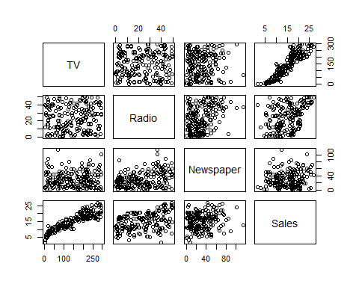

pairs(Advertising_data)  
  
  
summary(Advertising_data)

## TV Radio Newspaper Sales   
## Min. : 0.70 Min. : 0.000 Min. : 0.30 Min. : 1.60   
## 1st Qu.: 74.38 1st Qu.: 9.975 1st Qu.: 12.75 1st Qu.:11.00   
## Median :149.75 Median :22.900 Median : 25.75 Median :16.00   
## Mean :147.04 Mean :23.264 Mean : 30.55 Mean :15.13   
## 3rd Qu.:218.82 3rd Qu.:36.525 3rd Qu.: 45.10 3rd Qu.:19.05   
## Max. :296.40 Max. :49.600 Max. :114.00 Max. :27.00

cor(Advertising_data[,-1])

## Radio Newspaper Sales  
## Radio 1.0000000 0.3541038 0.3496311  
## Newspaper 0.3541038 1.0000000 0.1579600  
## Sales 0.3496311 0.1579600 1.0000000

hist(Advertising_data$Sales)

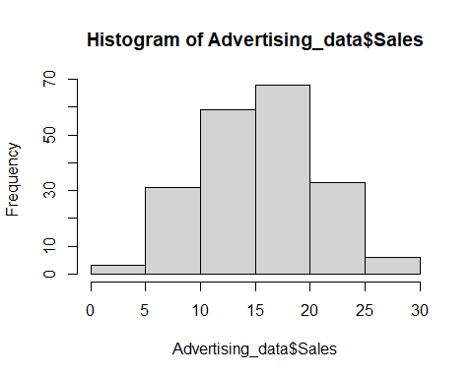

plot(Sales ~ TV, data = Advertising_data)

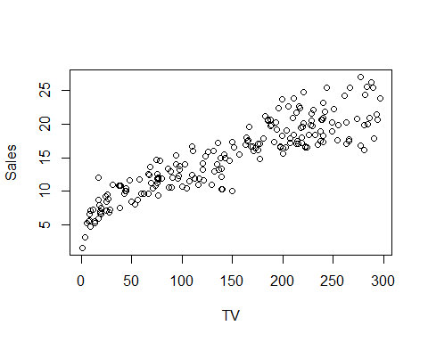

plot(jitter(Sales) ~ jitter(TV), data=Advertising_data)

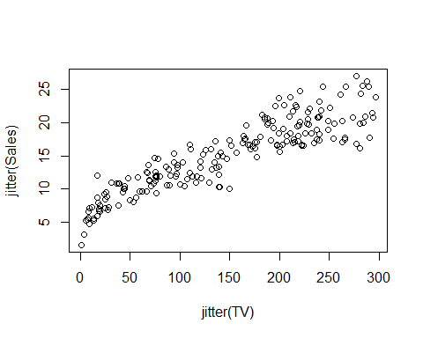

fit <- lm(Sales ~ TV, data=Advertising_data)  
fit

##   
## Call:  
## lm(formula = Sales ~ TV, data = Advertising_data)  
##   
## Coefficients:  
## (Intercept) TV   
## 6.97482 0.05546

plot(fit)

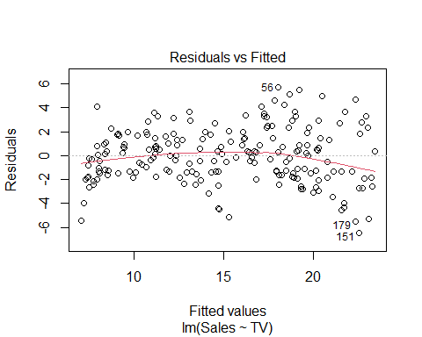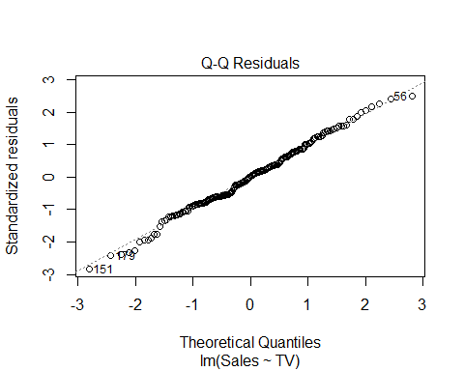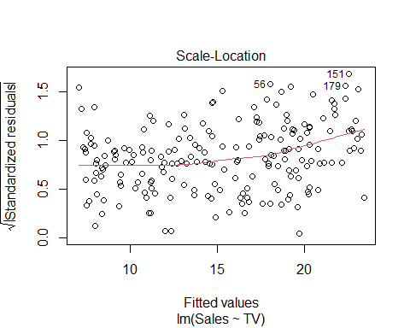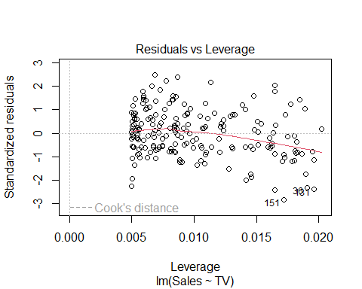

#ARIMA  
  
ndiffs(data_ts)

## [1] 0

tsdisplay(data_ts)

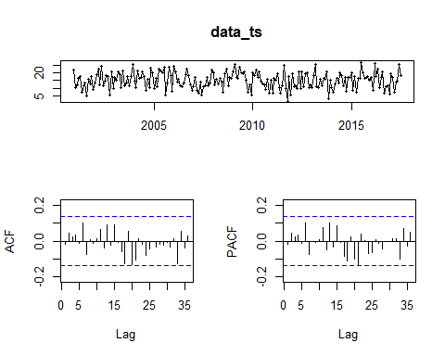

arima_timeseries_diff1 <- diff(data_ts, differences=1)  
plot(arima_timeseries_diff1)

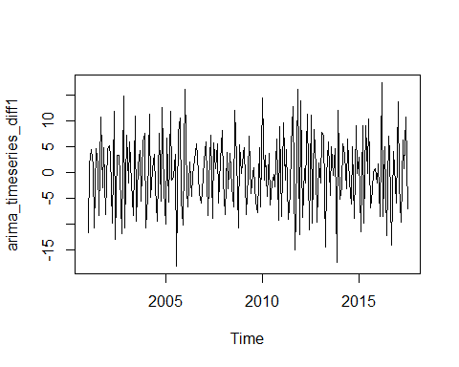

tsdisplay(arima_timeseries_diff1)

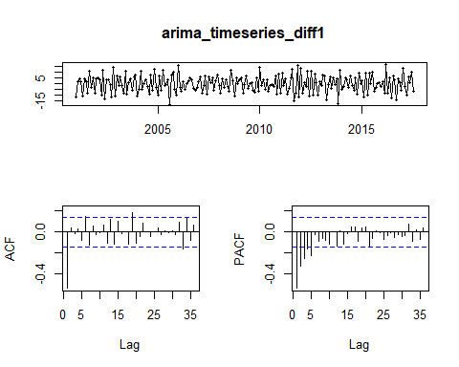

acf(arima_timeseries_diff1, lag.max=20)

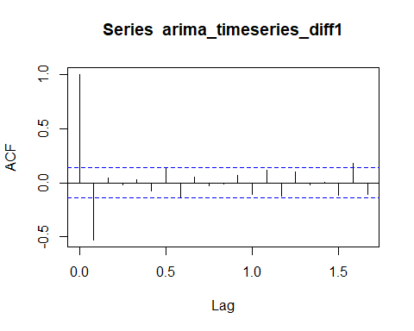

Acf(arima_timeseries_diff1, lag.max=20)

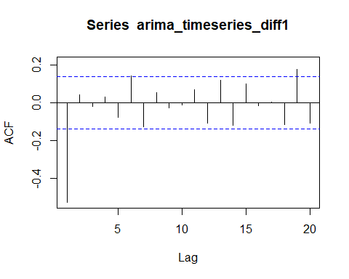

auto_fit <- auto.arima(data_ts, trace=TRUE, stepwise = FALSE)

##   
## Fitting models using approximations to speed things up...  
##   
## ARIMA(0,0,0) with zero mean : 1679.187  
## ARIMA(0,0,0) with non-zero mean : 1236.499  
## ARIMA(0,0,0)(0,0,1)[12] with zero mean : 1545.382  
## ARIMA(0,0,0)(0,0,1)[12] with non-zero mean : 1238.186  
## ARIMA(0,0,0)(0,0,2)[12] with zero mean : 1496.292  
## ARIMA(0,0,0)(0,0,2)[12] with non-zero mean : 1238.741  
## ARIMA(0,0,0)(1,0,0)[12] with zero mean : Inf  
## ARIMA(0,0,0)(1,0,0)[12] with non-zero mean : 1239.936  
## ARIMA(0,0,0)(1,0,1)[12] with zero mean : Inf  
## ARIMA(0,0,0)(1,0,1)[12] with non-zero mean : 1241.297  
## ARIMA(0,0,0)(1,0,2)[12] with zero mean : Inf  
## ARIMA(0,0,0)(1,0,2)[12] with non-zero mean : 1241.104  
## ARIMA(0,0,0)(2,0,0)[12] with zero mean : Inf  
## ARIMA(0,0,0)(2,0,0)[12] with non-zero mean : 1240.139  
## ARIMA(0,0,0)(2,0,1)[12] with zero mean : Inf  
## ARIMA(0,0,0)(2,0,1)[12] with non-zero mean : 1242.078  
## ARIMA(0,0,0)(2,0,2)[12] with zero mean : Inf  
## ARIMA(0,0,0)(2,0,2)[12] with non-zero mean : 1240.811  
## ARIMA(0,0,1) with zero mean : 1555.477  
## ARIMA(0,0,1) with non-zero mean : 1238.505  
## ARIMA(0,0,1)(0,0,1)[12] with zero mean : 1496.837  
## ARIMA(0,0,1)(0,0,1)[12] with non-zero mean : 1240.249  
## ARIMA(0,0,1)(0,0,2)[12] with zero mean : 1471.392  
## ARIMA(0,0,1)(0,0,2)[12] with non-zero mean : 1240.776  
## ARIMA(0,0,1)(1,0,0)[12] with zero mean : Inf  
## ARIMA(0,0,1)(1,0,0)[12] with non-zero mean : 1242  
## ARIMA(0,0,1)(1,0,1)[12] with zero mean : Inf  
## ARIMA(0,0,1)(1,0,1)[12] with non-zero mean : 1243.339  
## ARIMA(0,0,1)(1,0,2)[12] with zero mean : Inf  
## ARIMA(0,0,1)(1,0,2)[12] with non-zero mean : 1243.131  
## ARIMA(0,0,1)(2,0,0)[12] with zero mean : Inf  
## ARIMA(0,0,1)(2,0,0)[12] with non-zero mean : 1242.227  
## ARIMA(0,0,1)(2,0,1)[12] with zero mean : Inf  
## ARIMA(0,0,1)(2,0,1)[12] with non-zero mean : 1244.193  
## ARIMA(0,0,1)(2,0,2)[12] with zero mean : Inf  
## ARIMA(0,0,1)(2,0,2)[12] with non-zero mean : 1242.918  
## ARIMA(0,0,2) with zero mean : 1491.125  
## ARIMA(0,0,2) with non-zero mean : 1240.224  
## ARIMA(0,0,2)(0,0,1)[12] with zero mean : 1452.847  
## ARIMA(0,0,2)(0,0,1)[12] with non-zero mean : 1242.002  
## ARIMA(0,0,2)(0,0,2)[12] with zero mean : 1436.858  
## ARIMA(0,0,2)(0,0,2)[12] with non-zero mean : 1242.518  
## ARIMA(0,0,2)(1,0,0)[12] with zero mean : 1373.708  
## ARIMA(0,0,2)(1,0,0)[12] with non-zero mean : 1243.804  
## ARIMA(0,0,2)(1,0,1)[12] with zero mean : Inf  
## ARIMA(0,0,2)(1,0,1)[12] with non-zero mean : 1245.018  
## ARIMA(0,0,2)(1,0,2)[12] with zero mean : Inf  
## ARIMA(0,0,2)(1,0,2)[12] with non-zero mean : 1244.829  
## ARIMA(0,0,2)(2,0,0)[12] with zero mean : Inf  
## ARIMA(0,0,2)(2,0,0)[12] with non-zero mean : 1244.159  
## ARIMA(0,0,2)(2,0,1)[12] with zero mean : Inf  
## ARIMA(0,0,2)(2,0,1)[12] with non-zero mean : 1246.116  
## ARIMA(0,0,3) with zero mean : 1447.751  
## ARIMA(0,0,3) with non-zero mean : 1242.232  
## ARIMA(0,0,3)(0,0,1)[12] with zero mean : 1426.007  
## ARIMA(0,0,3)(0,0,1)[12] with non-zero mean : 1243.992  
## ARIMA(0,0,3)(0,0,2)[12] with zero mean : 1419.16  
## ARIMA(0,0,3)(0,0,2)[12] with non-zero mean : 1244.643  
## ARIMA(0,0,3)(1,0,0)[12] with zero mean : 1375.807  
## ARIMA(0,0,3)(1,0,0)[12] with non-zero mean : 1245.905  
## ARIMA(0,0,3)(1,0,1)[12] with zero mean : Inf  
## ARIMA(0,0,3)(1,0,1)[12] with non-zero mean : 1247.162  
## ARIMA(0,0,3)(2,0,0)[12] with zero mean : Inf  
## ARIMA(0,0,3)(2,0,0)[12] with non-zero mean : 1246.307  
## ARIMA(0,0,4) with zero mean : 1422.056  
## ARIMA(0,0,4) with non-zero mean : 1244.169  
## ARIMA(0,0,4)(0,0,1)[12] with zero mean : 1414.223  
## ARIMA(0,0,4)(0,0,1)[12] with non-zero mean : 1245.934  
## ARIMA(0,0,4)(1,0,0)[12] with zero mean : 1377.283  
## ARIMA(0,0,4)(1,0,0)[12] with non-zero mean : 1248.024  
## ARIMA(0,0,5) with zero mean : 1410.806  
## ARIMA(0,0,5) with non-zero mean : 1246.317  
## ARIMA(1,0,0) with zero mean : 1366.869  
## ARIMA(1,0,0) with non-zero mean : 1237.737  
## ARIMA(1,0,0)(0,0,1)[12] with zero mean : 1368.255  
## ARIMA(1,0,0)(0,0,1)[12] with non-zero mean : 1239.613  
## ARIMA(1,0,0)(0,0,2)[12] with zero mean : 1370.31  
## ARIMA(1,0,0)(0,0,2)[12] with non-zero mean : 1240.292  
## ARIMA(1,0,0)(1,0,0)[12] with zero mean : 1370.742  
## ARIMA(1,0,0)(1,0,0)[12] with non-zero mean : 1241.779  
## ARIMA(1,0,0)(1,0,1)[12] with zero mean : 1372.825  
## ARIMA(1,0,0)(1,0,1)[12] with non-zero mean : 1243.882  
## ARIMA(1,0,0)(1,0,2)[12] with zero mean : Inf  
## ARIMA(1,0,0)(1,0,2)[12] with non-zero mean : 1244.229  
## ARIMA(1,0,0)(2,0,0)[12] with zero mean : Inf  
## ARIMA(1,0,0)(2,0,0)[12] with non-zero mean : 1242.307  
## ARIMA(1,0,0)(2,0,1)[12] with zero mean : Inf  
## ARIMA(1,0,0)(2,0,1)[12] with non-zero mean : 1243.521  
## ARIMA(1,0,0)(2,0,2)[12] with zero mean : Inf  
## ARIMA(1,0,0)(2,0,2)[12] with non-zero mean : 1243.35  
## ARIMA(1,0,1) with zero mean : Inf  
## ARIMA(1,0,1) with non-zero mean : 1239.342  
## ARIMA(1,0,1)(0,0,1)[12] with zero mean : Inf  
## ARIMA(1,0,1)(0,0,1)[12] with non-zero mean : 1241.245  
## ARIMA(1,0,1)(0,0,2)[12] with zero mean : Inf  
## ARIMA(1,0,1)(0,0,2)[12] with non-zero mean : 1241.923  
## ARIMA(1,0,1)(1,0,0)[12] with zero mean : Inf  
## ARIMA(1,0,1)(1,0,0)[12] with non-zero mean : 1243.852  
## ARIMA(1,0,1)(1,0,1)[12] with zero mean : Inf  
## ARIMA(1,0,1)(1,0,1)[12] with non-zero mean : 1245.977  
## ARIMA(1,0,1)(1,0,2)[12] with zero mean : Inf  
## ARIMA(1,0,1)(1,0,2)[12] with non-zero mean : 1246.352  
## ARIMA(1,0,1)(2,0,0)[12] with zero mean : Inf  
## ARIMA(1,0,1)(2,0,0)[12] with non-zero mean : 1244.323  
## ARIMA(1,0,1)(2,0,1)[12] with zero mean : Inf  
## ARIMA(1,0,1)(2,0,1)[12] with non-zero mean : 1245.645  
## ARIMA(1,0,2) with zero mean : Inf  
## ARIMA(1,0,2) with non-zero mean : 1241.227  
## ARIMA(1,0,2)(0,0,1)[12] with zero mean : Inf  
## ARIMA(1,0,2)(0,0,1)[12] with non-zero mean : 1243.141  
## ARIMA(1,0,2)(0,0,2)[12] with zero mean : Inf  
## ARIMA(1,0,2)(0,0,2)[12] with non-zero mean : 1243.791  
## ARIMA(1,0,2)(1,0,0)[12] with zero mean : Inf  
## ARIMA(1,0,2)(1,0,0)[12] with non-zero mean : 1245.523  
## ARIMA(1,0,2)(1,0,1)[12] with zero mean : Inf  
## ARIMA(1,0,2)(1,0,1)[12] with non-zero mean : 1247.661  
## ARIMA(1,0,2)(2,0,0)[12] with zero mean : Inf  
## ARIMA(1,0,2)(2,0,0)[12] with non-zero mean : 1246.319  
## ARIMA(1,0,3) with zero mean : Inf  
## ARIMA(1,0,3) with non-zero mean : 1243.212  
## ARIMA(1,0,3)(0,0,1)[12] with zero mean : Inf  
## ARIMA(1,0,3)(0,0,1)[12] with non-zero mean : 1245.128  
## ARIMA(1,0,3)(1,0,0)[12] with zero mean : Inf  
## ARIMA(1,0,3)(1,0,0)[12] with non-zero mean : 1247.644  
## ARIMA(1,0,4) with zero mean : Inf  
## ARIMA(1,0,4) with non-zero mean : 1244.526  
## ARIMA(2,0,0) with zero mean : 1309.586  
## ARIMA(2,0,0) with non-zero mean : 1239.682  
## ARIMA(2,0,0)(0,0,1)[12] with zero mean : 1311.326  
## ARIMA(2,0,0)(0,0,1)[12] with non-zero mean : 1241.544  
## ARIMA(2,0,0)(0,0,2)[12] with zero mean : 1312.394  
## ARIMA(2,0,0)(0,0,2)[12] with non-zero mean : 1242.252  
## ARIMA(2,0,0)(1,0,0)[12] with zero mean : 1315.605  
## ARIMA(2,0,0)(1,0,0)[12] with non-zero mean : 1244.525  
## ARIMA(2,0,0)(1,0,1)[12] with zero mean : 1316.73  
## ARIMA(2,0,0)(1,0,1)[12] with non-zero mean : 1246.595  
## ARIMA(2,0,0)(1,0,2)[12] with zero mean : 1317.306  
## ARIMA(2,0,0)(1,0,2)[12] with non-zero mean : 1246.871  
## ARIMA(2,0,0)(2,0,0)[12] with zero mean : 1315.579  
## ARIMA(2,0,0)(2,0,0)[12] with non-zero mean : 1245.316  
## ARIMA(2,0,0)(2,0,1)[12] with zero mean : 1317.676  
## ARIMA(2,0,0)(2,0,1)[12] with non-zero mean : 1246.8  
## ARIMA(2,0,1) with zero mean : Inf  
## ARIMA(2,0,1) with non-zero mean : 1240.335  
## ARIMA(2,0,1)(0,0,1)[12] with zero mean : Inf  
## ARIMA(2,0,1)(0,0,1)[12] with non-zero mean : 1242.324  
## ARIMA(2,0,1)(0,0,2)[12] with zero mean : Inf  
## ARIMA(2,0,1)(0,0,2)[12] with non-zero mean : 1243.465  
## ARIMA(2,0,1)(1,0,0)[12] with zero mean : Inf  
## ARIMA(2,0,1)(1,0,0)[12] with non-zero mean : 1246.626  
## ARIMA(2,0,1)(1,0,1)[12] with zero mean : Inf  
## ARIMA(2,0,1)(1,0,1)[12] with non-zero mean : 1248.707  
## ARIMA(2,0,1)(2,0,0)[12] with zero mean : Inf  
## ARIMA(2,0,1)(2,0,0)[12] with non-zero mean : Inf  
## ARIMA(2,0,2) with zero mean : Inf  
## ARIMA(2,0,2) with non-zero mean : Inf  
## ARIMA(2,0,2)(0,0,1)[12] with zero mean : Inf  
## ARIMA(2,0,2)(0,0,1)[12] with non-zero mean : Inf  
## ARIMA(2,0,2)(1,0,0)[12] with zero mean : Inf  
## ARIMA(2,0,2)(1,0,0)[12] with non-zero mean : Inf  
## ARIMA(2,0,3) with zero mean : Inf  
## ARIMA(2,0,3) with non-zero mean : Inf  
## ARIMA(3,0,0) with zero mean : 1290.401  
## ARIMA(3,0,0) with non-zero mean : 1242.232  
## ARIMA(3,0,0)(0,0,1)[12] with zero mean : 1291.855  
## ARIMA(3,0,0)(0,0,1)[12] with non-zero mean : 1244.13  
## ARIMA(3,0,0)(0,0,2)[12] with zero mean : 1293.721  
## ARIMA(3,0,0)(0,0,2)[12] with non-zero mean : 1244.951  
## ARIMA(3,0,0)(1,0,0)[12] with zero mean : 1296.316  
## ARIMA(3,0,0)(1,0,0)[12] with non-zero mean : 1247.131  
## ARIMA(3,0,0)(1,0,1)[12] with zero mean : 1298.254  
## ARIMA(3,0,0)(1,0,1)[12] with non-zero mean : 1249.279  
## ARIMA(3,0,0)(2,0,0)[12] with zero mean : 1298.107  
## ARIMA(3,0,0)(2,0,0)[12] with non-zero mean : 1248.612  
## ARIMA(3,0,1) with zero mean : Inf  
## ARIMA(3,0,1) with non-zero mean : 1244.358  
## ARIMA(3,0,1)(0,0,1)[12] with zero mean : Inf  
## ARIMA(3,0,1)(0,0,1)[12] with non-zero mean : 1246.278  
## ARIMA(3,0,1)(1,0,0)[12] with zero mean : Inf  
## ARIMA(3,0,1)(1,0,0)[12] with non-zero mean : 1247.878  
## ARIMA(3,0,2) with zero mean : Inf  
## ARIMA(3,0,2) with non-zero mean : Inf  
## ARIMA(4,0,0) with zero mean : Inf  
## ARIMA(4,0,0) with non-zero mean : 1245.068  
## ARIMA(4,0,0)(0,0,1)[12] with zero mean : Inf  
## ARIMA(4,0,0)(0,0,1)[12] with non-zero mean : 1246.946  
## ARIMA(4,0,0)(1,0,0)[12] with zero mean : Inf  
## ARIMA(4,0,0)(1,0,0)[12] with non-zero mean : 1248.17  
## ARIMA(4,0,1) with zero mean : Inf  
## ARIMA(4,0,1) with non-zero mean : 1247.194  
## ARIMA(5,0,0) with zero mean : Inf  
## ARIMA(5,0,0) with non-zero mean : 1247.911  
##   
## Now re-fitting the best model(s) without approximations...  
##   
##   
##   
##   
## Best model: ARIMA(0,0,0) with non-zero mean

auto_fit

## Series: data_ts   
## ARIMA(0,0,0) with non-zero mean   
##   
## Coefficients:  
## mean  
## 15.1305  
## s.e. 0.3727  
##   
## sigma^2 = 27.92: log likelihood = -616.22  
## AIC=1236.44 AICc=1236.5 BIC=1243.03

plot(auto_fit)

## Warning in plot.Arima(auto_fit): No roots to plot

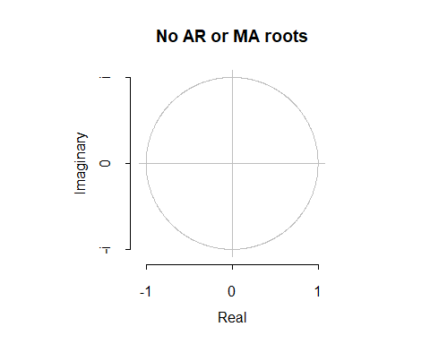

attributes(auto_fit)

## $names  
## [1] "coef" "sigma2" "var.coef" "mask" "loglik" "aic"   
## [7] "arma" "residuals" "call" "series" "code" "n.cond"   
## [13] "nobs" "model" "bic" "aicc" "x" "fitted"   
##   
## $class  
## [1] "forecast_ARIMA" "ARIMA" "Arima"

fun <- plot(forecast(auto_fit,h=12,level=c(99.5)))

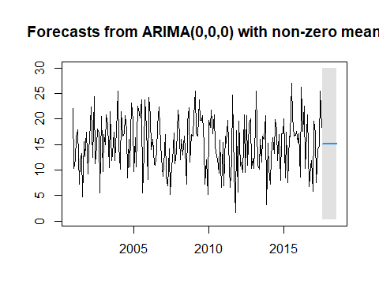

Acf(auto_fit$residuals)

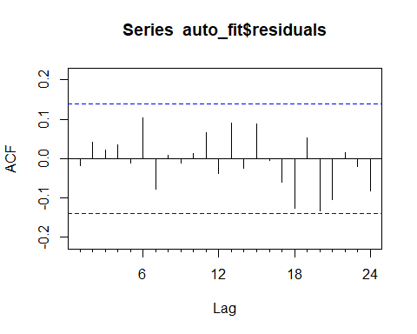

Box.test(residuals(auto_fit), lag=20, type="Ljung")

##   
## Box-Ljung test  
##   
## data: residuals(auto_fit)  
## X-squared = 18.051, df = 20, p-value = 0.584

plot.ts(residuals(auto_fit))

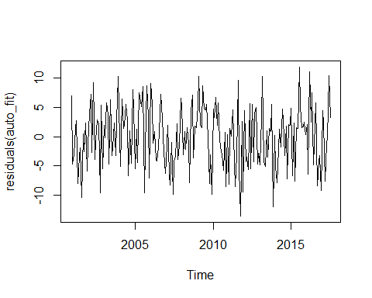

hist(auto_fit$residuals)

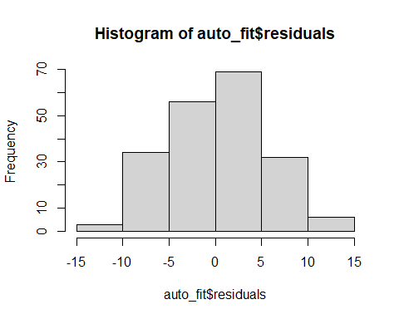

tsdiag(auto_fit)

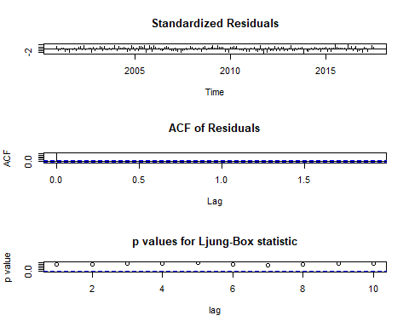

accuracy(auto_fit)

## ME RMSE MAE MPE MAPE MASE  
## Training set 6.955336e-14 5.270666 4.431365 -20.50372 41.8058 0.7029758  
## ACF1  
## Training set -0.01736017

accuracy_measures <- list()  
  
accuracy_measures$naive <- accuracy(naive_forecast)[, "RMSE"]  
accuracy_measures$ets <- accuracy(ets_forecast)[, "RMSE"]  
accuracy_measures$ses <- accuracy(ses_forecast)[, "RMSE"]  
accuracy_measures$hw <- accuracy(hw_forecast)[, "RMSE"]  
accuracy_measures$arima <- accuracy(auto_fit)[, "RMSE"]  
  
# Combine into a data frame for better readability  
accuracy_summary <- data.frame(  
 Method = names(accuracy_measures),  
 RMSE = unlist(accuracy_measures)  
)  
  
# Print the summary  
print("Accuracy Summary (RMSE):")

## [1] "Accuracy Summary (RMSE):"

print(accuracy_summary)

## Method RMSE  
## naive naive 7.517353  
## ets ets 5.270932  
## ses ses 5.270929  
## hw hw 5.313751  
## arima arima 5.270666

# Highlight the method with the lowest RMSE  
best_method <- accuracy_summary[which.min(accuracy_summary$RMSE), ]  
cat("Best method based on RMSE:\n")

## Best method based on RMSE:

print(best_method)

## Method RMSE  
## arima arima 5.270666