Part 1 – Initial Setup

IBM Cloud Hello World Example.

1. Start -> Windows PowerShell
2. Install Python

<https://www.python.org/downloads/>

1. Install Flask – pip install flask
2. Install IBM Cloud

<https://cloud.ibm.com/docs/cli?topic=cloud-cli-install-ibmcloud-cli>

Below are the versions that were used for this tutorial.

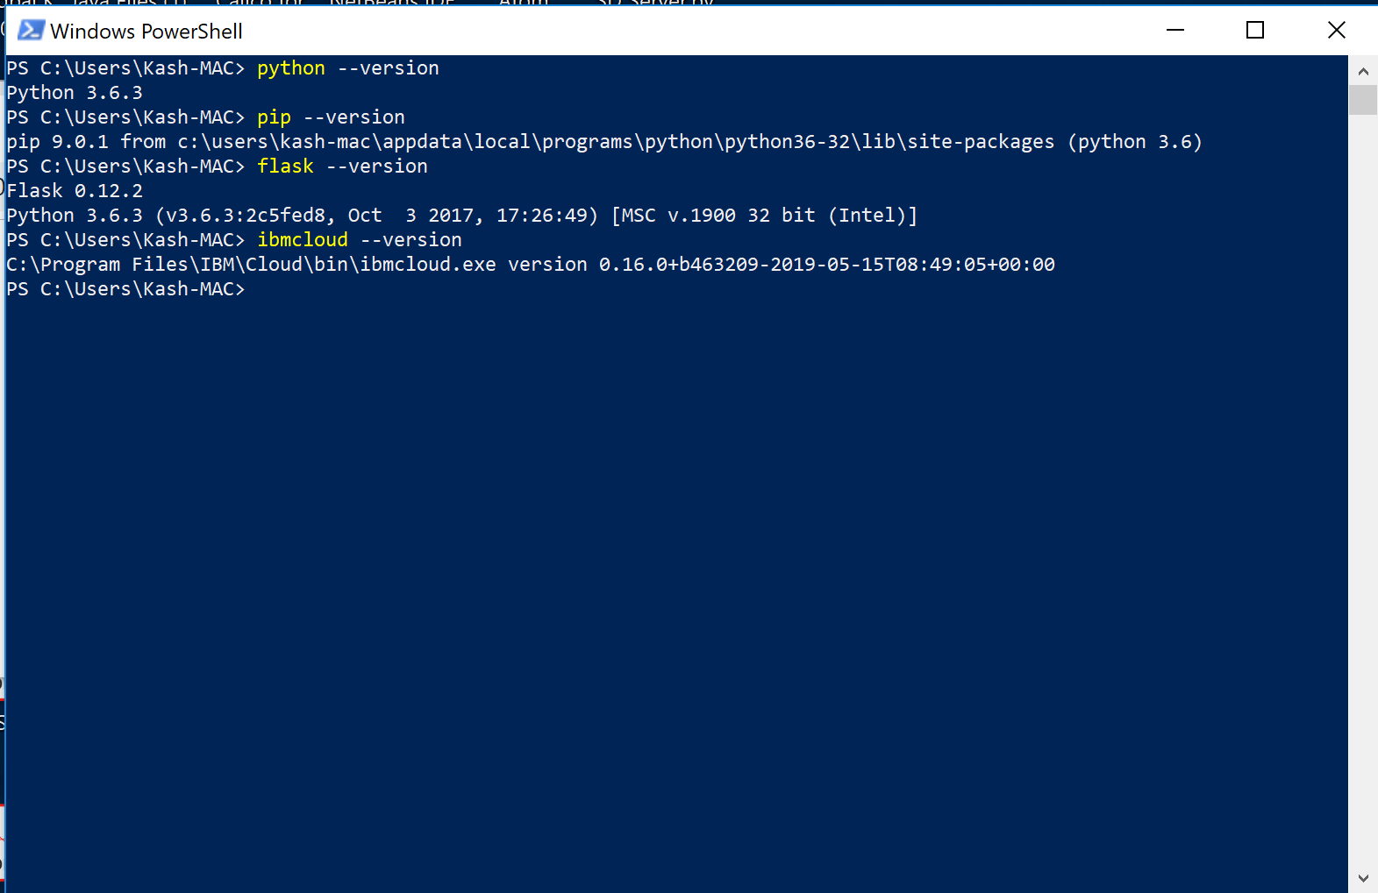

1. Clone git repository.

Download git bash <https://gitforwindows.org/>

<https://github.com/kash-if47/CloudExampleBasic.git>

After cloning your local should have these files.

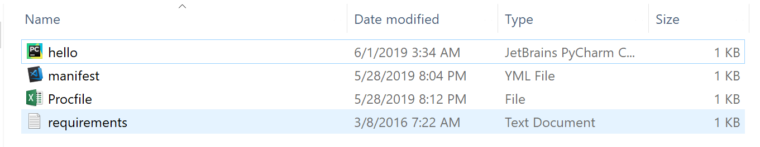

1. Next try running the app in PowerShell.

Navigate to the above directory and run the following command.

**python .\hello.py**

The output should look like this.

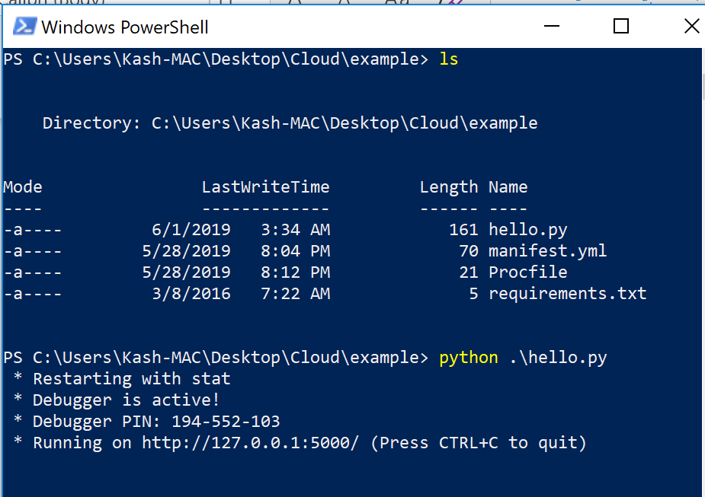

Copy the URL and paste it into your Chrome browser. The Webpage displayed should look like this.

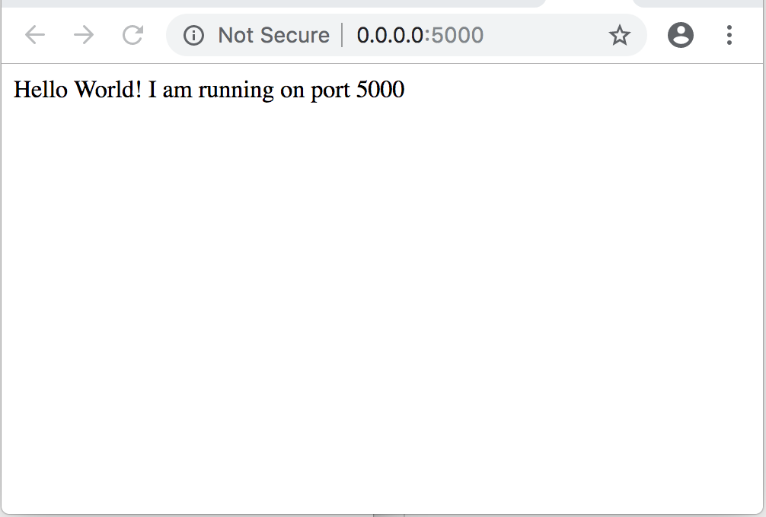

Note: DO NOT move any further until you can get the above part working correctly.

Part 2 – Pushing app to IBM Cloud

1. Create a new IBM Cloud account.

<https://cloud.ibm.com/registration>

1. After registration and email verification. Login into IBM Cloud and click on Create resource.

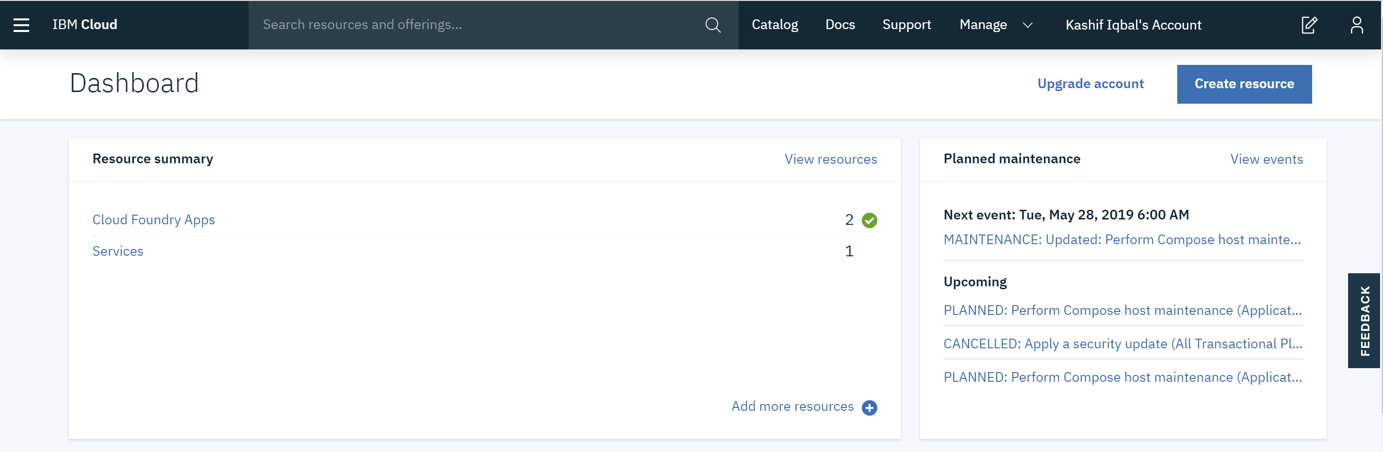

1. Under Cloud Foundry, click on Python

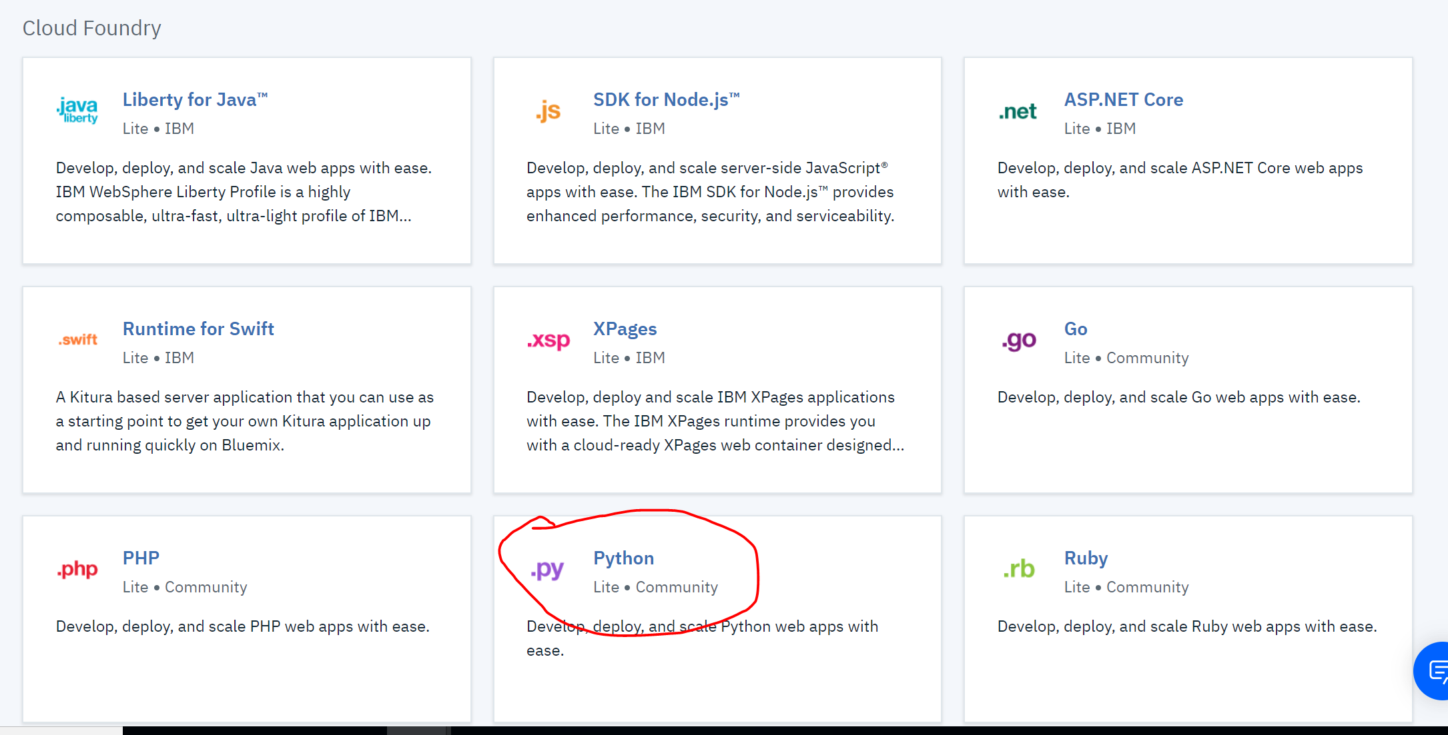

1. Leave all the settings as default including the lite pricing plan. Enter a custom App name, Host name should automatically fill up with the same name. In this case I have entered it as myNewApp-001. Then click on Create.

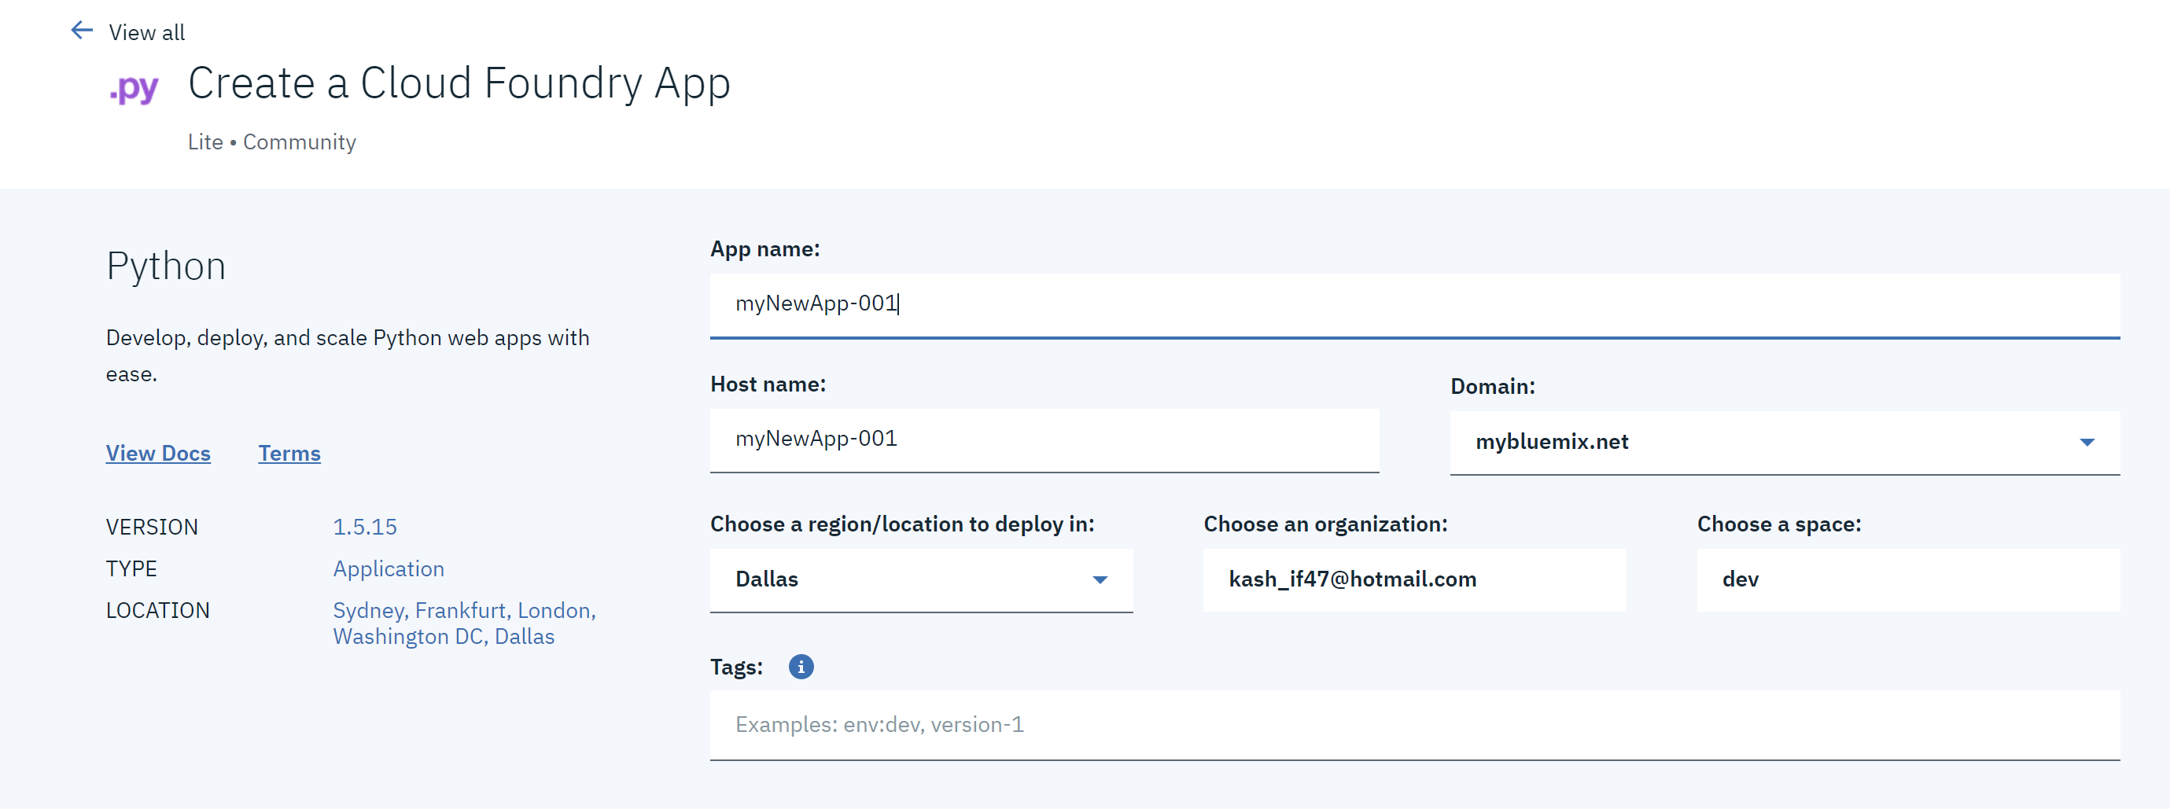

1. Open the manifest..yml file and update the name property with the unique name that you entered above. In my case its myNewApp-001. Then Save the file.

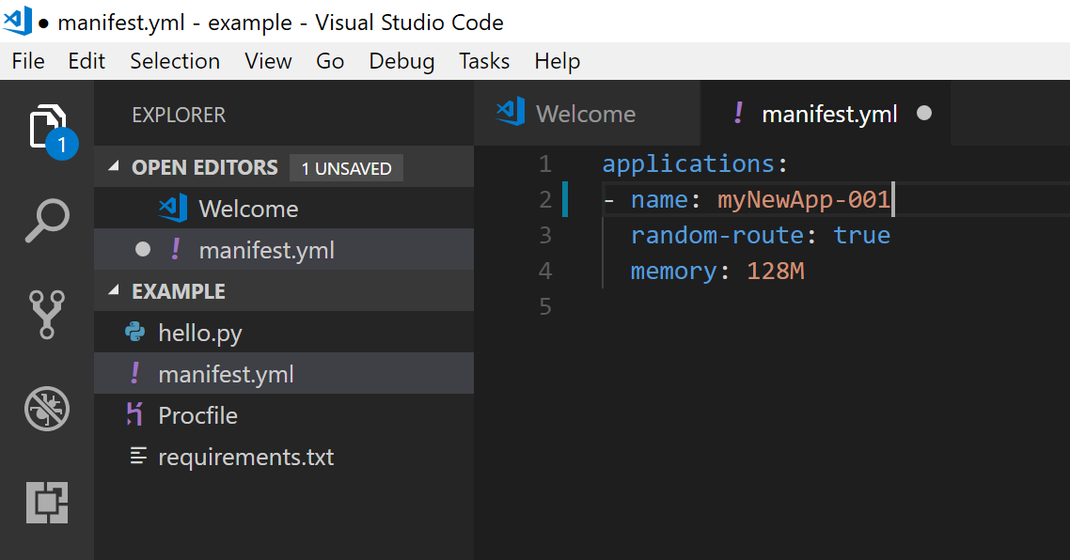

1. Login to IBM Cloud in windows PowerShell by entering. You can skip the region if prompted.

**Ibmcloud login**

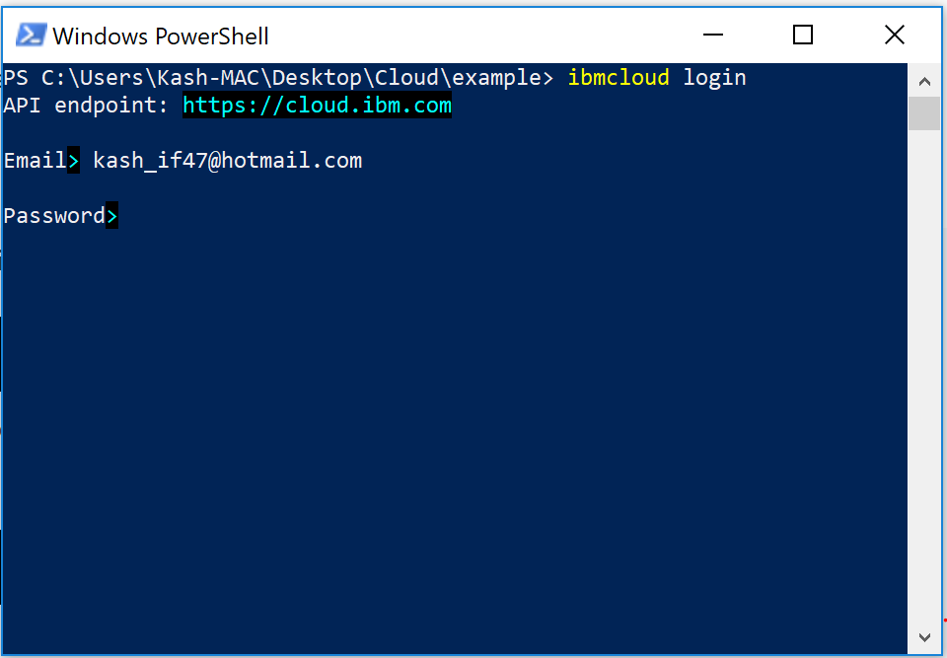

1. Enter command

**Ibmcloud target –cf**

Select 1 if prompted

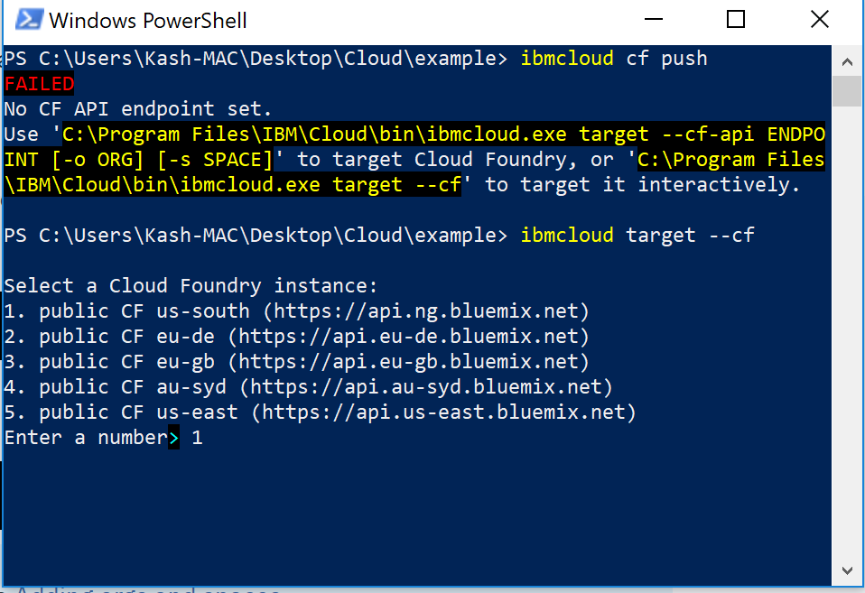

1. Then run ibmcloud cf push

Should get output as below.

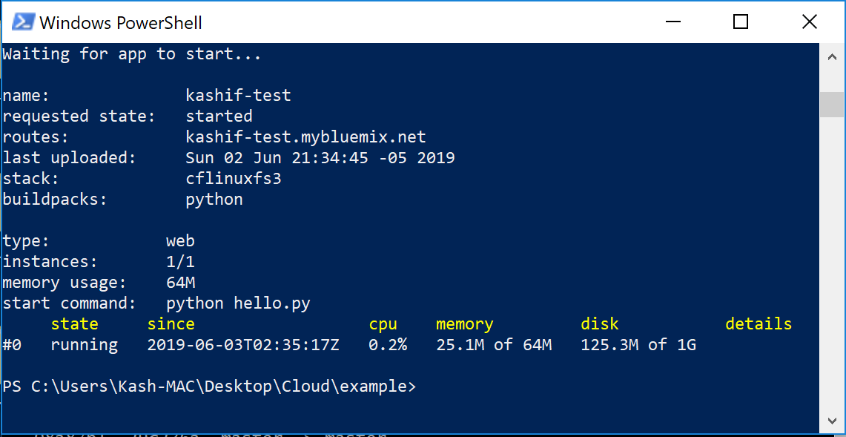

1. Click on Visit app URL

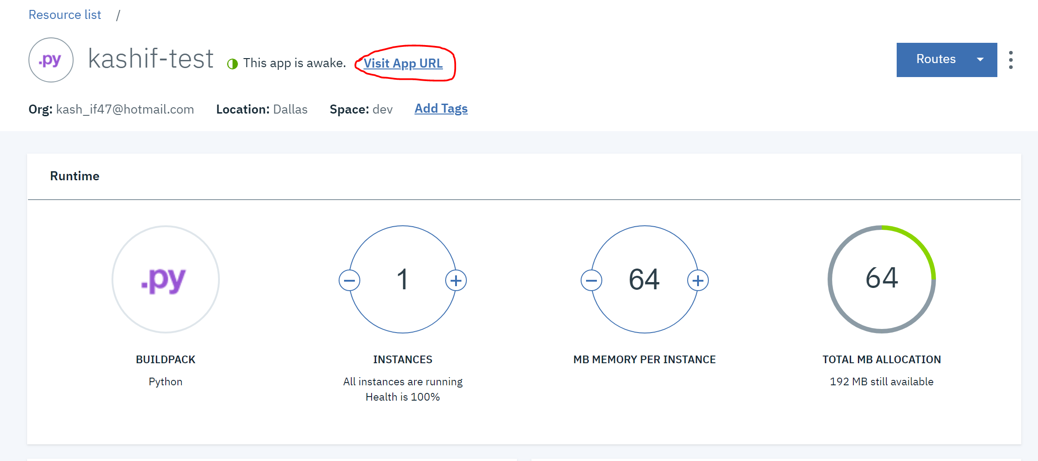

Our App should load now. It is now deployed on IBM Cloud.

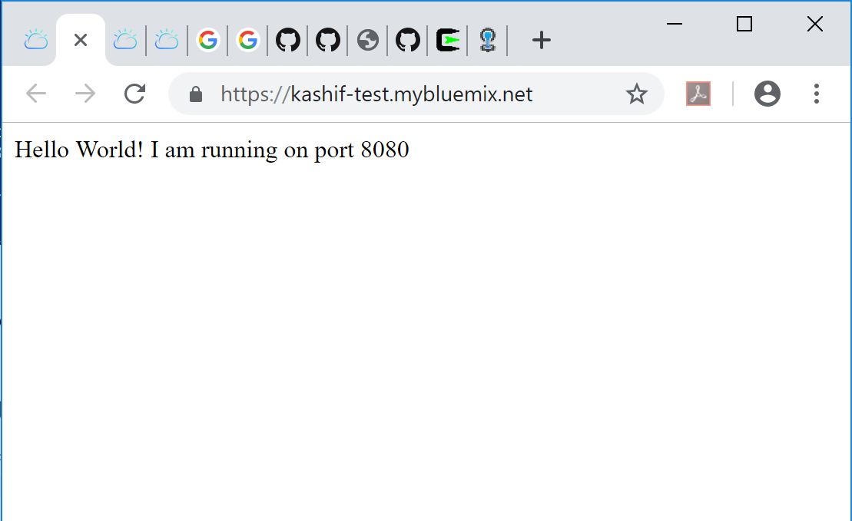

Part 3 – Loading and displaying Student data

1. Download SQLite browser from the Link below.

<https://sqlitebrowser.org/dl/>

1. Switch to the branch called part3 in git by entering the below command in git bash.

git checkout part3

1. You should see a csv file in your project folder now.