**19CSE312- Distributed Systems-CSE-A**

**Tutorial-1-Set-1-Answer Key**

**Answer :**

**1 a. Makes the distribution of processes and resources transparent invisible to end users and applications.**

**Access Transparency : differences in Machine Architecture, reading a document stored in cloud**

**Replication Transparency: user profile on social media app**

**b. Layered Architecture: Components are organized in a layered fashion. downcall / upcall interaction**

**Event Based: Temporally coupled and referentially decoupled. publish/ subscribe notification.**

2.a. Figure 1 :2 MArks Figure 2: 1 Mark

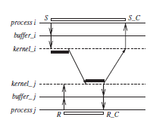

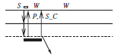

**Answer:**

**a. Figure 1: Blocking sync send ,blocking receive Figure 2: non blocking async send**

b.

**Answer:**

**Data are passed within the memory in the local function and data has to be transformed to a compatible format acceptable by the network and the server machine, where no meta data information is available.**

**Placement of bytes in the memory may vary based on the architecture.**

3.Answer:

a. a || e , c || e, b || e, d || e, h || f, h ||g

b. {a,b,c,d,e,h} {a,b,c,d,h}, {a,b,c,d,e,h,f}

**b. Answer: Refer Section 4.3.2 -Kshemkalyani Text book**

**19CSE312- Distributed Systems-CSE-A**

**Tutorial-1-Set-2**

**Answer :**

**1.a.**

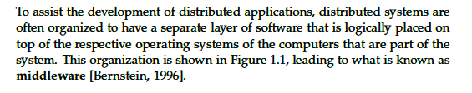

**Example : Communication Service(RPC) , Service Composition (Web Services)**

**b. homogeneity in cluster and heterogeneity in Grid. Resource sharing in Cluster and HPC in grid**

2 a.

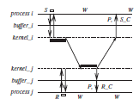

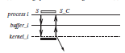

**Answer:**

**Fig 1 : sync non blocking send, non blocking receive Fig 2: Asyn blocking send**

b.

**Answer:**

local function executes in same process where stub creations are done in RPC.

Marshalling and unmarshalling of parameters in RPC is done.

3.a.i. **Answer:**

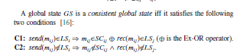

GS1 = {e11, e21, e31} GS2= {e13, e23, e32}

ii. e11 || e21, e13 || e31

b. **Answer: Refer Section 4.3.2 -Kshemkalyani Text book**