SCALA-One compiler challenges

CB.EN.U4CSE22544

J.V.SHREYA

1)

object HelloWorld {

def main(args: Array[String]): Unit = {

println("Hello World")

}

}

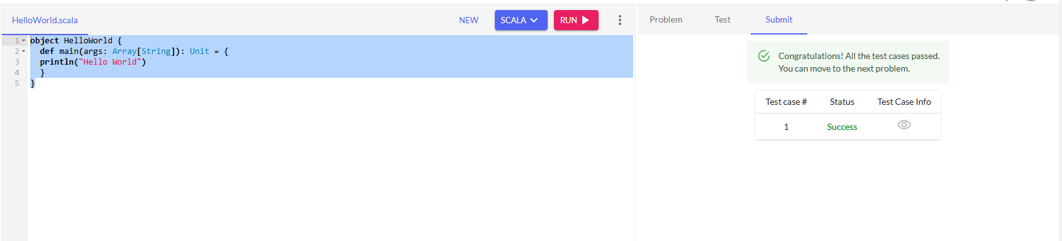

2)

import java.util.*;

public class Main {

public static void main(String[] args) {

System.out.println("Hello\nWorld");

}

}

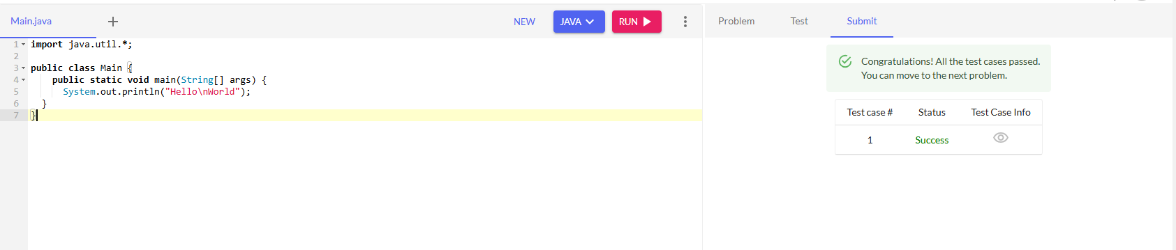

3)

object HelloWorld {

def main(args: Array[String]): Unit = {

val n=scala.io.StdIn.readLine()

println("Hello "+n)

}

}

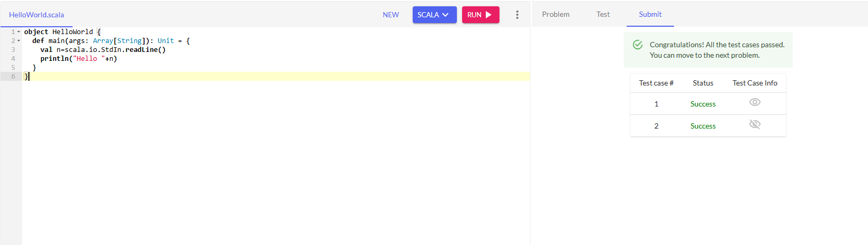

4)

object vowelorconsonant {

def main(args: Array[String]): Unit = {

val ch=scala.io.StdIn.readChar()

if("aeiou".contains(ch)){

println("vowel")

}

else{

println("consonant")

}

}

}

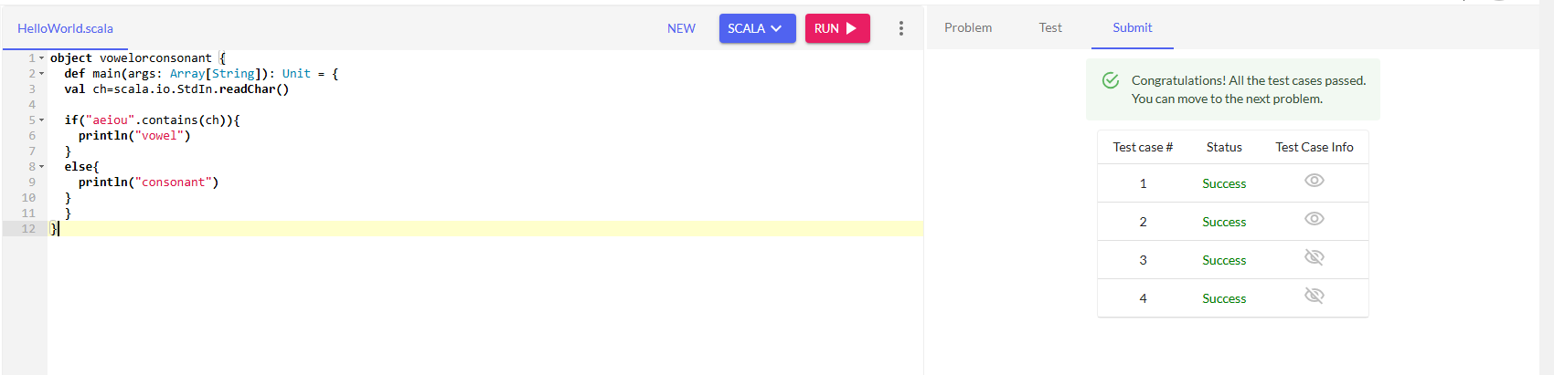

5)

object HelloWorld {

def main(args: Array[String]): Unit = {

for(i<-1 to 10){

println(i)

}

}

}

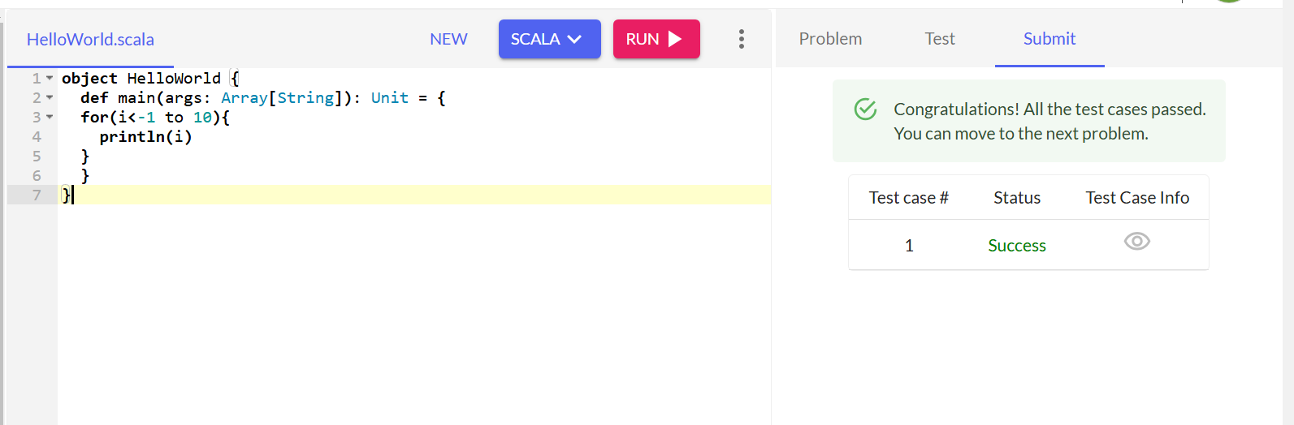

6)

object HelloWorld {

def main(args: Array[String]): Unit = {

val n=scala.io.StdIn.readInt()

n match{

case 0=>println("zero")

case 1=>println("one")

case 2=>println("two")

case 3=>println("three")

case 4=>println("four")

case 5=>println("five")

case 6=>println("six")

case 7=>println("seven")

case 8=>println("eight")

case 9=>println("nine")

case _=>println("none")

}

}

}

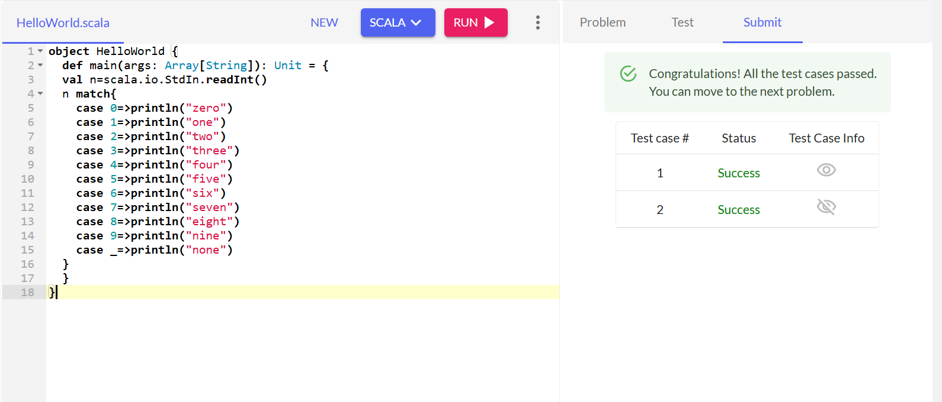

7)

object HelloWorld {

def main(args: Array[String]): Unit = {

val a =scala.io.StdIn.readInt()

val b =scala.io.StdIn.readInt()

println(a+b)

}

}

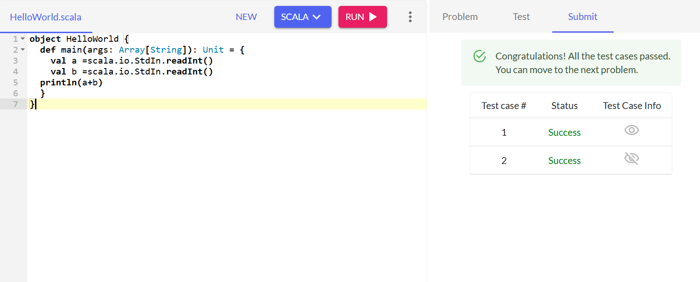

8)

object HelloWorld {

def main(args: Array[String]): Unit = {

val a =scala.io.StdIn.readInt()

val b =scala.io.StdIn.readInt()

if(a>b){

print(a)

}

else{

print(b)

}

}

}

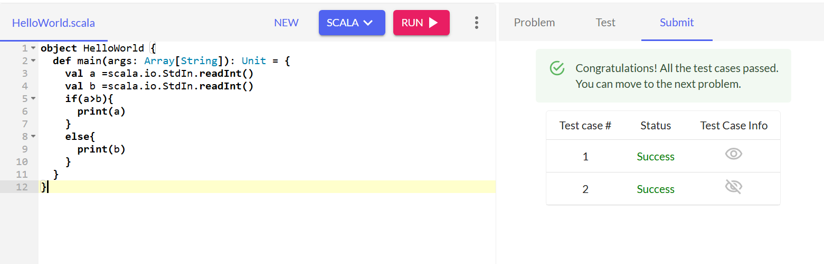

9)

object HelloWorld {

def main(args: Array[String]): Unit = {

val a =scala.io.StdIn.readInt()

val b =scala.io.StdIn.readInt()

val c=scala.io.StdIn.readInt()

if(a>b && a>c){

print(a)

}

else if(b>a && b>c){

print(b)

}

else{

print(c)

}

}

}

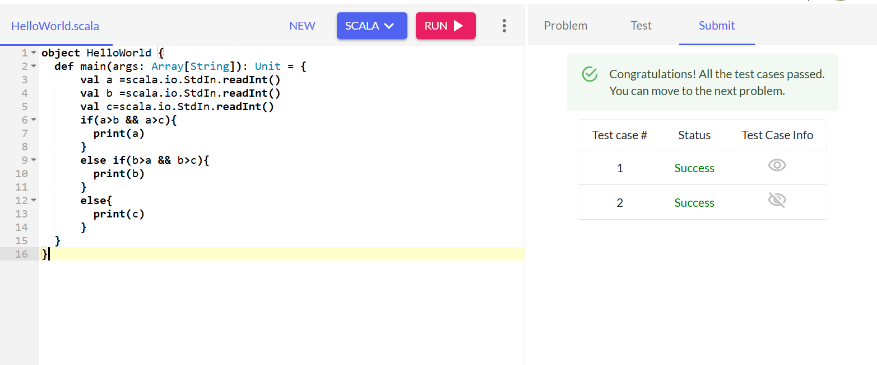

10)

object HelloWorld {

def main(args: Array[String]): Unit = {

val a =scala.io.StdIn.readInt()

if((a%4==0)&&(a%100!=0) || (a%400==0))

{

println("yes")

}

else{

println("no")

}

}

}

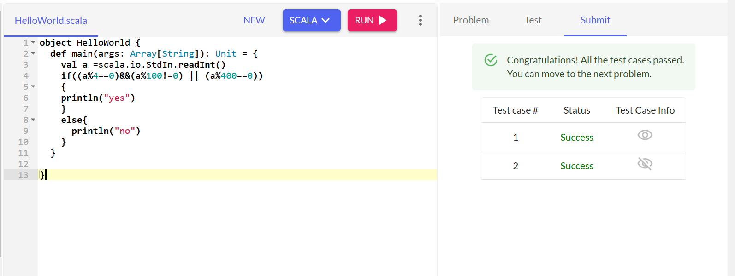

11)

object HelloWorld {

def main(args: Array[String]): Unit = {

val a =scala.io.StdIn.readInt()

val b =scala.io.StdIn.readInt()

print(a*b)

}

}

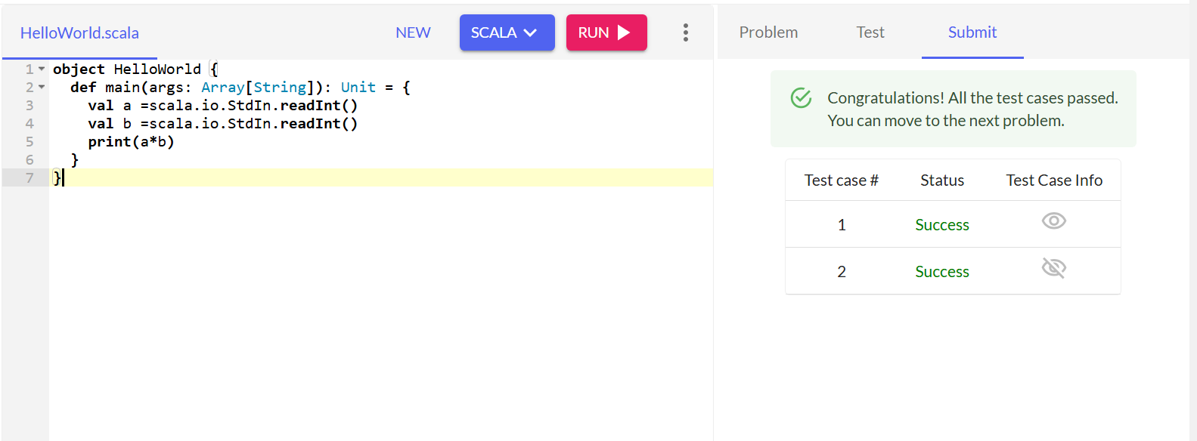

12)

object HelloWorld {

def main(args: Array[String]): Unit = {

val a =scala.io.StdIn.readInt()

if(a<0){

println("negative")

}

else{

println("positive")

}

}

}

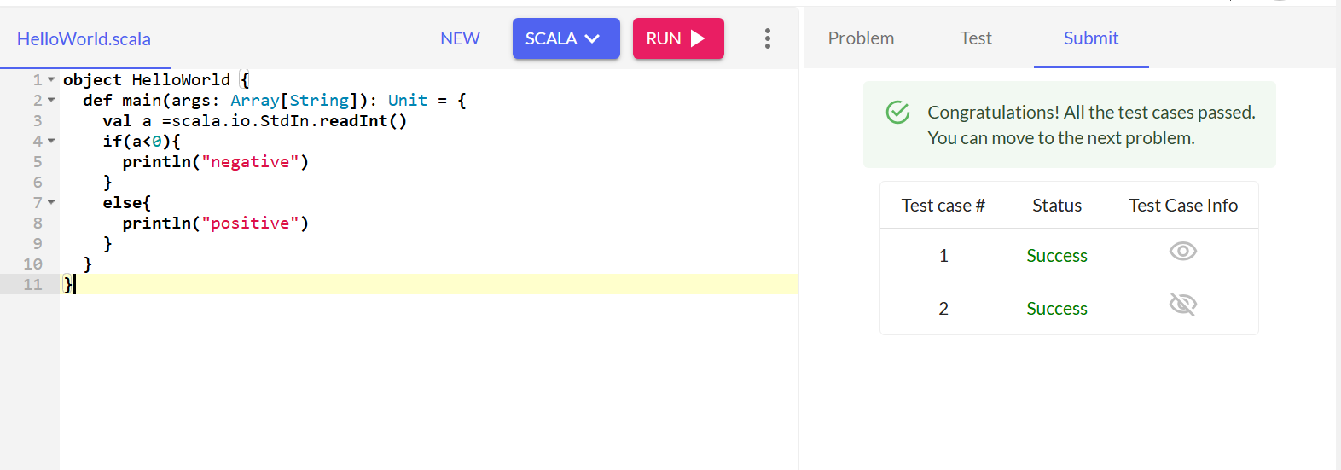

13)

object HelloWorld {

def main(args: Array[String]): Unit = {

val a =scala.io.StdIn.readInt()

print(a*a)

}

}

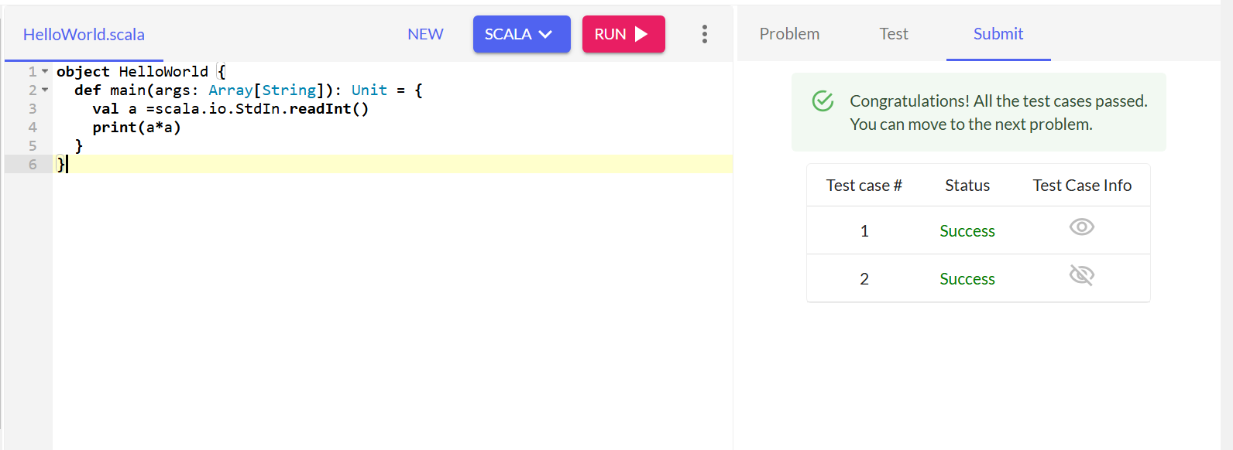

14)

object HelloWorld {

def main(args: Array[String]): Unit = {

val a =scala.io.StdIn.readInt()

if(a%2 ==0){

print("even")

}

else{

print("odd")

}

}

}

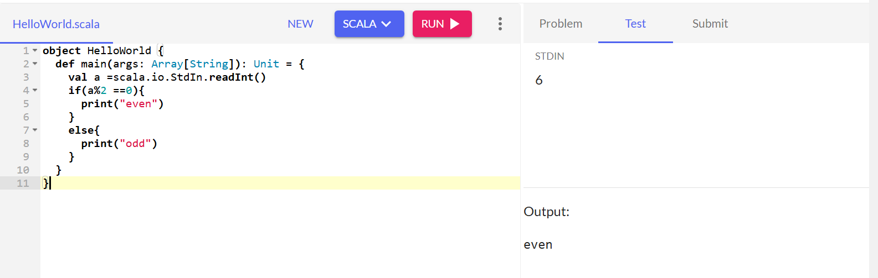

15)

object HelloWorld {

def main(args: Array[String]): Unit = {

val a =scala.io.StdIn.readInt()

val b =scala.io.StdIn.readInt()

val c =scala.io.StdIn.readInt()

print((a+b+c)/3)

}

}

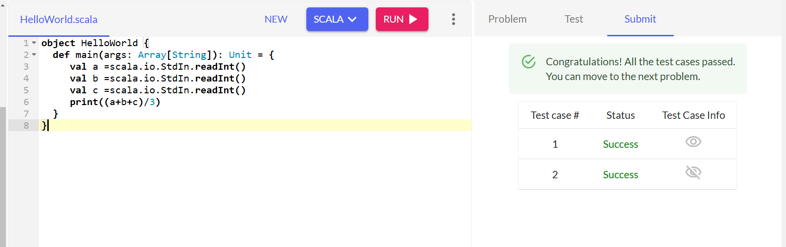

16)

object HelloWorld {

def main(args: Array[String]): Unit = {

val n =scala.io.StdIn.readInt()

var sum=0

for(i<-1 to n){

sum=sum+i

}

print(sum)

}

}

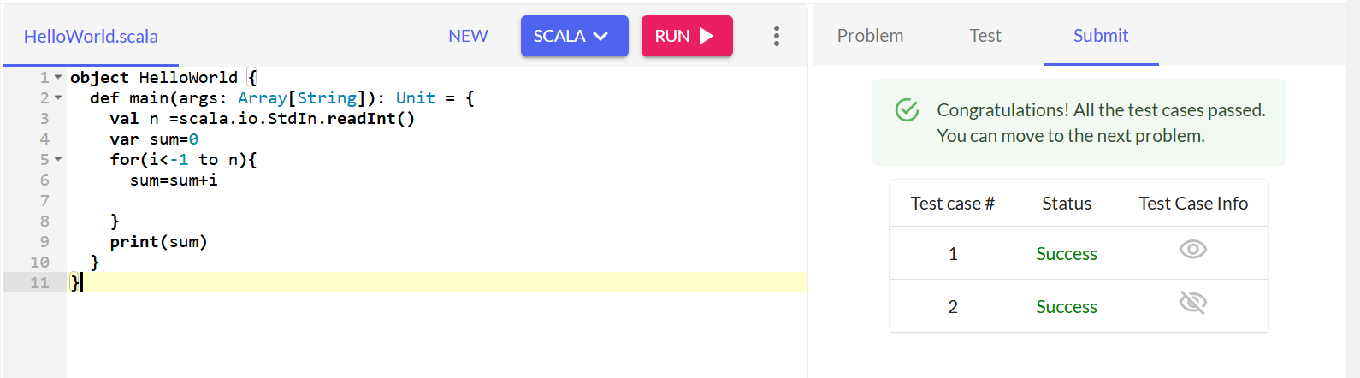

17)

object HelloWorld {

def main(args: Array[String]): Unit = {

val n =scala.io.StdIn.readInt()

var sum=1

for(i<-1 to n){

sum=sum*i

}

print(sum)

}

}

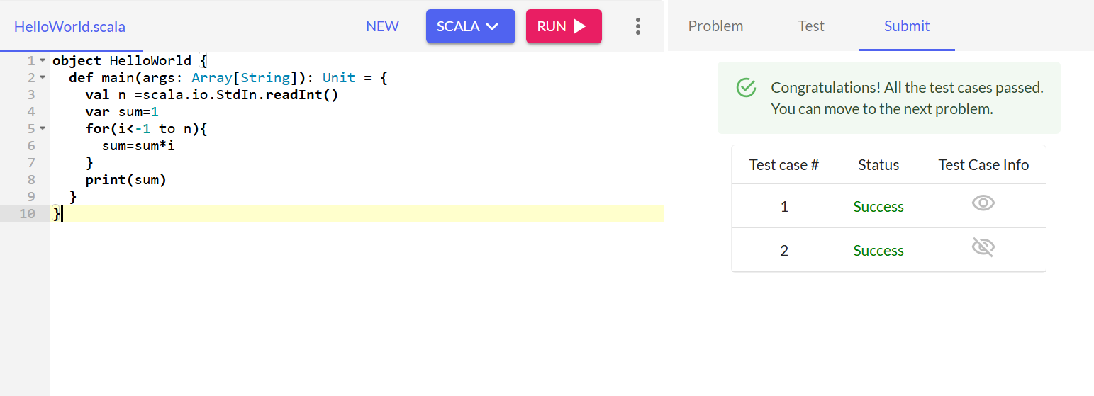

18)

object HelloWorld {

def main(args: Array[String]): Unit = {

val n =scala.io.StdIn.readInt()

print((scala.math.sqrt(n)).toInt)

}

}

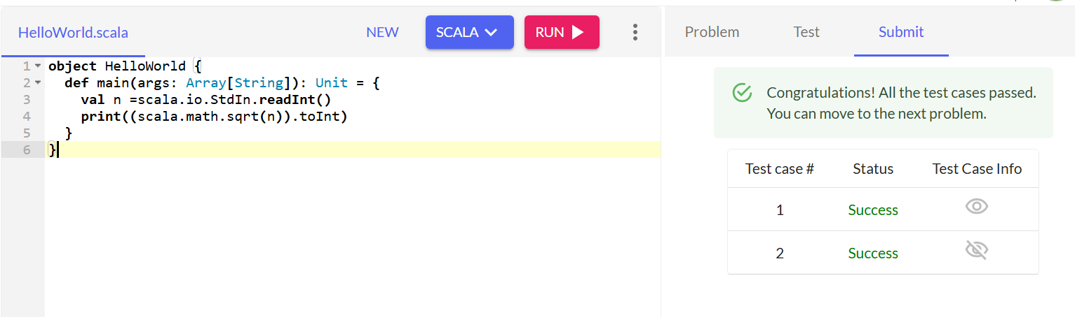

19)

object HelloWorld {

def main(args: Array[String]): Unit = {

val n =scala.io.StdIn.readInt()

var s=0

for(i<-1 to n)

{

if(n%i==0){

s=s+1

}

}

if(s==2){

print("yes")

}

else{

print("no")

}

}

}

