**Header**

Toll free number

Insta, twitter, facebook link . search

**Main Header**

Home page

Domestic

About us

Gallery

Feedback

Contact us

**About Us**

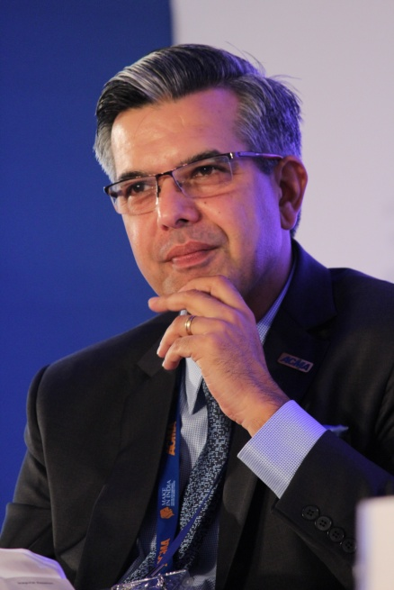

Founder and Chairperson

**Welcome to the new world of Book My Trip !**

Let me first begin with the inception of this concept. For a long time, I was watching a generation of unemployed youth who had no idea what to do with their future. They had no resources to whom to and did have the slightest clue as to how to improve their future. I shared this concern of mine with my fellow colleagues and friends. And from this discussion, the idea of travel agency gained momentum and book my trip was born. In the beginning, the operations started in Belgaum. The people in Beigaum and nearby areas gave them a tremendous response. They made possible to create commendable numbers of bookings. Today book my trip is operational in Maharashtra and Karnataka.

In our busy lives, every soul is searching for something. We all are in quest of happiness and contentment. Some find bliss in the arms of loved ones and some find it in snowclad mountains bathed with the beauty of nature. Some seek solace in solitude and some in friends. Whatever may be our channels of happiness; we all are seeking to quench our thirst. Life is a long journey and everyone is searching for the ultimate happiness. Happiness is all around us… it’s in the first light of day, in a newborn’s face. All we need is the vision to see this happiness scattered around us for us to grab it.

Travel is not just seeing places. It’s about soaking the inherent beauty of the place and its people. Travel inspires. A nomad seeks happiness in search of roads less travelled. Life is a long journey and every road; every destination is full of experiences. Let’s walk together to these lands of bliss and contentment and make our lives richer than before.

**Happy journey!**

**Why Book My Trip?**

Established in 2000, Book My Trip has since positioned itself as one of the leading companies, providing great offers, competitive airfares, exclusive discounts, and a seamless online booking experience to many of its customers. The experience of booking your flight tickets, hotel stay, and holiday package through our desktop site or mobile app can be done with complete ease and no hassles at all. We also deliver amazing offers, such as Instant Discounts, Fare Calendar, MyWallet, and many more while updating them from time to time to better suit our customers’ evolving needs and demands.

**Feedbacks**



*It was best decision to have called on book my trip’s toll free number and get my travel plan sorted. Everything worked out perfect. It didn’t require to plan much on the travel as book my trip has resolved our worries. We will definitely book our next tour with them.*



*Book my Trip is one of the leading travel company . It provides an excellent service with good accommodation and great amenities on tours. Tour Managers are expertise and extremely knowledgeable. Had an amazing experience travellin.*



*The best and trusted travel agency. Accommodation, planning, air-fare, services all are good .All packages are in our budget. Thanks to Book my Trip*

**Footer**

**Contact us**

If you have a story to share or a question that has not been answered on our website, please get in touch with us via contact details listed below or fill in the form on the right.

**OFFICE: Book my Trip, 1st Floor, Near RPD cross, Tilakwadi, Belgaum-59006**

**0831-2556231**

[**Enquiries@bookmytrip.in**](mailto:Enquiries@bookmytrip.in)

 Office Time :

Mon – Sat

10 AM to 7 PM

For any Queries

Name

Email

Subject

Message

SEND

Connect Us

Instagram

Facebook

Youtube

Twitter

Our Branches

**Book my Trip**

**1st Floor, Near RPD cross,**

**Tilakwadi,**

**Belgaum-59006**

**0831-2556231**

**Book my Trip**

**#101/8 , Near YPR railway station,**

**Yeshvantpur,**

**Bangalore-570002**

**080-4856957**

**Book my Trip**

**#25 ABC Arcade, 2nd Floor,**

**Pimpri chinchwad,**

**Pune-410014**

**020-4422568**

**Book my Trip**

**Ground Floor,**

**Bhavya Sphurti Co-Op. Housing Society Ltd,**

**Borivali (W),**

**Mumbai.-400092.**

**022-28993214**