Technologies
- Standard alone application
  - Application to be installed on individual PCS
  - No DB
  - No Network
  - Example : calculator
  - Browser - No
- Standard alone application with DB
  - Application to be installed on individual PC’s
  - DB – Yes
  - Network – Yes
  - Example : Old Banking system, Old Railway reservation
  - Browser - No

- Web Technology
  - Application need not to be installed
  - Application can be accessed on a browser

API – Application program interface

An API (Application Programming Interface) is like a waiter in a restaurant.
- You (the customer) sit at a table and order food.
- The waiter takes your order to the kitchen (the system) and brings back your food.
- You don’t need to know how the kitchen works; you just get your meal!

How Does This Relate to an API?
- The API is the middleman between two applications.
- It helps them talk to each other and exchange information.
- You don’t need to know how the other system works; the API delivers what you need.

Real-World Example: Weather App
1. You open a weather app and enter your city.
2. The app sends a request to a weather API (e.g., OpenWeather API).
3. The API fetches the latest weather data from a weather database.
4. The API sends the data back to the app.
5. The app displays the weather on your screen.

Why Are APIs Useful?
Allow apps to communicate easily.
Save time by using existing services (like Google Maps API).
Enable developers to build powerful applications quickly.
Would you like a hands-on example of using an API?

Front end – for Java

Front end – for Web

HTML
HTML (HyperText Markup Language)
- It is the skeleton of a web page.
- It defines the structure of a page using elements like headings, paragraphs, images, and links.

CSS
CSS (Cascading Style Sheets)
- It is the makeup and styling of a web page.
- It controls the colors, fonts, layout, and spacing to make the page look nice.

Java script
- It is the brain of a web page.
- It makes web pages interactive (like buttons, animations, and dynamic content).

ReactJS
- It is a JavaScript library for building fast and interactive web applications.
- It helps create components (small reusable pieces of UI) instead of writing long HTML code.

Bootstrap
- Bootstrap is the most popular HTML, CSS, and JavaScript framework for developing responsive, mobile-first websites.

Back end

Http Server
- Developer

Node JS

API – Express

DB – Mongo DB

WebTechnology
- Front end developer (Develops webpages)
  - Create webpage
  - Checks if webpage is compatible in all browsers
  - Checks if webpage loading / rending time
- Software developer (Writes code)
  - Writes code
  - Creates database structure
- Performance improvement
  - Maintains load balancing using appropriate algorithm – Round robin
  - Maintain load balancing server – Apache Tomcat server

- IT Adminstrator (Deployes application)
  - Builds a server for hosting application
  - Builds a server for storing DB
  - Creates External IP address
  - Looks after security (Firewalls)
- Architectures
  - Restructure application deployment design
  - Application on multiple servers – Improves performance
  - DB on a different server

Web Development Setup

IDE

Webserver
- There are different types of webservers depends on technology (Java, MS, Unix... etc)
  - Java application – Apache Tomcat server, JBOSS, Java simple webserver
  - Microsoft – Internet Information Server, Web App service
  - Unix – Apache web server

WebBrowser
- Internet explorer
- Chrome
- Firefox
- Edge

Scripting

Node JS

Questions

Script Vs Code
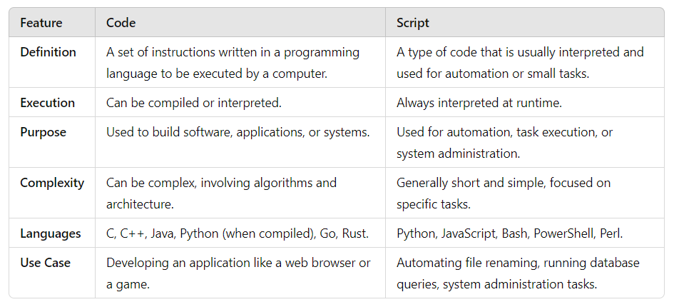

FTP Vs HTTP
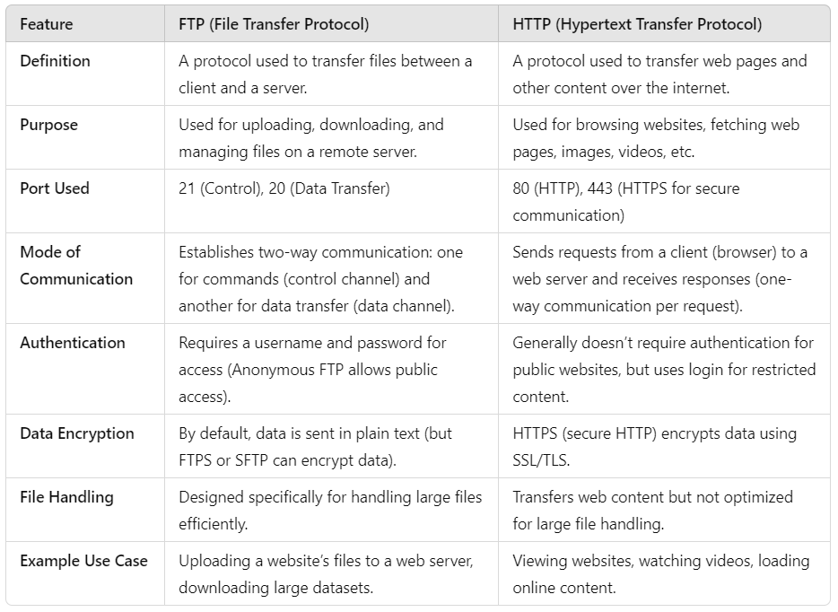

HTTP Vs HTTPS

