**Crowdfunding Platform**

### A Project Report

*Submitted by*

|  |  |
| --- | --- |
| **Hariom Badarkhe** | **112103017** |
| **Shrikant Hamand** | **112103048** |

*of*

**TY (Computer Engineering)**

Under the guidance of

### Dr. Tanuja R. Pattanshetti

COEP Technological University



### DEPARTMENT OF COMPUTER ENGINEERING

**COEP Technological University**

April, 2024

**DEPARTMENT OF COMPUTER ENGINEERING**

**COEP Technological University**

**CERTIFICATE**

This project has been successfully completed by

|  |  |
| --- | --- |
| **Hariom Badarkhe** | **112103017** |
| **Shrikant Hamand** | **112103048** |

and is approved for the fulfilment of the requirements of “Software Engineering Mini Project- Stage II”.

SIGNATURE

### Dr. Tanuja R. Pattanshetti

**Project Guide**

**Department of Computer Engineering COEP Technological University, Shivajinagar, Pune - 5.**

Abstract

Our project revolves around crafting a user-friendly website where individuals can present their innovative ideas and seek financial backing from interested supporters.

This platform acts as a virtual stage where creators outline their projects, set fundraising targets, and engage with potential backers.

Emphasizing simplicity and security, our website ensures a seamless experience for both project creators and backers alike. By fostering an environment of collaboration and support, we aspire to facilitate the realization of groundbreaking ideas.

Our endeavor aims to democratize the funding process, empowering creators from diverse backgrounds to turn their visions into reality with the backing of a vibrant community.

Contents

* 1. Project Title 6
  2. Internal Guide 6
  3. Problem Statement 6
  4. Plan of Project Execution 7

Goals: 8

Objectives: 8

Statement of Scope 8

* 1. Software context 9
  2. Project Schedule 11
     1. Gantt Chart 11
  3. Introduction 12
     1. . Use Case View 13
  4. Data Model and Description 15
  5. Functional Model and Description 16
     1. Data Flow Diagram 17
     2. Swimline Diagram 20

1. Design & Diagrams 23
2. Summary &

Conclusion 33

**Chapter 1**

# Synopsis

### Project Title

Crowdfunding Platform

### Internal Guide

Dr. Tanuja R. Pattanshetti

### Problem Statement

Traditional funding methods pose barriers for creators seeking support, while potential backers lack accessible avenues to discover and contribute to projects aligned with their interests. Our project aims to bridge this gap by developing a user-friendly crowdfunding platform that democratizes the funding process, empowers creators to showcase their projects, and facilitates seamless engagement between creators and backers.

### Plan of Project Execution

|  |  |  |  |  |
| --- | --- | --- | --- | --- |
| Task | Start Date | End Date | Duration | Resources |
| Problem statement fi-  nalization | 08-Jan-24 | 15-Jan-24 | 8 | Hariom and Shrikant |
| Project Plan | 16-Jan-24 | 31-Jan-24 | 16 | Shrikant |
| Research | 01-Feb-24 | 05-Feb-24 | 5 | Hariom |
| Requirement Analysis | 06-Feb-24 | 09-Feb-24 | 4 | Both |
| Architectural Design | 10-Feb-24 | 13-Feb-24 | 4 | Hariom |
| User-Interface Design | 13-Feb-24 | 18-Feb-24 | 6 | Shrikant |
| Security Design | 19-Feb-24 | 29-Feb-24 | 10 | Shrikant |
| Prototyping | 01-Mar-24 | 10-Mar-24 | 10 | Both |
| Backend Development | 11-Mar-24 | 20-Mar-24 | 10 | Both |
| Frontend | 21-Mar-24 | 31-Mar-24 | 10 | Both |
| Testing | 01-Apr-24 | 10-Apr-24 | 10 | Both |
| Documentation and  project report | 11-Apr-24 | 15-Apr-24 | 5 | Both |

**Chapter 2**

# Problem Definition and scope

## Goals:

* Develop a user-friendly crowdfunding platform that allows creators to showcase their projects, set funding goals, and engage with backers effectively.
* Enable seamless and secure transactions to instill trust and confidence among backers, ensuring a smooth funding process.

### Objectives:

* + Enable project creators to raise funds on crowdfunding platforms.
  + Foster a community-driven approach to crowdfunding, empowering backers and creators alike.
  + Provide tools for project creators to manage and customize their campaigns effectively.
  + Integrate payment gateways to facilitate seamless and secure financial transactions between backers and creators.

### Statement of Scope:

* + - Target Products: Design and development of a user-friendly web interface for creators to create project profiles, set funding goals, and interact with backers.
    - Target Projects: Various crowdfunding campaigns including creative projects, startups, charitable initiatives, and social causes.
    - Target Audience: Individuals, entrepreneurs, startups, non-profits, and organizations seeking funding for their projects or ventures.

## Software context

The crowdfunding platform will be developed as a web application.

* + - Frontend Development :- The user interface is built using HTML, CSS, and JavaScript
    - Backend Development :- The backend infrastructure is developed using server-side technologies such as PHP and JS. APIs is implemented to facilitate communication between the frontend and backend components
    - Database Development :- Data storage and management is handled using a relational database management system (RDBMS) such as MySQL.
    - Payment Gateway Integration:- Payment gateways such as PayPal is integrated into the platform to enable secure and efficient financial transactions

## Major Constraints:

* + - Budget Limitations: We must manage our spending carefully to stay within the allocated budget.
    - Time Constraints: We need to work efficiently to meet project deadlines and milestones.
    - Technical Constraints: We must ensure our project aligns with existing systems and meets technical standards.
    - Security and Privacy Regulations : Compliance with data privacy and security laws will impact our project's design and implementation.
    - Scalability Requirements : Our platform needs to accommodate growth in users and projects, requiring scalable infrastructure.
    - User Experience Expectations: We must prioritize usability, accessibility, and performance to meet user expectations and preferences.

## Outcome:

* + - Empowering Creativity: Providing a platform for creators to share their ideas and receive support, empowering them to bring their projects to life.
    - Access to Funding: Increasing opportunities for creators to secure funding by connecting them with a broad pool of potential backers.
    - Community Engagement: Fostering a supportive community where like-minded individuals can collaborate, share feedback, and support each other's projects.
    - Transparency and Accountability: Promoting transparency in project management and fund utilization, building trust between creators and backers.

## Applications:

* + - Creative Projects: Artists, musicians, filmmakers, writers, and other creatives can utilize the platform to fund their artistic endeavors, such as producing albums, films, books, or artworks.
    - Startups and Entrepreneurial Ventures: Entrepreneurs and startup founders can raise capital to launch new businesses, develop innovative products, or scale existing ventures.
    - Social Causes and Nonprofit Initiatives: Organizations and individuals can raise funds for social causes, charitable projects, community development initiatives, environmental conservation efforts, and humanitarian aid campaigns.
    - Technology and Innovation: Tech enthusiasts, inventors, and researchers can finance the development of new technologies, gadgets, software applications, or scientific breakthroughs.
    - Healthcare Initiatives: Healthcare professionals, medical researchers, and patients can raise funds for medical treatments, healthcare facilities, disease awareness campaigns, or medical research projects.

**Chapter 3 : Project Plan**

## Project Schedule

* + 1. 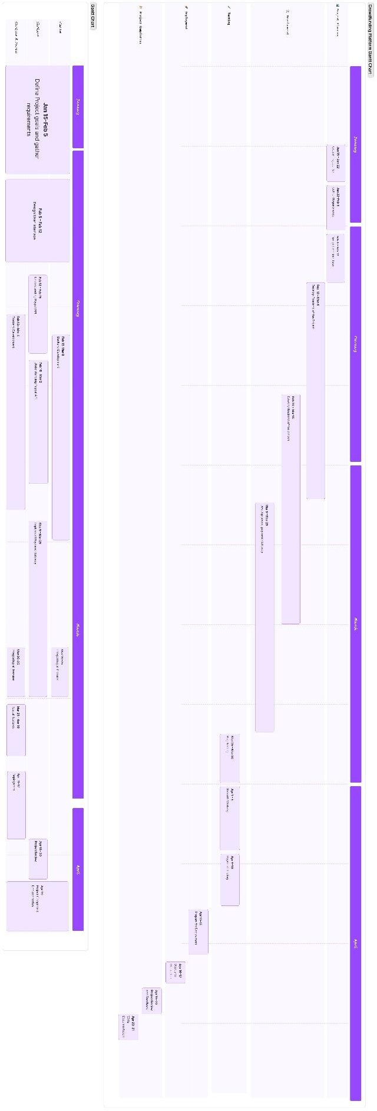**Gantt Chart**

**Chapter 4**

# Software requirement specification

### Introduction

* + 1. **Use-cases:**

.

* + - 1. User Registration:- Users sign up for an account on the crowdfunding platform by providing necessary information such as name, email, and password. Upon registration, the platform generates a unique user identifier.
      2. Project Creation:- Project creators initiate crowdfunding campaigns by providing details about their project, including title, description, funding goal, and duration.
      3. Payment Processing:- PayPal integration facilitates secure payment processing, allowing backers to contribute funds to support crowdfunding campaigns by selecting a project and specifying the amount they wish to contribute.
      4. Contribution:- Backers contribute funds to support crowdfunding campaigns by selecting a project and completing the payment process through PayPal.
      5. Investor Dashboard: Investors track their contributions, view project updates, and manage their portfolio through an intuitive dashboard interface.
      6. Project Discovery: Users explore and discover new crowdfunding campaigns based on categories, popularity, and other relevant criteria.

## Use Case View

**Use Case Diagram**:

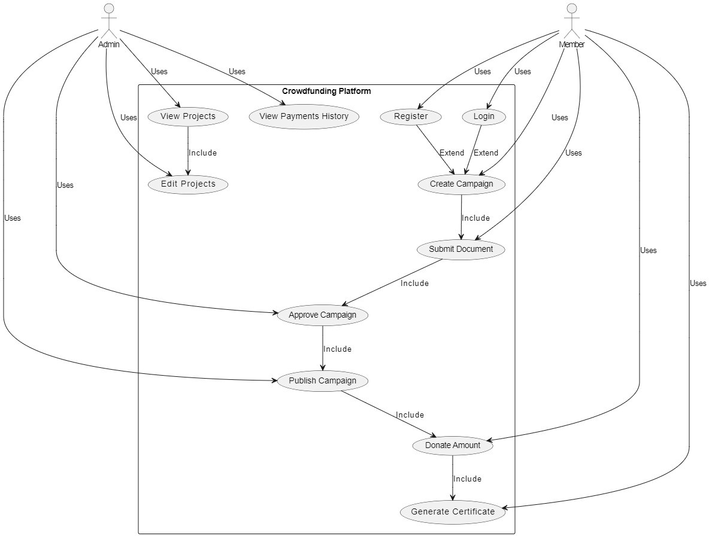

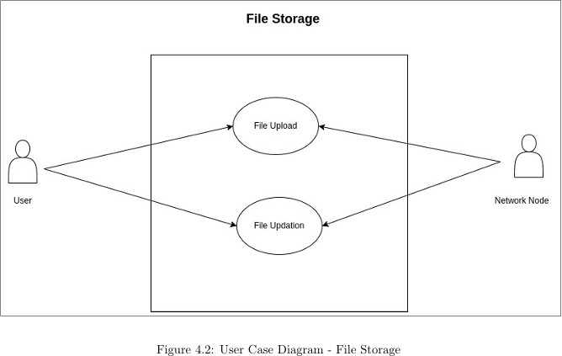

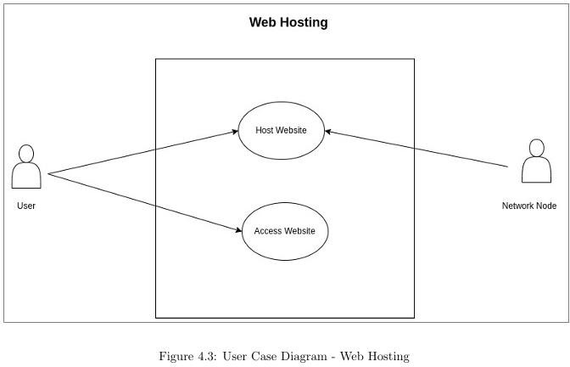

### Data Model and Description

* + 1. **Data Objects and Relationships :**

1. **User**: Represents individuals or entities participating in the crowdfunding platform. Users

register, authenticate, and engage in crowdfunding activities such as creating campaigns, contributing funds, and managing their accounts.

1. **Project:** Represents a crowdfunding campaign initiated by a user to raise funds for a specific venture or cause. Projects have attributes such as title, description, funding goal, duration, and current status.
2. **Contribution:** Records the contributions made by users to support crowdfunding projects. Each contribution includes details such as the amount contributed, the backer's information, and the associated project.

**5. Transaction**: Records the financial transactions associated with crowdfunding activities, including contributions made by backers, withdrawals initiated by project creators, and any fees or charges incurred during the process.

**Entity Relationship Diagram:**

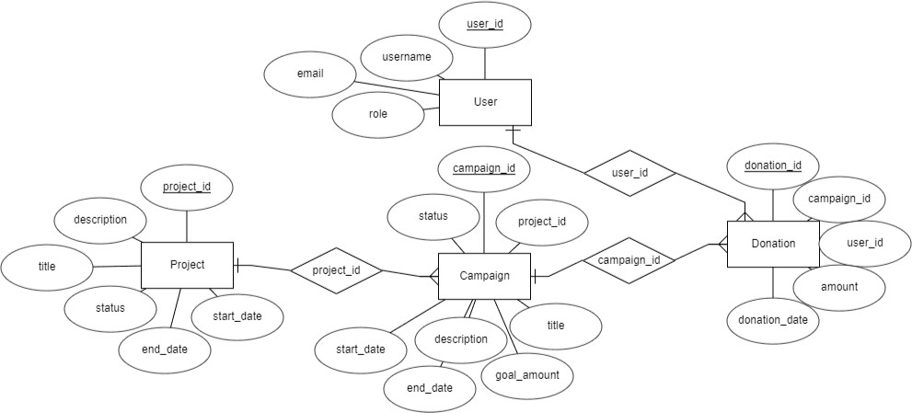

Figure 4.4: Entity Relationship diagram

### Functional Model and Description

* + 1. **Functional Requirements:**
       1. **Node Registration**: Nodes register on the platform by providing necessary information and authenticating their identity.
       2. **Website Deployment**: Users deploy their websites on the platform, specifying hosting requirements.
       3. **Content Verification**: Nodes verify hosted content integrity to prevent tampering, ensuring website reliability.
       4. **User Authentication**: Users securely authenticate to access hosting services and manage their websites.
    2. **Data Flow Diagram**

**Level 0 Data Flow Diagram**

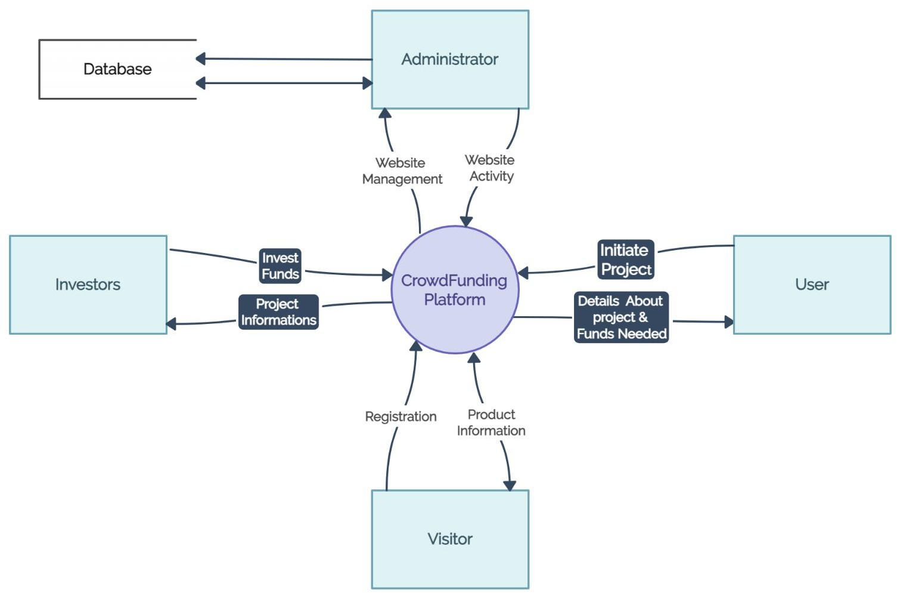

Figure 4.5: DFD Level0

**Level 1 Data Flow Diagram**

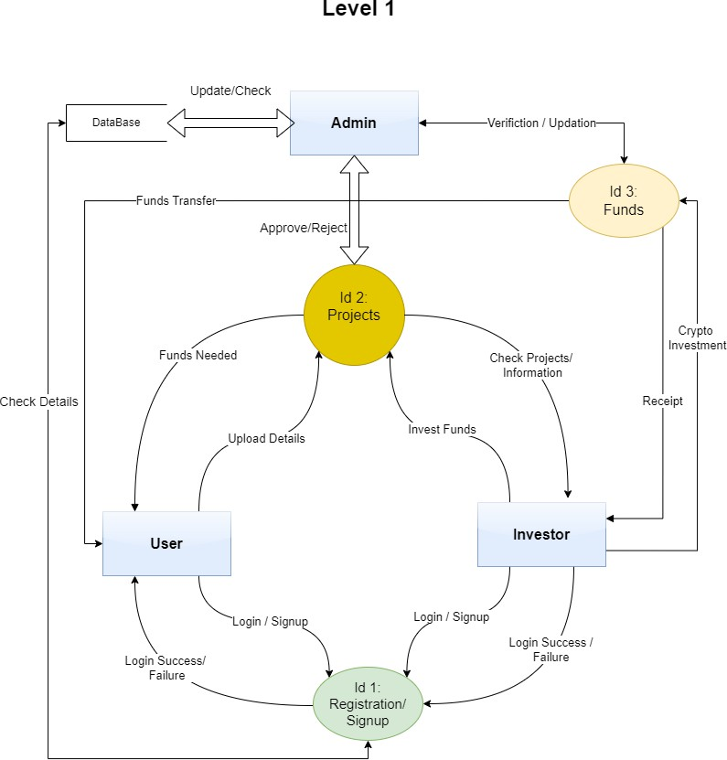

Figure 4.6: DFDLevel1

**Level 2 Diagram**

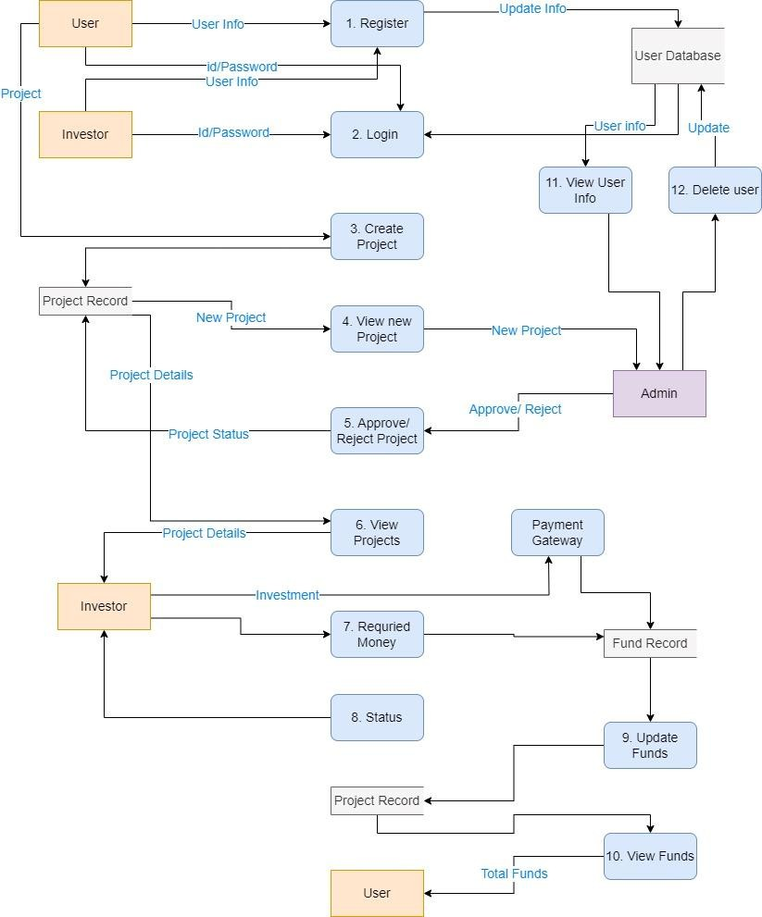

### Swimline Diagram :

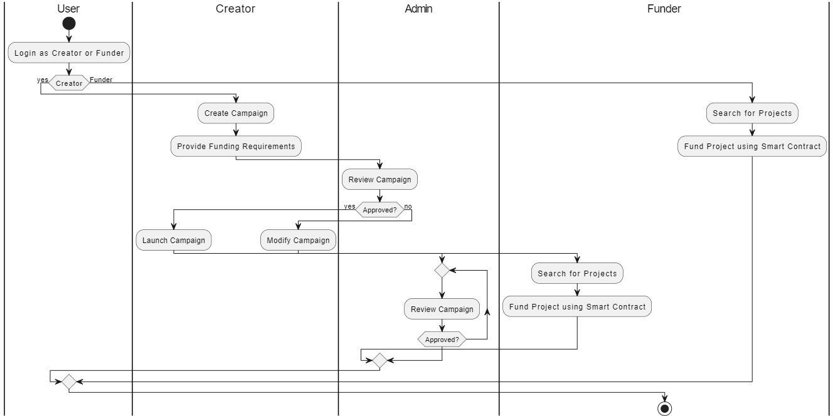

**4.3.5 Non-Functional Requirements**:

**Performance Requirements:**

* **Response Time**: The crowdfunding platform should respond quickly to user interactions such as project creation, contribution, and updates.
* **Scalability**: The platform's infrastructure should be scalable to accommodate increasing user activity and project demand without degradation in performance.
* **Concurrency**: The system should support multiple concurrent interactions, allowing users to create, manage, and contribute to projects simultaneously without delays.
* **Error Handling**: The platform should effectively handle errors, providing informative feedback to users in case of failed transactions or system anomalies.

**Safety and Security Requirements:**

* **Data Privacy**: User data and transaction details should be securely stored and encrypted to prevent unauthorized access.
* **Content Integrity**: Project content should be verified to ensure accuracy and reliability, reducing the risk of fraudulent or misleading information.

### 4.3.6 Design Constraints:

**Data Acquisition**:

* **Adaptation to Network Changes**: The platform should adapt to changes in network conditions and user connectivity.
* **Compliance with Ethical Guidelines**: Data acquisition techniques must adhere to ethical standards and regulatory requirements.

**Client-side Constraints:**

* **Offline Access**: Users should have limited access to platform functionalities even when offline.
* **Data Synchronization**: Client-side and server-side data should synchronize to maintain consistency across different devices and sessions.

**Data Processing:**

* **Optimization of Performance**: Data processing should be optimized to handle increasing project activity efficiently without compromising platform performance.

**Chapter 5**

**Detailed Design Document**

* 1. **Component Design**
     1. **Class Diagram:**

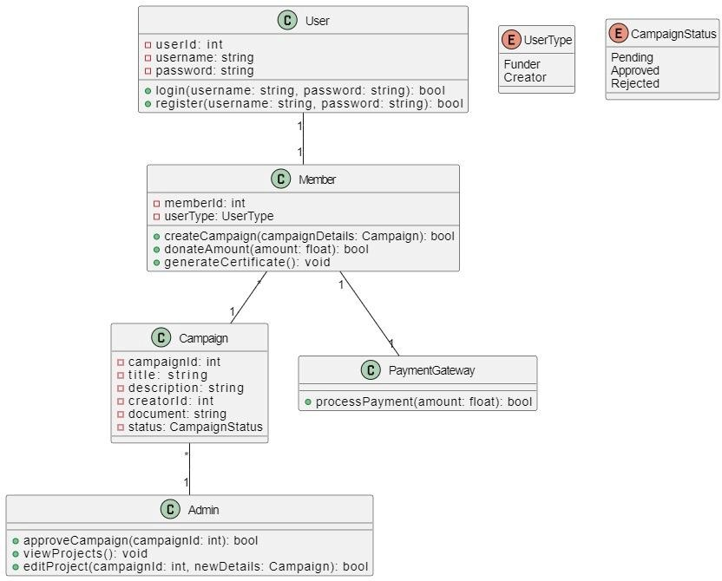

* + 1. **Sequence Diagram:**

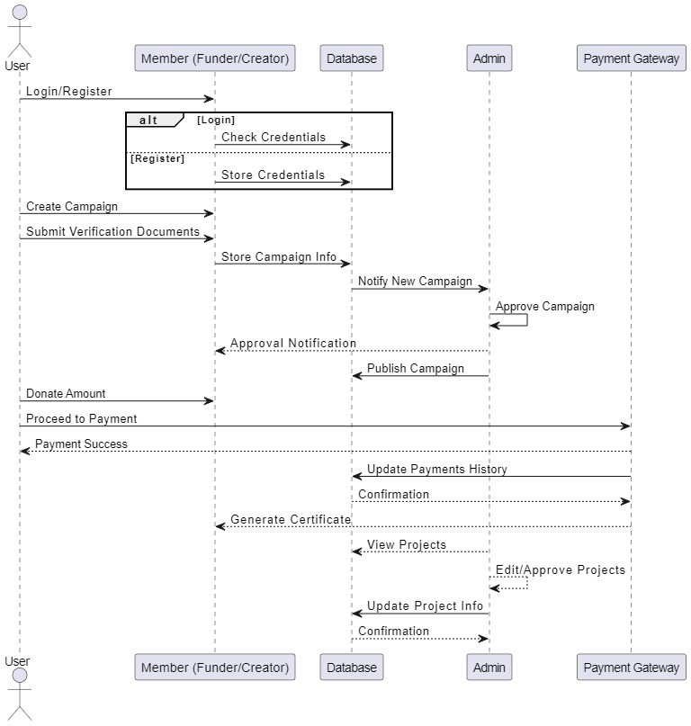

* + 1. **Component Diagram:**

25

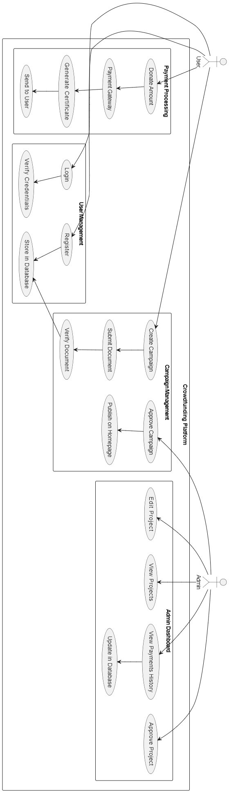

* + 1. **Deployment Diagram:**

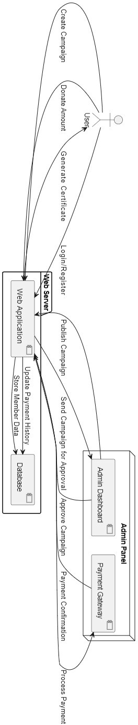

* 1. **Navigation Flow:**
     1. 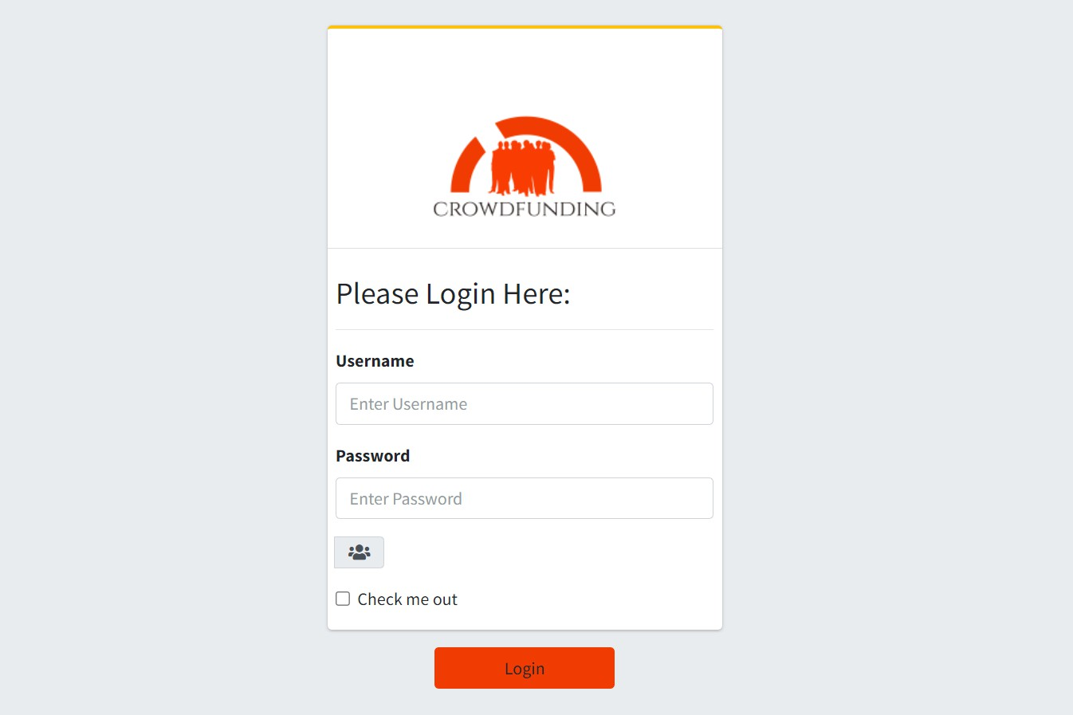**User and Admin Login:**
     2. **Home Page:**

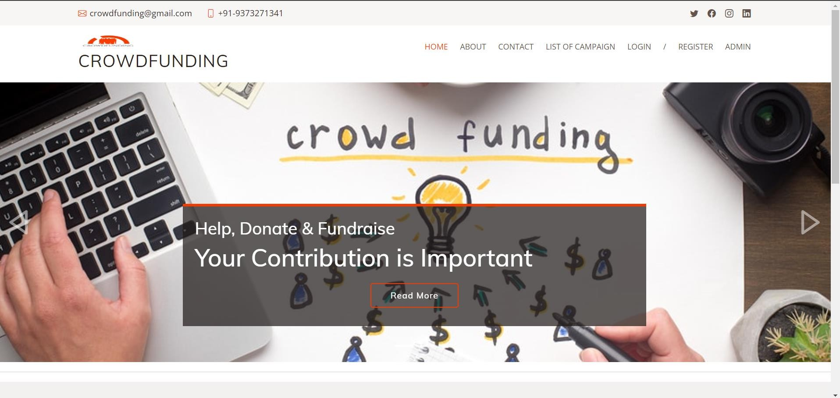

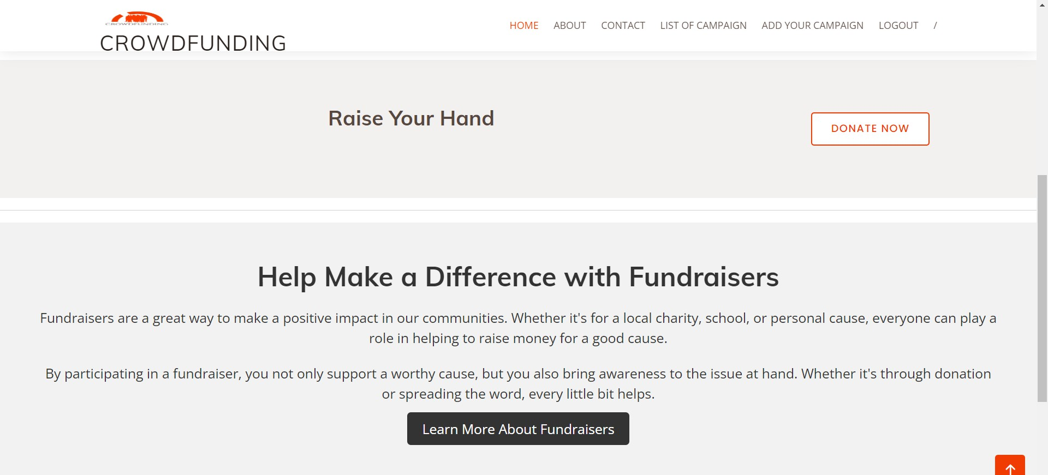

* + 1. **About Page:**

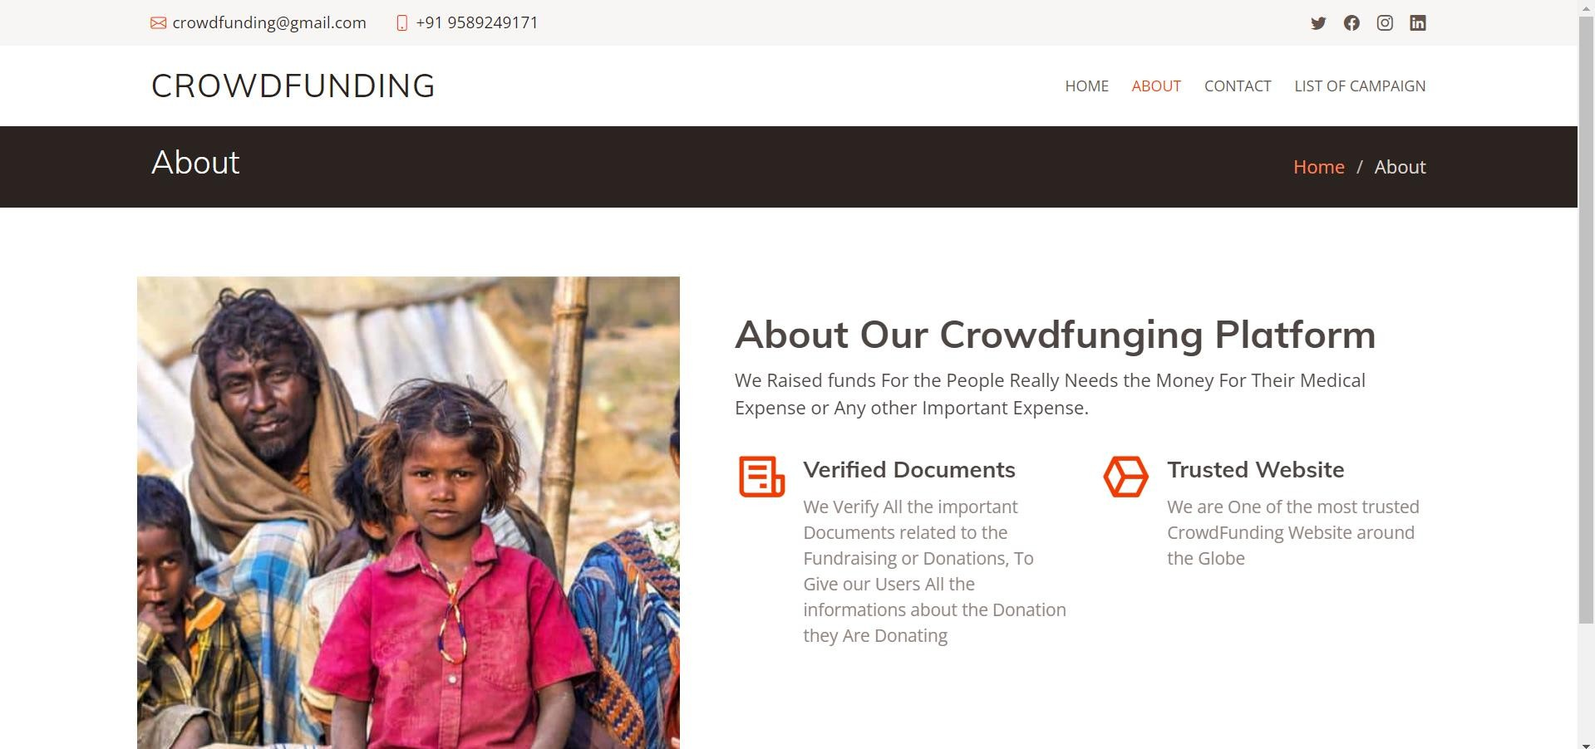

* + 1. **Contact Page:**

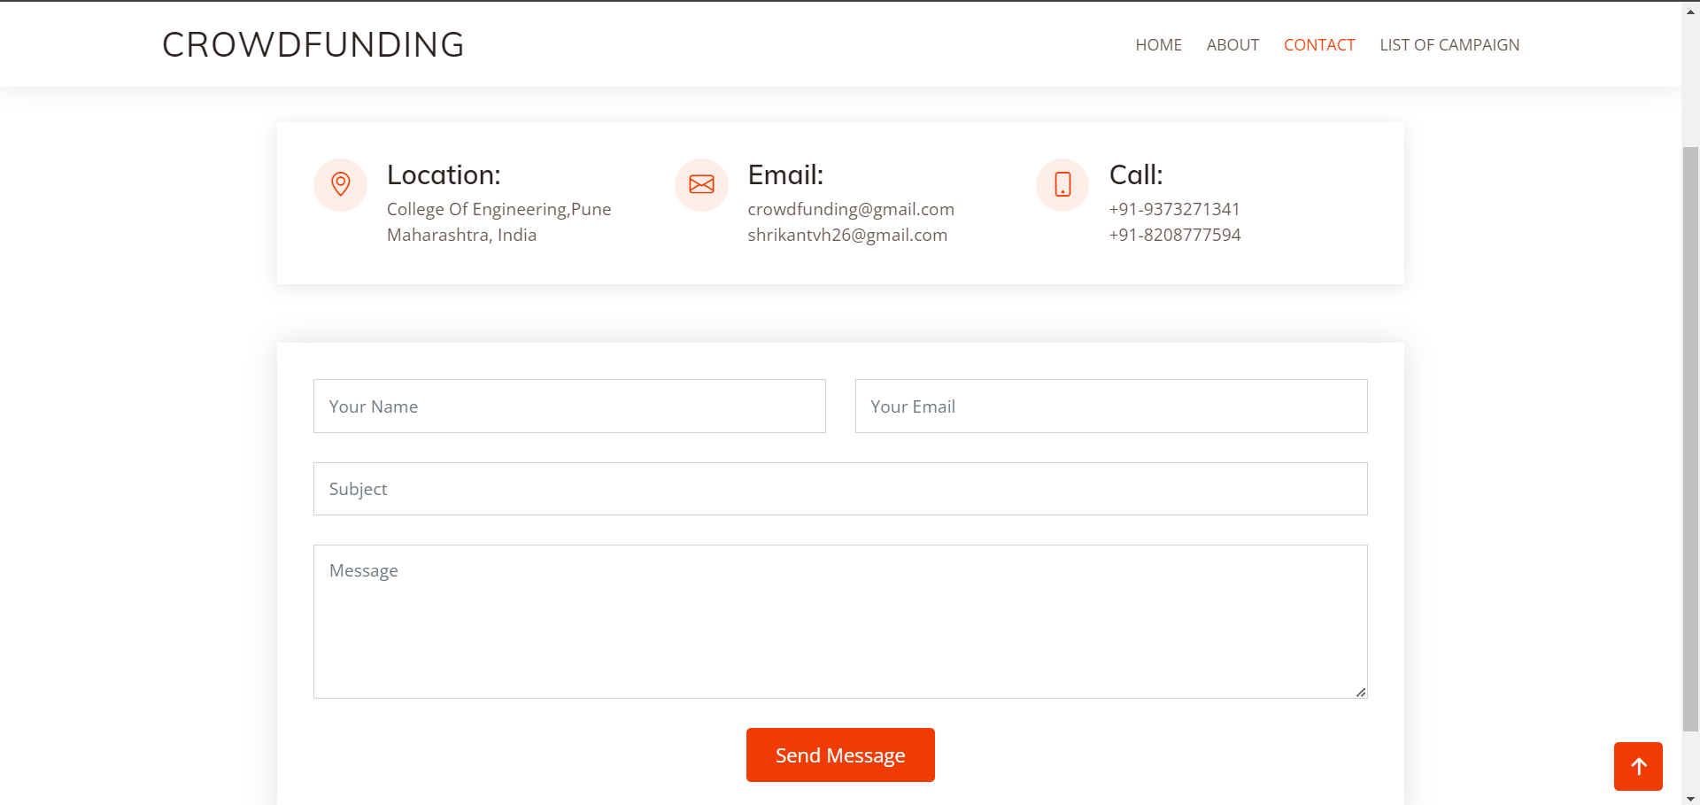

* + 1. **List of Campaigns:**

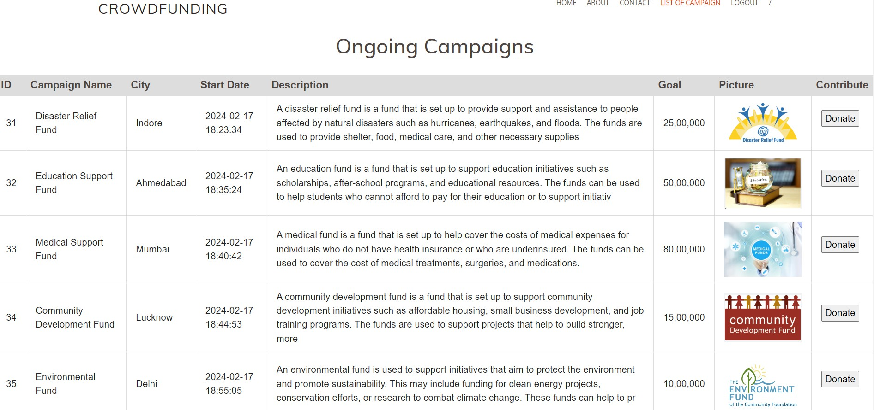

* + 1. **Admin Dashboard:**

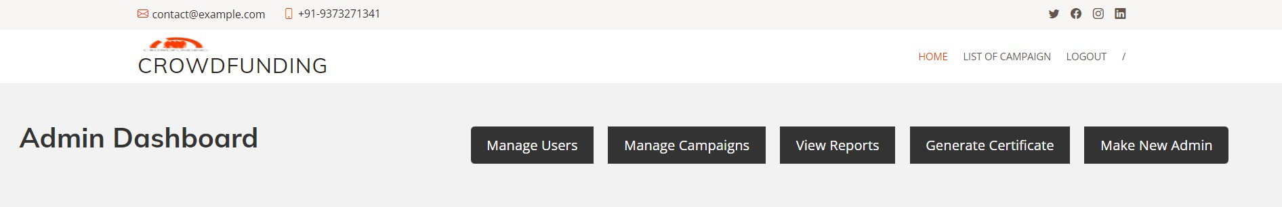

* + 1. **Payment Gateway:**

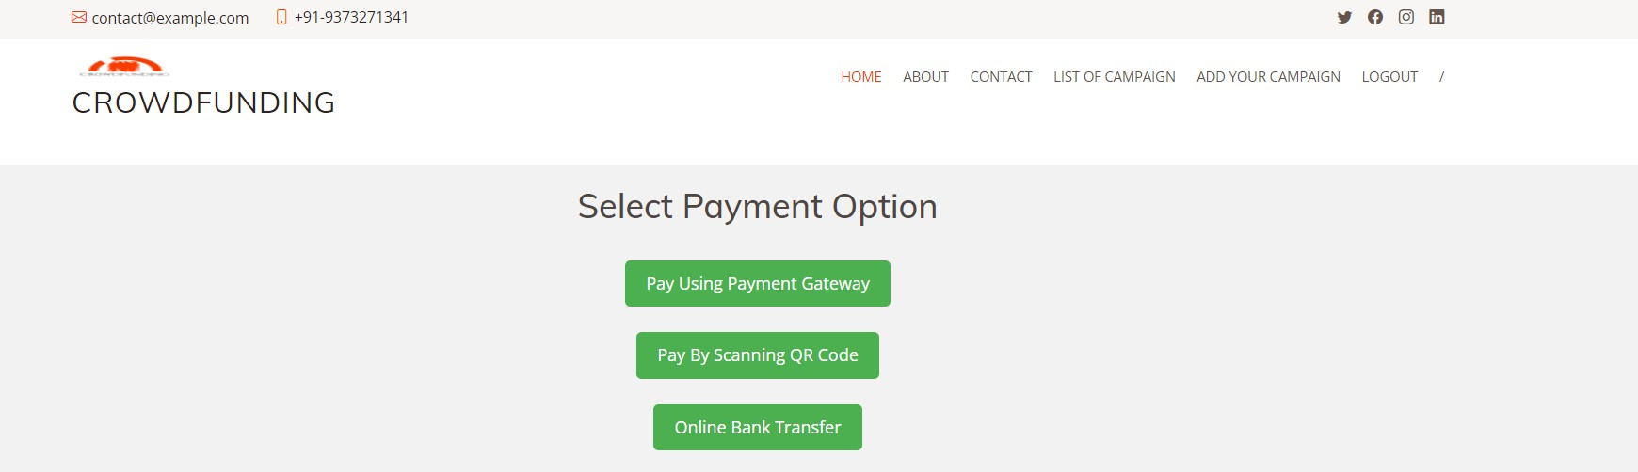

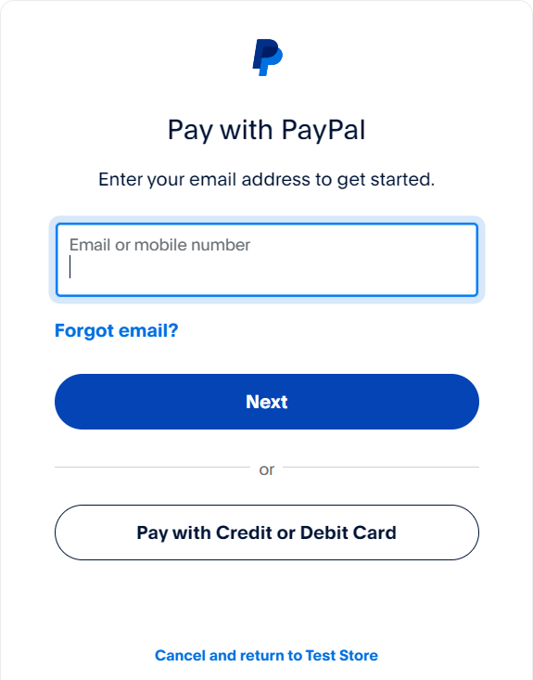

* + 1. **Certificate**

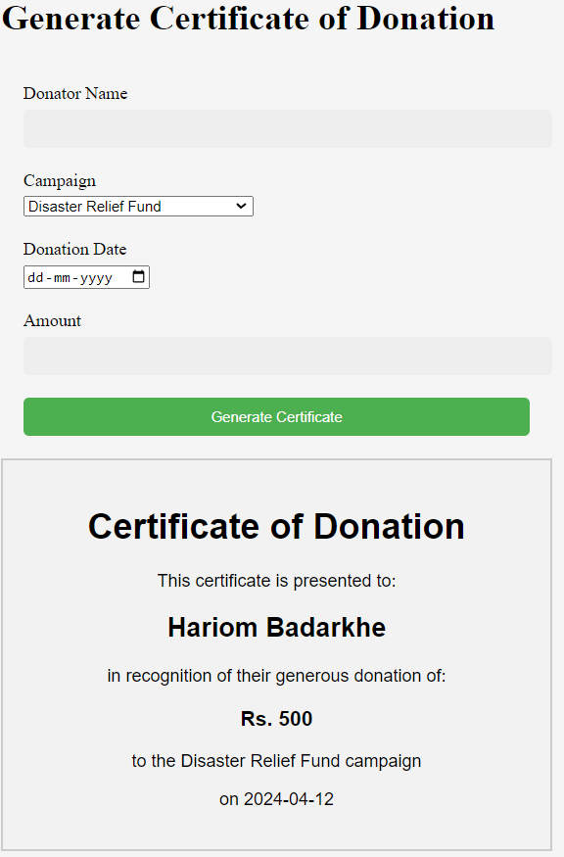

**Chapter 6**

**Summary and Conclusion:**

Our project is all about creating a website where people with great ideas can ask for money from others who want to help out. We've made it easy for creators to sign up, showcase their projects, and receive funds through PayPal. Backers can explore projects, contribute money, and get updates on how things are going. Overall, our platform aims to bring together creators and backers to make cool projects happen.

In conclusion, our crowdfunding website is a big step towards making it easier for people to support creative ideas. By making the funding process simple and secure, we're helping creators turn their dreams into reality. We'll keep working to improve the website and spread the word so that more people can join our community and make great things happen together.