**DOMAIN : ARTIFICIAL INTELLIGENCE**

**PROJECT TITLE : CHATBOT USING PYTHON**

**PHASE :05 SUBMISSION**

**Mentor:InduPoornima.R**

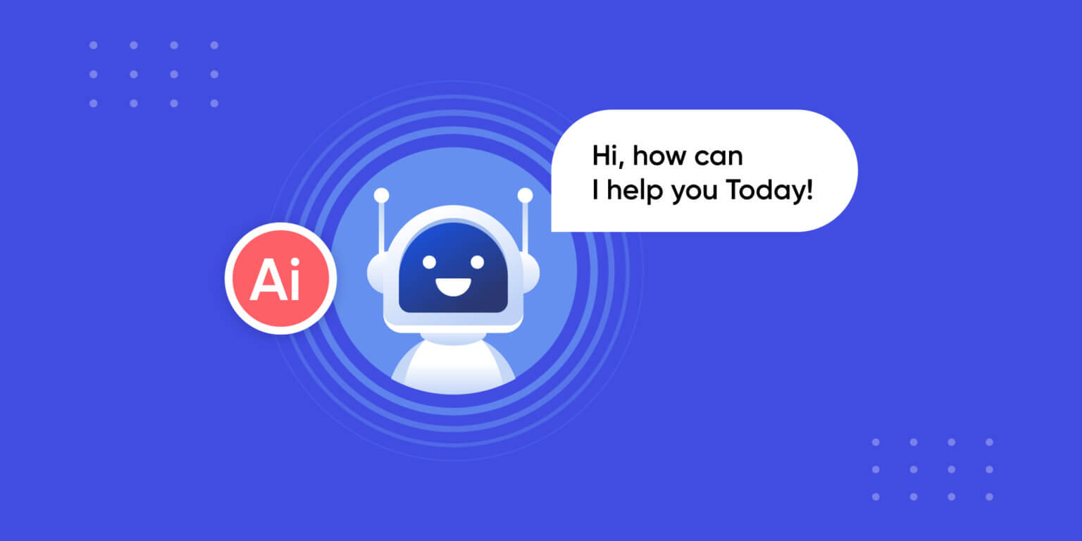

***1. Introduction***

This documentation outlines the development of a Chatbot using Python, emphasizing its problem statement, design thinking, and various phases of development.

***2. Problem Statement***

In the contemporary digital landscape, there's a rising demand for efficient and responsive chatbots capable of handling diverse user queries across various domains. Traditional customer support methods often struggle to meet the demand for immediate assistance. The problem is to develop a chatbot that can rapidly and accurately respond to user inquiries, resulting in reduced response times and streamlined support operations.

***3. Design Thinking Process***

Architecture

- Client Interface: The chatbot is accessible through web interfaces, mobile apps, and messaging platforms.

- Server: The chatbot server processes incoming user messages and generates responses.

Natural Language Processing (NLP)

- Intent Recognition: NLP models like spaCy and BERT are employed to understand user message intents.

- Entity Recognition: Relevant entities are extracted from user queries to provide context-aware responses.

- Sentiment Analysis: User sentiment is analyzed to gauge emotional states and respond accordingly.

Knowledge Base

- FAQs and Documentation: A knowledge base contains frequently asked questions, product information, and troubleshooting guides.

- Content Management: A Content Management System (CMS) is used to update and manage the knowledge base.

Dialogue Management

- State Management: Conversation state, context, user preferences, and previous interactions are tracked to maintain coherent and context-aware conversations.

- Response Generation: Responses are generated based on recognized intents, extracted entities, and the current dialogue context.

- Fallback Mechanism: A fallback mechanism handles queries the chatbot cannot confidently respond to, potentially involving human agent escalation.

Integration

- API Integration: The chatbot is connected to backend systems and databases to fetch real-time data, order information, or account details.

- Third-Party Services: Integration with third-party services provides functionalities like language translation, weather updates, or location-based services.

Security and Privacy

- Data Encryption: Encryption ensures the security and privacy of user data.

- User Authentication: User authentication is required for accessing sensitive information.

- Data Retention Policy: A data retention policy is defined to manage data storage and handling.

Scalability and Load Balancing

- The chatbot is deployed on scalable infrastructure to handle varying user traffic levels.

- Load balancing distributes incoming requests evenly among multiple servers.

Monitoring and Analytics

- Monitoring tools are set up to track chatbot performance, including response times, user satisfaction, and error rates.

- Analytics gather insights into user behavior and preferences, supporting continuous improvement.

Testing and Quality Assurance

- Automated testing evaluates NLP model performance, regression testing, and dialogue flows.

- User acceptance testing (UAT) ensures the chatbot meets user expectations.

Deployment

- The chatbot is deployed on cloud infrastructure (e.g., AWS, Azure, or Google Cloud) for scalability and accessibility.

Continuous Improvement

- A feedback loop gathers user feedback, contributing to ongoing enhancements in the chatbot's performance.

Documentation and Training

- Comprehensive documentation is available for developers, support staff, and users, facilitating interaction and maintenance.

***4. Libraries and NLP Integration***

The project uses the following libraries and technologies:

- Python: The primary programming language for chatbot development.

- spaCy: Facilitates natural language processing, including entity recognition and intent analysis.

- BERT: A pre-trained transformer model for advanced NLP tasks.

- Flask: A web framework for setting up API endpoints, supporting web-based interactions.

- CSV: Used for storing and managing the dataset of questions and answers.

- Translate (unspecified library): Employed for language translation within the project.

***5. Interaction with Users and the Web Application***

The chatbot interacts with users through a variety of channels, such as websites, mobile apps, and messaging platforms. It processes user queries, providing responses based on recognized intents and context. Users can ask questions spanning diverse domains, access information, and seek assistance.

***6. Innovative Techniques and Approaches***

- NLP Techniques: Advanced NLP techniques, including spaCy and BERT, empower the chatbot to understand user intent, extract entities, and deliver context-aware responses.

- Feedback Loop: The integration of a feedback loop allows continuous improvement, based on user feedback, enhancing the chatbot's performance and user satisfaction.

- Scalability: Deployment on scalable infrastructure ensures effective handling of varying levels of user traffic.

- API Integration: Integration with APIs and third-party services enhances the chatbot's capabilities, such as language translation and real-time data retrieval.

***7. Conclusion***

The Chatbot project represents a versatile solution to the growing demand for immediate assistance and streamlined communication. By harnessing advanced AI capabilities and NLP techniques, the project prioritizes user satisfaction and continuous improvement.

***8. References***

Reference Projects for Chatbot Development: Several reference projects offer valuable insights into chatbot development. A Customer Support Chatbot focused on enhancing customer support operations with NLP techniques, while an Educational Chatbot for Institutions streamlined academic and non-academic inquiries. An AI-Powered Virtual Assistant demonstrated general task handling and continuous learning, and a Multi-lingual Chatbot addressed multilingual user interactions. These projects collectively showcase problem-solving, design thinking, NLP libraries, and innovative techniques in chatbot development across diverse domains.

---

**Team Members:**

**1.Haaripriya .A .L**

**2.Hari Nandhinie.K.R**

**3.Akalya.A**

**4.Akshara Preethi.S**

**5.Harini.S**

**6.Poornashri.S.R**

**7.Vikram.K.N**