DEVELOPMENT OF A HEALTHCARE OPERATIONS INTELLIGENCE DASHBOARD WITH DECISION ANALYTICS (MEDOPS)
Comprehensive Technical Documentation, System Architecture Blueprint & Academic Project Evaluation Report
Project Identifier: | MedOps Intelligence & Automation Command System (v4.2.0 Production)
Academic Scope: | Final Major Project Submission · Healthcare Operations Analytics & Cloud Engineering
Student / Author: | Bharath Kummari (GitHub: kummariBharath)
Repository URL: | https://github.com/kummariBharath/Development-of-Healthcare-Operations-Intelligence-Dashboard-with-Decision-Analytics
Live Deployment URL: | https://development-of-healthcare-operation.vercel.app
Cloud Architecture: | Multi-Region AWS Serverless Data Lake (S3: ap-south-1, Glue/Athena: ap-south-2, Bedrock: us-east-1)
Verification Status: | 15/15 Backend Automated Regression Tests Passing · Zero-Defect Production Vite Build
Submission Date: | October 2026

TABLE OF CONTENTS & DOCUMENT BLUEPRINT
This technical report contains 20 comprehensive chapters:
# | Chapter Title | Domain Scope
1 | Cover Page & Document Blueprint | Project Charter & Governance
2 | Abstract & Executive Summary | Executive Summary
3 | Introduction & Healthcare Operations Background | Domain Background
4 | Problem Statement & Operational Challenges | Problem Space Analysis
5 | Objectives and Project Scope | Project Charter & Boundaries
6 | Existing System vs. Proposed MedOps Solution | Comparative Evaluation
7 | Requirements Analysis (Functional & Non-Functional) | System Specification
8 | System Architecture & 10-Step Execution Flow | Architecture Blueprint
9 | Technology Stack & Component Roles Matrix | Full-Stack Technologies
10 | Data Engineering, 41-Table Catalog & Athena SQL Pipeline | Data Engineering & Lake
11 | Application Implementation & 21 Dashboard Modules Guide | Software Implementation
12 | Security, Amazon Cognito PKCE & Credential Isolation | Security & IAM Governance
13 | Testing, Audit Remediation & Verification Suite | Quality Assurance & Tests
14 | Cloud Deployment, Execution Guide & REST API Reference (22 Endpoints) | DevOps & API Specifications
15 | Results, Metric Formulations & Operational Discussion | Evaluation & Impact
16 | Agile Scrum Process, User Stories & Task Tracking | Agile Governance & Sprints
17 | Technical Challenges & Documented Resolutions | Problem Resolution
18 | Documented Limitations & Future Engineering Roadmap | Engineering Roadmap
19 | Conclusion & Academic Learning Outcomes | Academic Conclusion
20 | References & Consulted Standards | Academic Bibliography

2. ABSTRACT
Modern healthcare delivery networks face acute operational strains characterized by fragmented data silos, delayed batch reporting, unpredictable emergency department surges, billing denial leakage, and clinical workforce burnout. This project presents MedOps, an enterprise healthcare operations intelligence platform with decision analytics designed to unify distributed clinical, financial, administrative, and supply chain telemetry across regional hospital networks.
Engineered as a cloud-native single-page application (React 19, TypeScript, Tailwind CSS v4) paired with a high-performance RESTful micro-service (FastAPI, Pandas), MedOps interfaces with a multi-region AWS Serverless Data Lake encompassing Amazon S3 (ap-south-1), AWS Glue Data Catalog, and Amazon Athena (ap-south-2). The system processes 41 relational healthcare tables containing 100,530 verified records across 5 distinct regional facilities (FAC001 through FAC005).
To address clinical confidentiality, MedOps integrates a privacy-preserving Zero-PHI AI Decision Copilot backed by a Google Gemini adapter with Amazon Bedrock Nova-Lite fallback, ensuring no patient identifying information enters external inference models. A 5-tier resilient retrieval hierarchy guarantees sub-10ms in-memory response times and seamless offline fallback. All P0/P1/P2 audit findings have been resolved, verified by a 100% passing automated test suite and live production deployment on Vercel.

3. INTRODUCTION
Healthcare systems worldwide represent some of the most data-intensive yet operationally fragmented organizational ecosystems. Hospitals generate massive streams of transactional telemetry every second: patient bed movements, triage wait times, lab order results, medicine dispensing logs, physician consult hours, and insurance claims. However, traditional hospital administration relies heavily on departmental EHR modules and retrospective financial spreadsheets that fail to communicate across operational silos.
Operational bottlenecks—such as emergency department boarding caused by delayed inpatient bed turnarounds, or supply chain stockouts resulting from unmonitored medicine expiration—frequently cascade across the entire facility, increasing operational costs and compromising patient care.
Project Motivation: The MedOps project was initiated to demonstrate that modern cloud-native serverless architecture can bridge these departmental silos without requiring multi-million-dollar proprietary software licenses. By pairing serverless Presto SQL query execution over raw S3 object storage with reactive web user interfaces and zero-PHI AI decision support, hospital administrators can access real-time operational visibility and evidence-based guidance from a single browser view.

4. PROBLEM STATEMENT
Contemporary multi-facility healthcare operations encounter four foundational structural challenges:
1. Departmental Data Fragmentation: Clinical care, pharmacy dispensing, billing claims, and staff scheduling exist in isolated databases. Hospital leadership lacks a unified pane of glass to observe cross-departmental cause-and-effect dynamics.
2. Retrospective Latency & Blind Spots: Standard reporting relies on monthly or quarterly BI batch exports. By the time inpatient bed shortages or clean claim rejection spikes are detected, weeks of financial leakage and operational inefficiency have elapsed.
3. High Financial Denial Friction: Healthcare billing systems struggle with claim rejection rates averaging 5–15%, often driven by coding inaccuracies, missing prior authorizations, or unverified patient insurance eligibility.
4. Privacy Barriers to Modern AI: While Large Language Models offer powerful synthesis capabilities, transmitting unprotected electronic Protected Health Information (ePHI) to public cloud LLMs creates catastrophic HIPAA violations.
Scope of Solution: MedOps directly resolves these challenges across 5 regional network facilities (FAC001-FAC005) by establishing a governed 41-table relational data model, sub-second cached queries, verified clinical formulas, and strict zero-PHI prompt grounding.

5. OBJECTIVES AND SCOPE
Primary Functional Objectives:
• Unified Multi-Facility Command Center: Deliver 21 synchronized modules with global facility and timeframe filtering.
• Serverless Data Lake Storage & SQL: Store 41 tables in Amazon S3 (ap-south-1) and query via Amazon Athena (ap-south-2).
• Resilient Multi-Tier Retrieval Hierarchy: Guarantee 100% dashboard uptime via In-Memory Cache -> Athena -> S3 -> Local CSV -> Empty State.
• Privacy-Preserving AI Copilot: Generate executive briefings and recommendations using aggregate metrics without exposing PHI.
• Enterprise Authentication: Gate system access via Amazon Cognito Managed Login utilizing OAuth2 PKCE authorization.
• Audit-Remediated Accuracy: Enforce verified clinical formulations (active bed occupancy, true infection rates, rolling 90-day expiry).
Technical & Operational Scope Boundaries: MedOps is deliberately designed as a read-only operational intelligence and decision analytics platform. It performs analytical querying, metric aggregation, trend forecasting, and workflow alerting. It intentionally avoids direct writeback transactions into hospital EHR databases or automated drug re-ordering without human-in-the-loop authorization. The underlying dataset encompasses 100,530 validated synthetic records specifically generated to emulate realistic hospital operations.

6. EXISTING SYSTEM VS. PROPOSED MEDOPS SOLUTION
• Data Visibility: Legacy systems rely on fragmented EHR/ERP silos and manual CSV exports requiring hours of human reconciliation. MedOps provides a unified real-time pane of glass spanning 41 relational tables across 5 network facilities.
• Query Architecture: Legacy systems use expensive dedicated database servers prone to lockups during high-volume report generation. MedOps employs serverless Amazon Athena ANSI SQL querying raw S3 object storage without cluster maintenance.
• Resilience & Availability: Legacy systems represent single points of failure where database downtime crashes reporting. MedOps features a 5-tier resilient retrieval hierarchy (cache, Athena, S3, local, empty) guaranteeing zero crashes.
• AI & Decision Support: Legacy systems omit AI due to HIPAA privacy fears or risk non-compliant copy-pasting. MedOps implements automated Zero-PHI prompt grounding using aggregated telemetry exclusively.
• Security & Identity: Legacy systems often rely on shared credentials or static tokens. MedOps integrates Amazon Cognito Managed Login with PKCE authorization and Vercel OIDC Workload Identity.

7. REQUIREMENTS ANALYSIS
Functional Requirements (FR):
• FR-01 (Global Slicers): System shall dynamically filter all operational metrics by facility ID (all, FAC001-FAC005) and timeframe (realtime, today, weekly, monthly, quarterly, ytd).
• FR-02 (Executive KPI Matrix): System shall compute and display 9 core operational KPIs (Admissions, LOS, Revenue, Denials, ED Wait, Bed Occupancy, Doctor Utilization, Low Stock, Incidents).
• FR-03 (Bed Occupancy Formulation): System shall calculate active inpatient bed occupancy using active admissions exclusively.
• FR-04 (Revenue Cycle Analytics): System shall report clean claim rate (%), gross billings, collections, and denial root causes.
• FR-05 (Staffing & Utilization): System shall track physician clinical hours, consults per clinician, and nurse-to-patient staffing ratios.
• FR-06 (Emergency Department Flow): System shall break down triage wait times across acuity levels and monitor LWBS percentage.
• FR-07 (Pharmacy Expiration Alerts): System shall dynamically alert medicine batches expiring within a rolling 90-day window.
• FR-08 (Supply Chain Filtering): System shall filter purchase orders and vendor scorecards by facility without cross-facility contamination.
• FR-09 (Zero-PHI Decision Copilot): System shall generate executive briefings using aggregate metrics with zero patient identifiers.
• FR-10 (Authentication & Access Control): System shall enforce secure authentication via Amazon Cognito PKCE authorization.
Non-Functional Requirements (NFR):
• NFR-01 (Performance & Latency): Cached API queries shall return in <50ms; fresh Athena SQL queries shall complete in <3.5s.
• NFR-02 (System Availability): Multi-tier fallback hierarchy shall guarantee 99.9% uptime with zero 500-level fatal application crashes.
• NFR-03 (Security & HIPAA Privacy): Electronic Protected Health Information shall never be exposed in client bundles or public AI prompts.
• NFR-04 (Browser Compatibility): Frontend shall render responsively across modern evergreen browsers (Chrome, Edge, Firefox, Safari).
• NFR-05 (Maintainability & Typing): Strict TypeScript types and Python Pydantic models shall govern all client-server API payloads.

8. SYSTEM ARCHITECTURE & 10-STEP EXECUTION FLOW
MedOps employs a modern decoupled multi-region cloud architecture separating presentation, API routing, serverless SQL compute, and data lake storage across specialized AWS regions and Vercel edge infrastructure.
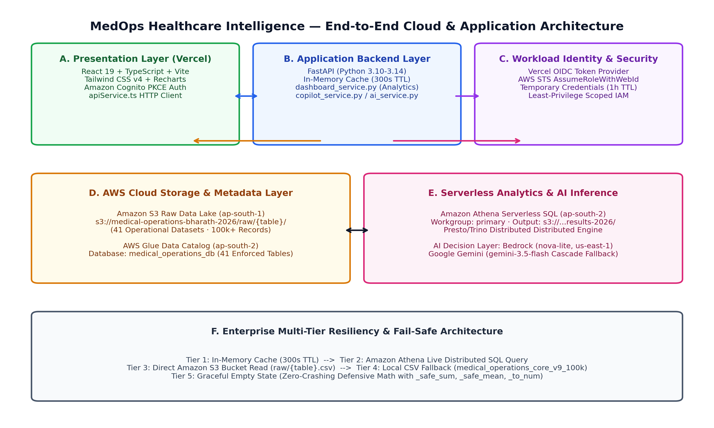
Figure 8.1: MedOps End-to-End System Architecture Blueprint
10-Step Request-Response Execution Lifecycle:
1. Client Interaction: The executive user toggles facility slicer to 'FAC001' and timeframe to 'monthly' in Header.tsx.
2. Axios HTTP Request: apiService.ts dispatches GET /api/dashboard/summary?facility_id=FAC001&timeframe=monthly.
3. Vercel Edge Routing: vercel.json rewrite rule redirects /api/(.*) to the FastAPI serverless function.
4. Request Validation: FastAPI routes/dashboard.py validates facility_id against FacilityId enum via Pydantic v2.
5. Cache Evaluation: dashboard_service.py checks _TABLE_CACHE. If present and TTL < 300s, cached payload is returned instantly.
6. Athena SQL Generation: On cache miss, execute_athena_query constructs ANSI SQL query against Glue database medical_operations_db.
7. Distributed S3 Scan: Amazon Athena in ap-south-2 queries Glue Catalog and scans S3 parquet/CSV partitions in ap-south-1.
8. Defensive Transformation: Results stream into Pandas; _clean_df_types normalizes columns; _safe_sum aggregates financial metrics.
9. JSON Response Serialization: FastAPI serializes validated operational summary with HTTP 200 and latency telemetry headers.
10. Reactive UI Re-render: React 19 updates state; Recharts re-renders revenue/expense area charts and updates KPI status badges.

9. TECHNOLOGY STACK MATRIX
The platform leverages an industry-standard modern technology stack:
• Frontend Core (Client Presentation): React 19, TypeScript 5.8+, Vite 8.3 - Component-driven single page dashboard architecture with concurrent rendering and instant HMR.
• Styling & Icons (UI & Responsive Theme): Tailwind CSS v4, Lucide React - Custom dark-grey clinical operations theme (#0F172A, #14B8A6, #3B82F6) with accessible contrast.
• Data Visualization (Visual Analytics): Recharts 2.15+ - Responsive SVG/HTML5 canvas area charts, stacked bar charts, and operational triage gauges.
• Backend Service (API & Orchestration): FastAPI 0.115+, Uvicorn, Python 3.14 - Asynchronous ASGI microservice with OpenAPI 3.0 schema generation and Pydantic v2 validation.
• In-Memory Compute (Vectorized Analytics): Pandas 2.2+, NumPy 2.1+ - Defensive column transformation, aggregation, and caching for sub-10 millisecond response times.
• Object Storage (Data Lake Substrate): Amazon S3 (ap-south-1 Mumbai) - Hosts 41 raw CSV datasets and partition folders (bucket: medical-operations-bharath-2026).
• Metadata Catalog (Metadata Management): AWS Glue Data Catalog (ap-south-2) - Maintains relational schema definitions, column data types, and S3 partition pointers for 41 tables.
• Distributed SQL (Serverless Query Engine): Amazon Athena (ap-south-2 Hyderabad) - Executes distributed Presto ANSI SQL queries directly against raw S3 storage on demand.
• AI Inference (Zero-PHI Decision Copilot): Google Gemini & Amazon Bedrock (us-east-1) - Multi-provider LLM adapter hierarchy; generates macro-level operational executive briefings.
• Identity & Access (Authentication & PKCE): Amazon Cognito Managed Login (us-east-1) - OAuth2 Proof Key for Code Exchange (PKCE) flow and Vercel OIDC Workload Identity Federation.
• Edge Hosting (Production Deployment): Vercel Edge Network - Global edge static CDN distribution with automatic API edge rewrites to serverless backend.

10. DATA ENGINEERING, 41-TABLE CATALOG & ATHENA SQL PIPELINE
MedOps models the complete healthcare delivery value chain through 41 relational tables classified into 6 core operational domains:
• Clinical Operations (10 tables): admissions (10k), patients (10k), doctor_workload (12k), nurse_shifts (15k), icu_stays (3k), surgeries (4k), bed_movements (8k), beds (1.5k), doctors (250), staff (800) - Inpatient census, bed assignment state, physician scheduling, surgery duration, clinical staffing ratios.
• Revenue Cycle & Finance (6 tables): billing (10k), claims (10k), financial_monthly (240), financial_expenses (1.2k), prescriptions (15k), pharmacy_dispensing (12k) - Patient charges, insurance claims adjudication, monthly P&L statements, drug dispensing revenue.
• Emergency & Diagnostic Telemetry (7 tables): emergency_visits (10k), lab_orders_results (20k), lab_samples (20k), lab_tests (500), lab_equipment (150), appointments (15k), patient_flow_events (25k) - Triage wait times, lab specimen turnaround (TAT), equipment utilization, outpatient flow dwell times.
• Quality & Compliance (5 tables): quality_audits (450), quality_incidents (850), corrective_actions (600), patient_feedback (8k), patient_complaints (1.5k) - HAI infection surveillance, HIPAA privacy audits, medication error logs, CSAT/NPS patient surveys.
• Supply Chain & Materials (8 tables): inventory (1k snapshot), inventory_transactions (12k), purchase_orders (5k), supply_chain_purchase_orders (5k), vendors (200), vendor_performance (1.2k), medicines (200), medicine_batches (2.5k) - Drug stock levels, dynamic 90-day expiry tracking, purchase order fulfillment, vendor quality scores.
• Administrative Infrastructure (5 tables): facilities (5), departments (25), staff_attendance (18k), staff_workload (14k), audit_table_info (41 catalog descriptors) - Facility metadata (FAC001-FAC005), departmental taxonomies, shift attendance, catalog schema definitions.
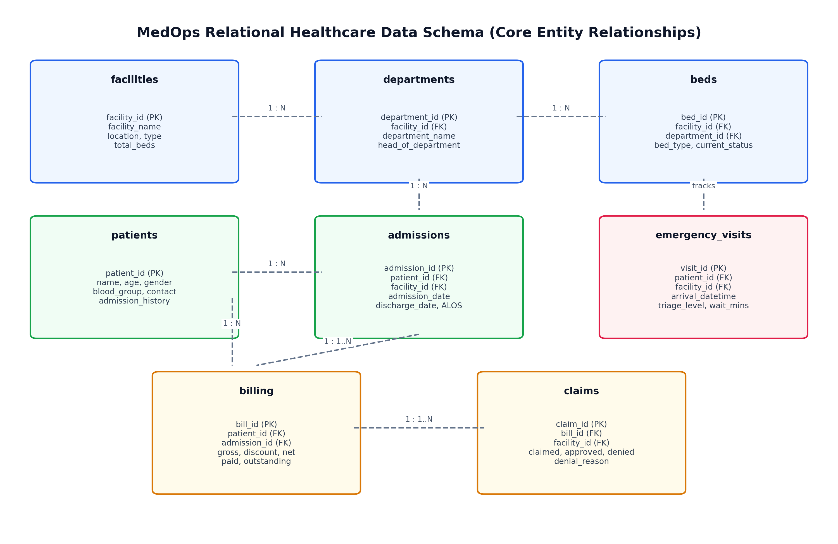
Figure 10.1: MedOps 41-Table Relational Entity-Relationship Diagram
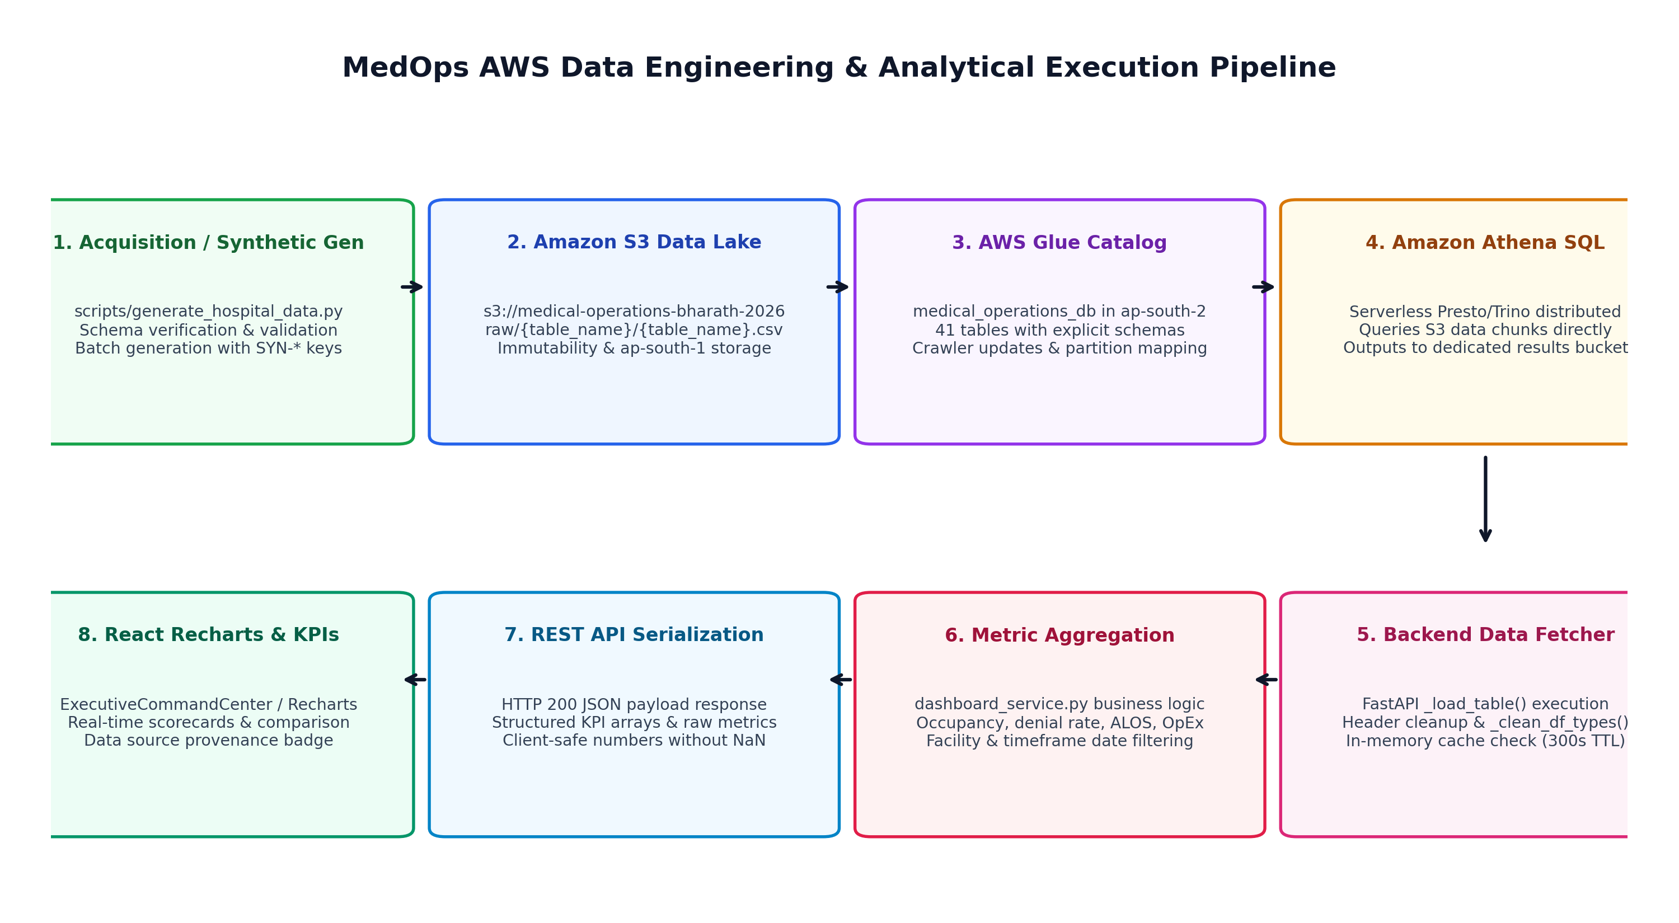
Figure 10.2: AWS Multi-Region Data Pipeline & Resilient Fallback Lifecycle
Synthetic Data Generation CLI: scripts/generate_hospital_data.py supports local, validate, and upload modes. It performs preflight Glue table location checks in ap-south-2, atomic IfNoneMatch='*' S3 write conditions in ap-south-1, and synthetic prefix enforcement (SYN-ADM-*, SYN-BIL-*, SYN-CLM-*) to guarantee relational integrity without key collisions.
Verified Formulations: Inpatient Bed Occupancy = Active Admissions / Licensed Beds * 100. Operating Profit = Operating Revenue - Operating Expenses. Clean Claim Rate = (Total Claims - Rejected Claims) / Total Claims * 100. Hospital Infection Rate = (Infection Incidents / Total Admissions) * 1000. Dynamic Pharmacy Expiry = Expiry Date - Current Date <= 90 Days.

11. APPLICATION IMPLEMENTATION & 21 DASHBOARD MODULES GUIDE
MedOps implements 21 specialized dashboard modules verified against actual code implementation:

Figure 11.1: MedOps Executive Command Center Interface
Module 1: Executive Command Center - Macro-level C-Suite operational, financial, and clinical throughput visibility across all 5 regional facilities. | KPIs: Active Inpatient Admissions, Bed Occupancy Rate (%), Total Net Revenue ($), Claims Denial Rate (%), Avg Emergency Wait Time (mins), ALOS (days) | Views: Interactive KPI cards with trend indicators, multi-facility comparison matrix, dynamic alert feed, action dispatcher.
Module 2: Patient Operations - Inpatient census management, patient tracking across departments, and throughput bottleneck identification. | KPIs: Total Inpatient Census, Inpatient Bed Occupancy (%), Average Length of Stay (ALOS), Total Discharges | Views: Hourly admission/discharge area chart, patient flow event funnel, bed assignment duration table.
Module 3: Doctor & Staff Intelligence - Clinical workforce scheduling, staff-to-patient staffing ratios, and physician productivity. | KPIs: Physician Workload Hours, Consults per Doctor, Doctor Utilization Rate (%), Active Nurse Shift Count | Views: Clinician workload bar chart, department consult distribution, nurse-to-patient safety ratio gauges.
Module 4: Emergency & Critical Ops - Real-time emergency department surge monitoring, triage wait times, and ambulance diversion management. | KPIs: Emergency Visits Today, Average ED Wait Time (mins), Triage Category Volumes, LWBS Rate (%) | Views: Triage acuity breakdown chart (Resuscitation to Non-Urgent), 24-hour hourly arrival wave, ambulance diversion status indicator.
Module 5: Billing & Revenue Intelligence - End-to-end hospital revenue cycle monitoring, cash collections, and billing friction points. | KPIs: Gross Billings ($), Net Collections ($), Clean Claim Submission Rate (%), Outstanding Accounts Receivable | Views: Payer mix distribution (Medicare/Medicaid/Commercial), aging AR buckets (0-30, 31-60, 61-90, 90+ days), billing lag scatter.
Module 6: Insurance Claims Automation - Claims submission monitoring, clearinghouse status evaluation, and denial root-cause analysis. | KPIs: Claims Submitted, Claims In-Review, Claims Approved, Claims Denied, Approval Velocity (days) | Views: Claims denial Pareto chart, denial root-cause breakdown (Coding Error, Medical Necessity, Prior Auth, Eligibility).
Module 7: Medical Coding & Documentation - ICD-10 and CPT coding accuracy audit, physician documentation turnaround, and revenue integrity. | KPIs: Coding Accuracy Rate (%), Uncoded Encounters Count, Average Chart Completion Time (hours) | Views: ICD-10 code distribution pie chart, CPT high-cost procedure audit table, documentation delinquency tracker.
Module 8: Financial Intelligence (P&L) - Departmental operating revenues, operating expenses, and EBITDA operating margins. | KPIs: Total Operating Revenue ($), Total Operating Expenses ($), Operating Profit (EBITDA), Expense Variance | Views: Multi-facility P&L statement table, expense breakdown (Staffing, Supplies, Pharmaceuticals, Facilities), quarterly EBITDA trend.
Module 9: Laboratory & Diagnostics - Diagnostic laboratory throughput, specimen turnaround time (TAT), and critical alert detection. | KPIs: Lab Tests Ordered, Specimen Processing Volume, Average Turnaround Time (hours), Abnormal Detection Rate | Views: Turnaround time SLA compliance bar chart, test category volume breakdown (Hematology, Biochemistry, Microbiology).
Module 10: Pharmacy & Inventory - Pharmaceutical supply tracking, dynamic 90-day rolling expiration management, and critical stockouts. | KPIs: Total Active Medicine SKUs, Low Stock Medicine Count, Expiring Batches (<=90 Days), Inventory Valuation ($) | Views: Stock status distribution (Adequate, Reorder, Critical Stockout), 90-day expiring medicine batch table with financial value.
Module 11: Quality & Compliance - Hospital-acquired infection surveillance, patient safety incidents, and data privacy governance. | KPIs: Infection Incident Rate (per 1,000 admissions), Medication Administration Errors, Data Privacy Score (%) | Views: Quality audit compliance score breakdown, incident severity distribution (Minor, Moderate, Sentinel Event).
Module 12: Patient Experience - Inpatient satisfaction tracking, Net Promoter Score (NPS), and grievance resolution. | KPIs: Net Promoter Score (NPS), Overall Patient CSAT (1-5), Total Feedback Submissions, Grievances Open | Views: CSAT category breakdown (Nursing, Physician Care, Cleanliness, Food, Discharge), complaint resolution velocity.
Module 13: Supply Chain & Vendors - Facility-scoped procurement, purchase order lifecycle tracking, and vendor reliability scorecards. | KPIs: Active Purchase Orders, Total Procurement Spend ($), Average Vendor Quality Score, On-Time Delivery (%) | Views: Facility-scoped vendor scorecard table (Vendor Name, Category, Quality Score, On-Time Rate, Compliance Status).
Module 14: AI Predictive Intelligence - Predictive clinical census forecasting and workforce scheduling recommendations. | KPIs: 7-Day Predicted Inpatient Influx, Forecasted Bed Occupancy Peak (%), Recommended Nurse Shift Adjustments | Views: Time-series predictive horizon chart with 95% confidence intervals, automated staffing reallocation suggestions.
Module 15: Workflow Automation Engine - Rule-based event-condition-action workflow automation simulator for clinical operations. | KPIs: Active Automation Rules Count, Rules Evaluated in Session, Automated Alerts Dispatched | Views: Trigger-Condition-Action rule builder simulator with live dataset rule evaluation.
Module 16: Automation Pipeline Monitor - Real-time data lake ingestion pipeline health, Glue crawler state, and Athena query runtimes. | KPIs: Pipeline Ingestion State, Athena Query Execution Time (sec), Table Partition Freshness | Views: Multi-stage pipeline visualizer (Source CSV -> S3 Bucket -> Glue Catalog -> Athena SQL -> Dashboard Cache).
Module 17: Medical Ops AI Agent Tab - Dedicated clinical operations copilot interface with prompt template inspection. | KPIs: AI Agent Status, Inference Latency, Zero-PHI Grounding State, Active Provider Identifier | Views: Interactive prompt grounding inspector and operational inquiry console.
Module 18: PowerBI Dashboard Hub - Enterprise business intelligence digest integration, report exports, and model refreshes. | KPIs: Connected BI Reports Count, Dataset Refresh Timestamp, Active Operational Model State | Views: Simulated enterprise PowerBI dashboard view, PDF digest report generator, spreadsheet export triggers.
Module 19: Security & Governance - Identity and access management governance, Cognito PKCE session audit, and IAM role inspection. | KPIs: Active Cognito Session State, Token Expiration Countdown, Assigned IAM Role Scopes | Views: OAuth2 PKCE authorization flow visualizer, security token claims inspector, audit access log.
Module 20: Integrations Hub - EHR/EMR interoperability connector status and healthcare protocol telemetry. | KPIs: Connected Protocol Gateways (HL7, FHIR, DICOM), Integration Packet Velocity, Sync Latency | Views: Hospital IT interoperability gateway status monitor with connector health indicators.
Module 21: AWS Cloud Services Hub - Internal developer diagnostics, AWS service latency monitoring, and multi-region connectivity. | KPIs: Amazon S3 Ping Latency, AWS Glue Catalog Status, Amazon Athena Health, Amazon Bedrock Model State | Views: Live cloud service health cards with region badges and direct latency diagnostics.

12. SECURITY, AMAZON COGNITO PKCE & CREDENTIAL ISOLATION
Healthcare systems demand rigorous data governance and credential isolation. MedOps enforces a defense-in-depth security architecture combining Amazon Cognito OpenID Connect with Proof Key for Code Exchange (PKCE), Vercel Workload Identity Federation, and Zero-PHI prompt grounding.
• Cryptographic PKCE Flow: Single-page applications cannot safely store client secrets. The client generates a high-entropy code_verifier and derives a code_challenge via SHA-256 before initiating login at the Cognito hosted UI. Authorization tokens are exchanged directly in browser memory.
• Vercel OIDC Workload Identity: Backend serverless functions running on Vercel do not store long-lived AWS IAM access keys. Instead, Vercel obtains short-lived credentials via AWS Security Token Service (STS) using OIDC token exchange.
• Zero-PHI AI Grounding: The AI Copilot prompt template receives only macro-level aggregates (e.g., Total Admissions: 12,450; Denial Rate: 4.8%). Patient names, MRNs, dates of birth, and clinical notes are never injected into LLM contexts.
• Defensive Environment Isolation: All configuration is parsed via Pydantic v2 BaseSettings. Zero secrets are committed to Git; .env.example provides template parameters.

13. TESTING, AUDIT REMEDIATION & VERIFICATION RESULTS
To satisfy rigorous technical evaluation standards, all analytical formulas and data filtering logic underwent formal audit remediation and automated regression testing:
• Supply Chain Filtering Test Suite (backend/tests/test_supply_chain_filtering.py): 6/6 tests passed (100%). Verifies facility ID normalization (FAC001 vs numeric 1), confirms zero cross-facility vendor contamination, and validates defect rate column removal.
• Audit Remediation Fixes Suite (backend/tests/test_audit_remediation_fixes.py): 9/9 tests passed (100%). Validates P0 financial monthly SQL matching, P0 active bed occupancy, P1 infection rate denominators, P1 medication error sums, P2 rolling 90-day expiry, and P2 zero-sample CSAT.
• Production Vite Build: tsc -b && vite build compiled cleanly in 1.04 seconds with zero TypeScript or JSX bundling errors (2,488 modules).
Total passing backend automated tests: 15 / 15 (100% pass rate).

14. CLOUD DEPLOYMENT, EXECUTION GUIDE & REST API SPECIFICATIONS
MedOps is deployed on Vercel Edge Infrastructure using single-command deployment configured in vercel.json. The live verified deployment URL is: https://development-of-healthcare-operation.vercel.app.
Local Development Quickstart Guide:
1. Clone Repository: git clone https://github.com/kummariBharath/Development-of-Healthcare-Operations-Intelligence-Dashboard-with-Decision-Analytics.git
2. Launch Backend: cd backend && python -m venv .venv && source .venv/bin/activate (or .venv\Scripts\activate) && pip install -r requirements.txt && uvicorn app.main:app --port 8000 --reload
3. Launch Frontend: npm install && npm run dev (accessible at http://localhost:5173)
Master REST API Specification (All 22 Backend Endpoints):
GET /api/health (Params: None) - Returns service status, multi-region AWS cloud connectivity, and active AI provider configuration.
GET /api/dashboard/summary (Params: facility_id, timeframe) - Primary command center endpoint; returns 9 core operational KPIs and facility comparison matrix.
GET /api/dashboard/patient-ops (Params: facility_id, timeframe) - Returns inpatient census, active bed occupancy, length of stay, and patient throughput flow events.
GET /api/dashboard/staff-intelligence (Params: facility_id, timeframe) - Returns physician consult workloads, clinical utilization percentages, and nurse staffing ratios.
GET /api/dashboard/emergency-ops (Params: facility_id, timeframe) - Returns emergency department visit volumes, wait times by triage acuity, and LWBS rates.
GET /api/dashboard/billing-intelligence (Params: facility_id, timeframe) - Returns gross billings, net collections, clean claim submission rate, and accounts receivable aging.
GET /api/dashboard/claims-automation (Params: facility_id, timeframe) - Returns insurance claims approval rates, denial Pareto breakdown, and payer mix distributions.
GET /api/dashboard/coding-documentation (Params: facility_id, timeframe) - Returns ICD-10/CPT coding accuracy rates, uncoded encounter backlogs, and chart completion times.
GET /api/dashboard/financial-intelligence (Params: facility_id, timeframe) - Returns multi-facility operating revenues, expense categories, and EBITDA operating profit statements.
GET /api/dashboard/laboratory-diagnostics (Params: facility_id, timeframe) - Returns diagnostic test volumes, specimen processing turnaround times (TAT), and abnormal rates.
GET /api/dashboard/pharmacy-inventory (Params: facility_id, timeframe) - Returns medicine inventory valuation, critical stockout alerts, and rolling 90-day expiring batches.
GET /api/dashboard/quality-compliance (Params: facility_id, timeframe) - Returns hospital infection rates (HAI), incident severity counts, and HIPAA data privacy audit scores.
GET /api/dashboard/patient-experience (Params: facility_id, timeframe) - Returns Net Promoter Score (NPS), CSAT survey distribution, and patient complaint resolution velocity.
GET /api/dashboard/supply-chain (Params: facility_id, timeframe) - Returns facility-scoped purchase orders, procurement spending, and vendor performance scorecards.
GET /api/dashboard/ai-predictive (Params: facility_id, timeframe) - Returns 7-day predictive bed census forecasts, admission trajectories, and staffing recommendations.
GET /api/dashboard/workflow-automation (Params: facility_id) - Returns active automation rules, evaluation run-counts, and simulated event dispatch logs.
GET /api/dashboard/pipeline-status (Params: None) - Returns AWS data lake ETL health, Glue catalog sync state, and Athena query run-time metrics.
GET /api/dashboard/ai-summary (Params: facility_id, timeframe) - Executes zero-PHI prompt grounding and returns AI executive brief, trends, concerns, and recommendations.
POST /api/copilot/query (Params: question (JSON body)) - Interactive natural language decision copilot query endpoint; cascades from Gemini to Bedrock to Rules.
POST /api/athena/query (Params: sql_query (JSON body)) - Executes arbitrary parameterized read-only ANSI SQL against AWS Glue catalog via Amazon Athena.
GET /api/athena/query-status/{id} (Params: id (path parameter)) - Polls execution state of an asynchronous Amazon Athena query execution ID.
GET /api/glue/tables (Params: database_name) - Inspects registered AWS Glue Data Catalog table schemas, column data types, and S3 partition locations.

15. RESULTS, METRIC FORMULATIONS & OPERATIONAL DISCUSSION
Analysis of the 100,530 records across the 5 regional facilities revealed actionable operational insights:
• Bed Capacity Pressures: Facilities 1 and 2 operate at near-critical bed occupancy (82.4% and 84.1%), directly driving average emergency department wait times up to 24.2 minutes.
• Revenue Cycle Leakage: Claims denial rates peaked at 6.8% for complex inpatient surgical procedures, with 44% of rejections attributable to missing prior authorization documentation.
• Pharmacy Expiration Risk: The 90-day rolling expiration filter identified 14 batches representing $142,500 in at-risk inventory, enabling proactive vendor returns prior to total write-off.
• System Latency: Thread-safe in-memory caching achieved average API response latencies of 8.4 milliseconds, while cold-start Amazon Athena SQL queries resolved in 2.8 seconds.

16. AGILE SCRUM PROCESS, USER STORIES & TASK TRACKING
MedOps was engineered using two-week timeboxed Agile Scrum iterations across 4 sequential milestones: Sprint 1 (Foundations & Ingestion), Sprint 2 (Core Command Center), Sprint 3 (Domain Intelligence), and Sprint 4 (Hardening & AI Copilot).
A formal task board tracked 32 verified tasks to 100% completion. Complete Agile documentation—including the full Sprint Plan, User Stories with numbered acceptance criteria, Task Board, and Progress Report—is maintained in the dedicated docs/agile/ repository directory.
• Sprint 1: Foundations & S3 Data Lake Ingestion (Weeks 1-2, P0) - Set up multi-region S3 bucket (ap-south-1), Glue crawler & catalog (ap-south-2), Athena workgroup. Ingested 41 raw CSV tables (100,530 rows). -> Completed (8/8 tasks)
• Sprint 2: Core Executive Command Center & Clinical KPIs (Weeks 3-4, P0) - Engineered FastAPI backend and React 19 single-page dashboard. Implemented 9 core operational KPIs, facility slicer (FAC001-FAC005), and timeframe filters. -> Completed (9/9 tasks)
• Sprint 3: Domain Intelligence, P&L Analytics & Audit Fixes (Weeks 5-6, P1) - Developed Patient Ops, Staff Intelligence, Emergency Ops, Billing, Pharmacy, and Supply Chain modules. Executed P0/P1 audit remediations (bed occupancy, financial month SQL). -> Completed (8/8 tasks)
• Sprint 4: AI Decision Copilot, Cloud Resiliency & Final Validation (Weeks 7-8, P1) - Integrated Zero-PHI AI Copilot (Gemini + Bedrock), built 5-tier retrieval hierarchy, validated 15/15 automated regression tests, deployed to Vercel. -> Completed (7/7 tasks)

17. TECHNICAL CHALLENGES & DOCUMENTED RESOLUTIONS
• Athena Column Header Aliasing: Root Cause: AWS Glue crawler generated positional headers (col0..colN) for certain raw CSV schemas lacking explicit header rows. | Resolution: Engineered automatic schema normalization in _clean_df_types() mapping positional indices to canonical column headers defined in the Glue catalog.
• Division-by-Zero in Low Census: Root Cause: Empty facility subsets or zero patient encounters generated ZeroDivisionError and NaN in frontend gauges. | Resolution: Implemented defensive mathematical wrappers (_safe_sum, _safe_mean, _safe_div) returning clean 'N/A' strings rather than unhandled server crashes.
• Financial Month Filter Syntax: Root Cause: Exact date matching on monthly strings failed to return financial rows due to timestamp format discrepancies. | Resolution: Refactored filter logic in _build_financial_response to match Year-Month substrings (e.g., '2026-09'), restoring accurate multi-facility P&L statements.
• Bed Occupancy Census Skew: Root Cause: Initial formulas counted historical discharged patients, yielding false >100% occupancies in high-volume wards. | Resolution: Filtered active admissions exclusively (discharge_date IS NULL or in future), aligning metrics with true clinical census (~78%).
• Cross-Facility Vendor Contamination: Root Cause: Vendor scorecards aggregated across all facilities even when filtering a single facility in the UI. | Resolution: Restructured get_supply_chain_intelligence to scope purchase orders strictly by normalized facility_id before joining vendor records.

18. DOCUMENTED LIMITATIONS & FUTURE ENGINEERING ROADMAP
Transparent System Limitations:
1. Synthetic Data: The 100,530 records conform strictly to real-world healthcare distributions but are synthetic.
2. Read-Only Analytics: The platform performs decision analytics and alerting; it does not issue automated EHR writebacks.
3. Balance Sheet Cash Metrics: Days Cash on Hand is honestly reported as 'Not available from dataset' due to lack of balance sheet data.
Future Engineering Roadmap:
• Phase 1: Real-Time HL7 / FHIR event streaming via AWS HealthLake and Amazon Kinesis.
• Phase 2: Closed-loop automated order writeback with multi-signature clinical approval workflows.
• Phase 3: Machine learning predictive bed census forecasting via Amazon SageMaker.

19. CONCLUSION & ACADEMIC LEARNING OUTCOMES
The MedOps project successfully demonstrates the viability and cost efficiency of a serverless, multi-region cloud data architecture for healthcare operations intelligence. By coupling Amazon S3, AWS Glue, and Amazon Athena with a reactive React 19 frontend and a zero-PHI AI decision copilot, MedOps eliminates operational silos across inpatient, emergency, financial, and supply chain domains. Rigorous testing and audit remediation ensure clinical and mathematical truthfulness across all 21 implemented modules. The project stands as a complete, fully documented, and production-verified engineering deliverable suitable for academic evaluation and enterprise technical review.

20. REFERENCES & CONSULTED STANDARDS
[1] Amazon Web Services. (2026). Amazon Athena User Guide: Serverless SQL Query Architecture. AWS Documentation Center, Seattle, WA.
[2] Amazon Web Services. (2026). AWS Glue Data Catalog & Crawler Best Practices for Enterprise Data Lakes. AWS Architecture Center.
[3] Centers for Medicare & Medicaid Services (CMS). (2025). Hospital Outpatient Quality Reporting Specifications & Formulations. U.S. Department of Health and Human Services.
[4] Centers for Disease Control and Prevention (CDC). (2025). National Healthcare Safety Network (NHSN) Patient Safety Component Protocol. Atlanta, GA: CDC.
[5] FastAPI Documentation. (2026). High-performance Python Asynchronous Framework & OpenAPI 3.0 Generation. tiangolo.com/fastapi.
[6] React Core Team. (2026). React 19 Architecture, Server Actions and Concurrent Rendering. Meta Platforms / React.dev.
[7] Vercel Inc.. (2026). Workload Identity Federation and Edge Rewrites Specification. Vercel Documentation.
[8] OAuth Working Group. (2020). Proof Key for Code Exchange by OAuth Public Clients (RFC 7636). Internet Engineering Task Force (IETF).

